Experiment 10
StyleHub Online Fashion Store
My Details
Name | Narjala Saptha Nageswar
Register Number | 192372001
Department | Artificial Intelligence
Course Code | CSA4304
Course Name | Internet Programming
Aim
To develop an online fashion store using HTML5, CSS and JavaScript with categories for men, women and children, size selection, size guide, wishlist, reviews, flash sale, return and exchange, and an administrator panel.
Algorithm
- Start and open the home page; the login page is displayed.
- A new customer registers with name, username, password, email and phone number.
- The user selects the role, enters the credentials and clicks Login.
- The customer browses the categories and sub categories, searches and filters by category, sub category and price; discounted prices are shown during a flash sale.
- The customer opens the product, checks the size guide, selects a size, reads or writes reviews and adds the product to the cart or the wishlist.
- The customer checks out with an address and payment method, tracks the order and requests a return or an exchange after delivery; the admin manages products, starts the flash sale and updates order status.
- The user logs out and the program stops.
Output
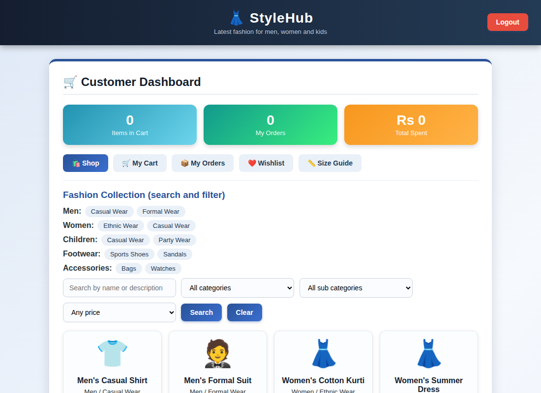
Customer dashboard displayed after login
Result
Thus the StyleHub Online Fashion Store was designed and developed successfully using HTML5, CSS and JavaScript, and the output of the dashboard was verified.

