Experiment 11
Home Finder Real Estate Portal
My Details
Name | Narjala Saptha Nageswar
Register Number | 192372001
Department | Artificial Intelligence
Course Code | CSA4304
Course Name | Internet Programming
Aim
To design a real estate website using HTML5, CSS and JavaScript where buyers search properties, view results on Google Maps, save search criteria and favorites, schedule viewings and use the mortgage and valuation calculators, and the admin manages properties and agents.
Algorithm
- Start and open the page; the login page is displayed.
- A new buyer registers and logs in; the visit of the buyer is recorded for the admin.
- The buyer searches properties by location, type, buy or rent, maximum price, bedrooms and amenities.
- The matching properties are displayed with the area or property shown on the Google map, and the search criteria can be saved and used again.
- The buyer saves favorite listings, schedules a property viewing, contacts the agent and searches agents and companies.
- The buyer uses the mortgage EMI calculator and the valuation tool; the admin adds, updates and deletes properties and agents, views visitors, approves viewings and reads messages.
- The user logs out and the program stops.
Output
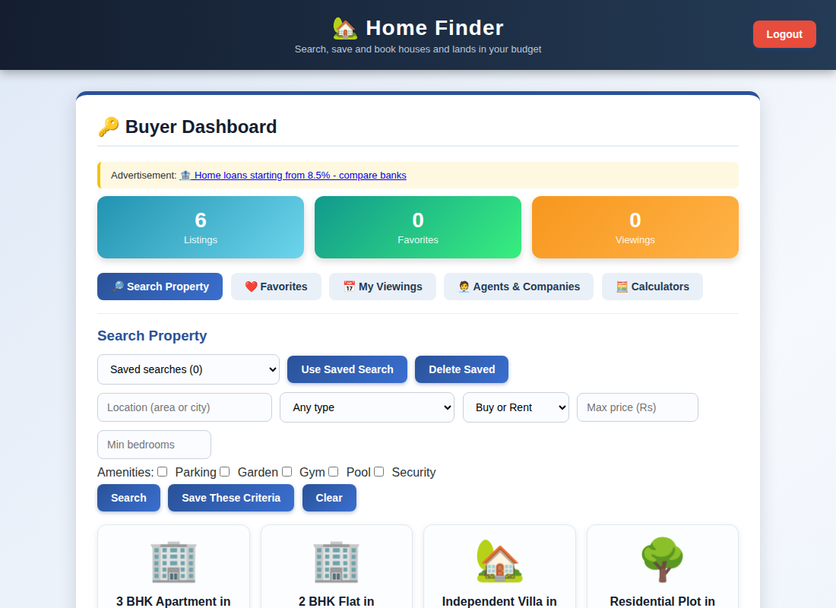
Buyer dashboard displayed after login
Result
Thus the Home Finder Real Estate Portal was designed and developed successfully using HTML5, CSS and JavaScript, and the output of the dashboard was verified.

