Experiment 12
InsureEasy Insurance Management System
My Details
Name | Narjala Saptha Nageswar
Register Number | 192372001
Department | Artificial Intelligence
Course Code | CSA4304
Course Name | Internet Programming
Aim
To develop an insurance management website using HTML5, CSS and JavaScript where agents create customers and policies and send SMS alerts, customers manage and compare policies, and the admin approves agents.
Algorithm
- Start and open the page; the login page is displayed.
- A new agent registers; the admin approves or rejects the agent and only an approved agent can login.
- The user selects Customer, Agent or Admin, enters the credentials and clicks Login.
- The agent creates customer logins and creates policies by selecting the plan and start date; the premium due date is set.
- The agent sends SMS alerts for premiums that are due within 7 days or overdue and handles the claims of the customers.
- The customer views the policies, pays or renews the premium, files a claim, compares plans and reads the SMS alerts; the admin views all agent details and commission.
- The user logs out and the program stops.
Output
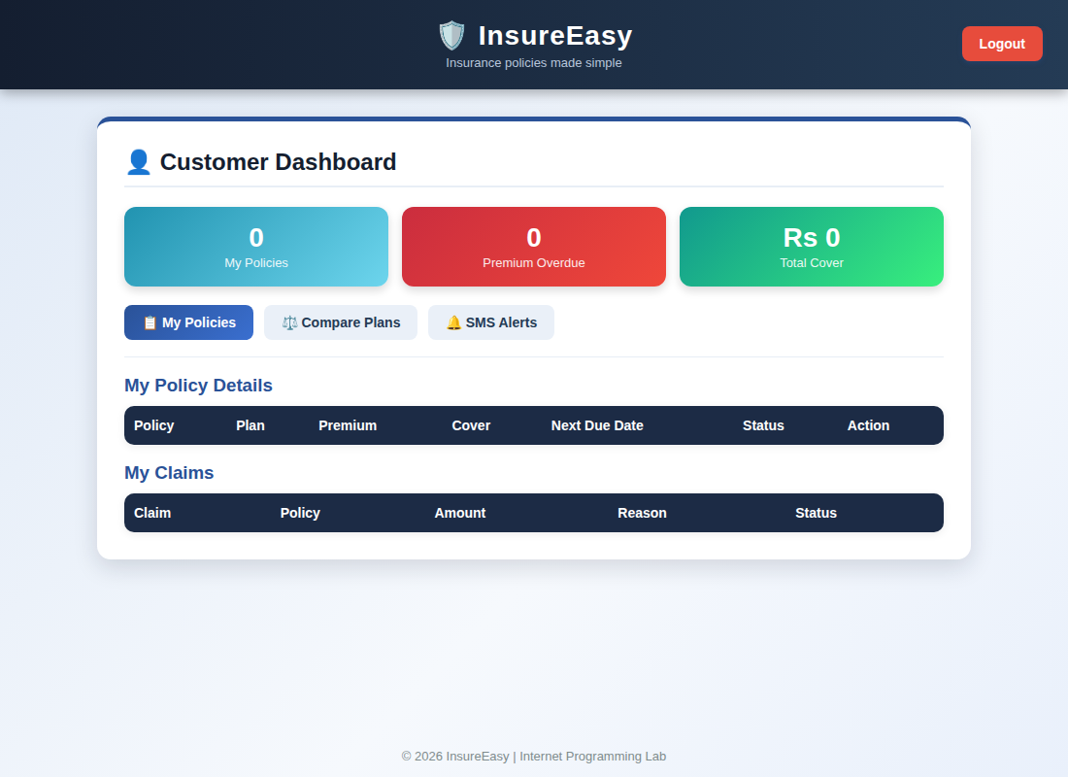
Customer dashboard displayed after login
Result
Thus the InsureEasy Insurance Management System was designed and developed successfully using HTML5, CSS and JavaScript, and the output of the dashboard was verified.

