Experiment 14
ReNewMarket Second Hand Marketplace
My Details
Name | Narjala Saptha Nageswar
Register Number | 192372001
Department | Artificial Intelligence
Course Code | CSA4304
Course Name | Internet Programming
Aim
To design an online marketplace for second hand goods using HTML5, CSS and JavaScript where users list, search, negotiate, buy and sell items and track transactions, and the admin manages users, categories, items and orders.
Algorithm
- Start and open the page; the login page is displayed.
- A new user registers; the same user can act as a buyer and a seller.
- The user selects User or Admin, enters the credentials and clicks Login.
- The seller lists an item with category, price, condition, location and delivery option; buyers browse, search and filter the items and save favorites.
- The buyer makes a price offer; the seller accepts or rejects it and the buyer buys the item at the agreed price with pick-up or delivery.
- The admin changes the logistics status (Paid, Shipped, Received), the buyer rates the seller and users read notifications; the admin also manages users, categories and commodities.
- The user logs out and the program stops.
Output
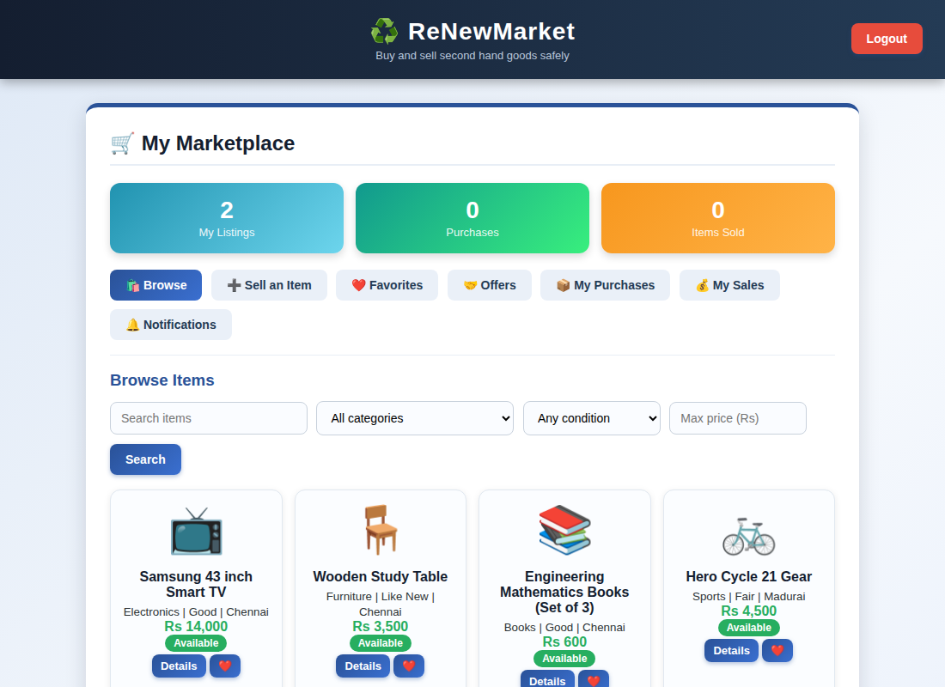
User (buyer and seller) dashboard displayed after login
Result
Thus the ReNewMarket Second Hand Marketplace was designed and developed successfully using HTML5, CSS and JavaScript, and the output of the dashboard was verified.

