Experiment 16
ComplainEase Complaint Management System
My Details
Name | Narjala Saptha Nageswar
Register Number | 192372001
Department | Artificial Intelligence
Course Code | CSA4304
Course Name | Internet Programming
Aim
To develop a public complaint management website using HTML5, CSS and JavaScript where citizens post and track complaints, officers resolve them with proof of work, and the admin manages officer logins and features.
Algorithm
- Start and open the page; the login page is displayed.
- A citizen or an officer registers; the admin can also generate an officer ID and password.
- The user selects Citizen, Officer or Administrator, enters the credentials and clicks Login.
- The citizen posts a complaint with category, description, location marked on the Google map and a supporting document.
- The officer views all complaints, takes a case, updates the status and uploads the proof of work; the citizen is informed by email and SMS.
- The citizen tracks the status, gives feedback and views the admin contact details; the admin manages accounts and passwords, shows or hides features and posts information.
- The user logs out and the program stops.
Output
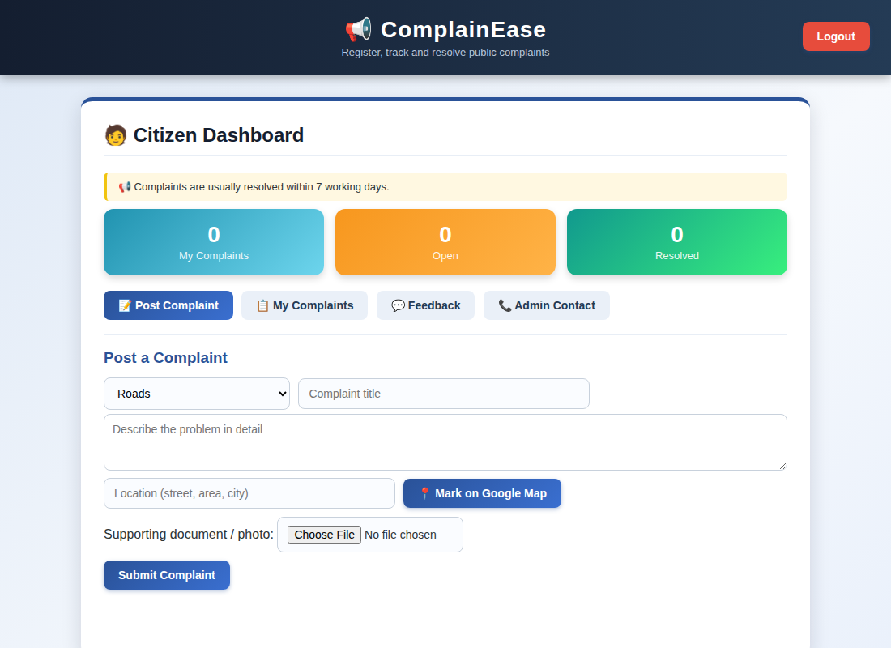
Citizen dashboard displayed after login
Result
Thus the ComplainEase Complaint Management System was designed and developed successfully using HTML5, CSS and JavaScript, and the output of the dashboard was verified.

