Experiment 18
AgriMart Online Agriculture Store
My Details
Name | Narjala Saptha Nageswar
Register Number | 192372001
Department | Artificial Intelligence
Course Code | CSA4304
Course Name | Internet Programming
Aim
To develop an agriculture shopping website using HTML5, CSS and JavaScript where farmers sell seeds, fertilizers and tools and the public buys them with a wallet, shipping address and order tracking.
Algorithm
- Start and open the page; the login page is displayed.
- A user registers as a customer or a farmer and verifies the mobile number with an OTP.
- The verified user selects the role, enters the credentials and clicks Login.
- The customer searches products by name, category and price, views the details and adds products to the cart.
- The customer edits the cart, adds the shipping address, selects Wallet or Cash on Delivery and orders the products.
- The customer tracks the order and shipping status and manages the wallet and account; the farmer adds, updates and deletes products, updates the order and shipping status and views the sales.
- The user logs out and the program stops.
Output
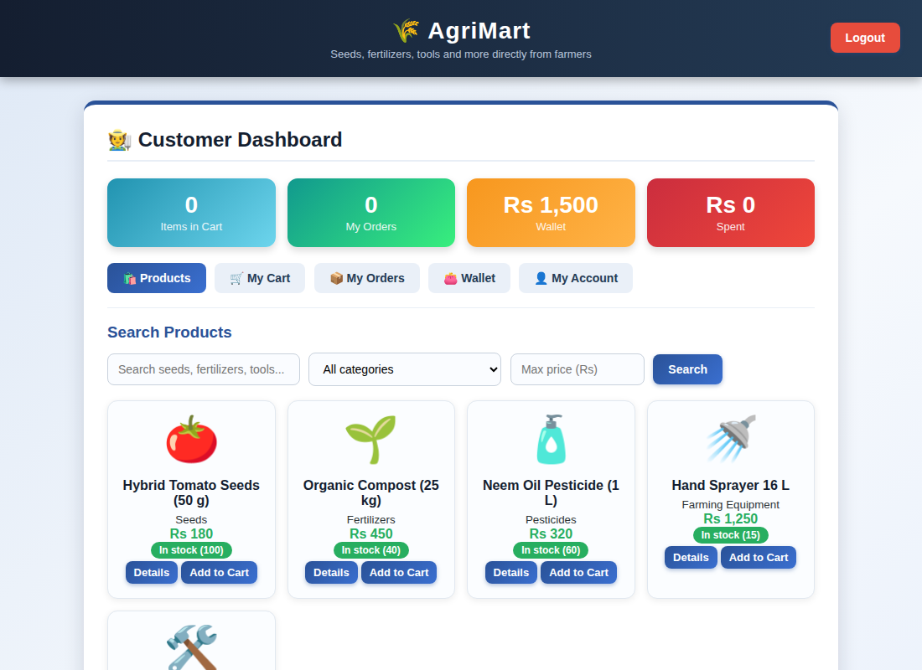
Customer dashboard displayed after login
Result
Thus the AgriMart Online Agriculture Store was designed and developed successfully using HTML5, CSS and JavaScript, and the output of the dashboard was verified.

