Experiment 20
RentRide Vehicle Rental System
My Details
Name | Narjala Saptha Nageswar
Register Number | 192372001
Department | Artificial Intelligence
Course Code | CSA4304
Course Name | Internet Programming
Aim
To design an online vehicle rental website using HTML5, CSS and JavaScript where customers search and book vehicles for given dates and the admin manages vehicles, bookings and reviews.
Algorithm
- Start and open the page; the login page is displayed.
- A new customer registers with name, username, password, phone number and address.
- The user selects Customer or Admin, enters the credentials and clicks Login.
- The customer searches vehicles by type, location, price per day and rental dates; vehicles already booked for those dates are not shown.
- The customer selects a vehicle, enters name, number, address and customer type and the total rent is calculated for the days selected.
- The booking request is approved by the admin and the customer views the booking status and writes a review after the vehicle is returned.
- The admin adds, updates and deletes vehicles, manages bookings and views the reviews; the user logs out and the program stops.
Output
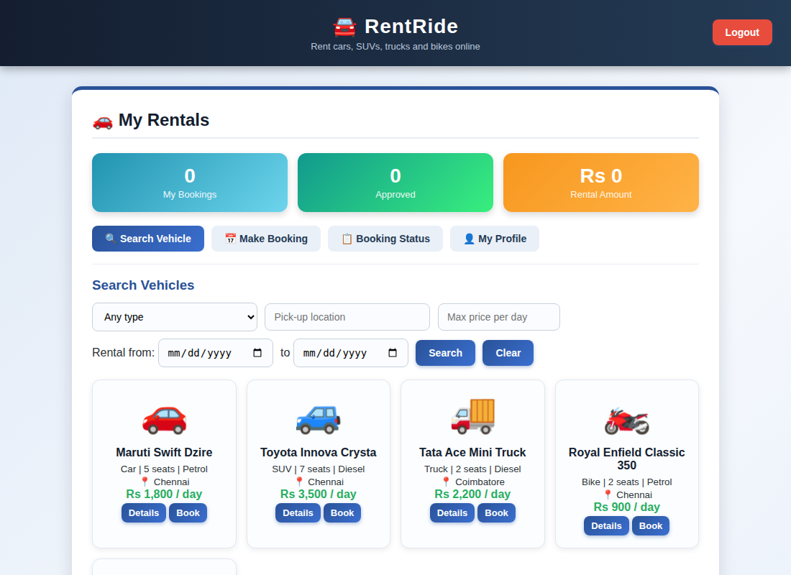
Customer dashboard displayed after login
Result
Thus the RentRide Vehicle Rental System was designed and developed successfully using HTML5, CSS and JavaScript, and the output of the dashboard was verified.

