**NAME : N.SAPTHA NAGESWAR**

**REG.NO : 192372001**

**ASSIGNMENT : 4**

**COURE CODE : CSA 0987  
COURE NAME : JAVA PROGRAMMING.**

1. Find the LCM and GCD of n numbers?

Sample Input:

N value = 2

Number 1 = 16

Number 2 = 20

Sample Output:

LCM = 80

GCD = 4

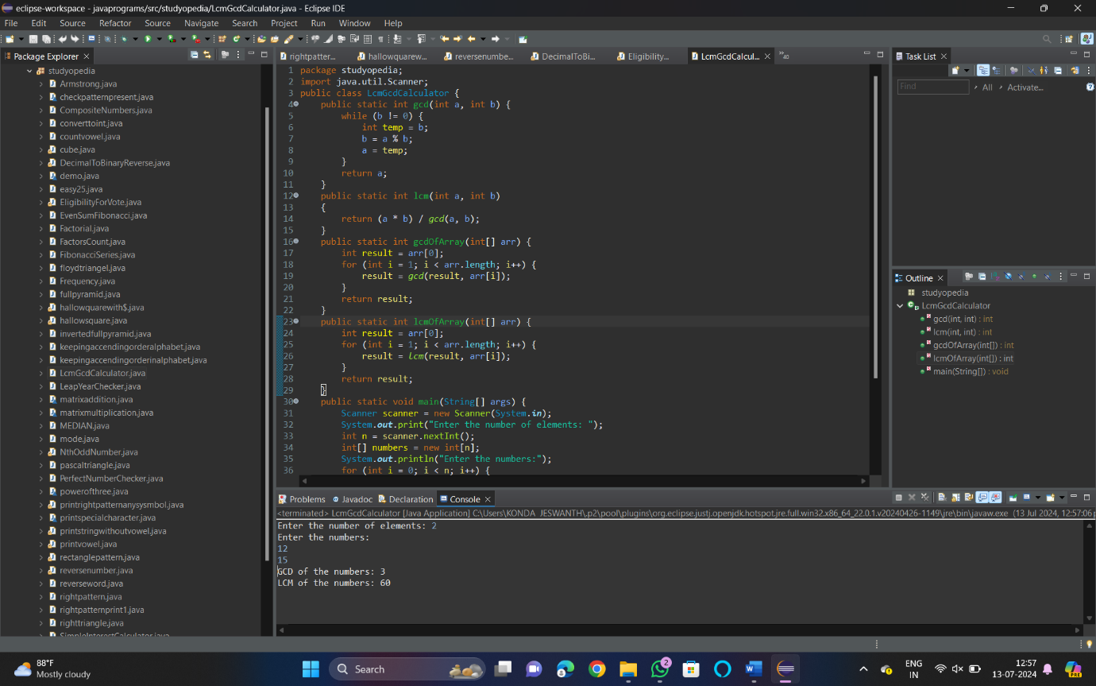

1. Write a program using function to calculate the simple interest. Suppose the customer is a senior citizen. He is being offered 12 percent rate of interest; for all other customers, the ROI is 10 percent.

Sample Input:

Enter the principal amount: 200000

Enter the no of years: 3

Is customer senior citizen (y/n): n

Sample Output:

Interest: 60000

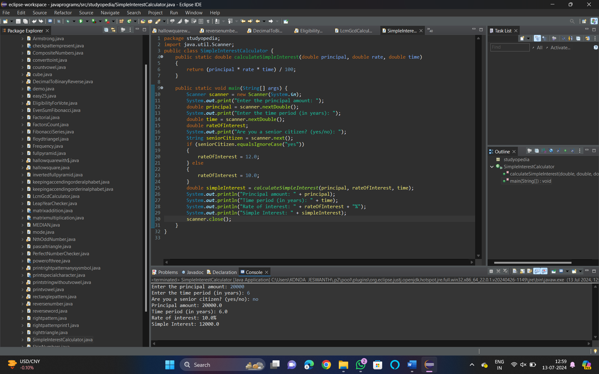

1. Write a program to print the Fibonacci series.

Sample Input:

Enter the n value: 6

**Sample Output:**

0 1 1 2 3 5

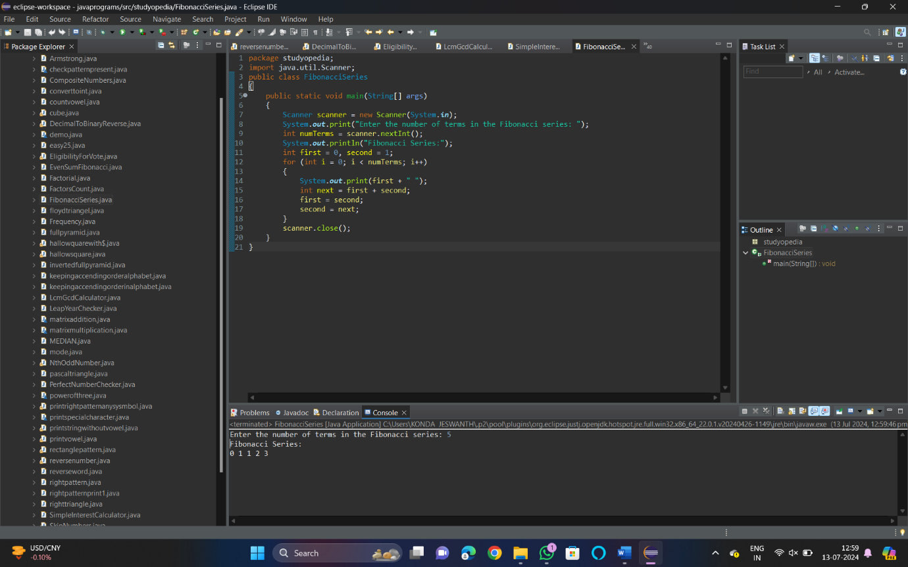

1. [Java Program to Find Even Sum of Fibonacci Series Till number N](https://www.geeksforgeeks.org/java-program-to-find-sum-of-fibonacci-series-numbers-of-first-n-even-indexes/)?

Sample Input: n = 4

Sample Output: 33

(N = 4, So here the fibonacci series will be produced from 0th term till 8th term:0, 1, 1, 2, 3, 5, 8, 13, 21

Sum of numbers at even indexes = 0 + 1 + 3 + 8 + 21 = 33)

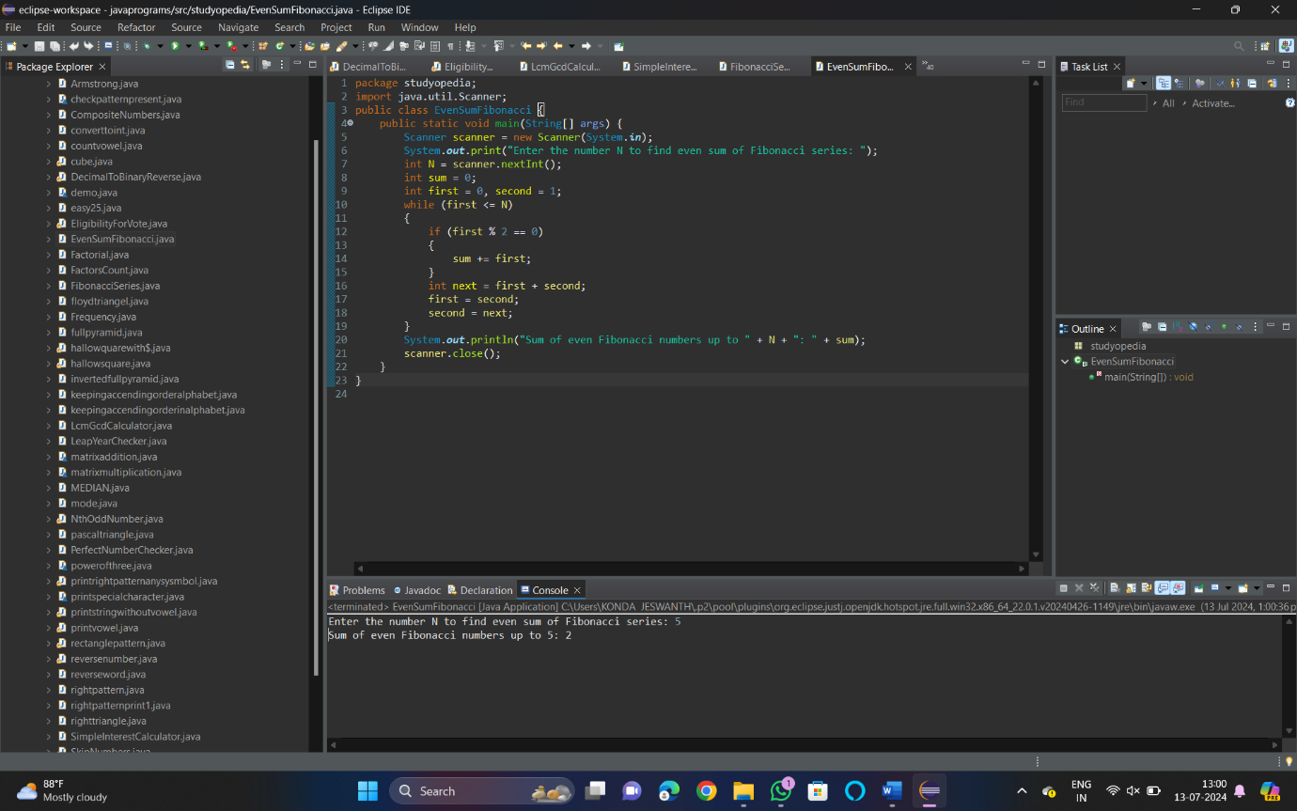

1. Write a program to print the numbers from M to N by skipping K numbers in between?

Sample Input:

M = 50

N = 100

K = 7

Sample Output:

50, 58, 66, 74, …..

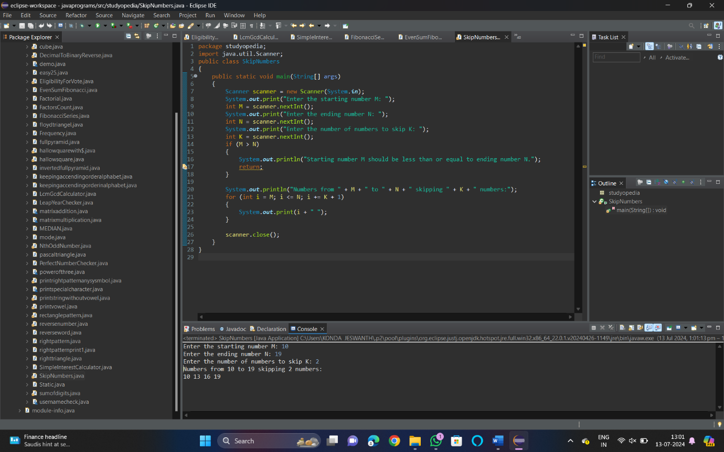

1. Write a program to print all the composite numbers between a and b?

Sample Input:

A = 12

B = 19

Sample Output

14, 15, 16, 18

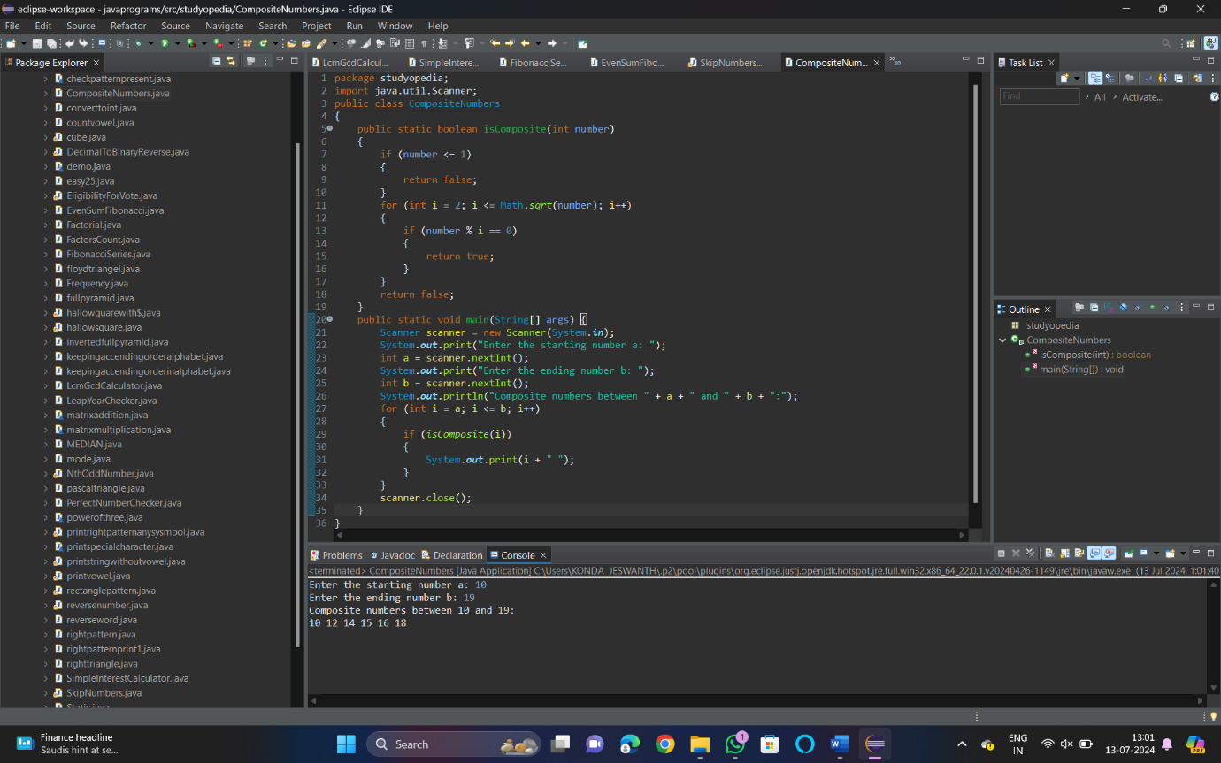

1. Find the factorial of n?

Sample Input:

N = 4

Sample Output:

4 Factorial = 24

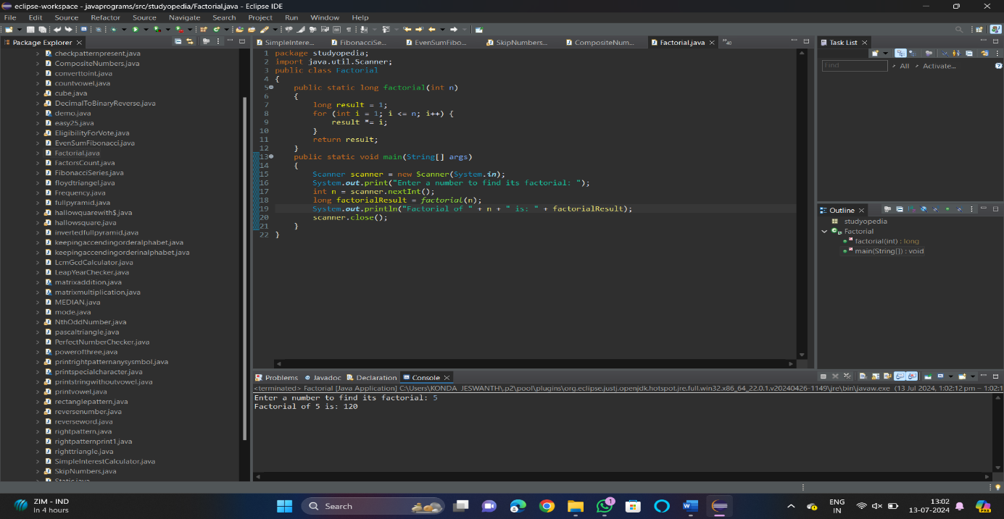

1. Find the year of the given date is leap year or not

Sample Input:

Enter Date: 04/11/1947

Sample Output:

Given year is Non Leap Year

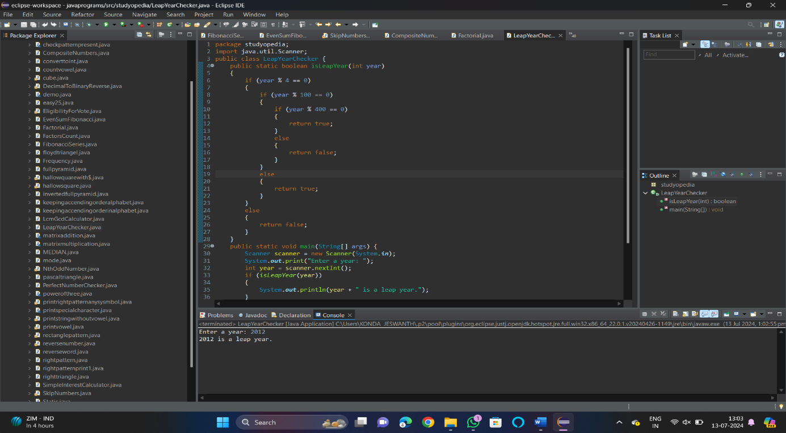

1. Find the number of factors for the given number

Sample Input:

Given number: 100

Sample Output:

Number of factors = 9

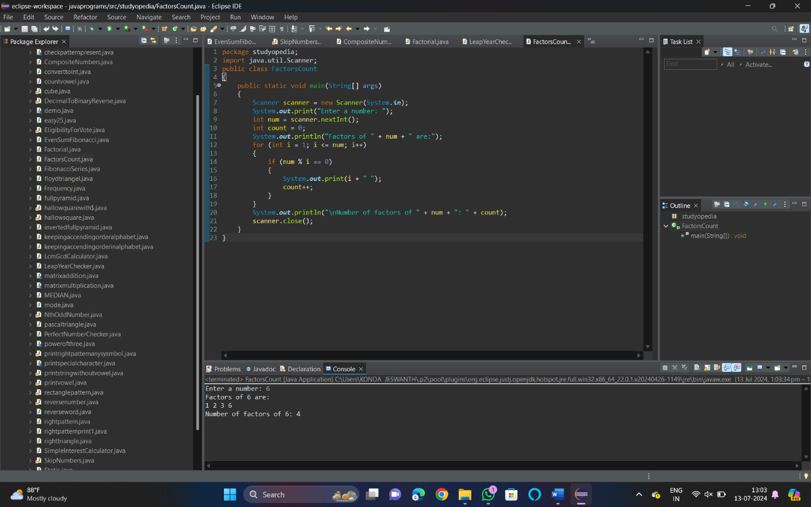

1. Write a program to print the given number is Perfect number or not?

Sample Input:

Given Number: 6

Sample Output:

It’s a Perfect Number

