Loopwell — A Daily Habit Tracker
ICT725 User Experience and Mobile Application Development — Assessment 3
Student: Pradeep Bhandari
Trimester: T2 2026
Platform: Flutter (cross-platform: Android, iOS, web, desktop)

1. Introduction
Loopwell is a cross-platform mobile application that helps a person build and keep daily habits. Its promise is deliberately narrow — small steps, every day — and the whole interface is arranged around a single question the user asks each morning: what do I still need to do today?
Most habit trackers fail their users in one of two ways. They either demand so much setup and configuration that logging a habit becomes another chore, or they punish inconsistency by resetting a streak to zero the moment a day is missed, which is precisely the point at which a discouraged user abandons the app. Loopwell was designed against both failure modes.
The usability of the application rests on four decisions. First, logging is a single tap: the completion circle sits on the right-hand edge of every habit card on the Home screen, so marking a habit done requires no navigation, no confirmation dialog, and no gesture the user has to be taught. Second, the summary is honest: the progress card counts only habits actually scheduled for today, so a weekday-only habit does not read as “missed” on a Sunday. Third, the form has sensible defaults — a new habit arrives with an icon, a colour, “every day”, and no reminder already selected, so a user in a hurry can type a name and save. Fourth, nothing is a dead end: every screen has a clear way back, and destructive actions are confirmed.
The application requires no account and no internet connection. All data is stored on the device, which removes the sign-up friction that typically sits between a user and their first logged habit, and means the application works offline from the moment it is installed.

2. Functional and Non-Functional Requirements
These requirements are carried forward from the Assessment 2 report and were used directly as the build specification.

2.1 Functional requirements
ID | Requirement | Status in Assessment 3
FR1 | Onboarding — introduce the value proposition and route into the app | Fully implemented
FR2 | Daily dashboard — every habit with status, one-tap completion, and a summary | Fully implemented
FR3 | Create habit — name, icon, colour, and frequency | Fully implemented
FR4 | Reminders — a per-habit reminder with a set time | Partly implemented (see Section 5)
FR5 | Mark complete or undo — toggle completion for the day | Fully implemented
FR6 | Habit detail — streak, completion rate, and heat map | Fully implemented
FR7 | Edit or delete an existing habit | Fully implemented
FR8 | Settings — notifications, appearance, data export, profile | Fully implemented
Seven of the eight functional requirements are fully working end to end, well beyond the assessment’s requirement of a minimum of two major features.

2.2 Non-functional requirements
Requirement | How the implementation satisfies it
Usability — completion usable without instruction | One tap on the status circle on the Home card; no confirmation, no gesture to learn
Performance — transitions resolve quickly | Standard MaterialPageRoute transitions; the UI updates optimistically and the disk write is awaited afterwards, so the interface never blocks on storage
Accessibility — WCAG 2.1 AA contrast, 44pt touch targets | Every tappable control clears a 44×44pt hit area even where the painted control is smaller; the completion tick publishes its own accessibility node so a screen reader does not announce the whole card as one control
Consistency — one shared design system | lib/theme/app_theme.dart is the single place colours, radii, and type are defined; it is generated from the design token table used for the Figma prototype
Responsiveness — usable across device sizes | Flexible layouts with no hardcoded pixel widths; verified on compact (320×568), standard (390×844) and large (430×932) viewports with no overflow
Privacy — no account, data on device | No backend and no authentication; habits are JSON-encoded into shared_preferences on the device

3. Figma High-Fidelity Prototype
The interactive high-fidelity prototype produced for Assessment 2, with all frames wired together:
https://www.figma.com/design/yZf92ARQOn7lqavVbicKaS/Loopwell—UX-Prototype–ICT725-?node-id=14-3
The file contains three pages: a Cover, a Wireframes page with five linked low-fidelity screens, and a Hi-Fi Prototype page with seven high-fidelity frames (three onboarding slides, Home, Add/Edit Habit, Habit Detail & Stats, and Settings), all linked with click-through interactions.

4. Implemented Front-End Functionality
The application was built in Flutter 3.47.2 / Dart 3.13.2 using provider for state management and shared_preferences for local persistence. flutter analyze reports no issues, and 15 unit tests cover the streak and completion-rate logic.

4.1 Onboarding (FR1)
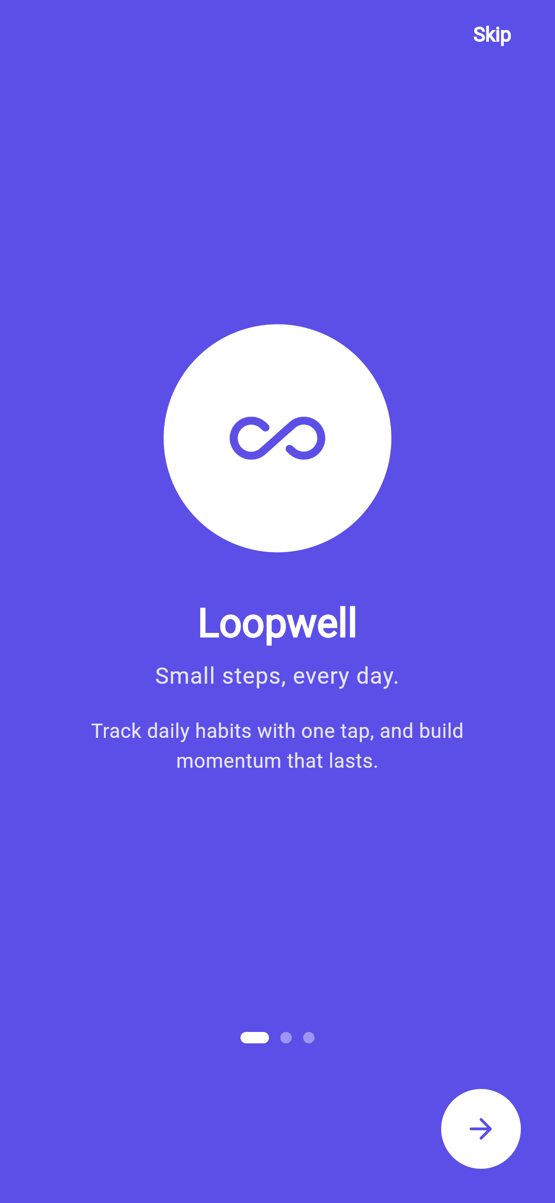
Onboarding
A three-slide carousel on the brand indigo background introduces the value proposition. Slides one and two offer Skip; the third commits with Get Started. Completion is persisted, so the carousel is shown only on first launch and the app opens directly on Home thereafter.

4.2 Daily dashboard and one-tap completion (FR2, FR5)
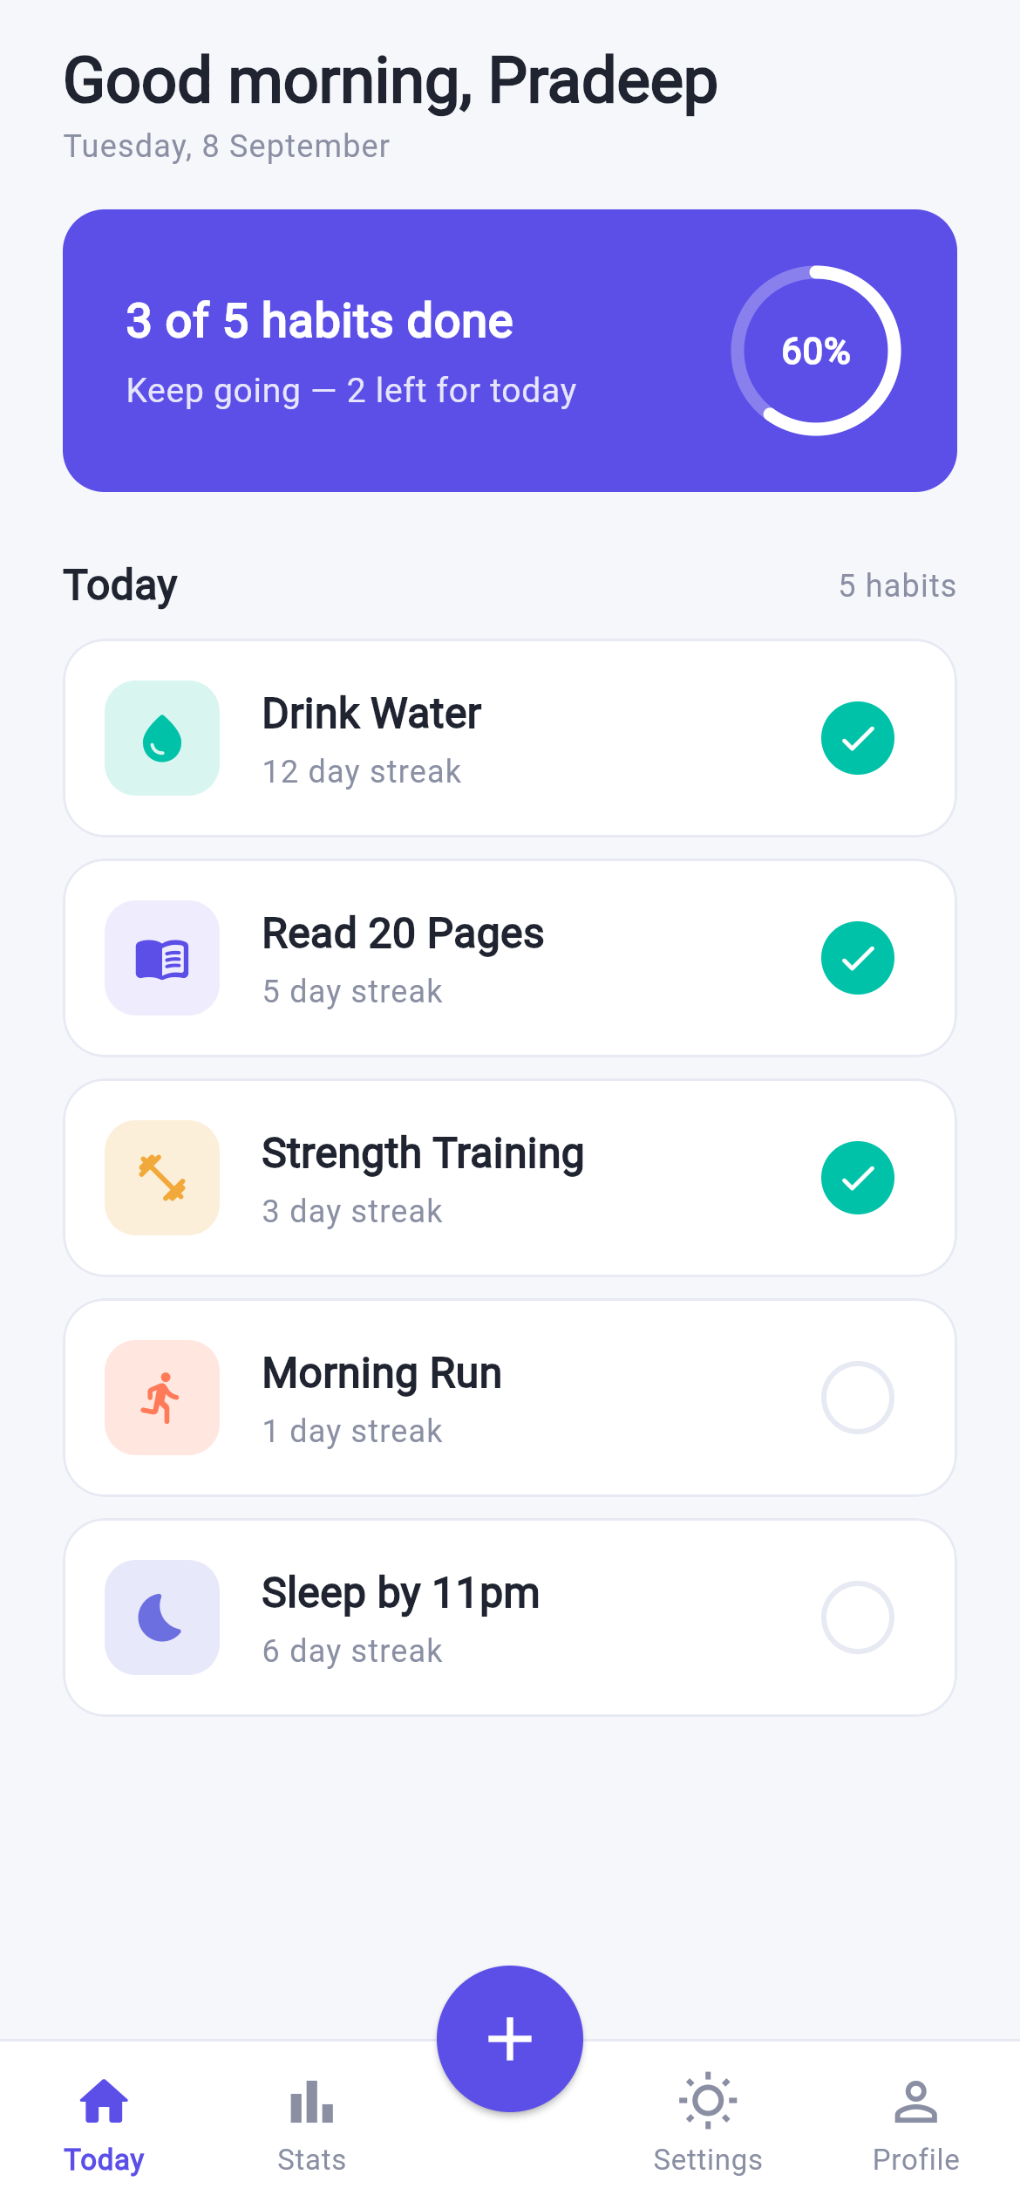
Home
Home is the hub of the application. A time-aware greeting and today’s date sit above a filled progress card that states how many of today’s scheduled habits are done, with a matching progress ring. Below it, each habit is a card showing its icon in a tinted tile, its name, and its current streak.
The circle on the trailing edge of each card is the one-tap completion control (FR5). Tapping it toggles today’s completion in place: the circle fills, the streak recalculates, the summary card and progress ring update, and the change is written to disk — all without leaving the screen. Tapping the body of the card instead opens that habit’s detail screen. A docked “+” button opens the create-habit form, and a bottom navigation bar provides the four top-level destinations.

4.3 Create and edit a habit (FR3, FR7)
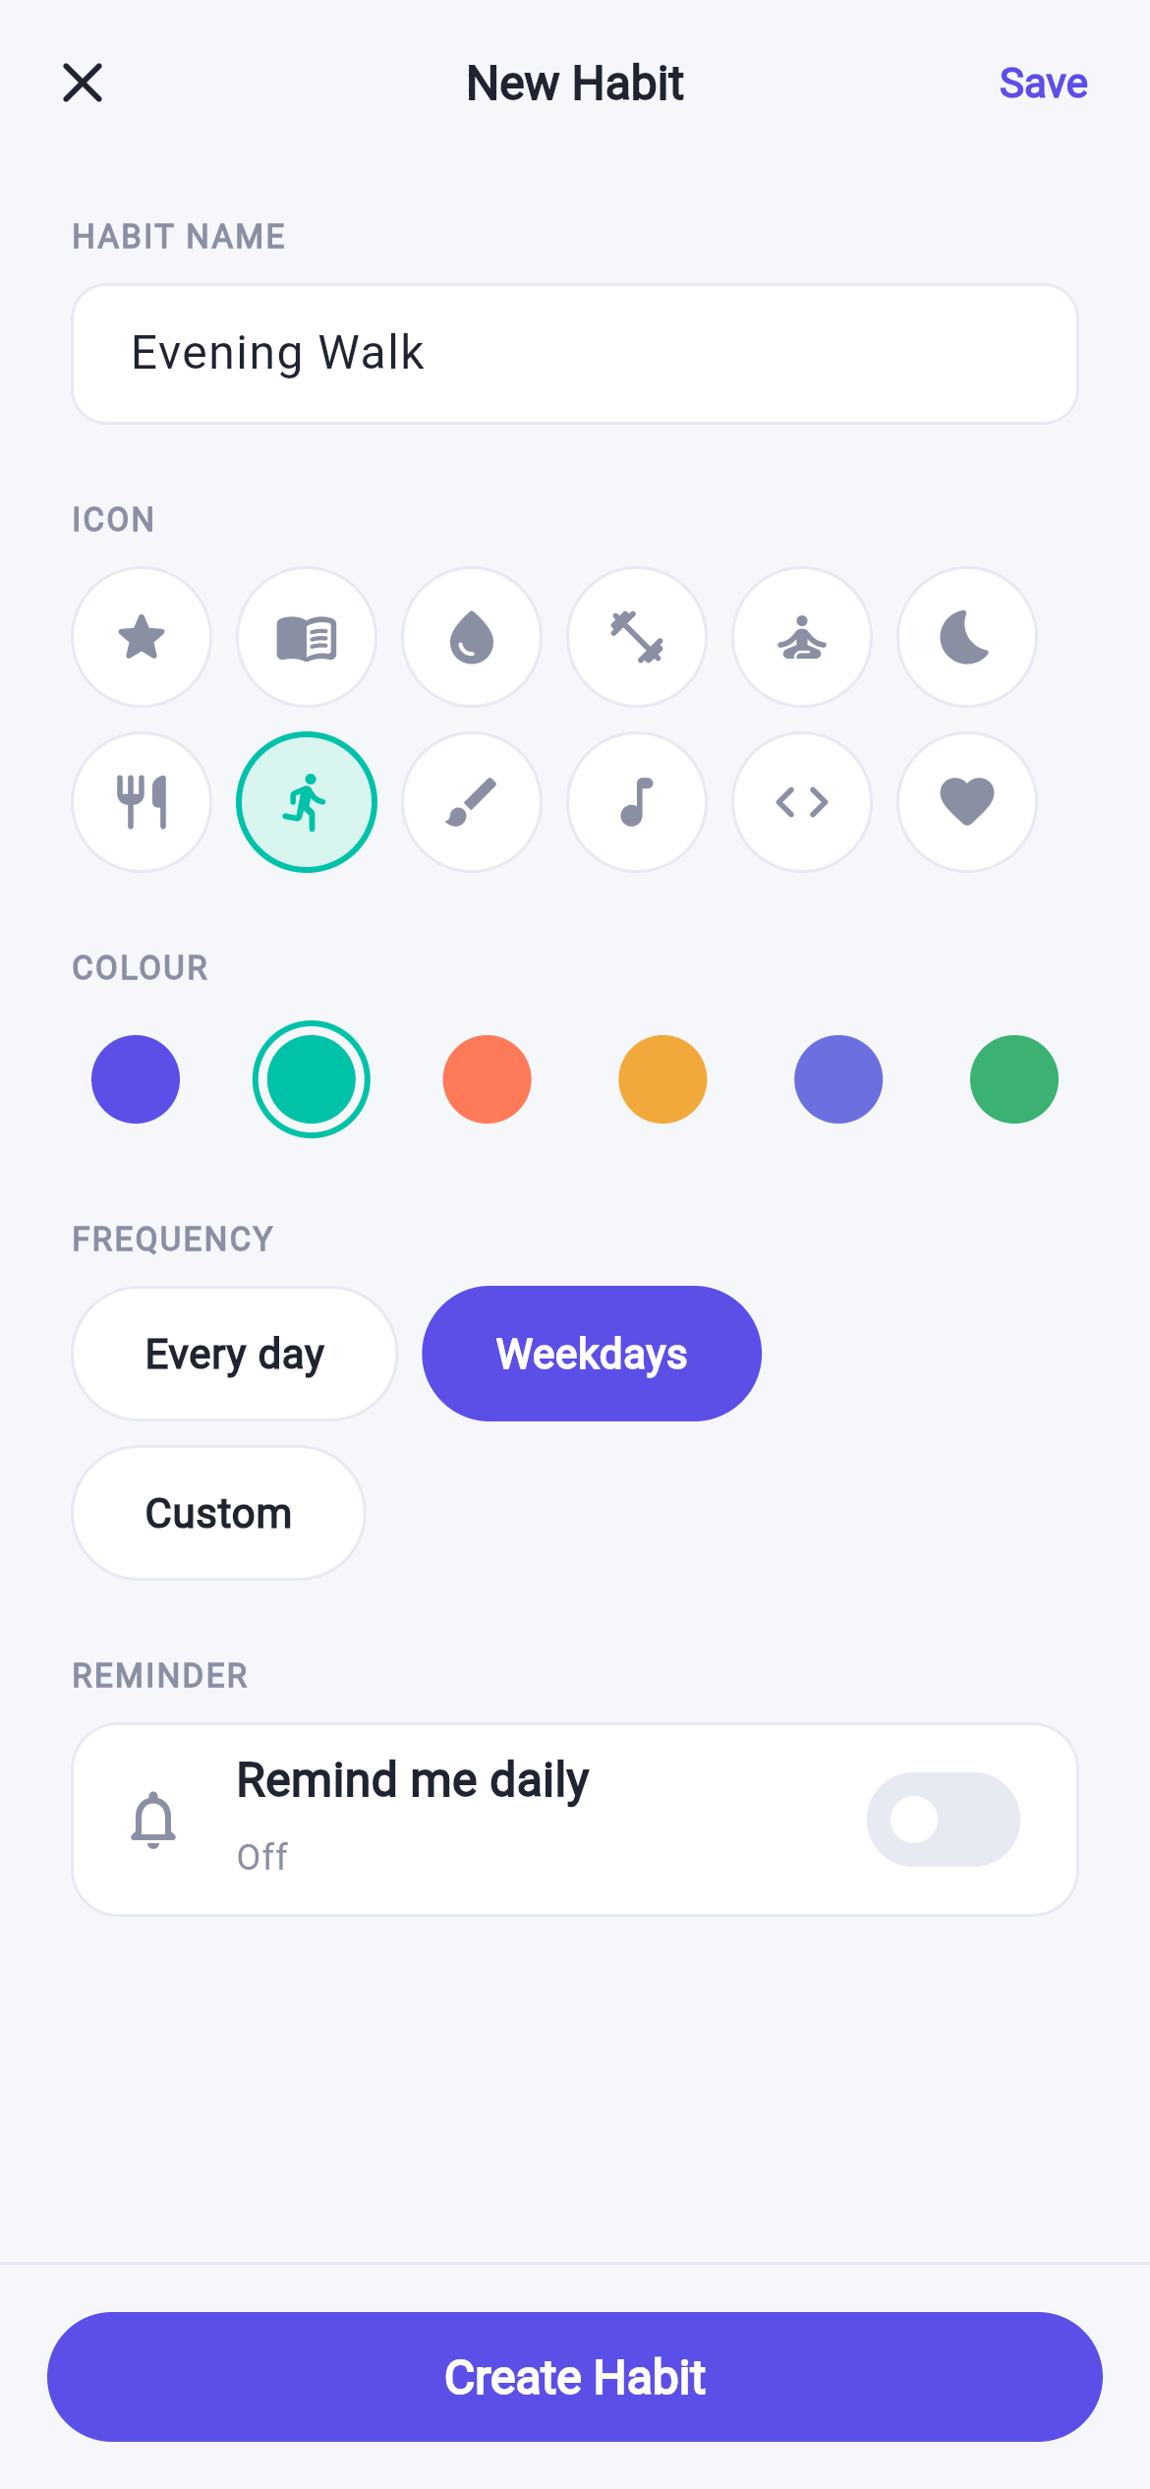
Add Habit
The form collects a name, an icon from a twelve-icon grid, one of six brand colours, a frequency, and an optional reminder. Frequency is expressed as three presets — Every day, Weekdays, and Custom — where Custom reveals a Monday-to-Sunday picker. This keeps the common case to a single tap while still supporting arbitrary schedules.
Every field is pre-filled with a sensible default, so a habit can be created by typing a name and pressing Create Habit. Saving with an empty name is blocked with an inline validation message. The same screen serves editing (FR7), pre-filled from the existing habit, with a delete action behind a confirmation dialog that names the habit and warns that its history will be lost.

4.4 Habit detail and statistics (FR6)
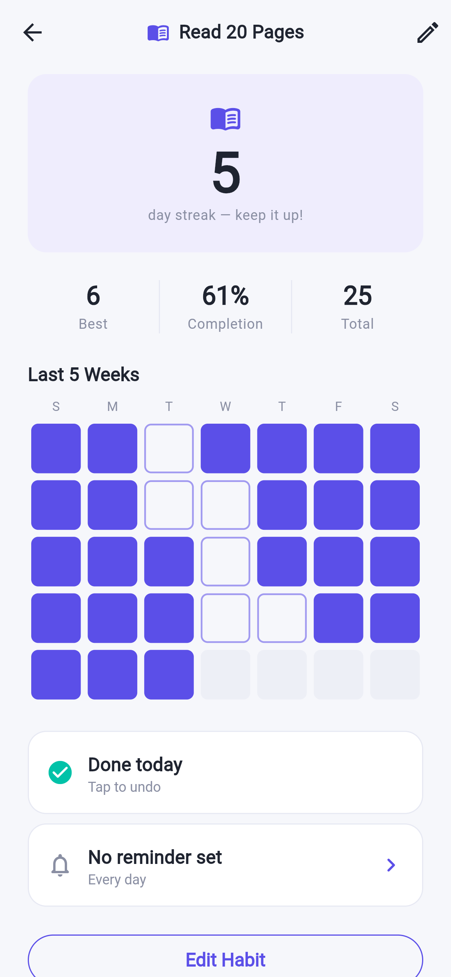
Habit Detail
The detail screen opens on a tinted hero card carrying the current streak as a large numeral. Beneath it sit three statistics — best streak ever, lifetime completion percentage, and total completions — followed by a five-week heat map. Each cell is one day: filled in the habit’s colour when completed, outlined when the habit was scheduled and missed, and faint when it was not scheduled or predates the habit. This turns an abstract percentage into a pattern the user can read at a glance.
Importantly, none of these figures are stored. Streaks and rates are computed from the completion history every time they are read, so they can never disagree with the underlying data after a day is un-ticked.

4.5 Settings (FR8)
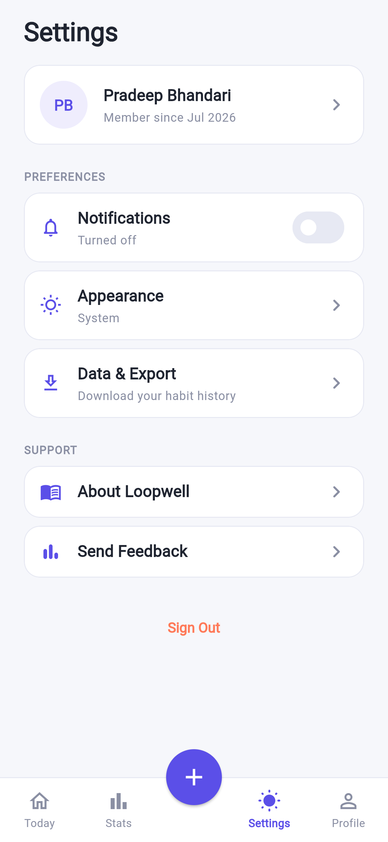
Settings
Settings opens on a profile card, then groups preferences and support options as individually carded rows. Appearance switches between Light, Dark, and System and applies immediately across the app. Data & Export opens the user’s complete habit history as formatted JSON with a copy-to-clipboard action, which supports the privacy commitment by making the stored data fully visible and portable. Sign Out is presented honestly: a dialog explains that Loopwell has no account system, that this returns the user to the welcome screens, and that their habits remain saved on the device.

4.6 Additional functionality beyond the prototype
Three additions were made during implementation: a Stats screen giving a weekly completion rate across all habits and a per-habit ranking; a Profile screen with an editable display name and lifetime totals; and a complete dark theme, which the Figma prototype did not cover.

5. Remaining Front-End Functionality Not Implemented
One requirement is deliberately incomplete.
FR4 — Reminders (partly implemented). The front-end work for this requirement is finished: a reminder can be switched on, given a time through the platform time picker, and is stored, persisted, and displayed on both the habit card and the detail screen. What is not implemented is the delivery of an actual operating-system notification at that time.
This was a considered decision rather than an oversight. Firing a real notification requires the flutter_local_notifications package, runtime notification permissions, Android manifest changes with an exact-alarm permission, an iOS notification capability, and timezone-aware scheduling. That work sits outside front-end UI development, and — more importantly — it cannot be verified honestly without a physical device to confirm that a notification actually arrives at the scheduled time on a locked phone. Shipping scheduling code that has never been observed working would be worse than scoping it out clearly. It is therefore documented as the next increment of work, with the UI that will drive it already complete and tested.
No other functional requirement is outstanding.

6. GitHub Repository
The complete source code, including all platform folders, the design tokens, the Figma reference frames, and the application screenshots:
https://github.com/Sapun2/loopwell
The repository is public. It builds from a clean clone with flutter pub get followed by flutter run, requires no configuration or API keys, and seeds sample habits with history on first launch so every screen has content to show. A step-by-step guide for running it on Android, iOS, web, or desktop is included in RUN_GUIDE.md.

7. Conclusion
Loopwell delivers seven of its eight functional requirements as working cross-platform software, with the eighth scoped and documented rather than left implied. The implementation follows the Assessment 2 high-fidelity prototype closely, drawing its colours, spacing, and corner radii from the same design token table so that the built application and the Figma file remain visibly the same product.
The exercise reinforced how much of usability is decided before any code is written. The choices that make Loopwell pleasant to use — one-tap logging, an honest denominator on the summary card, defaults that make the create form optional — were all made at the prototype stage, and implementing them was largely a matter of not compromising them under pressure. Equally, the parts that required the most care during the build were the invisible ones: keeping derived statistics derived rather than stored, ensuring the accessibility tree reflected what the interface actually offered, and confirming the layout held together on a small phone as well as a large one.
The clearest next step is completing FR4 with real notification scheduling on a physical device, followed by an optional encrypted backup so a user’s history survives changing phones — the one genuine cost of the local-only privacy model this application deliberately chose.

AI use disclosure
This application and report were produced with substantial AI assistance (Claude), consistent with the disclosure made for Assessment 2 and KOI’s academic integrity requirements.

