APP (Aluminum Plate Panel) Siding & Soffit MENU ICON
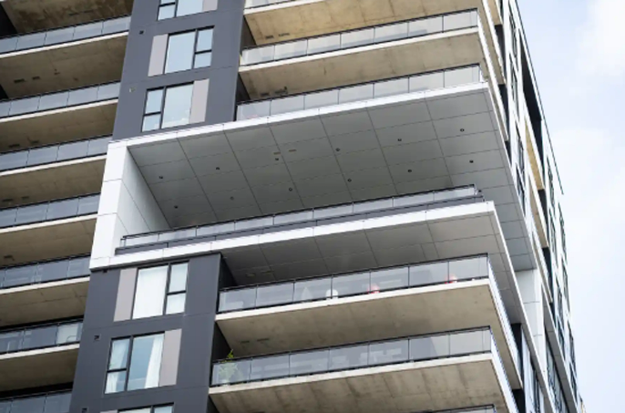
The High-Performance Architectural Aluminum Plate Panels are designed for advanced drained and back ventilated rainscreen systems, this aluminum panel delivers both durability and sophistication..... (Learn More / Expand)

MAIN SUB PAGE
APP (High-Performance Architectural Aluminum Plate Panel) Siding & Soffit
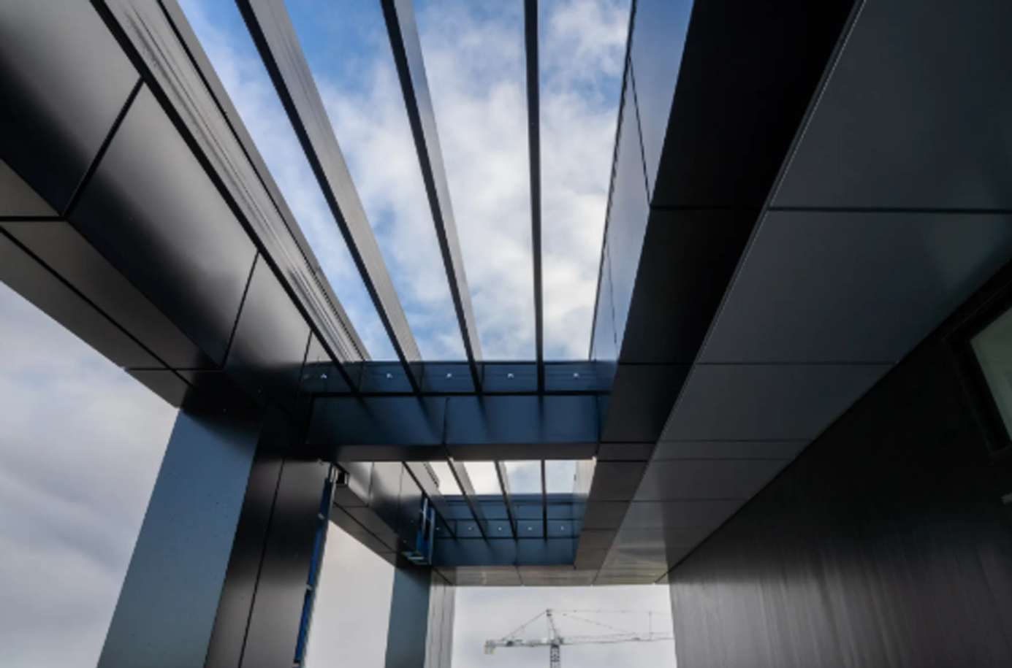
Industrial / Residential / Commercial
Expanded …The High-Performance Architectural Aluminum Plate Panels are designed for advanced drained and back ventilated rainscreen systems, this aluminum panel delivers both durability and sophistication. Crafted from premium 5000-series aluminum with a sturdy 3.2 mm thickness, it offers exceptional strength while maintaining a sleek, modern aesthetic. A concealed fastening system, made from robust 6000-series extruded aluminum, ensures a clean, uninterrupted façade. Ideal for complex architectural projects, this panel is engineered for precision, longevity, and effortless integration into cutting-edge designs.

Key Features
- Thermal expansion brackets for enhanced flexibility.
- Quick and efficient installation.
- Non-combustible, high-performance panels.
- Eco-friendly, solvent-free powder coating ensures long-lasting, fade-resistant colors.
- Highly durable and fully recyclable at the end of its lifespan.

Applications
- Exterior wall cladding for ventilated rainscreen systems.
- Interior decorative paneling for modern design applications.

Speak with an Expert Get personalized advice and expert guidance to achieve your project goals with confidence.

APP Siding & Soffit MENU ICON (PREVIEW)

APP 01 - Architectural Panel with Concealed Brackets
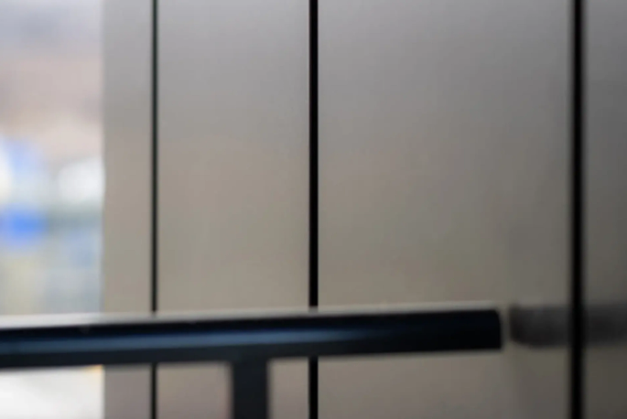
APP-01 is a precision-engineered architectural panel built for strength, durability, and visual impact.... (Learn More / Expand)

APP 01 - Architectural Panel with Concealed Brackets
(EXPANDED)
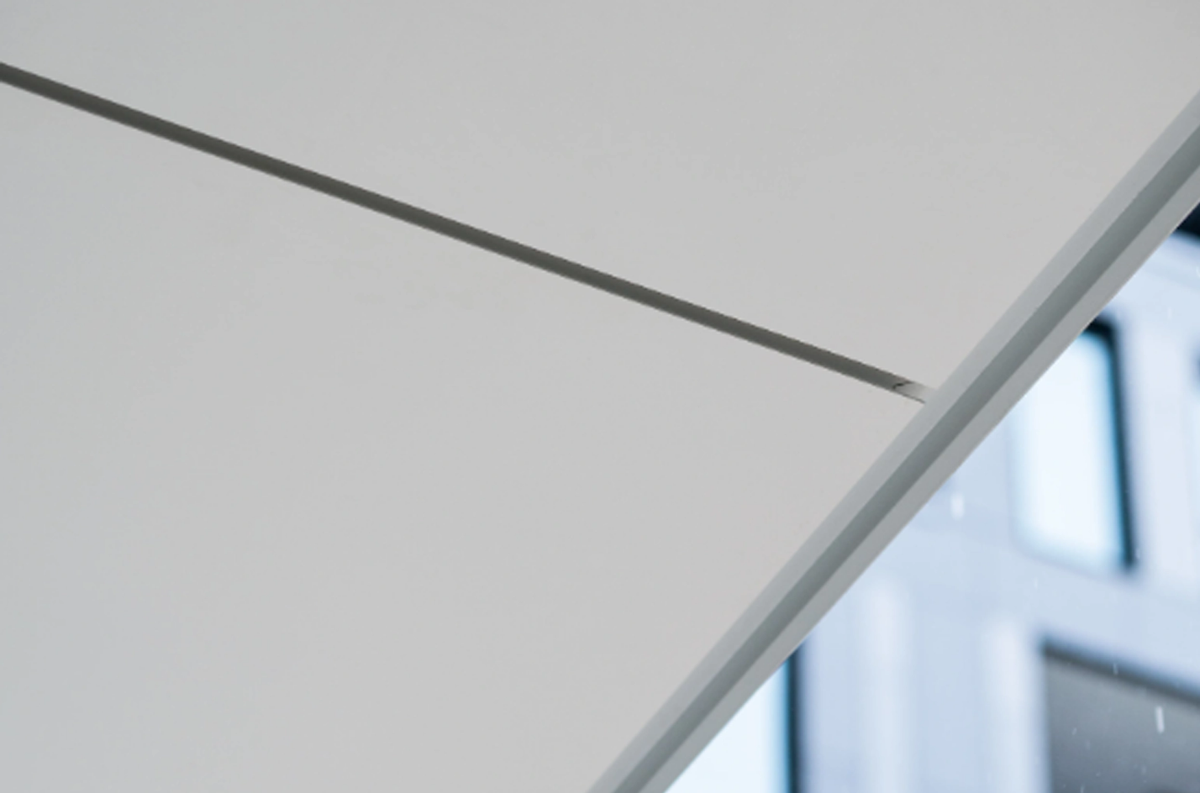
Expanded … APP-01 is a precision-engineered architectural panel built for strength, durability, and visual impact. Fabricated entirely from 3.2 mm (0.125”) premium 5000 series aluminum and framed with robust 6000 series aluminum perimeter extrusions, it delivers exceptional rigidity and longevity.

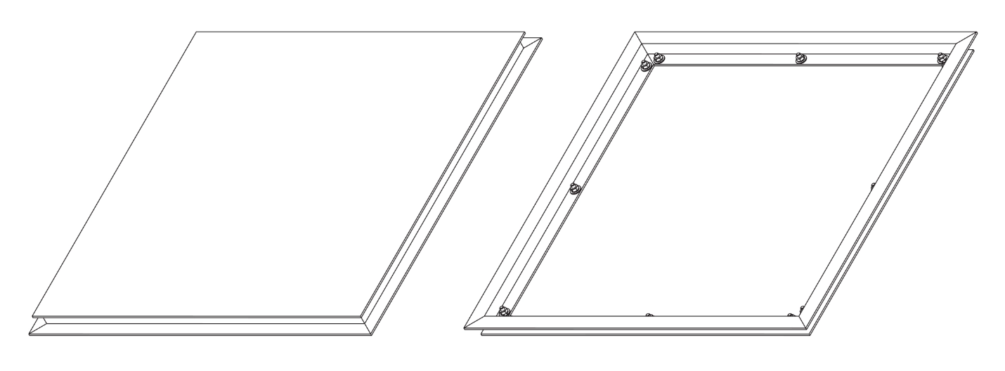
What sets the APP-01 apart is its sleek, modern aesthetic—achieved through a concealed fastening system that creates the illusion of panels floating cleanly off the surface. Ideal for high-end commercial, institutional, or custom architectural applications, this panel offers both structural performance and bold design flexibility.

Standard Folds
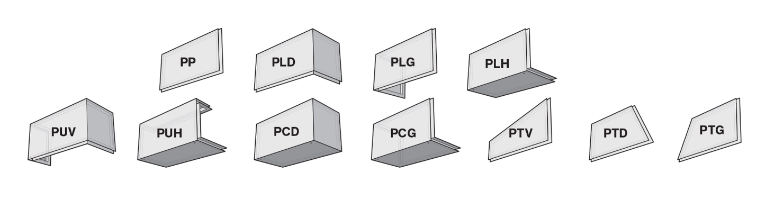

General Specifications
Highlights:
- Engineered for quick and efficient installation, saving time on site
- Built from non-combustible materials for enhanced safety
- Highly durable and 100% recyclable at the end of its life cycle
- Finished with an eco-friendly, solvent-free powder coating, offering long-lasting color stability and resistance to fading

Performance Standards:
- Perimeter extrusion deflection under service loads limited to L/180
- Panel deflection under service loads limited to L/60

Materials:
- Constructed from 3.2 mm (0.125”) thick 5000 series aluminum for the main panel
- Reinforced with 3.2 mm (0.125”) thick 6000 series aluminum perimeter extrusions for added structural integrity
Finish & Color Options:
- Coated using an electrostatic powder finish that meets AAMA 2604 and 2605 performance standards
- Wide range of custom color options available to suit any architectural vision

Recommended Applications:
- Exterior cladding for commercial, institutional, or residential buildings
- Interior use as decorative wall features or design elements
- *Note: For specific project suitability or custom details, consult with our technical team.

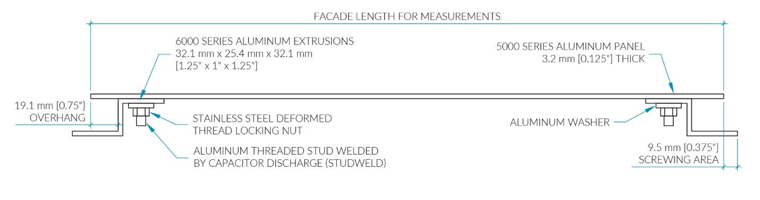
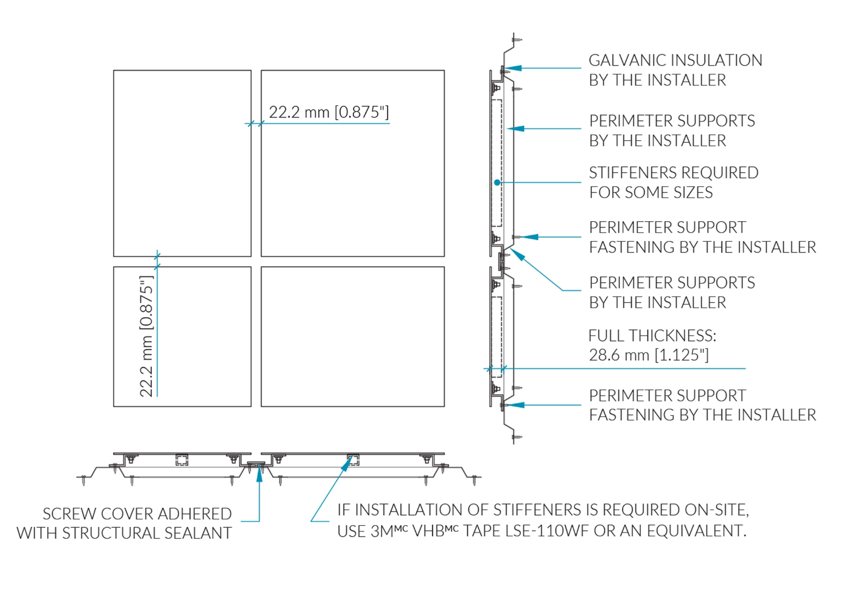

Technical Details
Panel Dimensions:
- Rectangular Panels: From 4.5” x 12” (114.3 mm x 304.8 mm) up to 58” x 142” (1473.2 mm x 3606.8 mm)
- Square Panels: From 6” x 6” (152.4 mm x 152.4 mm) up to 58” x 58” (1473.2 mm x 1473.2 mm)
- Panel Depth (Relief): 1” (25.4 mm)
- Joint Width: 0.875” (22.2 mm)
Manufacturing Tolerances:
- Extrusion Alignment: ±0.063” (±1.6 mm)
- Panel Dimensions: ±0.031” (±0.79 mm)

Elevate Your Project with Premium Aluminum Panels

When performance and appearance matter, aluminum panels finished with electrostatic powder coating—meeting AAMA 2604 and 2605 standards—deliver on every front.
At the heart of our aluminum siding line is our custom-built powder coating facility, designed to apply one of the most environmentally friendly and durable finishes available today. This in-house capability ensures consistent quality, rich colour depth, and long-lasting protection against the elements.
Endless Colour Possibilities
From anodized-style finishes to specialty effects and carefully curated palettes, we offer full customization to match your vision. Whether you’re aiming for bold, subtle, or one-of-a-kind textures, our partners can formulate powders tailored precisely to your design goals.

If you can imagine it, we can match it.

