**Demonstration**

* After copying the code to the Arduino IDE, upload the code to your board. Don’t forget to select the right board in **Tools**> **Board**and the right COM port in **Tools**> **Port**.
* After uploading, open the Serial Monitor at a baud rate of 115200 and press the ESP32 RST button so that the code starts working.

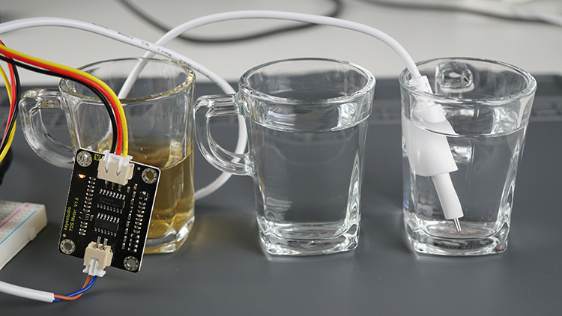

* It will show a value of 0 if the probe is not submerged. Put the probe on a solution to check its TDS. You can try with tap water and add some salt to see if the values increase.

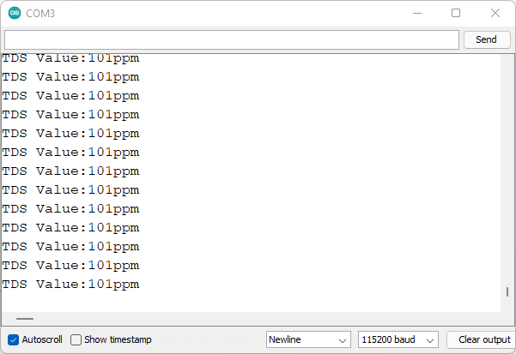

* I measured the TDS value for tap water in my house, and I got a value of around 100ppm, which is a good value for drinking water.
* I also tested tea, and the TDS value increased to about 230ppm, which seems a reasonable value.
* Finally, I also measured the TDS value of bottled water and I got a value of 0ppm. I’m not sure if this value is correct because the water is advertised as mineral water, so the minerals dissolved in the water should account for a TDS value. I think this value can be explained due to the non-linearity of the ESP32 ADC pins for small voltage values. Do you have one of these sensors? What values did you get for bottled water?