Practical-3: Implementation of operations on binary heaps.
#include<iostream.h>
void swap(int *x, int *y);

class MinHeap
{
int *harr;
int capacity;
int heap_size;
public:
MinHeap(int capacity);
void MinHeapify(int );

int parent(int i) { return (i-1)/2; }
int left(int i) { return (2*i + 1); }
int right(int i) { return (2*i + 2); }
int extractMin();
void decreaseKey(int i, int new_val);
int getMin() { return harr[0]; }
void deleteKey(int i);
void insertKey(int k);
};
MinHeap::MinHeap(int cap)
{
heap_size = 0;
capacity = cap;
harr = new int[cap];
}
void MinHeap::insertKey(int k)
{
if (heap_size == capacity)
{
cout << "\nOverflow: Could not insertKey\n";
return;
}
heap_size++;
int i = heap_size - 1;
harr[i] = k;
while (i != 0 && harr[parent(i)] > harr[i])
{
swap(&harr[i], &harr[parent(i)]);
i = parent(i);
}
}
void MinHeap::decreaseKey(int i, int new_val)
{
harr[i] = new_val;
while (i != 0 && harr[parent(i)] > harr[i])
{
swap(&harr[i], &harr[parent(i)]);
i = parent(i);
}
}

int MinHeap::extractMin()
{
if (heap_size <= 0)
return INT_MAX;
if (heap_size == 1)
{
heap_size--;
return harr[0];
}

int root = harr[0];
harr[0] = harr[heap_size-1];
heap_size--;
MinHeapify(0);

return root;
}

void MinHeap::deleteKey(int i)
{
decreaseKey(i, INT_MIN);
extractMin();
}

void MinHeap::MinHeapify(int i)
{
int l = left(i);
int r = right(i);
int smallest = i;
if (l < heap_size && harr[l] < harr[i])
smallest = l;
if (r < heap_size && harr[r] < harr[smallest])
smallest = r;
if (smallest != i)
{
swap(&harr[i], &harr[smallest]);
MinHeapify(smallest);
}
}
void swap(int *x, int *y)
{
int temp = *x;
*x = *y;
*y = temp;
}
int main()
{
MinHeap h(11);
h.insertKey(3);
h.insertKey(2);
h.deleteKey(1);
h.insertKey(15);
h.insertKey(5);
h.insertKey(4);
h.insertKey(45);
cout <<"Ectracted Min: "<< h.extractMin() << "\n";
cout << "GetMin after ExtractMin (New Min): "<< h.getMin() << "\n";
h.decreaseKey(2, 1);
cout << "New Min after decreaseKey: "<<h.getMin();
return 0;
}
Output:
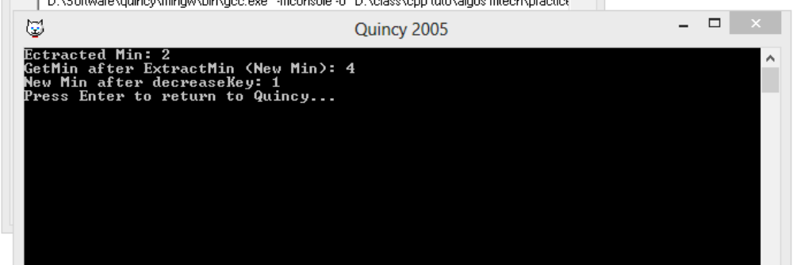

Practical-4: Implementation of operations on Fibonacci heaps.
#include <cmath>
#include <cstdlib>
#include <iostream>
struct node {
node* parent;
node* child;
node* left;
node* right;
int key;
int degree;
char mark;
char c;
};
struct node* mini = NULL;
int no_of_nodes = 0;
void insertion(int val)
{
struct node* new_node = (struct node*)malloc(sizeof(struct node));
new_node->key = val;
new_node->degree = 0;
new_node->mark = 'W';
new_node->c = 'N';
new_node->parent = NULL;
new_node->child = NULL;
new_node->left = new_node;
new_node->right = new_node;
if (mini != NULL) {
(mini->left)->right = new_node;
new_node->right = mini;
new_node->left = mini->left;
mini->left = new_node;
if (new_node->key < mini->key)
mini = new_node;
}
else {
mini = new_node;
}
no_of_nodes++;
}
void Fibonnaci_link(struct node* ptr2, struct node* ptr1)
{
(ptr2->left)->right = ptr2->right;
(ptr2->right)->left = ptr2->left;
if (ptr1->right == ptr1)
mini = ptr1;
ptr2->left = ptr2;
ptr2->right = ptr2;
ptr2->parent = ptr1;
if (ptr1->child == NULL)
ptr1->child = ptr2;
ptr2->right = ptr1->child;
ptr2->left = (ptr1->child)->left;
((ptr1->child)->left)->right = ptr2;
(ptr1->child)->left = ptr2;
if (ptr2->key < (ptr1->child)->key)
ptr1->child = ptr2;
ptr1->degree++;
}
void Consolidate()
{
int temp1;
float temp2 = (log(no_of_nodes)) / (log(2));
int temp3 = temp2;
struct node* arr[temp3];
for (int i = 0; i <= temp3; i++)
arr[i] = NULL;
node* ptr1 = mini;
node* ptr2;
node* ptr3;
node* ptr4 = ptr1;
do {
ptr4 = ptr4->right;
temp1 = ptr1->degree;
while (arr[temp1] != NULL) {
ptr2 = arr[temp1];
if (ptr1->key > ptr2->key) {
ptr3 = ptr1;
ptr1 = ptr2;
ptr2 = ptr3;
}
if (ptr2 == mini)
mini = ptr1;
Fibonnaci_link(ptr2, ptr1);
if (ptr1->right == ptr1)
mini = ptr1;
arr[temp1] = NULL;
temp1++;
}
arr[temp1] = ptr1;
ptr1 = ptr1->right;
} while (ptr1 != mini);
mini = NULL;
for (int j = 0; j <= temp3; j++) {
if (arr[j] != NULL) {
arr[j]->left = arr[j];
arr[j]->right = arr[j];
if (mini != NULL) {
(mini->left)->right = arr[j];
arr[j]->right = mini;
arr[j]->left = mini->left;
mini->left = arr[j];
if (arr[j]->key < mini->key)
mini = arr[j];
}
else {
mini = arr[j];
}
if (mini == NULL)
mini = arr[j];
else if (arr[j]->key < mini->key)
mini = arr[j];
}
}
}
void Extract_min()
{
if (mini == NULL)
cout << "The heap is empty" << endl;
else {
node* temp = mini;
node* pntr;
pntr = temp;
node* x = NULL;
if (temp->child != NULL) {

x = temp->child;
do {
pntr = x->right;
(mini->left)->right = x;
x->right = mini;
x->left = mini->left;
mini->left = x;
if (x->key < mini->key)
mini = x;
x->parent = NULL;
x = pntr;
} while (pntr != temp->child);
}
(temp->left)->right = temp->right;
(temp->right)->left = temp->left;
mini = temp->right;
if (temp == temp->right && temp->child == NULL)
mini = NULL;
else {
mini = temp->right;
Consolidate();
}
no_of_nodes--;
}
}

void Cut(struct node* found, struct node* temp)
{
if (found == found->right)
temp->child = NULL;

(found->left)->right = found->right;
(found->right)->left = found->left;
if (found == temp->child)
temp->child = found->right;

temp->degree = temp->degree - 1;
found->right = found;
found->left = found;
(mini->left)->right = found;
found->right = mini;
found->left = mini->left;
mini->left = found;
found->parent = NULL;
found->mark = 'B';
}

void Cascase_cut(struct node* temp)
{
node* ptr5 = temp->parent;
if (ptr5 != NULL) {
if (temp->mark == 'W') {
temp->mark = 'B';
}
else {
Cut(temp, ptr5);
Cascase_cut(ptr5);
}
}
}
void Decrease_key(struct node* found, int val)
{
if (mini == NULL)
cout << "The Heap is Empty" << endl;

if (found == NULL)
cout << "Node not found in the Heap" << endl;

found->key = val;

struct node* temp = found->parent;
if (temp != NULL && found->key < temp->key) {
Cut(found, temp);
Cascase_cut(temp);
}
if (found->key < mini->key)
mini = found;
}
void Find(struct node* mini, int old_val, int val)
{
struct node* found = NULL;
node* temp5 = mini;
temp5->c = 'Y';
node* found_ptr = NULL;
if (temp5->key == old_val) {
found_ptr = temp5;
temp5->c = 'N';
found = found_ptr;
Decrease_key(found, val);
}
if (found_ptr == NULL) {
if (temp5->child != NULL)
Find(temp5->child, old_val, val);
if ((temp5->right)->c != 'Y')
Find(temp5->right, old_val, val);
}
temp5->c = 'N';
found = found_ptr;
}

void Deletion(int val)
{
if (mini == NULL)
cout << "The heap is empty" << endl;
else {

Find(mini, val, 0);

Extract_min();
cout << "Key Deleted" << endl;
}
}

void display()
{
node* ptr = mini;
if (ptr == NULL)
cout << "The Heap is Empty" << endl;

else {
cout << "The root nodes of Heap are: " << endl;
do {
cout << ptr->key;
ptr = ptr->right;
if (ptr != mini) {
cout << "-->";
}
} while (ptr != mini && ptr->right != NULL);
cout << endl
<< "The heap has " << no_of_nodes << " nodes" << endl
<< endl;
}
}

int main()
{
cout << "Creating an initial heap" << endl;
insertion(5);
insertion(2);
insertion(8);

display();

cout << "Extracting min" << endl;
Extract_min();
display();

cout << "Decrease value of 8 to 7" << endl;
Find(mini, 8, 7);
display();

cout << "Delete the node 7" << endl;
Deletion(7);
display();

return 0;
}

Output:
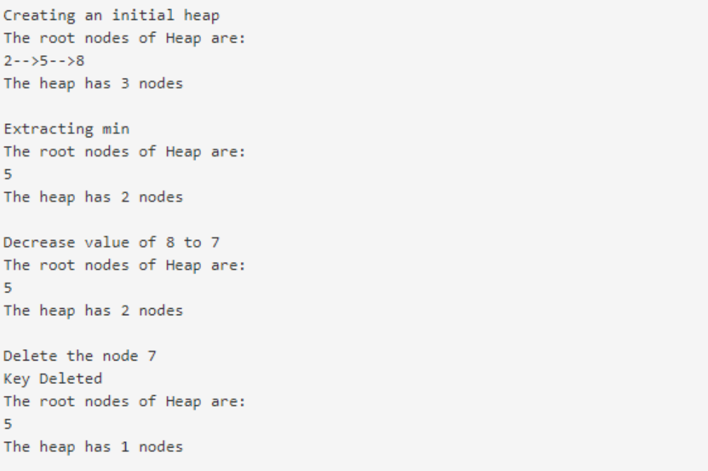

Practical-5: Implementation on operations on B-Trees.
#include<iostream>
using namespace std;

class BTreeNode
{
int *keys;
int t;
BTreeNode **C;
int n;
bool leaf;

public:

BTreeNode(int _t, bool _leaf);
void traverse();

BTreeNode *search(int k);
int findKey(int k);

void insertNonFull(int k);

void splitChild(int i, BTreeNode *y);

void remove(int k);

void removeFromLeaf(int idx);

void removeFromNonLeaf(int idx);

int getPred(int idx);

int getSucc(int idx);

void fill(int idx);

void borrowFromPrev(int idx);

void borrowFromNext(int idx);

void merge(int idx);

friend class BTree;
};

class BTree
{
BTreeNode *root;
int t;
public:

BTree(int _t)
{
root = NULL;
t = _t;
}

void traverse()
{
if (root != NULL) root->traverse();
}

BTreeNode* search(int k)
{
return (root == NULL)? NULL : root->search(k);
}

void insert(int k);
void remove(int k);

};

BTreeNode::BTreeNode(int t1, bool leaf1)
{
t = t1;
leaf = leaf1;
keys = new int[2*t-1];
C = new BTreeNode *[2*t];
n = 0;
}

int BTreeNode::findKey(int k)
{
int idx=0;
while (idx<n && keys[idx] < k)
++idx;
return idx;
}
void BTreeNode::remove(int k)
{
int idx = findKey(k);
if (idx < n && keys[idx] == k)
{

if (leaf)
removeFromLeaf(idx);
else
removeFromNonLeaf(idx);
}
else
{

if (leaf)
{
cout << "The key "<< k <<" is does not exist in the tree\n";
return;
}
bool flag = ( (idx==n)? true : false );

if (C[idx]->n < t)
fill(idx);

if (flag && idx > n)
C[idx-1]->remove(k);
else
C[idx]->remove(k);
}
return;
}

void BTreeNode::removeFromLeaf (int idx)
{

for (int i=idx+1; i<n; ++i)
keys[i-1] = keys[i];

n--;

return;
}

void BTreeNode::removeFromNonLeaf(int idx)
{

int k = keys[idx];

if (C[idx]->n >= t)
{
int pred = getPred(idx);
keys[idx] = pred;
C[idx]->remove(pred);
}

else if (C[idx+1]->n >= t)
{
int succ = getSucc(idx);
keys[idx] = succ;
C[idx+1]->remove(succ);
}
else
{
merge(idx);
C[idx]->remove(k);
}
return;
}

int BTreeNode::getPred(int idx)
{
BTreeNode *cur=C[idx];
while (!cur->leaf)
cur = cur->C[cur->n];

return cur->keys[cur->n-1];
}

int BTreeNode::getSucc(int idx)
{

BTreeNode *cur = C[idx+1];
while (!cur->leaf)
cur = cur->C[0];

return cur->keys[0];
}

void BTreeNode::fill(int idx)
{
if (idx!=0 && C[idx-1]->n>=t)
borrowFromPrev(idx);

else if (idx!=n && C[idx+1]->n>=t)
borrowFromNext(idx);

else
{
if (idx != n)
merge(idx);
else
merge(idx-1);
}
return;
}
void BTreeNode::borrowFromPrev(int idx)
{

BTreeNode *child=C[idx];
BTreeNode *sibling=C[idx-1];

for (int i=child->n-1; i>=0; --i)
child->keys[i+1] = child->keys[i];

if (!child->leaf)
{
for(int i=child->n; i>=0; --i)
child->C[i+1] = child->C[i];
}

child->keys[0] = keys[idx-1];

if(!child->leaf)
child->C[0] = sibling->C[sibling->n];

keys[idx-1] = sibling->keys[sibling->n-1];

child->n += 1;
sibling->n -= 1;

return;
}

void BTreeNode::borrowFromNext(int idx)
{

BTreeNode *child=C[idx];
BTreeNode *sibling=C[idx+1];

child->keys[(child->n)] = keys[idx];

if (!(child->leaf))
child->C[(child->n)+1] = sibling->C[0];

keys[idx] = sibling->keys[0];

for (int i=1; i<sibling->n; ++i)
sibling->keys[i-1] = sibling->keys[i];

if (!sibling->leaf)
{
for(int i=1; i<=sibling->n; ++i)
sibling->C[i-1] = sibling->C[i];
}

child->n += 1;
sibling->n -= 1;

return;
}

void BTreeNode::merge(int idx)
{
BTreeNode *child = C[idx];
BTreeNode *sibling = C[idx+1];

child->keys[t-1] = keys[idx];

for (int i=0; i<sibling->n; ++i)
child->keys[i+t] = sibling->keys[i];

if (!child->leaf)
{
for(int i=0; i<=sibling->n; ++i)
child->C[i+t] = sibling->C[i];
}
for (int i=idx+1; i<n; ++i)
keys[i-1] = keys[i];

for (int i=idx+2; i<=n; ++i)
C[i-1] = C[i];

child->n += sibling->n+1;
n--;
delete(sibling);
return;
}
void BTree::insert(int k)
{
if (root == NULL)
{
root = new BTreeNode(t, true);
root->keys[0] = k;
root->n = 1;
}
else
{
if (root->n == 2*t-1)
{
BTreeNode *s = new BTreeNode(t, false);

s->C[0] = root;
s->splitChild(0, root);
int i = 0;
if (s->keys[0] < k)
i++;
s->C[i]->insertNonFull(k);
root = s;
}
else
root->insertNonFull(k);
}
}
void BTreeNode::insertNonFull(int k)
{
int i = n-1;
if (leaf == true)
{
while (i >= 0 && keys[i] > k)
{
keys[i+1] = keys[i];
i--;
}
keys[i+1] = k;
n = n+1;
}
else
{
while (i >= 0 && keys[i] > k)
i--;
if (C[i+1]->n == 2*t-1)
{
splitChild(i+1, C[i+1]);
if (keys[i+1] < k)
i++;
}
C[i+1]->insertNonFull(k);
}
}
void BTreeNode::splitChild(int i, BTreeNode *y)
{
BTreeNode *z = new BTreeNode(y->t, y->leaf);
z->n = t - 1;

for (int j = 0; j < t-1; j++)
z->keys[j] = y->keys[j+t];

if (y->leaf == false)
{
for (int j = 0; j < t; j++)
z->C[j] = y->C[j+t];
}

y->n = t - 1;

for (int j = n; j >= i+1; j--)
C[j+1] = C[j];
C[i+1] = z;
for (int j = n-1; j >= i; j--)
keys[j+1] = keys[j];

keys[i] = y->keys[t-1];

n = n + 1;
}
void BTreeNode::traverse()
{
int i;
for (i = 0; i < n; i++)
{
if (leaf == false)
C[i]->traverse();
cout << " " << keys[i];
}
if (leaf == false)
C[i]->traverse();
}
BTreeNode *BTreeNode::search(int k)
{
int i = 0;
while (i < n && k > keys[i])
i++;

if (keys[i] == k)
return this;
if (leaf == true)
return NULL;
return C[i]->search(k);
}

void BTree::remove(int k)
{
if (!root)
{
cout << "The tree is empty\n";
return;
}
root->remove(k);
if (root->n==0)
{
BTreeNode *tmp = root;
if (root->leaf)
root = NULL;
else
root = root->C[0];

delete tmp;
}
return;
}

int main()
{
BTree t(3);

t.insert(1);
t.insert(2);
t.insert(5);
t.insert(10);
t.insert(7);
t.insert(3);
t.insert(6);
t.insert(16);
t.insert(12);

cout << "Traversal of tree constructed is\n";
t.traverse();
cout << endl;

t.remove(6);
cout << "Traversal of tree after removing 6\n";
t.traverse();
cout << endl;

t.remove(12);
cout << "Traversal of tree after removing 12\n";
t.traverse();
cout << endl;

t.remove(7);
cout << "Traversal of tree after removing 7\n";
t.traverse();
cout << endl;

t.remove(5);
cout << "Traversal of tree after removing 5\n";
t.traverse();
cout << endl;

t.remove(2);
cout << "Traversal of tree after removing 2\n";
t.traverse();
cout << endl;

t.remove(16);
cout << "Traversal of tree after removing 16\n";
t.traverse();
cout << endl;

return 0;
}
Output:
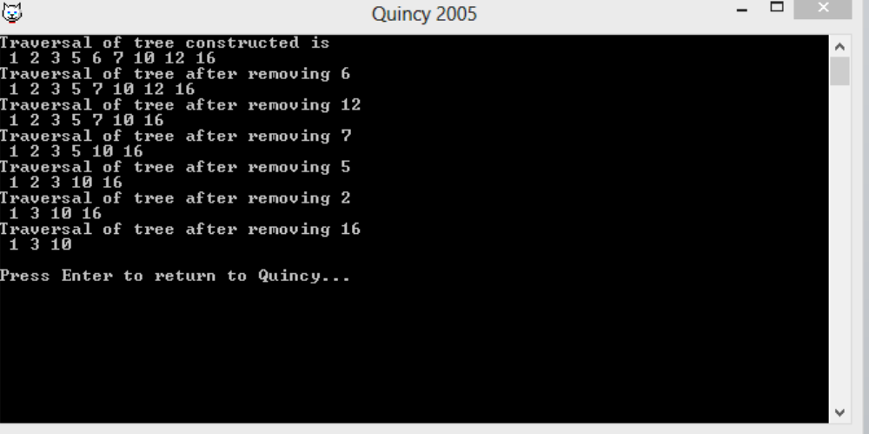

Practical-6: Implementation of operations on union-find data structures
.
#include <iostream.h>
class Edge
{
public:
int src, dest;
};
class Graph
{
public:
int V, E;
Edge* edge;
};
Graph* createGraph(int V, int E)
{
Graph* graph = new Graph();
graph->V = V;
graph->E = E;

graph->edge = new Edge[graph->E * sizeof(Edge)];
return graph;
}

int find(int parent[], int i)
{
if (parent[i] == -1)
return i;
return find(parent, parent[i]);
}

void Union(int parent[], int x, int y)
{
int xset = find(parent, x);
int yset = find(parent, y);
if(xset != yset)
{
parent[xset] = yset;
}
}
int isCycle( Graph* graph )
{
int *parent = new int[graph->V * sizeof(int)];
memset(parent, -1, sizeof(int) * graph->V);
for(int i = 0; i < graph->E; ++i)
{
int x = find(parent, graph->edge[i].src);
int y = find(parent, graph->edge[i].dest);

if (x == y)
return 1;

Union(parent, x, y);
}
return 0;
}
int main()
{
int V = 3, E = 3;
Graph* graph = createGraph(V, E);
graph->edge[0].src = 0;
graph->edge[0].dest = 1;
graph->edge[1].src = 1;
graph->edge[1].dest = 2;

graph->edge[2].src = 0;
graph->edge[2].dest = 2;

if (isCycle(graph))
cout<<"graph contains cycle";
else
cout<<"graph doesn't contain cycle";

return 0;
}
Output:


Practical-7: Implementation of Bellman-Ford algorithm
#include <bits/stdc++.h>
struct Edge {
int src, dest, weight;
};
struct Graph {
int V, E;
struct Edge* edge;
};
struct Graph* createGraph(int V, int E)
{
struct Graph* graph = new Graph;
graph->V = V;
graph->E = E;
graph->edge = new Edge[E];
return graph;
}
void printArr(int dist[], int n)
{
printf("Vertex Distance from Source\n");
for (int i = 0; i < n; ++i)
printf("%d \t\t %d\n", i, dist[i]);
}
void BellmanFord(struct Graph* graph, int src)
{
int V = graph->V;
int E = graph->E;
int dist[V];
for (int i = 0; i < V; i++)
dist[i] = INT_MAX;
dist[src] = 0;
for (int i = 1; i <= V - 1; i++) {
for (int j = 0; j < E; j++) {
int u = graph->edge[j].src;
int v = graph->edge[j].dest;
int weight = graph->edge[j].weight;
if (dist[u] != INT_MAX && dist[u] + weight < dist[v])
dist[v] = dist[u] + weight;
}
}
for (int i = 0; i < E; i++) {
int u = graph->edge[i].src;
int v = graph->edge[i].dest;
int weight = graph->edge[i].weight;
if (dist[u] != INT_MAX && dist[u] + weight < dist[v]) {
printf("Graph contains negative weight cycle");
return; // If negative cycle is detected, simply return
}
}
printArr(dist, V);
return;
}
int main()
{
int V = 5;
int E = 8;
struct Graph* graph = createGraph(V, E);
graph->edge[0].src = 0;
graph->edge[0].dest = 1;
graph->edge[0].weight = -1;
graph->edge[1].src = 0;
graph->edge[1].dest = 2;
graph->edge[1].weight = 4;
graph->edge[2].src = 1;
graph->edge[2].dest = 2;
graph->edge[2].weight = 3;
graph->edge[3].src = 1;
graph->edge[3].dest = 3;
graph->edge[3].weight = 2;
graph->edge[4].src = 1;
graph->edge[4].dest = 4;
graph->edge[4].weight = 2;
graph->edge[5].src = 3;
graph->edge[5].dest = 2;
graph->edge[5].weight = 5;
graph->edge[6].src = 3; graph->edge[6].dest = 1;
graph->edge[6].weight = 1;
graph->edge[7].src = 4; graph->edge[7].dest = 3; graph->edge[7].weight = -3;
BellmanFord(graph, 0);

return 0;
}
Output:
