Practical-1: Implementation of randomized quicksort algorithm.
#include<iostream.h>
#include<ctime>
#include<stdlib.h>
void swap(int *m,int *n)
{
int temp=*m;
*m=*n;
*n=temp;
}
int partition(int a[],int low,int high)
{
int x=a[high];
int i=low-1;
for(int j=low;j<high;j++)
{
if(a[j]<=x)
{
i++;
swap(&a[j],&a[i]);
}
}
swap(&a[i+1],&a[high]);
return i+1;
}
int randomization(int a[],int low,int high)
{
int r=low+(rand()%(high-low+1));
int x=a[r];
int i=low-1;
for(int j=low;j<high;j++)
{
if(a[j]<=x)
{
i++;
swap(&a[j],&a[i]);
}
}
swap(&a[i+1],&a[high]);
return i+1;
}
void quickshort(int a[],int low,int high)
{
if(low<high)
{
//int pivotIndex=partition(a,low,high);
int pivotIndex=randomization(a,low,high);
quickshort(a,low,pivotIndex-1);
quickshort(a,pivotIndex+1,high);
}
}
int main()
{
int n=6;
int arr[6]={1,4,2,3,6,5};
//int n=10000;
//int arr[10000];
//for(int i=0;i<n;i++)
// arr[i]=rand()*rand();
clock_t start_time,end_time;
start_time = clock();
quickshort(arr,0,n-1);
end_time = clock();
for(int j=0;j<n;j++)
cout<<arr[j]<<endl;
//cout<<"Time Taken: "<<(end_time - start_time)<<endl;;
return 0;
}

Output:
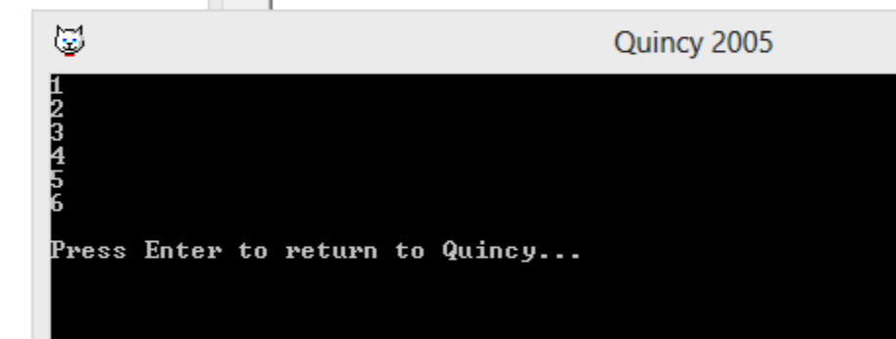

Practical-2: Implementation of operations on splay trees.
#include<iostream.h>
struct node
{
int key;
struct node *left,*right;
};
struct node *head=0;
struct node *create(int value)
{
struct node *a=new(struct node);
a->key=value;
a->left=0;
a->right=0;
return a;
}
node *zig(struct node *x)
{
//cout<<endl<<"zig-"<<x->key;
node *y = x->left;
x->left = y->right;
y->right = x;
return y;
}
node *zag(struct node *x)
{
//cout<<endl<<"zag-"<<x->key;
node *y = x->right;
x->right = y->left;
y->left = x;
return y;
}
struct node *splay(struct node *root, int key)
{
if (root == NULL || root->key == key)
return root;
if (root->key > key)
{
if (root->left == NULL) return root;
if (root->left->key > key)
{

root->left->left = splay(root->left->left, key);
root = zig(root);
}
else if (root->left->key < key)
{
root->left->right = splay(root->left->right, key);
if (root->left->right != NULL)
root->left = zag(root->left);
}
return (root->left == NULL)? root: zig(root);
}
else
{
if (root->right == NULL) return root;

if (root->right->key > key)
{
root->right->left = splay(root->right->left, key);

if (root->right->left != NULL)
root->right = zig(root->right);
}
else if (root->right->key < key)
{
root->right->right = splay(root->right->right, key);
root = zag(root);
}
return (root->right == NULL)? root: zag(root);
}
}
struct node *search(struct node *root,int key)
{
return splay(root,key);
}
void preOrder(node *root)
{
if (root != NULL)
{
cout<<root->key<<" ";
preOrder(root->left);
preOrder(root->right);
}
}
void inOrder(node *root)
{
if (root != NULL)
{
inOrder(root->left);
cout<<root->key<<" ";
inOrder(root->right);
}
}
struct node *insert(node *root, int k)
{
if (root == NULL) return create(k);
root = splay(root, k);
if (root->key == k) return root;
node *newnode = create(k);
if (root->key > k)
{
newnode->right = root;
newnode->left = root->left;
root->left = NULL;
}
else
{
newnode->left = root;
newnode->right = root->right;
root->right = NULL;
}
return newnode;
}
struct node* delete_key(struct node *root, int key)
{
struct node *temp;
if (!root)
return NULL;
root = splay(root, key);
if (key != root->key)
return root;
if (!root->left)
{
temp = root;
root = root->right;
}
else
{
temp = root;
root = splay(root->left, key);
root->right = temp->right;
}
free(temp);
return root;
}
int main()
{
struct node *root=create(20);
root->left=create(10);
root->right=create(30);
root->left->left=create(5);
root->left->left->left = create(2);
root->left->left->left->left = create(1);
cout<<"pre-1:";preOrder(root);cout<<endl;
cout<<"in-1:";inOrder(root);cout<<endl;cout<<endl;
root=search(root,5);
root = delete_key(root, 5);
cout<<"pre-2:";preOrder(root);cout<<endl;
cout<<"in-2:";inOrder(root);
}

Output:
