**INTRODUCTION**

The project titled as “Online Complain Management System (OCMS) is a web based application. This project provides facility for reporting online complains, complaints, missing persons, show most wanted person details mailing as well as chatting. Any Number of clients can connect to the server. Each user first makes their login to sever to show their availability.

Online complain management system (OCMS) is a record of a person’s criminal history and their personal details used by the investigators or Online complain management system (OCMS) is the proposed system that manages the records of the criminals. CRMS will assist investigators in managing and analyzing huge volumes of investigate data .A criminal record officers to the investigate the cases.

**In the existing system only we can see the details of particular information about the police stations in our state, the existing system has more workload for the authorized person, but in the case of Proposed System, the user can registered in our site and send the complainreport and complaint about a particular city or person.**

**End User Of The System**

This project is used by-

1. Head of the investigation agencies

2. Various Officers of that

**PROBLEM FORMULATION**

* 1. **OBJECTIVES**

To design and develop a computer based “Complain Management System” to enable optimal utilization of resources at some stages of implementation of system.

* To provide information to the concerned personals to monitor the flow of inputs in relation to physical output.
* To developed the system for Windows.
* To develop a facility of graphic presentation of reports.
* To incorporate proper editing facility.
* To make an available print preview of reports.
* To insure data security and software security
  1. **NEED FOR COMPUTERIZATION**

A Jail has many of criminals. In this context it is essential for the authority to keep the detail and well integrated record of all Criminals. Therefore it becomes essential to provide a centralized system, which can provide all information about any Criminal in the Jail without any chance of wrongness, inaccurate results in any case.

The motivation for building computerized database system is essentially Economical and Technological in nature. Due to rapid technological progress, it is the need of hour to have a fast information processing system capable of providing processed data at right time and to right person for making right decision, which is appropriately justified by the following limitation of existing manual system. These are:

* Delay in information search and retrieval.
* Inefficient system.
* Problem in updating of current information and maintaining proper backup of information.
* Huge physical volume of storage media (paper) at present is used.
* Possible damage of paper carrying the information, thereby chances of losing valuable information.
* Less reliability and maintainability of data.
* Security of information may not be maintained due to visible facts on paper.
  1. **IMPORTANCE OF COMPUTERIZATION**

# “Complain Management System” is concerned with the keeping up of information regarding Criminals. This Database system provides the “Complain Management System” an easy management, which is one of its most valuable for making reports in short period of time. This will provide:

* Easy storage and retrieval of data.
* Report generation with less effort and high accuracy.
* Magnification for less chance of change or loss of data.

**Reason for developing this system**there are following reasons for deciding to develop this system-

1. The existing system is manual in working.
2. There are several people required for managing this manual system so wastage of human power.
3. There are several files are used for recording the personalinformation about the criminal and their complains.
4. In file system the various types of error occurred like inconsistency in database and redundancy is also occurred.
5. Wastage of time for gathering any type of typical information about the criminal.

**Project Facilities**

* All information about the Criminal.
* Entry of the new criminal.
* Add all information about the criminal.
* Delete a particular criminal record
* Search criminal according to its file no.

**MINIMUM H/W AND S/W REQUIREMENTS FOR SYSTEM IMPLEMENTATION**

Hardware selection for any system generally means that what is the amount of main memory required, how much memory required, how much minimum hard disk space should be needed etc. so for implementing “Complain Management System” required a microcomputer of least 32-MB main memory and hard disk of space at least 96 Mb. Similarly, the software is standardized on Windows 8 as an operating system, which includes flexibility of transporting the data that facilitates future extension.

The minimum configuration of the system on which this work has been tested working fine is

**HORDWARE :-**

Processor : Intel coretm i3 : must

CD ROM DRIVE : any : optional

Display type : CRT (VGA) : must

RAM : 512 MB : must

Free HD-Drive Space : 4 GB (approx.) : must

CPU Clock speed : 1.6GH : must

**SOFTWARE :-**

Operating SysteM : Windows 8

IDE : VisualStudio.NET 2010

Front End **:** ASP.NET

Language **:** C#.NET

Database **:** Sqlserver2008

**Technology used for developing project**

**Operating system : windows 8**

**RDBMS : Sql server express 2008**

**Front End : Active server pages, C#, java script, css**

**CHOICE OF THE OPERATING SYSTEM FOR SOFTWARE IMPLEMENTATION:**

The “Complain Management System” is developed under windows8 environments. Reason is being that “ASP.NET” requires windows Application program interface (API). Windows operating system mentioned above is very rich in API feature. Windows NT and window 98 also support important feature like portability, multitasking and multiprogramming etc.

**Proposed Modules of the present system :**

**1.Admin :-**

1. Register police
2. Register criminal
3. View Fir
4. View Police Record
5. View Criminal Record
6. View Missing Person Record
7. Log Out
8. **Police :-**
9. Register Fir
10. Register Missing Person Record
11. Register Criminal Record
12. View Fir
13. View Missing Person Record
14. View Criminal Record
15. View Complaint
16. Log Out

**3.Public :-**

1. Registration
2. Report Missing Person
3. Report Any Complaint
4. Log Out

**Database Design:**

1. **Criminal Record**

|  |  |
| --- | --- |
| **FIELD** | **DATATYPE** |
| **File_n** | **Varchar(50)** |
| **Name** | **Varchar(50)** |
| **Age** | **Number** |
| **Area** | **Varchar(50)** |
| **Sex** | **Varchar(50)** |
| **Height** | **Number** |
| **Complain** | **Varchar(50)** |
| **Weight** | **Varchar(50)** |
| **Body­_sign** | **Varchar(50)** |
| **Types_of_criminal** | **Varchar(50)** |
| **Photo** | **Varchar(50)** |
| **Admin_or_police** | **Varchar(50)** |

**2.Fir Data**

|  |  |
| --- | --- |
| **FIELD** | **DATATYPE** |
| **File_N** | **Varchar(50)** |
| **Police_Station** | **Varchar(50)** |
| **Distt** | **Varchar(50)** |
| **Pin_Code** | **Number** |
| **Time_and_Date** | **Varchar(50)** |
| **Type_of_Complain** | **Varchar(50)** |
| **Date_of_Reporting** | **Number** |
| **Name_of_Reporter** | **Varchar(50)** |
| **Place** | **Varchar(50)** |
| **Name_of_Criminal** | **Varchar(50)** |
| **Address** | **Varchar(50)** |
| **Act** | **Varchar(50)** |
| **Case_Under** | **Varchar(50)** |
| **Case_of_Complain** | **Varchar(50)** |
|  |  |

**3.Missing Person Data**

|  |  |
| --- | --- |
| **FIELD** | **DATATYPE** |
| **Missing_Person_Name** | **Varchar(2)** |
| **Ggender** | **Varchar(2)** |
| **Color** | **Varchar(2)** |
| **DOB** | **Number** |
| **Clothes** | **Varchar(2)** |
| **DOM** | **Date** |
| **AOI** | **Varchar(2)** |
| **Name_of_Reporting_Person** | **Varchar(50)** |
| **Address** | **Varchar(50)** |
| **Contact** | **number** |
| **Email** | **Varchar(2)** |
| **AO12** | **Number** |
| **Photo** | **image** |
|  |  |
|  |  |

**4.Police Data**

|  |  |
| --- | --- |
| **BatchID** | **Varchar(50)** |
| **Password** | **Varchar(50)** |
| **Name** | **Varchar(50)** |
| **Father_Name** | **Varchar(50)** |
| **Dob** | **date** |
| **Gender** | **Varchar(50)** |
| **Education** | **Varchar(50)** |
| **Exp** | **number** |
| **SPCL** | **Varchar(50)** |
| **AOI** | **Varchar(50)** |
| **State** | **Varchar(50)** |
| **Post** | **Varchar(50)** |
| **Address** | **Varchar(50)** |
| **Contact** | **number** |
| **Email** | **Varchar(50)** |
| **Admin** | **Varchar(50)** |
| **Photo** | **image** |
|  |  |

**CONTEXT DIAGRAM**

**Administrator**

**Police department**

**Client**

Administrator

Charge a Criminal Info for new Criminal

with Act by Record

Criminal Info

View information View Charge on criminal

Add/modify record

**LEVEL 0 DFD OF ONLINE COMPLAIN**

**MANAGEMENT SYSTEM**

**TOP LEVEL DFD OF ONLINE COMPLAIN MANAGEMENT SYSTEM**

**Administrator**

**police**

Login Login

Login

**Investigation**

**Department**

Police department

Login-db

Add/Modify

Report Criminal-db

Information View

New Record Information Criminal-db

View Record View Record

**Reference:-**

* + - 1. C# 3.0 - The Complete Reference - Herbert Schildt (Book)
      2. ASPNET_Web_Deployment_using_Visual_Studio (Book)

**Snap shot 1**

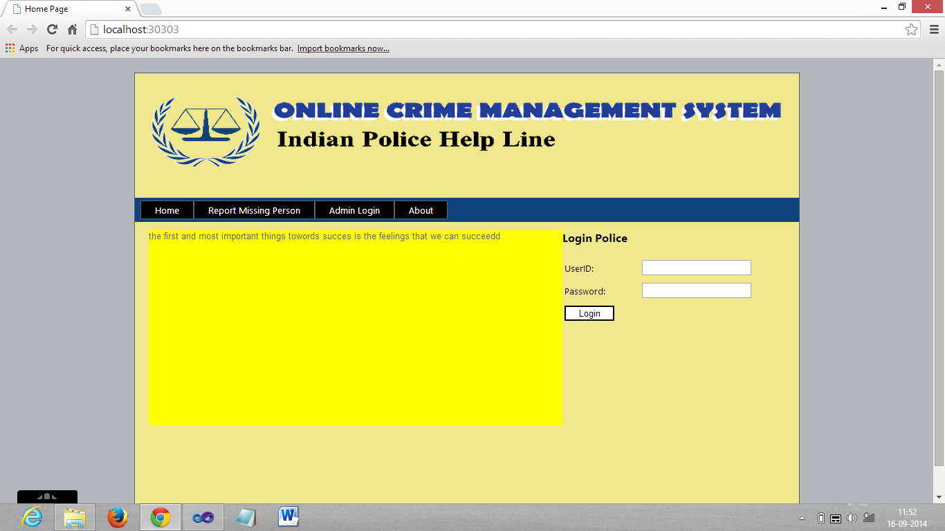

**snap shot 2**

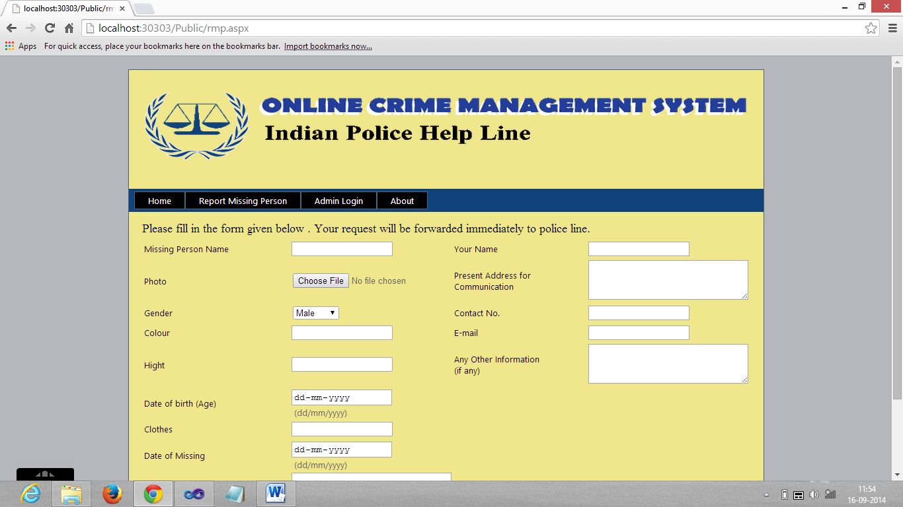

**Snap shot 3**

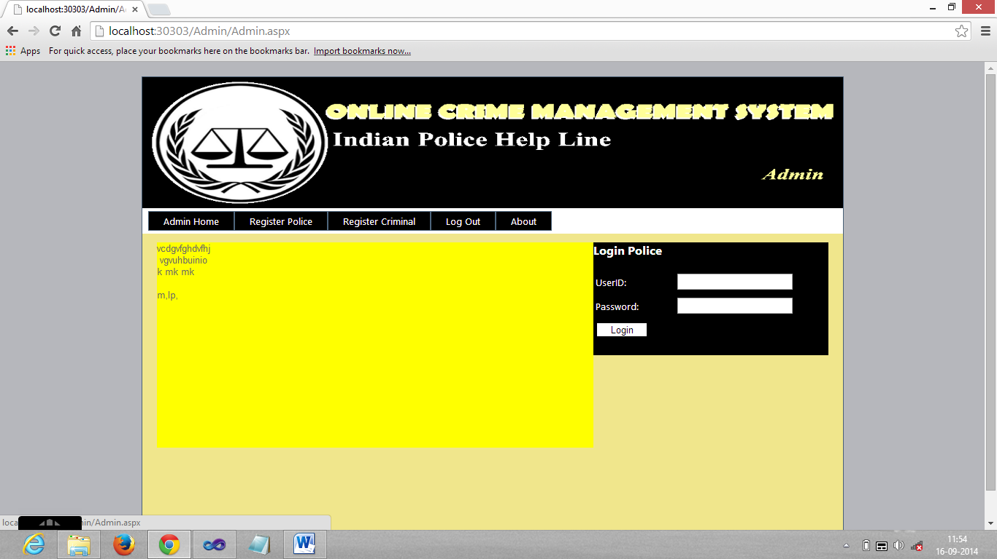

**Snap shot 4**

