Adaptive Pathfinding on Hexagonal Grids using Hybrid A*

Saqib Ahmed K
School of CSE
REVA University
Bengaluru, India
saqibak045@gmail.com
Mohammed Umar
School of CSE
REVA University
Bengaluru, India
23020300295@reva.edu.in

Abstract—Pathfinding is a major research problem in Artificial Intelligence and is widely applied in robotics, autonomous navigation, logistics optimization, and game AI. Classical algorithms such as A* provide optimal shortest paths efficiently in static environments, but their performance degrades in complex or dynamic environments due to increased node exploration and computation time. Reinforcement Learning (RL), particularly Deep Q Networks (DQN), offers adaptability by learning navigation strategies through trial and error, but it requires significant training and does not always guarantee optimal solutions. This paper presents an adaptive pathfinding system designed on a hexagonal grid environment using three approaches: A* search, Deep Q Network-based Reinforcement Learning, and a Hybrid RL-assisted A* algorithm. The hybrid method combines the optimality of A* with the adaptive learning capability of RL by using the RL agent to guide heuristic decision-making during A* exploration. A simulation framework is developed using Python Flask for backend processing and React with Tailwind CSS for frontend visualization. The algorithms are evaluated using metrics such as execution time, path cost, explored nodes, and steps taken. Experimental results show that the hybrid approach reduces unnecessary exploration while maintaining near-optimal path quality compared to the baseline A* algorithm.
Keywords— Pathfinding, A*, Reinforcement Learning, Deep Q Network, Hybrid Algorithm, Hexagonal Grid, Adaptive Navigation

Introduction
Pathfinding refers to the process of determining an optimal route between a source and destination while avoiding obstacles and minimizing cost. It is a fundamental problem in Artificial Intelligence and is widely used in autonomous vehicles, robotics navigation, game AI, route planning, and logistics management. The difficulty of pathfinding increases when the environment becomes complex, partially unknown, or dynamic, where obstacles and weights may change over time.
The A* algorithm is one of the most popular heuristic-based search algorithms used for shortest path computation. It guarantees an optimal solution when an admissible heuristic is used. However, in large environments with many obstacles or weighted terrains, A* can explore a large number of nodes, resulting in increased computation time and inefficiency.
Reinforcement Learning (RL) provides an alternative approach where an agent learns to navigate by interacting with the environment and receiving rewards or penalties. Deep Q Networks (DQN) enhance RL performance by using deep neural networks to approximate Q-values for decision making in large state spaces. While DQN improves adaptability, it requires extensive training and does not always guarantee optimal shortest paths.
To overcome these limitations, hybrid methods combining classical search algorithms with reinforcement learning have gained attention. In such systems, RL is used to guide or improve heuristic evaluation in search algorithms, reducing exploration while maintaining performance.
This paper proposes an adaptive pathfinding system on a hexagonal grid environment using three approaches: A*, DQN-based RL, and a Hybrid RL-assisted A* algorithm. Hexagonal grids provide more balanced movement compared to square grids because each cell has six equidistant neighbours, reducing diagonal movement bias and improving navigation realism.
The system is implemented using a web-based simulation framework with a Flask backend and React + Tailwind CSS frontend visualization. Performance comparisons are made based on path cost, execution time, explored nodes, and number of steps.

Related Work
Pathfinding algorithms have been extensively studied in Artificial Intelligence. Hart, Nilsson, and Raphael introduced the A* search algorithm, which became one of the most widely used heuristic search algorithms due to its completeness and optimality [1]. A* uses a cost function f(n) = g(n) + h(n), where g(n) is the cost from start to node n, and h(n) is an estimated cost from node n to the goal.
Reinforcement Learning was introduced as a method where an agent learns optimal behaviour through reward-based interaction with an environment. Sutton and Barto presented RL as a learning paradigm that can solve sequential decision-making problems effectively [2]. Q-learning was among the earliest RL methods applied to navigation tasks.
Later, Mnih et al. introduced Deep Q Networks (DQN), which combined Q-learning with deep neural networks, enabling RL to handle large state spaces and complex environments [3]. DQN achieved significant results in navigation and control tasks but requires training and may not always generate optimal paths.
Hybrid approaches combining heuristic search and RL have also been proposed. Such methods use RL to improve heuristic functions or guide node expansion in A* and related algorithms. Koenig and Likhachev proposed D* Lite for dynamic replanning, demonstrating the importance of adaptability in changing environments [4].
Hexagonal grid systems have been used in AI simulations due to their uniform neighbour distances. Patel described the advantages of hexagonal grids in reducing movement bias compared to square grids, making them suitable for navigation problems [5].
This work builds on these studies by implementing A*, DQN-based navigation, and a hybrid RL-assisted A* approach in a hexagonal grid environment.

Methodology
The proposed system is designed to compare three navigation approaches in a hexagonal grid environment: A*, DQN-based RL, and Hybrid RL-assisted A*.

Hexagonal Grid Representation
A hexagonal grid is represented using axial coordinates (q, r). Each cell has six neighboring cells, allowing movement in six directions. The distance between two hex cells is computed using the hex distance heuristic:
hex_distance(a, b) = (|aq - bq| + |ar - br| + |(aq + ar) - (bq + br)|) / 2
This representation ensures efficient neighbor calculation and accurate distance estimation.

A* Pathfinding Algorithm
A* is implemented as the baseline approach. It uses a priority queue to explore nodes based on minimum f(n):

f(n) = g(n) + h(n)

Where:
- g(n) is the cost from start to node n
- h(n) is the heuristic estimate to goal (hex distance)

A* guarantees the shortest path when h(n) is admissible.

Reinforcement Learning using DQN
A Deep Q Network agent is implemented to learn navigation behaviour. The agent observes the environment state and selects actions corresponding to movement directions. The reward function is designed as follows:
- Positive reward for reaching goal
- Negative penalty for hitting obstacles
- Negative reward for each step to encourage shorter paths
The DQN is trained through multiple episodes, and the learned Q-network is used to generate navigation paths.

Hybrid RL-assisted A* Approach
The hybrid approach integrates RL guidance into A* search. The trained RL agent provides heuristic suggestions by predicting favourable moves, reducing unnecessary exploration.
Instead of relying only on hex distance, the heuristic is adjusted using RL policy guidance, allowing the algorithm to prioritize more promising nodes.
This approach aims to maintain near-optimal path quality while improving efficiency in terms of explored nodes and execution time.

System Framework
The system is implemented as a web-based simulator.
- Backend: Python Flask API handles algorithm execution
- Frontend: React.js with Tailwind CSS provides interactive grid visualization
- Output: paths, explored nodes, cost, and performance metrics are returned as JSON

System Architecture and Modules
The system consists of the following modules:

Module 1: Hexagonal Grid Module
- Generates valid hexagonal cells
- Defines neighbours and coordinate mapping
- Provides hex distance calculation

Module 2: A* Pathfinding Module
- Implements priority queue-based A* search
- Stores explored nodes and final path
- Computes steps and total cost.

Module 3: DQN Reinforcement Learning Module
- Defines environment states and actions
- Implements reward function
- Trains agent through episodes
- Saves trained model weights

Module 4: Hybrid RL-assisted A* Module
- Uses RL model output to guide A* exploration
- Reduces unnecessary node expansion
- Improves efficiency

Module 5: Backend API Module
- Flask endpoints handle algorithm execution
- Returns metrics and paths as JSON

Module 6: Frontend Visualization Module
- Allows user to set start, goal, obstacles, and weights
- Visualizes explored nodes and computed path
- Displays performance comparison

- Architecture Diagram of Adaptive Pathfinding Simulator
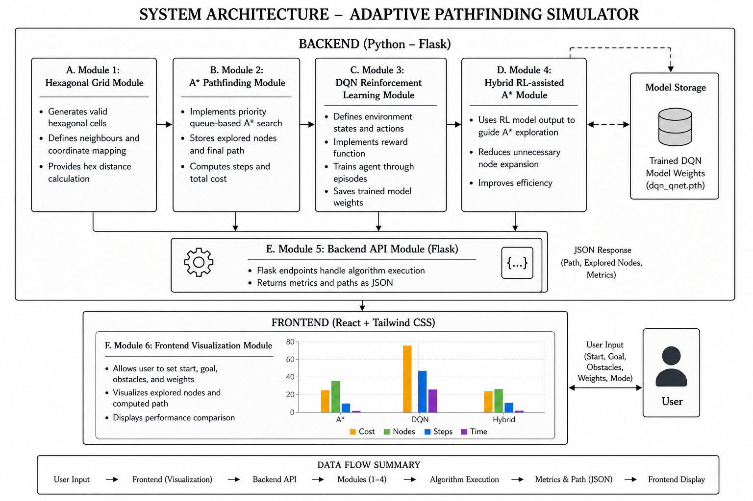

Core Algorithms and Mathemathical Modelling
This section presents the mathematical formulation and core algorithmic models used in the proposed adaptive pathfinding system. The project integrates classical heuristic search with deep reinforcement learning to improve navigation efficiency on hexagonal grid environments.

A* Search Cost Function
The A* algorithm is a heuristic-based search method that computes the optimal shortest path by minimizing the evaluation function:

f(n) = g(n) + h(n)
where:
- g(n) represents the accumulated path cost from the start node to the current node ,
- h(n) represents the heuristic estimate of the cost from node to the goal node.
The algorithm expands nodes with the lowest f(n) value, ensuring optimality when the heuristic is admissible.

Hexagonal Grid Representation and Distance Heuristic

The hexagonal grid is represented using axial coordinates (q, r). Each hex cell has six valid neighboring directions. The distance between two hexagonal cells a(q1, r1) and b(q2, r2) is calculated using the hex distance heuristic:

d(a,b) = ( |qa - qb| + |ra - rb| + |(qa + ra) - (qb + rb)| ) / 2
This heuristic is admissible and consistent, making it suitable for A* search on hexagonal grids.

Reinforcement Learning using Deep Q Network (DQN)
Reinforcement Learning is modeled as a Markov Decision Process (MDP) defined by (S’, A’, R’, γ), where:
- S is the set of states,
- A is the set of actions,
- R is the reward function,
- γ is the discount factor.
The DQN agent learns an optimal policy by estimating the action-value function . The Q-learning update rule is given by:

Q(s,a) ← Q(s,a) + α [ r + γ max Q(s',a') − Q(s,a) ]
where:
- α is the learning rate,
- r is the reward received after taking action ,
- S’ is the next state.
The neural network approximates the Q-values and selects actions using an epsilon-greedy strategy.

Reward Function Modelling
The DQN agent is trained using a reward function designed to encourage goal-reaching behaviour and penalize inefficient movement. The reward is modelled as:
- Positive reward for reaching the goal
- Negative reward for collision with obstacles
- Step penalty for each move to encourage shorter paths

R = +100 (goal reached), −100 (obstacle hit), −1 (each step)

This reward design improves learning efficiency and reduces wandering behaviour.

Hybrid RL-Assisted A* Heuristic Formulation
In the proposed hybrid approach, Reinforcement Learning is used to guide the heuristic estimation of A*. Instead of relying only on the standard hex distance heuristic, an adaptive heuristic is formed by combining classical heuristic values with RL-based guidance.
The modified heuristic function is expressed as:

h′(n) = h(n) + λ⋅ϕ(n)
where:
- h(n) is the classical hex distance heuristic,
- ϕ(n) is an RL-based heuristic guidance value derived from the DQN policy,
- λ is a weighting factor controlling the influence of RL guidance.
This hybrid heuristic reduces unnecessary node expansion by prioritizing more promising nodes based on learned navigation behavior, thereby improving computational efficiency while maintaining near-optimal path quality.

Performance Evaluation Metrics
The proposed algorithms are evaluated using the following performance measures:
- Execution Time

T = t(end) ​– t(start)
​
- Total Path Cost

C = i=1∑k​wi​

- Nodes Explored

N=∣{n∣n expanded during search}∣

- Steps Taken

S = k

Implementation Details

Backend API Execution
The Flask API endpoint runs all algorithms and returns outputs for comparison. The system supports both static and dynamic environments. A sample endpoint logic is:
- Parse hex grid data
- Build weights and valid cell list
- Run A*, DQN, and Hybrid algorithms
- Compute metrics such as time, nodes explored, and cost
- Return JSON response to frontend

- Actual Project Code Structure
File | Responsibility
app.py | Main Flask backend server. Handles API requests from frontend, runs algorithms (A*, DQN, Hybrid) in static/dynamic mode and returns paths with metrics.
hex_grid.py | Defines hexagonal grid structure using axial coordinates (q, r). Handles grid creation, valid cell generation, neighbor logic and weight/obstacle handling.
dynamic_grid.py | Generates and updates the dynamic hex grid environment. Responsible for periodically changing terrain weights while keeping obstacles unchanged.
dynamic_runner.py | Runs the full dynamic simulation loop. Executes all 3 algorithms frame-by-frame, stores frames, states and collects metrics like steps. Supports adaptive heuristic input.
astar.py | Implements the A* pathfinding algorithm for hex grids. Computers optimal paths, explored nodes, total cost and steps. Supports adoptive heuristic input.
rl_agent.py | Implements the DQN reinforcement learning agent. Loads the trained model (dqn_qnet.pth) and selects actions to navigate from start to goal.
rl_env.py | Defines the RL environment learning/testing DQN on the hex grid. Provides state representation, rewards, steps, transitions and termination conditions.
hybrid.py | Implements the Hybrid pathfinding approach. Combines A* search with RL-based adaptive heuristic adjustments to improve decision making.

- Workflow Diagram of Adaptive Pathfinding Simulator
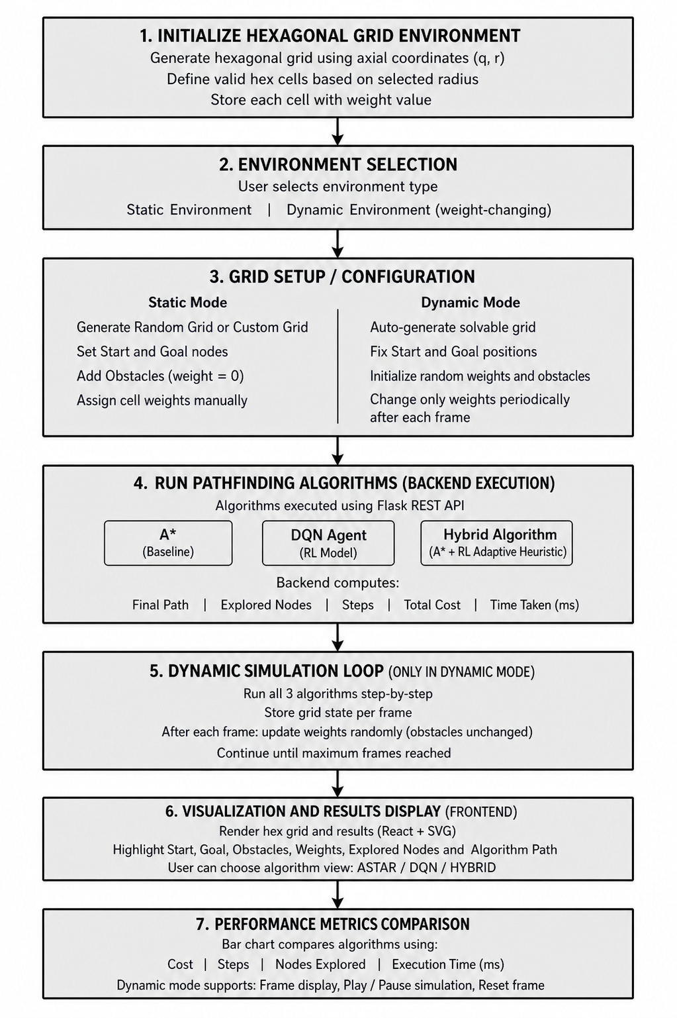

Frontend Visualization
The React frontend displays the grid and allows interactive placement of:
- Start node
- Goal node
- Obstacles
- Weighted terrain cells
The computed paths and explored nodes are highlighted with different colours for clear visualization.

Experimental Setup and Results

Evaluation Metrics
The algorithms are evaluated based on:
- Path cost
- Number of steps taken
- Nodes explored
- Execution time (ms)
- Success rate

Test Scenarios
The algorithms are tested under multiple conditions:
- Static environment with obstacles
- Weighted terrain environment
- Dynamic weight-changing environment
- Complex maze-like environments

Observations
The experimental results show the following:
- A* produces optimal shortest paths but explores many nodes in complex environments.
- DQN provides adaptability and learns navigation patterns but requires training and sometimes produces non-optimal paths.
- Hybrid RL-assisted A* reduces node exploration compared to A*, while maintaining near-optimal path cost and improved computation time.

The hybrid approach performs better in weighted and complex environments due to RL-guided heuristic prioritization.
- Output of Hex Grid Visualizer (A*, DQN, Hybrid Paths)

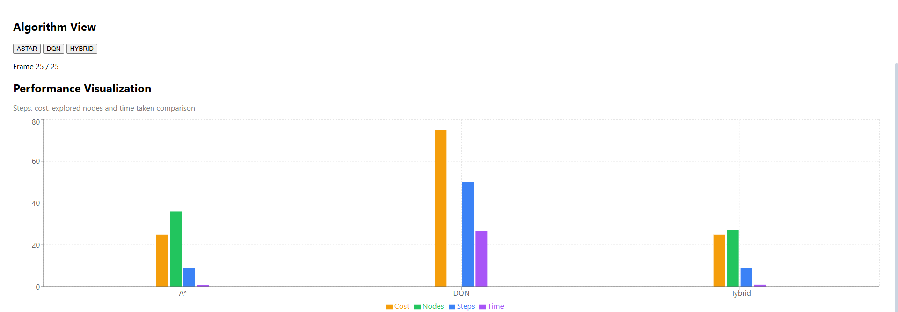

- Static Environment Performance Comparison (Cost, Steps, Nodes, Time)

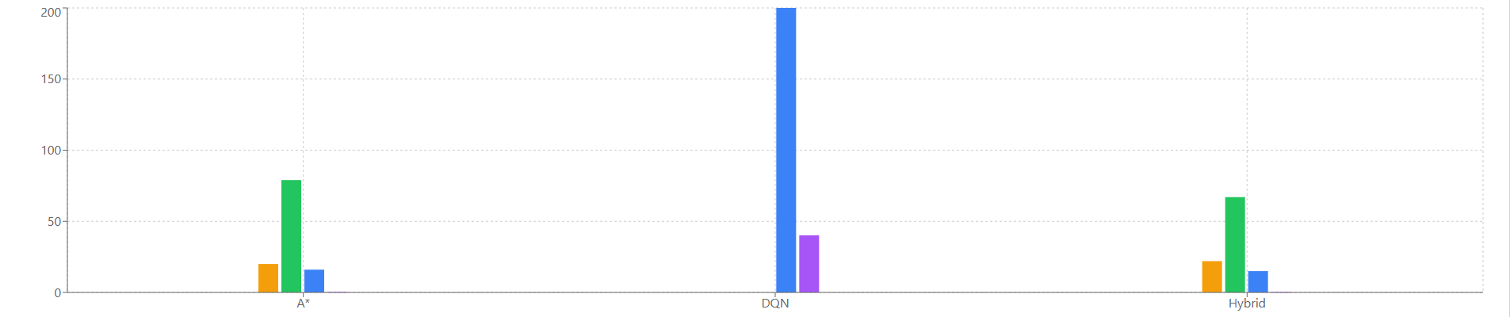

- Dynamic Environment Performance Comparison (Cost, Steps, Nodes, Time)
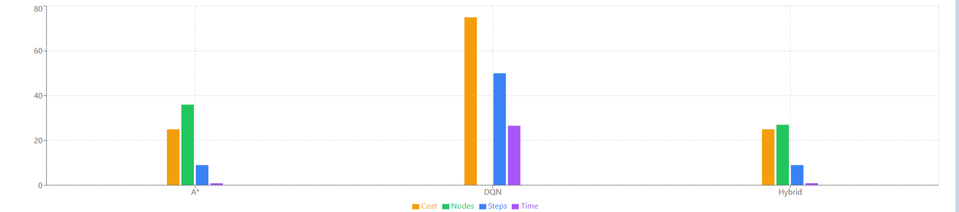

Discussion
The A* algorithm remains highly effective in static environments with a good heuristic. However, as the grid size increases or terrain weights become complex, the number of explored nodes increases significantly. DQN-based RL provides adaptability and can learn navigation behaviour but is computationally expensive due to training requirements.
The hybrid RL-assisted A* approach combines the strengths of both. It reduces exploration overhead by guiding the heuristic evaluation using RL policy. This results in improved efficiency while still maintaining good path quality.
This hybrid approach demonstrates potential for real-world applications such as autonomous navigation, robotics, and dynamic route planning systems.

Conclusion and Future Work

This paper presents an adaptive pathfinding system on a hexagonal grid environment using three approaches: A*, Deep Q Network-based Reinforcement Learning, and a Hybrid RL-assisted A* approach. A simulation framework is developed using Flask backend and React + Tailwind frontend for visualization and comparison.

Experimental analysis shows that A* guarantees optimal shortest paths but explores more nodes in complex environments. DQN provides adaptive navigation but requires extensive training and may not always generate optimal paths. The hybrid RL-assisted A* approach achieves improved efficiency by reducing unnecessary exploration while maintaining near-optimal performance.

Future work includes implementing moving goal scenarios, dynamic obstacle handling, multi-agent navigation, and improving RL training using advanced models such as Double DQN and Dueling DQN for better real-time performance.

References
- P. E. Hart, N. J. Nilsson, and B. Raphael, “A Formal Basis for the Heuristic Determination of Minimum Cost Paths,” IEEE Transactions on Systems Science and Cybernetics, vol. 4, no. 2, pp. 100–107, 1968.
- R. S. Sutton and A. G. Barto, Reinforcement Learning: An Introduction, 2nd ed. MIT Press, 2018.
- V. Mnih et al., “Human-level control through deep reinforcement learning,” Nature, vol. 518, pp. 529–533, 2015.
- S. Koenig and M. Likhachev, “D* Lite,” in Proceedings of the AAAI Conference on Artificial Intelligence, 2002.
- A. Patel, “Hexagonal Grids,” Red Blob Games, 2013.
- S. Ahmed K, “Adaptive Pathfinding on Hexagonal Grid using A*, DQN and Hybrid Approach,” GitHub Repository, 2026.

