Adaptive Pathfinding on Hexagonal Grids using Hybrid A*

Saqib Ahmed K
School of CSE
REVA University
Bengaluru, India
saqibak045@gmail.com
Mohammed Umar
School of CSE
REVA University
Bengaluru, India
23020300295@reva.edu.in

Abstract—Route computation in dynamic, obstacle-laden environments represents a core challenge in Artificial Intelligence research, with broad applications spanning robotics, self-driving systems, warehouse automation, and game-based simulations. While deterministic algorithms like A* yield provably optimal trajectories in well-defined static settings, their scalability suffers considerably when confronted with large-scale or frequently changing environments, owing to exhaustive node expansion. Although Reinforcement Learning (RL) — especially Deep Q-Network (DQN) architectures — introduces the capacity to acquire navigation policies through environmental feedback, such approaches demand intensive training cycles and yield no formal path-quality guarantees. This work introduces a three-pronged navigation framework evaluated on hexagonal grid topologies: a classical A* planner, a DQN-driven autonomous agent, and a novel Hybrid architecture in which the trained RL policy modulates the A* heuristic function. The resulting system reduces redundant search effort while preserving solution quality close to the A* optimum. A full-stack simulation platform was constructed using a Python Flask server for computational logic and a React/Tailwind CSS interface for interactive visualization, with performance benchmarked across execution latency, path cost, node expansion count, and traversal steps.
Keywords— Route Planning, A* Search, Deep Reinforcement Learning, DQN, Hybrid Navigation, Hex Grid, Intelligent Traversal

I. Introduction
Computing a least-cost traversal path between two spatial positions, while sidestepping impassable regions, constitutes one of the central challenges in intelligent systems design. This navigation problem underpins a broad spectrum of technologies — including unmanned ground vehicles, industrial robotic arms, real-time strategy game agents, delivery fleet coordination, and urban traffic management. Complexity escalates markedly when operating environments are partially observable, non-stationary, or subject to sudden weight and obstacle modifications.
Among informed search techniques, A* stands out for its theoretical guarantees: whenever the employed heuristic satisfies the admissibility criterion, the algorithm is assured to return the shortest feasible path. Despite its widespread adoption, A* becomes computationally burdensome in expansive grid maps with dense obstacle clusters or heterogeneous movement costs, as the open-list expansion can balloon significantly, degrading throughput.
A fundamentally different strategy emerges from Reinforcement Learning, wherein a navigating agent accumulates behavioural knowledge through iterative environmental interaction governed by scalar reward signals. The Deep Q-Network variant extends conventional Q-learning by substituting tabular value storage with a multi-layer neural network approximator, enabling operation in high-dimensional state representations. Notwithstanding these advantages, DQN-based navigation entails prolonged training and cannot offer the path-optimality assurances characteristic of deterministic search.
Recognising these complementary weaknesses, recent literature has increasingly explored composite architectures that embed learned behaviour within classical search frameworks. By leveraging an RL-derived policy to bias node prioritisation inside A*, it becomes possible to curtail unnecessary expansion without sacrificing the path-quality advantages of heuristic search.
This study contributes an integrated navigation simulator benchmarking three distinct strategies — A*, DQN-based RL, and a Hybrid RL-guided A* planner — within hexagonal grid topologies. Hexagonal tessellations offer inherently superior movement symmetry relative to rectilinear grids: every cell maintains six uniformly spaced neighbours, eliminating the anisotropy that diagonal movement introduces in square-grid planners and yielding more faithful representations of real traversal costs.
Implementation leverages a web-native architecture pairing a Flask-based REST backend with a React/Tailwind CSS visual interface. Quantitative assessment spans four principal dimensions: aggregate path cost, wall-clock computation time, total nodes expanded during search, and end-to-end step count.

II. Prior Research
The literature on graph-based navigation is rich and spans several decades of AI research. Hart, Nilsson, and Raphael's seminal contribution formalised best-first search with the A* algorithm, establishing the standard evaluation function f(n) = g(n) + h(n), where g(n) denotes accumulated travel cost from the origin and h(n) encodes a heuristic estimate toward the destination [1]. This framework remains a cornerstone of both theoretical analysis and applied path planning.
The RL paradigm was formalised by Sutton and Barto, who characterised it as a framework for solving sequential decision problems through trial-and-error interaction without explicit task supervision [2]. Early applications of tabular Q-learning to grid navigation demonstrated that autonomous agents could converge on near-optimal movement policies purely through environmental feedback.
A significant leap forward came with Mnih et al.'s Deep Q-Network architecture, which married convolutional neural networks with temporal-difference learning to operate across vast, continuous state spaces [3]. While DQN demonstrated compelling performance across a range of control benchmarks, its practical deployment in navigation tasks is constrained by training overhead and the absence of formal optimality proofs.
Integrating learning-based guidance into classical planners has attracted growing interest. Koenig and Likhachev's D* Lite algorithm demonstrated that incremental replanning strategies could dramatically reduce search overhead when environmental conditions fluctuate [4], highlighting the value of adaptability in dynamic domains. Subsequent works have explored using policy networks to warm-start or steer A* node expansion.
Hexagonal grid representations have gained traction in simulation-based AI research because of their geometric regularity. Patel's analysis highlighted how equal inter-cell distances across all six neighbours eliminate the systematic directional bias inherent in square-grid four- or eight-connectivity [5], making hex grids particularly well-suited to fair navigation evaluation.
Building on these foundations, the present work implements all three planning paradigms — classical A*, learned DQN navigation, and their hybrid integration — within a unified hexagonal grid simulator to enable rigorous cross-method comparison.

III. System Design and Methods
The experimental platform is architected to evaluate and contrast three complementary navigation strategies operating over a shared hexagonal grid substrate: the A* heuristic planner, the DQN reinforcement learner, and the proposed Hybrid RL-assisted A* system.

Hex Grid Encoding
The navigation workspace is encoded using the axial coordinate system (q, r), which assigns a unique integer pair to every hexagonal tile. Each cell maintains adjacency with exactly six neighbouring tiles, supporting uniform six-directional movement. Inter-cell distance is computed via the hex distance formula:
hex_distance(a, b) = (|aq - bq| + |ar - br| + |(aq + ar) - (bq + br)|) / 2
This coordinate scheme affords O(1) neighbour enumeration and an admissible distance estimate without requiring floating-point geometry.

Baseline A* Planner
The A* planner serves as the performance baseline. Node expansion is governed by a min-heap ordered on f(n):

f(n) = g(n) + h(n)

Where:
- g(n) — cumulative edge-weight sum from origin to n
- h(n) — admissible lower-bound estimate of remaining cost to target

Provided h(n) never overestimates true remaining cost, A* is guaranteed to terminate with a globally optimal trajectory.

DQN-Based Navigation Agent
A DQN agent is trained to autonomously acquire goal-directed navigation behaviour. At each timestep the agent receives a state observation encoding its current hex position and selects one of six directional actions. Training is shaped by the following reward structure:
- Goal-arrival bonus
- Obstacle-collision penalty
- Per-step cost to incentivise trajectory brevity
After iterative training across numerous episodes, the converged Q-network is deployed in inference mode to produce navigation trajectories.

Combined RL-Informed A* Strategy
The Hybrid method embeds the trained DQN policy as a secondary heuristic signal within the A* search loop. Rather than treating the RL agent as a standalone planner, its action-value predictions are queried at each candidate node to identify locally promising directions, thereby pruning less favourable branches before expansion.
The evaluation function is augmented beyond pure geometric distance: RL policy confidence scores bias node priority toward regions the agent associates with successful navigation, focusing search effort on more productive areas of the graph.
The objective is to preserve path-cost quality near the A* optimum while materially cutting node expansion count and wall-clock latency.

Deployment Architecture
The entire platform is deployed as a browser-accessible simulator with a clean separation of concerns:
- Computation Layer: a Flask REST API orchestrates algorithm invocation and returns structured results
- Presentation Layer: a React/Tailwind CSS single-page application renders the hex grid and overlays path data
- Data Exchange: each algorithm run serialises its path, expanded node set, cost, and timing figures as a JSON payload

IV. Module Breakdown
Six loosely coupled modules compose the overall system:

Component 1: Grid Engine
- Constructs and validates the set of traversable hexagonal tiles
- Encodes adjacency relationships and axial-to-pixel coordinate transforms
- Exposes the admissible hex distance heuristic for use by planners

Component 2: A* Search Engine
- Executes the open-list priority-queue search loop
- Records visited nodes and the reconstructed optimal trajectory
- Calculates aggregate step count and weighted path cost.

Component 3: RL Training Module
- Specifies the MDP state space encoding and available movement actions
- Applies the goal/obstacle/step reward scheme during training
- Runs episode-based experience collection and Q-network weight updates
- Persists the converged network checkpoint to disk for inference reuse

Component 4: Hybrid Planner
- Queries the trained DQN at each expansion step to bias node ordering
- Avoids expanding low-value branches identified by RL policy scoring
- Cuts total search overhead

Component 5: Server-Side API
- REST endpoints receive grid configuration and dispatch algorithm execution
- Serialises results — paths, expanded nodes, timing, cost — as JSON responses

Component 6: Interactive UI
- Provides an interactive canvas for defining start/goal positions, obstacles, and terrain weights
- Renders colour-coded overlays for explored nodes and computed trajectories
- Presents a side-by-side metrics panel comparing all three algorithms

- High-Level System Architecture Overview
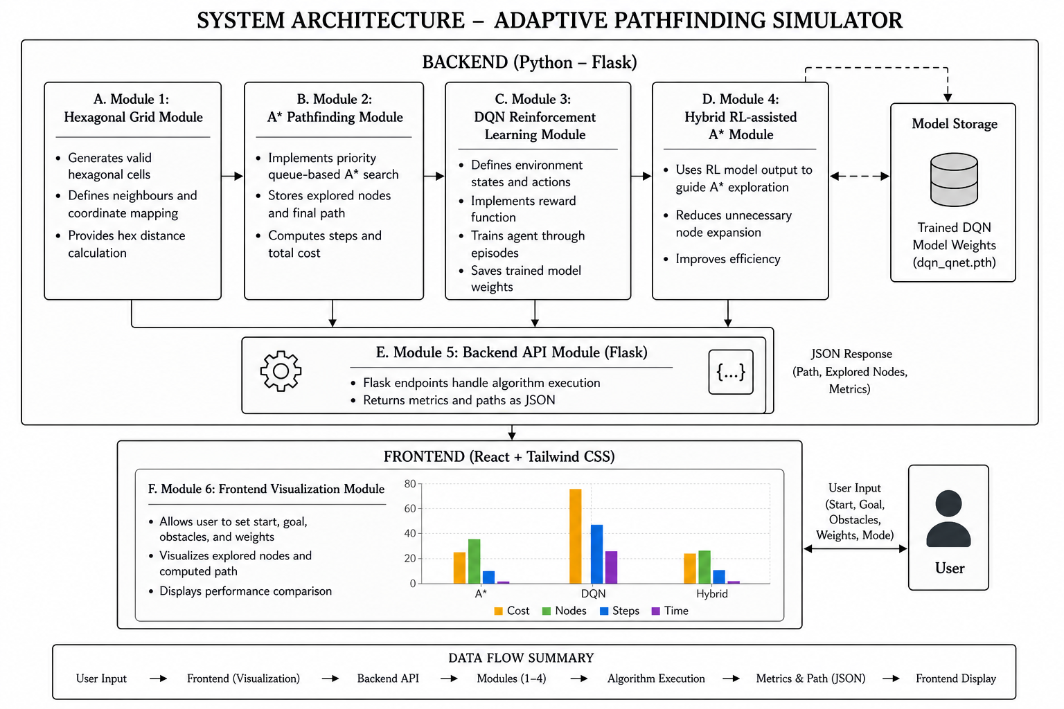

V. Algorithmic Foundations and Mathematical Analysis
The following sections formalise the mathematical underpinnings of each algorithmic component. The system merges deterministic heuristic search with learned value estimation to achieve improved navigation throughput on hexagonal topologies.

A* Evaluation Function
A* operates by iteratively expanding the frontier node with the lowest evaluation score, defined as:

f(n) = g(n) + h(n)
where:
- g(n) denotes the sum of edge weights along the path from origin to n ,
- h(n) is an admissible lower-bound estimate of cost from n to the goal node.
By always expanding the minimum f(n) candidate, the algorithm provably terminates with an optimal route whenever h(n) satisfies admissibility.

Hex Coordinate System and Admissible Heuristic

Spatial positions on the hexagonal map are encoded as axial coordinate pairs (q, r), with each cell maintaining six valid movement directions. For two cells a and b with respective coordinates (q₁, r₁) and (q₂, r₂), separation is measured by:

d(a,b) = ( |qa - qb| + |ra - rb| + |(qa + ra) - (qb + rb)| ) / 2
This distance function satisfies both admissibility and the consistency (monotone) condition, ensuring correct and complete A* behaviour on hex grids.

MDP Formulation and DQN Learning
The navigation learning task is cast as a Markov Decision Process characterised by the tuple (S, A, R, γ), where:
- S — the agent's observable state space,
- A — the discrete set of movement actions,
- R — the scalar feedback signal,
- γγ — the temporal discount coefficient.
The DQN approximates the optimal action-value function Q*(s,a) via stochastic gradient descent. The Bellman-based update target is:

Q(s,a) ← Q(s,a) + α [ r + γ max Q(s',a') − Q(s,a) ]
where:
- αα represents the gradient step size,
- r is the immediate reward signal collected after executing action a, ,
- S’ is the next state.
A target network stabilises training, and action selection follows an ε-greedy schedule that anneals exploration over time.

Incentive Signal Design
Training incentives are shaped by a three-component reward signal balancing goal attainment against movement efficiency:
- Destination bonus: awarded upon reaching the target cell
- Collision penalty: incurred upon entering an impassable cell
- Traversal cost: a small negative signal applied at every timestep to favour compact routes

R = +100 (goal reached), −100 (obstacle hit), −1 (each step)

Together these signals accelerate policy convergence and deter the agent from circling sub-optimal regions.

RL-Augmented Heuristic Derivation
The core contribution of the Hybrid approach is an RL-augmented heuristic that supplements the geometric hex distance with a learned navigation signal. Rather than evaluating nodes by geometry alone, the A* expansion function is enriched with the DQN policy's assessment of local node promise.
Formally, the enriched evaluation heuristic takes the form:

h′(n) = h(n) + λ⋅ϕ(n)
where:
- h(n) is the classical hex distance heuristic,
- ϕ(n) is an RL-based heuristic guidance value derived from the DQN policy,
- λ is a weighting factor controlling the influence of RL guidance.
By incorporating φ(n) the planner channels search toward regions the RL agent associates with efficient trajectories, materially cutting node expansion overhead while retaining path quality near the classical A* benchmark.

Benchmarking Criteria
Algorithm performance is assessed across four quantitative dimensions:
- Execution Time

T = t(end) ​– t(start)
​
- Total Path Cost

C = i=1∑k​wi​

- Nodes Explored

N=∣{n∣n expanded during search}∣

- Steps Taken

S = k

VI. System Implementation

Server Execution Flow
A unified Flask endpoint orchestrates all three planners within a single request-response cycle, supporting both fixed-terrain and dynamically changing grid configurations. The execution pipeline proceeds as follows:
- Deserialise the incoming hex grid specification from the request payload
- Construct the weighted adjacency structure and filter traversable cells
- Execute all three navigation strategies sequentially over the same grid
- Record per-algorithm timing, expansion counts, and aggregate path cost
- Package all results into a structured JSON envelope and dispatch to the client

- Codebase Overview
File | Responsibility
app.py | Primary server entry point. Receives grid configuration from the client, dispatches all three navigation algorithms in static or dynamic mode, and serialises results with performance metrics.
hex_grid.py | Encodes the hexagonal map using axial (q, r) coordinates. Manages tile instantiation, traversability validation, adjacency resolution, and terrain-weight assignment.
dynamic_grid.py | Produces and maintains a time-varying grid environment in which traversal costs shift periodically while obstacle positions remain fixed throughout the simulation.
dynamic_runner.py | Drives the dynamic simulation cycle by executing each planner on successive grid snapshots, accumulating per-frame states, trajectory data, and step-count statistics. Accepts external heuristic inputs for the Hybrid mode.
astar.py | Houses the core A* search routine adapted for hexagonal topology. Computes shortest-path trajectories, tracks expanded nodes, and reports total path cost and step count. Accepts an optional adaptive heuristic override.
rl_agent.py | Encapsulates the trained DQN inference engine. Restores network weights from the saved checkpoint and drives action selection to steer the agent from its starting cell to the designated target.
rl_env.py | Specifies the MDP environment used during DQN training and evaluation. Encodes agent state, applies the reward function, manages timestep transitions, and signals episode termination on success or collision.
hybrid.py | Realises the Hybrid planner by injecting DQN-derived action-value scores into the A* node-evaluation pipeline, steering expansion toward higher-promise regions of the search graph.

- System Execution Workflow
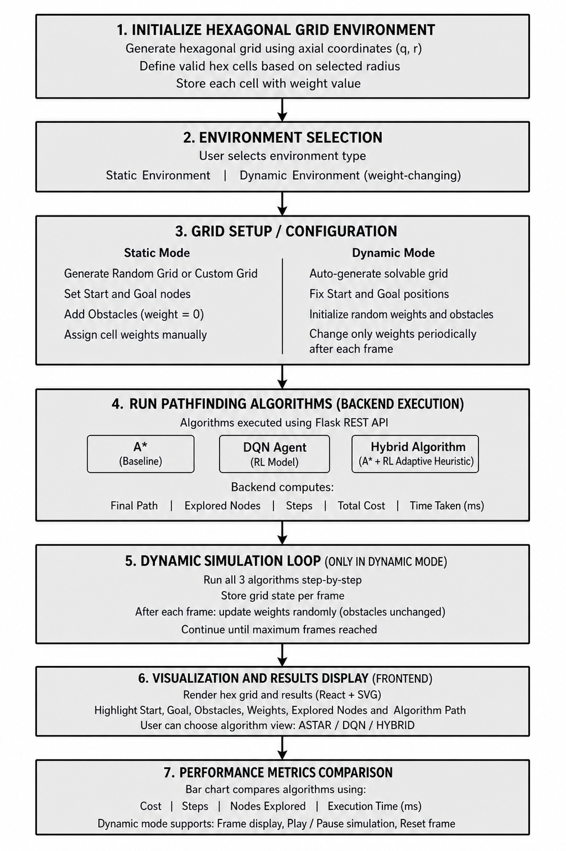

Client-Side Interface
The browser-based interface renders the hexagonal canvas and exposes interactive controls for:
- Origin cell selection
- Target cell designation
- Impassable cell marking
- Variable-cost tile assignment
Distinct colour channels distinguish explored cells from final path segments, giving users immediate visual feedback on algorithmic behaviour.

VII. Experiments and Findings

Performance Indicators
The algorithms are evaluated based on:
- Aggregate weighted traversal cost
- Total movement steps to destination
- Count of grid cells expanded during search
- Wall-clock runtime in milliseconds
- Rate of successful goal-reaching attempts

Experimental Conditions
The algorithms are tested under multiple conditions:
- Fixed-obstacle grid with no terrain changes
- Heterogeneous cost landscape with varied tile weights
- Non-stationary terrain with periodically shifting traversal costs
- Dense obstacle configurations resembling labyrinthine layouts

Key Findings
Analysis of the collected benchmark data reveals three key patterns:
- The A* planner consistently yields minimum-cost trajectories, though node expansion grows steeply with grid complexity.
- The DQN agent demonstrates environmental adaptability and generalisation across obstacle configurations, but its training overhead is non-trivial and occasional sub-optimal routes are observed.
- The Hybrid planner achieves a favourable trade-off, substantially lowering expansion count and reducing wall-clock latency relative to A* while sustaining path-cost quality within a narrow margin of the optimum.

Performance gains of the Hybrid method are most pronounced in weighted-terrain and maze-like scenarios, where RL-informed node prioritisation prevents the fruitless exploration of low-quality branches.
- Rendered Navigation Paths on Hex Grid: A*, DQN, and Hybrid Comparison

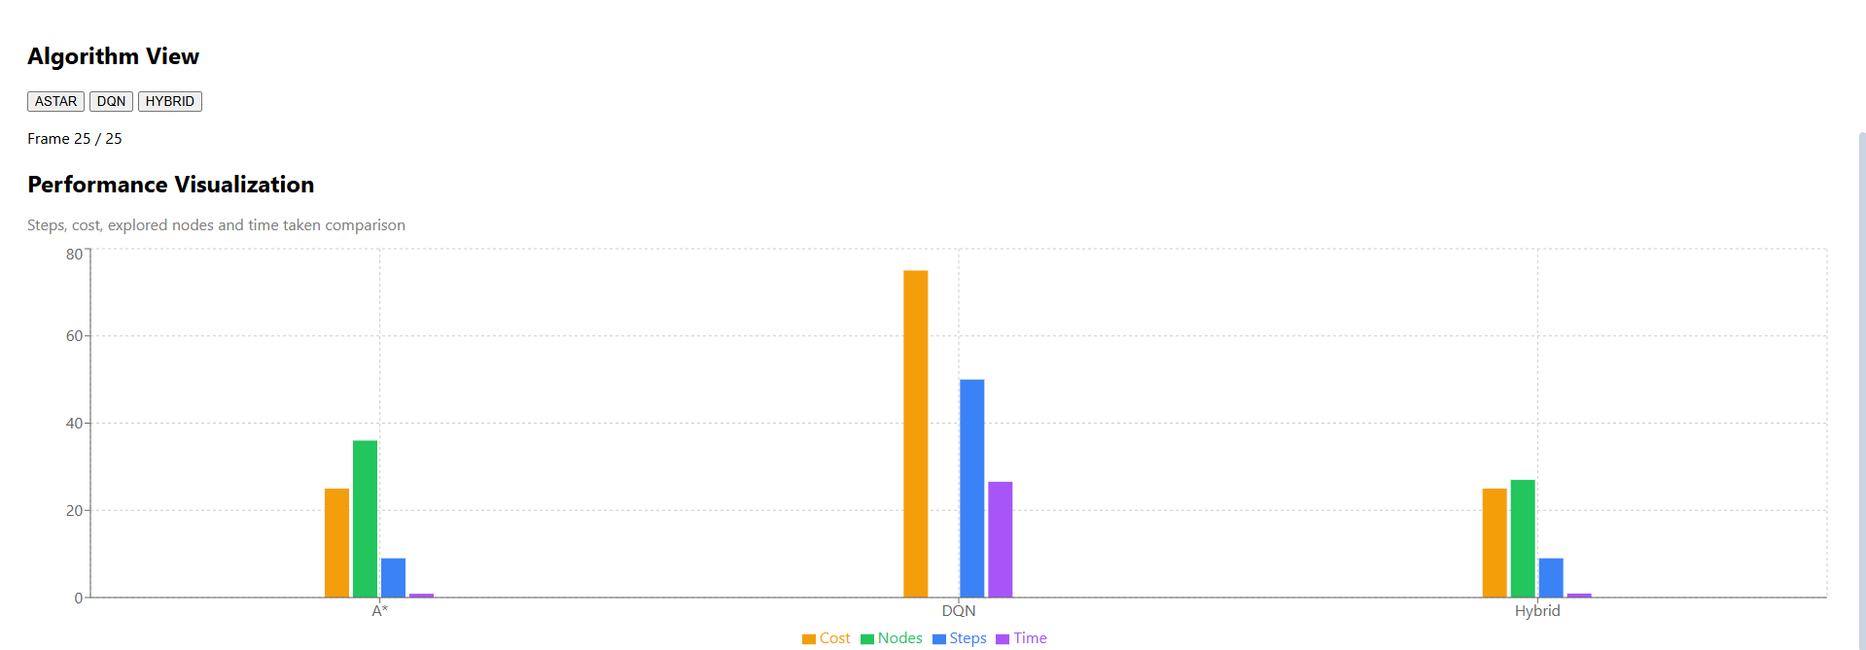

- Fixed-Terrain Benchmark Results Across All Three Planners

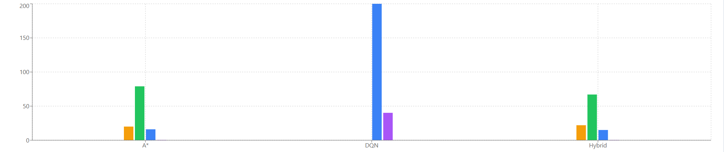

- Dynamic-Terrain Benchmark: Cost, Steps, Node Count, and Latency
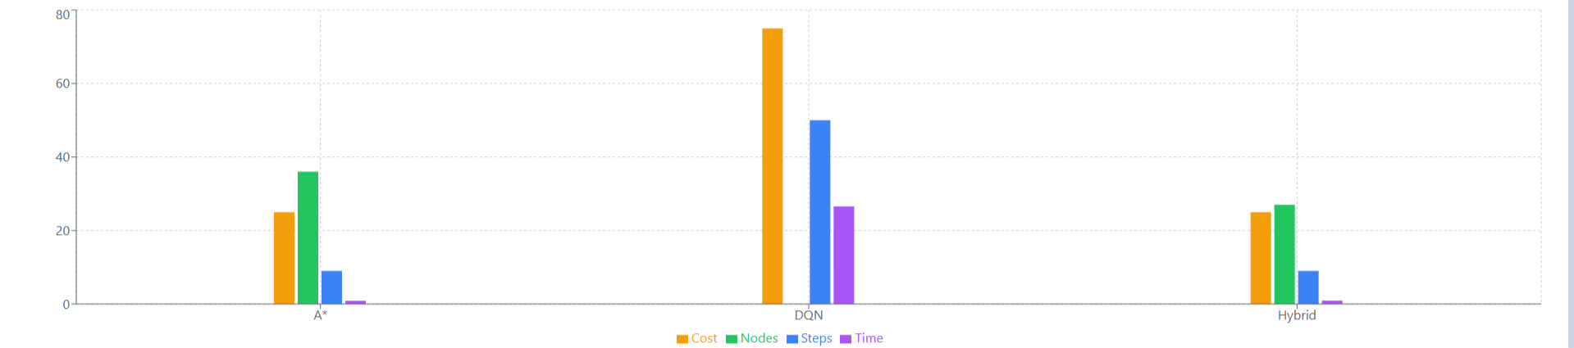

VIII. Analysis and Interpretation
Classical A* retains strong performance in well-defined, unchanging environments where a tight heuristic can be maintained. Its principal weakness surfaces in large or weight-heterogeneous grids, where the priority queue expands a disproportionately large fraction of the search space. Conversely, the DQN-based planner exhibits commendable adaptability to unseen configurations but imposes a significant upfront training budget and yields no hard path-quality guarantees.
The proposed Hybrid architecture bridges these two extremes by channelling the RL agent's acquired navigation intuition through the A* evaluation function. The result is a planner that inherits A*'s optimality-proximity while shedding a substantial fraction of its computational overhead through RL-directed node prioritisation.
Beyond the simulated benchmark, this integration paradigm holds tangible promise for deployment in real-world systems such as warehouse robots, autonomous vehicle planners, and adaptive logistics routing engines where both path quality and responsiveness are critical.

IX. Conclusion and Outlook

This paper introduced a comprehensive navigation benchmarking platform comparing three algorithmic strategies — classical A*, DQN-based RL, and a novel Hybrid RL-guided A* planner — on hexagonal grid environments. A full-stack simulation tool was developed to support interactive experimentation and objective side-by-side performance assessment.

Empirical evaluation confirmed that A* delivers path-optimality guarantees at the cost of escalating search overhead in intricate terrains. DQN-based navigation confers valuable adaptability but lacks optimality assurances and demands substantial training investment. The Hybrid RL-assisted A* planner successfully reconciles these trade-offs, demonstrating materially reduced node expansion and faster execution while closely tracking A*-quality solutions.

Prospective directions include extension to mobile-target pursuit scenarios, real-time obstacle insertion and removal during traversal, cooperative multi-agent path planning, and the adoption of advanced RL architectures — including Double DQN, Dueling DQN, and Prioritised Experience Replay — to accelerate convergence and enhance deployment-readiness.

References
- P. E. Hart, N. J. Nilsson, and B. Raphael, “A Formal Basis for the Heuristic Determination of Minimum Cost Paths,” IEEE Transactions on Systems Science and Cybernetics, vol. 4, no. 2, pp. 100–107, 1968.
- R. S. Sutton and A. G. Barto, Reinforcement Learning: An Introduction, 2nd ed. MIT Press, 2018.
- V. Mnih et al., “Human-level control through deep reinforcement learning,” Nature, vol. 518, pp. 529–533, 2015.
- S. Koenig and M. Likhachev, “D* Lite,” in Proceedings of the AAAI Conference on Artificial Intelligence, 2002.
- A. Patel, “Hexagonal Grids,” Red Blob Games, 2013.
- S. Ahmed K, “Adaptive Pathfinding on Hexagonal Grid using A*, DQN and Hybrid Approach,” GitHub Repository, 2026.

