
School of Computer Science and Engineering
Research Based Mini Project (B22EH0605)
Course Code: B22EH0605 |  |  | Mini Project Progress Report – Phase 2 |  |  | Year: 2025-2026
 |  |  |  |  |  | Sem: 6th
Project Group Members Details
Group No: |  | Group Name:
Sl. No | SRN | Full Name |  | Sec | Mobile No. | Email_ID |  | Sign
1 | R23EH075 | Mohammed Umar |  | AI & DS - B | 6361631781 | 23020300395@reva.edu.in
2 | R23EH115 | Saqib Ahmed K |  | AI & DS - B | 8660679775 | 23020300290@reva.edu.in
Project Details
Project Title: |  | Adaptive Pathfinding on Hexagonal Grids using Hybrid A*
Guide Details: |  | Name: Prof. Sowmya Somnath  Designation: Assistant Professor |  |  |  |  | Mobile No: 8884775216
Remarks by Guide: |  |  |  |  |  |  | Guide Signature  Date:

Abstract:

Pathfinding is an important problem in Artificial Intelligence and is widely used in robotics, autonomous vehicles, logistics systems, and game AI. Classical pathfinding algorithms such as A* provide optimal shortest paths efficiently in static environments. However, their performance decreases when dealing with dynamic obstacles, moving targets, or partially unknown environments. Reinforcement Learning (RL) offers an alternative method in which an agent learns navigation strategies through interaction with the environment. Although RL improves adaptability, it often requires long training time and heavy computation.

This project proposes an adaptive pathfinding system on a hexagonal grid environment using three approaches: A* algorithm, Reinforcement Learning using Deep Q Network (DQN), and a Hybrid Reinforcement Learning assisted A* approach. The hybrid approach uses RL to support and guide the heuristic evaluation of A* search, improving efficiency and reducing unnecessary exploration. A simulation framework is developed using Python Flask as the backend and React with Tailwind CSS as the frontend for visualization. The system allows the user to define start and goal states, set obstacles, assign weighted terrain, and compare algorithm outputs.

The algorithms are evaluated using metrics such as path optimality, computation time, explored nodes, steps taken, and total path cost. This project demonstrates an intelligent navigation system capable of adaptive decision-making. Future improvements include dynamic obstacle handling, moving goal scenarios, and optimization of RL training for real-time deployment.

Table of Contents:

SL.NO | CONTENT | PG.NO
 | Introduction | 01
 | Literature Survey | 02
 | Objectives | 03
 | Methodology | 04
 | Modules identified | 05
 | Work progress / plan & Implementation | 06
 | Sample Code | 07
 | Output | 10
 | Conclusions | 11
 | Reference | 12

- Introduction:

Pathfinding refers to the process of determining an optimal route between a source and destination while avoiding obstacles and minimizing cost. It is a core component in Artificial Intelligence and is used in robotics navigation, autonomous vehicles, game AI, logistics optimization, and route planning systems. The challenge of pathfinding increases when the environment becomes dynamic or partially unknown, where obstacles may appear or disappear and goal positions may shift.

The A* search algorithm is one of the most widely used pathfinding algorithms because it guarantees optimal paths when a valid heuristic is used. However, in large-scale maps or dynamic environments, A* may explore many unnecessary nodes, increasing computation time. Reinforcement Learning (RL) is an AI technique in which an agent learns optimal actions based on rewards received from the environment. RL is effective in dynamic and uncertain environments because the agent can adapt its navigation strategy through experience. The limitation is that RL requires training and computational resources.

This project focuses on developing an intelligent navigation system using hexagonal grids. Hexagonal grids provide smoother movement and better neighbor representation compared to square grids because each cell has six equidistant neighbors. The project implements three approaches: A*, Reinforcement Learning using Deep Q Network (DQN), and a Hybrid Reinforcement Learning assisted A* model. The hybrid model aims to combine the optimality of A* with the adaptability of RL.

The system is developed using React.js and Tailwind CSS for the frontend visualization and Python Flask for backend processing. The results are compared using metrics such as path optimality, computation time, nodes explored, and success rate.

- Literature Survey:

Pathfinding algorithms have been extensively studied in the field of Artificial Intelligence. Hart, Nilsson, and Raphael introduced the A* algorithm, which became one of the most widely used heuristic search algorithms due to its completeness and optimality [1]. A* uses a cost function f(n) = g(n) + h(n), where g(n) represents the cost from start to node n, and h(n) represents an estimated cost from node n to the goal. This approach enables efficient shortest path computation.

Reinforcement Learning gained popularity as an alternative method for navigation problems. Sutton and Barto presented RL as a learning method where agents improve their policies through reward-based interaction with the environment [2]. Q-learning was one of the earliest RL methods used for navigation tasks. Later, Mnih et al. proposed Deep Q Networks (DQN), which combined deep learning with Q-learning to handle complex decision-making environments [3]. DQN demonstrated high performance in large state spaces.

Recent research has focused on hybrid approaches combining classical pathfinding algorithms with RL. RL-assisted heuristic search can reduce node exploration while improving adaptability in dynamic environments. Such hybrid models allow RL to guide heuristic functions or decision-making steps in A*, improving efficiency [4].

Hexagonal grid environments have also been used in AI simulations due to their balanced movement properties. Unlike square grids, hex grids reduce diagonal bias and provide equal distance movement to all adjacent cells, making them suitable for robotics and strategy-based navigation systems [5].
This project is aligned with these studies by implementing A*, DQN-based navigation, and a hybrid RL-assisted A* algorithm on a hexagonal grid simulation environment.

- Objectives:

Problem Statement:
Pathfinding algorithms are widely used in robotics, autonomous vehicles, logistics systems, and game AI to determine optimal routes between locations. Traditional algorithms such as the A* search algorithm are efficient in static environments but often struggle when dealing with dynamic obstacles, moving goals, or partially unknown environments. Reinforcement Learning (RL) provides an alternative approach where an agent learns optimal navigation strategies by interacting with the environment.

However, RL alone can require large training time and computational resources. A hybrid approach that combines classical pathfinding algorithms with reinforcement learning can potentially improve adaptability and efficiency. This project aims to develop an intelligent pathfinding system on hexagonal grid environments that integrates Reinforcement Learning with the A* algorithm to learn adaptive heuristics and improve navigation in dynamic environments.

The objectives of this project are:
- To design and develop an interactive hexagonal grid-based pathfinding simulator using a web-based interface, supporting both static and dynamic environments.
- To implement the A* algorithm as a classical baseline method and visualize its shortest path along with explored nodes and performance metrics.
- To implement a Deep Q-Network (DQN) based reinforcement learning agent for navigation on hexagonal grids and compare its pathfinding behavior with traditional algorithms.
- To implement and evaluate a Hybrid approach combining A* with an RL-based adaptive heuristic, and analyse the performance of A*, DQN, and Hybrid algorithms using metrics such as cost, steps, nodes explored, and execution time in both static and dynamic weight-changing environments.

- Methodology:

Methodology describes the approach followed to solve the problem statement.
- A hexagonal grid environment is designed using axial coordinate representation (q,r).
- Obstacles, weighted cells, start state, and goal state are defined in the grid.
- A* algorithm is implemented as the baseline approach using hex distance heuristic.
- A Reinforcement Learning model using Deep Q Network (DQN) is developed where the agent learns navigation by reward-based episodes.
- A hybrid RL-assisted A* algorithm is implemented where RL is used to support A* heuristic guidance and improve efficiency.
- The system is tested in multiple scenarios such as static obstacles, dynamic obstacles, moving goals, and partially unknown maps.
- Performance is evaluated using path cost, nodes explored, time taken, and success rate.
- Results are visualized using a frontend interface for clear comparison.

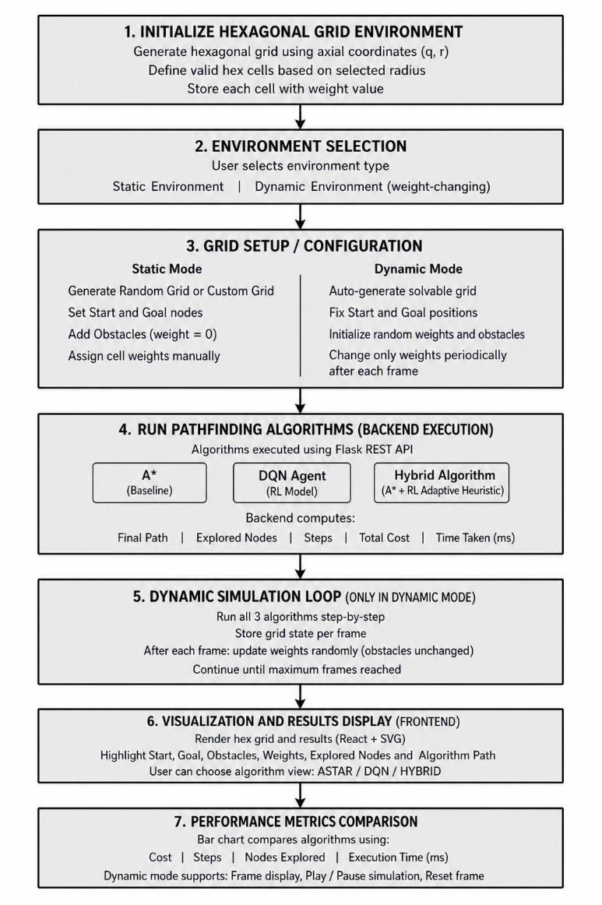
- Modules identified:

Module 1: Hexagonal Grid Module
- Defines hex grid representation
- Handles valid cells and neighbors
- Provides hex distance calculations

Module 2: A* Pathfinding Module
- Implements priority queue based A* search
- Computes optimal shortest path
- Stores explored nodes and total cost

Module 3: Reinforcement Learning (DQN) Module
- Defines environment, reward system, and actions
- Trains agent through episodes
- Saves trained model weights

Module 4: Hybrid RL-assisted A* Module
- Uses RL model to guide heuristic decisions
- Improves efficiency of A* exploration

Module 5: Backend API Module
- Flask API endpoints handle algorithm execution
- Returns JSON results including metrics and paths

Module 6: Frontend Visualization Module
- Interactive UI for grid generation
- Displays explored nodes and final path
- Displays metrics comparison

- Work progress / plan & Implementation

The project development started in late February 2026. The hexagonal grid environment and baseline A* implementation were completed first, followed by reinforcement learning (DQN) training and hybrid integration. The frontend visualization and backend API integration were completed in April 2026. Testing and evaluation were performed using different scenarios to compare A*, DQN, and Hybrid RL-assisted A* performance.

Month / Period | Work Planned | Status
Late Feb 2026 | Problem analysis, requirement study, project planning | Completed
Late Feb 2026 | Hexagonal grid environment design and implementation | Completed
Early Mar 2026 | Implementation of A* algorithm (baseline) | Completed
Mid Mar 2026 | Design of Reinforcement Learning environment | Completed
Mid Mar 2026 | Implementation of DQN model and training process | Completed
Late Mar 2026 | Hybrid RL-assisted A* integration | Completed
Early Apr 2026 | Flask backend API development and integration | Completed
Mid Apr 2026 | React + Tailwind frontend visualization development | Completed
Late Apr 2026 | Testing, debugging, and performance evaluation | Completed
Early May 2026 | Dynamic environment and optimization of RL model | Completed

- Sample Code

Hex Distance Heuristics:
def hex_distance(a, b):
aq, ar = a
bq, br = b
return (abs(aq - bq) + abs(ar - br) + abs((aq + ar) - (bq + br))) / 2

Flask API to run all algorithms:
@app.route("/api/run_all", methods=["POST"])
def run_all():
data = request.get_json()
env_mode = data.get("env_mode", "static")

if env_mode == "dynamic":
radius = int(data.get("radius", 6))
frame_count = int(data.get("frame_count", 25))
steps_per_frame = int(data.get("steps_per_frame", 2))

sim_data = simulate_dynamic(
radius=radius,
frame_count=frame_count,
steps_per_frame=steps_per_frame
)

return jsonify(sim_data)

hexes = data.get("hexes", [])

if not hexes:
return jsonify({"error": "No hexes provided"}), 400

weights, start, goal, valid_cells = build_weights_from_hexes(hexes)

t0 = time.perf_counter()
path, steps, cost, nodes_explored, explored_nodes = run_astar(
start, goal, weights, valid_cells
)
t1 = time.perf_counter()

astar_result = {
"path": [{"q": p[0], "r": p[1]} for p in path],
"steps": steps,
"cost": cost,
"nodes": nodes_explored,
"explored": explored_nodes,
"time_ms": round((t1 - t0) * 1000, 3)
}

t0 = time.perf_counter()
dqn_result = run_dqn(weights, start, goal)
t1 = time.perf_counter()
dqn_result["time_ms"] = round((t1 - t0) * 1000, 3)

t0 = time.perf_counter()
h_path, h_steps, h_cost, h_nodes_explored, h_explored_nodes = run_hybrid(
start, goal, weights, valid_cells
)
t1 = time.perf_counter()

hybrid_result = {
"path": [{"q": p[0], "r": p[1]} for p in h_path],
"steps": h_steps,
"cost": h_cost,
"nodes": h_nodes_explored,
"explored": h_explored_nodes,
"time_ms": round((t1 - t0) * 1000, 3)
}

return jsonify({
"mode": "static",
"hexes": hexes,
"astar": astar_result,
"dqn": dqn_result,
"hybrid": hybrid_result
})

- Conclusions

This project successfully implements an adaptive pathfinding system on a hexagonal grid environment using A*, Reinforcement Learning (DQN), and a hybrid RL-assisted A* approach. A* provides optimal shortest paths but explores many nodes in complex environments. Reinforcement Learning provides adaptability but requires training time and may not guarantee optimality initially. The hybrid RL-assisted A* approach combines both techniques to improve navigation efficiency by guiding heuristic search using learned policies. The developed frontend visualization and backend API framework allow interactive testing and comparison of the algorithms. The performance is analyzed using computation time, nodes explored, path cost, and steps. This project demonstrates an intelligent navigation system capable of adaptive decision-making. Future work includes dynamic obstacle simulation, moving goal implementation, and improved reinforcement learning optimization.

Output:


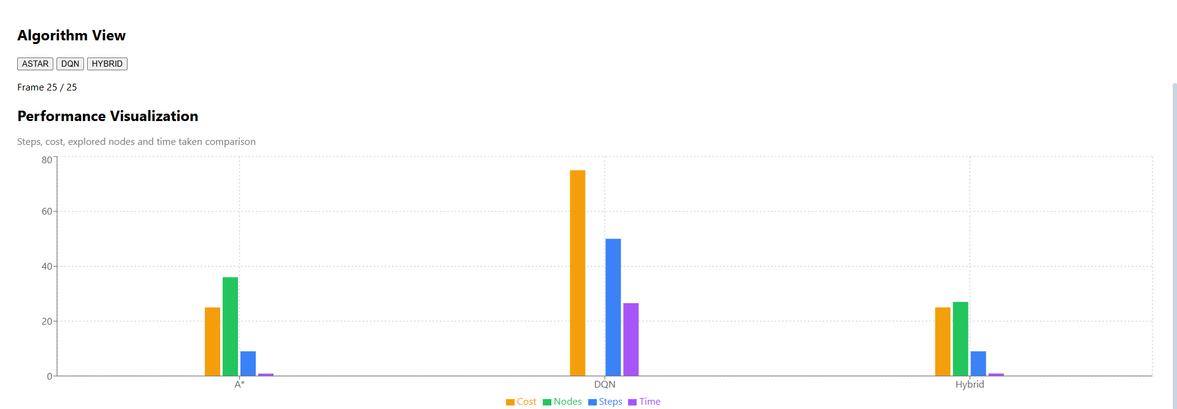

Results:

- Successfully developed a hexagonal grid-based adaptive pathfinding system.
- Implemented three algorithms: A*, DQN Reinforcement Learning, and Hybrid RL-assisted A*.
- Created an interactive simulation where users can set start, goal, obstacles, and weighted terrain.
- Developed a working Flask backend API and React + Tailwind frontend visualization.
- Compared all algorithms using metrics like time taken, steps, nodes explored, and total path cost.
- Observed that A* gives optimal paths but explores more nodes in static environments.
- Observed that DQN provides adaptability but requires training and may not always produce optimal paths.
- Observed that the Hybrid RL-assisted A* reduces unnecessary exploration and improves efficiency while maintaining near-optimal paths.
- Demonstrated that combining Reinforcement Learning with heuristic search improves performance in adaptive navigation tasks.

Future Work:
- Implement moving goal scenarios for more realistic navigation challenges.
- Optimize the DQN training process to reduce computation time and improve learning speed.
- Improve hybrid heuristic guidance using advanced RL techniques like Double DQN / Dueling DQN.
- Extend the system for real-time pathfinding applications in robotics and autonomous systems.
- Add support for multi-agent navigation where multiple agents find paths simultaneously.
- Integrate the system with real-world simulation environments for practical testing.

- References:

[1] P. E. Hart, N. J. Nilsson, and B. Raphael, “A Formal Basis for the Heuristic Determination of Minimum Cost Paths,” IEEE Transactions on Systems Science and Cybernetics, vol. 4, no. 2, pp. 100–107, 1968.
[2] R. S. Sutton and A. G. Barto, Reinforcement Learning: An Introduction, 2nd ed. MIT Press, 2018.
[3] V. Mnih et al., “Human-level control through deep reinforcement learning,” Nature, vol. 518, pp. 529–533, 2015.
[4] S. Koenig and M. Likhachev, “D* Lite,” in Proceedings of the AAAI Conference on Artificial Intelligence, 2002.
[5] A. Patel, “Hexagonal Grids,” Red Blob Games, 2013. Science, 1989.
[6] S. A. K., “Adaptive Pathfinding on Hexagonal Grid using A*, DQN and Hybrid Approach,” GitHub repository, 2026. [Online]. Available: https://github.com/SaqibAK001/adaptive-pathfinding

