Mehran University of Engineering and Technology, Jamshoro
Department of Software Engineering
Software Construction and Development (SW315)
Lab 16 — Open-Ended Lab: Complex Engineering Problem (CEP)
5th Semester
CampusCare
Smart Campus Service and Maintenance Management System
Group Members
Name | Roll Number
Shariyar | 24SW028
Saqib Anwar | 24SW046
Bansi | 24SW052
Safiullah | 24SW107
Saifullah | 24SW137
Janak | 24SW155
Course instructor: [to be filled in by the group]
Source repository: [to be inserted after the group pushes the project]
Submission deadline: 10-11-2026

Abstract
Reporting faults on a university campus is usually informal, which causes lost complaints, duplicate reports, unclear accountability and safety problems that wait in the same queue as cosmetic requests. This report describes CampusCare, a web-based service and maintenance request system built for the SW315 Lab 16 Complex Engineering Problem. Students and faculty report problems, maintenance staff resolve assigned tasks and administrators triage, assign, monitor and report, all under role-based access control.
We analysed the problem against the CEP characteristics, identified stakeholder conflicts (speed versus capacity, safety versus queue order, privacy versus accountability) and turned each into an explicit rule: a validated workflow state machine, target resolution times, safety-based priority escalation that preserves the reporter’s own priority, duplicate detection with reporter override, workload-aware assignment hints, and privacy-limited views. Two architectures were compared, a Flask monolith with SQLite and a separated single-page application with API services; the monolith was chosen for scope, security simplicity and time, with its scalability limits documented.
The Flask prototype has 25 routes, six database tables, an audit log, and use case, class, sequence, state, ER and architecture diagrams generated alongside editable Draw.io files. A pytest suite of 37 items covering 35 numbered test cases, including negative and security cases, passed in the final run; the first run had three failures that came from the test set-up rather than from the application, as explained in the report. A CI workflow is provided but has not yet been run on GitHub. The report ends with limitations, risks and improvements, and lists the evidence the group still has to produce.

Table of Contents
1. Introduction 5
1.1 Background 5
1.2 Problem statement 5
1.3 Objectives 5
1.4 Scope 5
2. Complex Engineering Problem Analysis 6
3. Stakeholder Analysis 7
3.1 Conflicting needs and how the system addresses them 7
4. Software Requirements Specification 8
4.1 Purpose, scope and users 8
4.2 Functional requirements 8
4.3 Non-functional requirements 9
4.4 Constraints, assumptions and risks 9
4.5 External interfaces and data 10
4.6 Requirements traceability 10
5. Engineering Alternatives and Decision-Making 11
5.1 The two approaches 11
5.2 Decision and trade-off 12
5.3 Smaller design decisions 12
6. Software Design 13
6.1 System architecture 13
6.2 Use case diagram 14
6.3 Class diagram 15
6.4 Sequence diagrams 17
6.5 Workflow state diagram 19
6.6 Database design 20
7. Implementation 21
7.1 Technology and structure 21
7.2 Key mechanisms 22
8. User Interface and Main Features 22
9. Development and DevOps 29
9.1 Version control 29
9.2 Continuous integration 30
9.3 Deployment considerations 30
10. Testing and Evaluation 30
10.1 Methodology 30
10.2 Results 30
10.3 Interpretation 33
10.4 Security testing considerations 33
10.5 Limitations, failure risks and improvements 34
10.6 Tests not executed 34
11. System Evaluation 34
12. Compliance with Lab 16 and Assessment Criteria 35
13. Limitations and Future Improvements 36
14. Lessons Learned and Team Contributions 36
14.1 Lessons learned 36
14.2 Team and proposed responsibilities 37
15. Conclusion 37
References 37
Appendix A: All Test Cases and Recorded Results 38
Appendix B: Running the Project 39
Appendix C: Evidence the Group Must Still Produce 40

1. Introduction

1.1 Background
A university campus is a collection of buildings, laboratories, classrooms, libraries, washrooms and electrical and network installations that all need continuous maintenance. In our department the usual way of reporting a fault is informal: a message to a class representative, a phone call, or a visit to the administration office. Nothing records who reported what, who was told, or whether anyone fixed it. Two students can report the same projector failure and nobody notices the duplicate; a genuine safety hazard can sit in the same pile as a request to repaint a wall.
CampusCare is our answer to that problem: a small web application in which students and faculty report problems, maintenance staff receive and resolve assigned tasks, and administrators triage, assign and monitor everything from one place. The project was chosen for Lab 16 because it has real interacting requirements and real conflicts between stakeholders, which is what the lab’s Complex Engineering Problem (CEP) brief asks for, rather than being a simple create-read-update-delete exercise.

1.2 Problem statement
Design, build and evaluate a centralised campus service-request system that (a) lets reporters describe a fault precisely and follow its progress, (b) gives administrators a defensible way to prioritise and assign scarce maintenance capacity, (c) gives staff enough information to act without chasing the reporter, and (d) keeps an accountable record of every decision while limiting how much personal information each role can see.

1.3 Objectives
- Provide a complete request life-cycle (Submitted → Under Review → Assigned → In Progress → Resolved → Closed, plus Rejected) with enforced valid transitions and role permissions.
- Resolve the main stakeholder conflicts with explicit, explainable rules (priority escalation, target resolution times, workload-aware assignment, privacy-limited views) instead of leaving them to ad-hoc judgement.
- Compare at least two architectural approaches against the requirements and justify the one selected, including its limits.
- Produce consistent UML models, a normalised database and a working, tested prototype kept in version control with a CI workflow.
- Evaluate the prototype honestly with positive and negative tests and report what is not yet covered.

1.4 Scope
In scope: the three roles, the request workflow, duplicate detection, priority handling, image upload, feedback, dashboards, reports, user management and audit logging. Out of scope for this lab: e-mail/SMS notifications, integration with university identity systems, mobile native apps, asset inventory and spare-parts management, and load testing at campus scale. These exclusions keep the prototype achievable within the lab period; Section 13 explains what each exclusion would cost in practice.

2. Complex Engineering Problem Analysis
The Lab 16 brief lists nine characteristics of a complex engineering problem and marks eight of them as applicable to this assignment. We checked each against CampusCare and only claim a characteristic where we can point to a concrete example in the project. One characteristic (diverse stakeholder groups) is not claimed, in line with the brief.
Table 1: CEP characteristics and where they appear in CampusCare
Characteristic | Applies | Evidence from the project
1. Depth of knowledge required | Yes | The solution combines requirements engineering, state-machine design, relational modelling with constraints, web security (CSRF, RBAC, upload validation, password storage), UML, testing and CI. A correct design needs all of them at once; for example the upload feature is simultaneously a usability, security and storage-design problem.
2. Range of conflicting requirements | Yes | Students want immediate resolution; administrators have limited staff; staff want complete information before accepting work; safety issues must jump the queue; privacy must be protected while every action stays accountable (Section 3 lists the conflicts and the rules used).
3. Depth of analysis required | Yes | There is no single correct answer to “what priority is this?” or “is this a duplicate?”. We had to define heuristics, test them against edge cases (e.g. “fire extinguisher” must not mean fire) and analyse their failure modes (RISK-01, RISK-06).
4. Infrequently encountered issues | Yes | Re-opened requests, a request reassigned while in progress, the same fault reported twice by different people, a reporter whose chosen priority differs from the real urgency, lock-out versus account enumeration, and files whose extension and content disagree.
5. Beyond codes / standards of practice | Partly | Standards (ISO/IEC/IEEE 29148 for requirements, OWASP guidance for security) help but do not say how a campus should rank a leaking tap against a flickering light, or what staff may see about a reporter. These rules are our own engineering judgement and are exposed as configurable constants.
6. Diverse groups of stakeholders | No | Three internal roles with clear responsibilities. There are no external contractors, public users or regulators in the prototype, so we do not claim this characteristic.
7. Interdependence of parts | Yes | Workflow rules, permissions, assignment, SLA timers, duplicate detection, audit logging and reporting all depend on the same request data. Changing the transition table changes what the UI offers, what the tests expect and what the reports count.
8. Significant consequences | Yes | A wrongly ranked sparking socket or a lost gas-leak report has safety consequences; a privacy leak affects individuals; an unresponsive system undermines trust in the service. Consequences differ by context (hostel, laboratory, library).
9. Judgement in decision-making | Yes | Architecture choice, escalation rules, what to log, how strict to make uploads, and what to leave out of the prototype all required trade-off decisions that are documented in Sections 5 and 13.

3. Stakeholder Analysis
Table 2: Stakeholder groups and their needs
Stakeholder | Needs | Concerns / constraints
Students and faculty (reporters) | Quick, simple reporting; proof the report was received; visible progress; a way to say the problem is not fixed. | Do not want to retype the same report; expect fast action; do not want contact details shown widely.
Maintenance staff | A prioritised list of assigned tasks; location, description and photo; ability to record what was done. | Limited hours; incomplete reports waste visits; should not be blamed for tasks that were never assigned to them.
Administrators (estate / department office) | Overview of all requests, overdue items and workload; control of assignment and priority; reports for management. | Limited staff and budget; must justify priority decisions; must manage user accounts safely.
University management (indirect) | Evidence of service quality (resolution time, satisfaction). | Accountability and data protection.

3.1 Conflicting needs and how the system addresses them
Table 3: Conflicts and the design response
Conflict | How CampusCare responds
Students expect immediate resolution; administrators have limited maintenance resources. | Every priority level has an explicit target resolution time (Critical 8 h, High 24 h, Medium 72 h, Low 168 h). The reporter sees the target and the assignee; the administrator sees overdue items and each staff member’s open-task count, so expectations and capacity are both visible.
Staff need sufficient information before accepting a task. | Title, 20-character minimum description, building, specific location, category and an optional photo are mandatory or supported at submission. Staff can read the administrator’s assignment note. Rejection requires a written reason, so incomplete requests are bounced with an explanation rather than ignored.
Safety issues must precede ordinary complaints. | Reporters choose a priority, but the system keeps that choice as requested_priority and computes an effective priority: Safety & Security is at least High, and danger keywords (e.g. sparking, smoke, gas leak) force Critical. Queues sort by effective priority. Administrators can lower a priority only with a recorded reason.
The university must protect user data and also keep accountability. | Staff see the reporter’s first name only; contact e-mail is shown to administrators. Passwords are stored as salted hashes. Every state change, assignment, priority change, login failure and export writes an audit row with user, time and IP address. Uploaded photos are served only to people allowed to see the request.
Reporters want to report freely; administrators do not want duplicates. | Duplicate detection warns the reporter (live and on submit) and lets them continue if the problem is different. The confirmed duplicate is flagged for the administrator instead of being silently dropped.

4. Software Requirements Specification

4.1 Purpose, scope and users
This section follows the structure recommended by ISO/IEC/IEEE 29148 in condensed form. CampusCare is a browser-based system used on a university network. It has three user roles; the permissions in Table 4 are enforced on the server for every request, not only by hiding buttons.
Table 4: Role permissions
Capability | Student / Faculty | Maintenance staff | Administrator
Register / log in | Yes (self-register) | Yes (created by admin) | Yes (created by admin)
Submit request, upload photo | Yes | No | No
View requests | Own only | Assigned to them | All
Start review, reject, assign, re-assign | No | No | Yes
Start work, resolve with notes | No | Assigned tasks only | No
Close or re-open a resolved request | Own request | No | Yes
Change priority | No | No | Yes (reason required)
Give feedback | Own, after resolution | No | No
Statistics, reports, CSV export | No | No | Yes
Manage users, view audit log | No | No | Yes

4.2 Functional requirements
Table 5: Functional requirements
ID | Requirement | Implemented in
FR-01 | Users shall register (reporters only), log in and log out with securely hashed passwords and session management. | routes/auth.py, models.User
FR-02 | The system shall enforce role-based access control for Student/Faculty, Maintenance Staff and Administrator. | routes/__init__.py (role_required)
FR-03 | A reporter shall submit a request with title, description, category, building, location, priority and an optional PNG/JPG image, with input validation. | services.create_request
FR-04 | Reporters shall track status, history and assigned staff of their requests. | requests/detail.html
FR-05 | The system shall enforce the workflow Submitted → Under Review → Assigned → In Progress → Resolved → Closed, with Rejected, valid transitions and role permissions. | services.TRANSITIONS, transition()
FR-06 | Administrators shall assign and re-assign requests to active maintenance staff, with workload and specialty hints. | services.assign, suggest_staff
FR-07 | Staff shall view assigned tasks, update status, add resolution notes and view task history. | routes/staff.py
FR-08 | Administrators shall view, search and filter all requests (category, priority, location/building, status, overdue) and change priority with a reason. | services.apply_filters, change_priority
FR-09 | The system shall detect probable duplicate requests using building, category and location. | services.find_duplicates
FR-10 | The system shall handle requests by priority and escalate safety hazards automatically. | services.escalate_priority
FR-11 | Reporters shall submit one rating (1–5) and comment after resolution. | services.submit_feedback
FR-12 | Administrators shall see dashboard statistics and overdue requests. | services.dashboard_stats, Chart.js
FR-13 | Administrators shall generate maintenance reports for a date range and export CSV. | services.report_summary, report_csv
FR-14 | Administrators shall create users, change roles and (de)activate accounts, but not their own. | routes/admin.py
FR-15 | The system shall record request/assignment history and an audit log. | RequestUpdate, AuditLog, services.audit

4.3 Non-functional requirements
Table 6: Non-functional requirements
ID | Requirement | How it is met / verified
NFR-01 | Security: hashed passwords, lock-out after 5 failed logins for 15 minutes, CSRF protection on all POSTs, restrictive response headers, validated uploads with random names. | Implemented; TC-02, 03, 04, 05, 10, 17–19
NFR-02 | Usability: responsive layout, clear status indicators, empty states and understandable error messages. | Manual review and screenshots (Section 8)
NFR-03 | Performance: ordinary pages should respond in well under one second with demonstration-sized data. | Measured mean 5–7 ms per page (Section 11); not a load test
NFR-04 | Maintainability: layered structure (routes → services → models), no business rules in templates, automated tests. | Code structure; 37 pytest tests
NFR-05 | Portability: runs locally with Python 3 and SQLite; no external services; database URL configurable. | README; config.py
NFR-06 | Privacy: staff see reporters’ first names only; photos only to authorised viewers. | TC-09, TC-17
NFR-07 | Data integrity: CHECK, UNIQUE and foreign-key constraints in the schema. | models.py; Section 6.6

4.4 Constraints, assumptions and risks
Table 7: Constraints
ID | Constraint
CR-01 | The prototype must run on a student laptop with no paid or external services (Python, Flask, SQLite).
CR-02 | The system must be built and tested by a group of six within the lab period, so scope was limited to the items in Section 1.4.
CR-03 | Only demonstration data is used; no real university or personal data.
CR-04 | Images are limited to PNG/JPG, 2 MB each.

Assumptions. Users reach the system over a trusted campus network or VPN; each user has a unique e-mail address; one administrator team is responsible for triage; maintenance staff are assigned by the administrator rather than self-selecting tasks.
Table 8: Risks
ID | Risk | Mitigation / residual risk
RISK-01 | Keyword escalation produces false positives (e.g. “fire drill” or “fire door”) and floods the Critical queue. | Rule excludes “fire extinguisher”; administrators can lower priority with a reason; keyword list is a constant that can be tuned. Residual: still crude compared with human reading.
RISK-02 | SQLite allows limited concurrent writes. | Acceptable for the prototype; DATABASE_URL allows PostgreSQL/MySQL for real deployment.
RISK-03 | Staff capacity cannot meet the target times, so many requests become overdue. | Overdue list and workload counts make this visible; targets are constants to be agreed with the estate office.
RISK-04 | Account takeover through weak or guessed passwords. | Password rules, lock-out, hashing. Residual: no two-factor authentication.
RISK-05 | Malicious or disguised uploads. | Extension, size and magic-byte checks; random names; access-controlled download. Residual: images are not re-encoded or virus-scanned.
RISK-06 | Duplicate heuristic misses differently worded locations or flags different problems in the same room. | Reporter can override; administrator sees the flag. Residual: free-text locations are inherently ambiguous.
RISK-07 | No notifications, so reporters or staff may not notice changes. | Documented limitation; future work.

4.5 External interfaces and data
User interface: server-rendered HTML pages (Jinja2, Bootstrap 5) with small ES6 scripts. HTTP interfaces: form posts for all state changes plus two read-only JSON endpoints (/api/duplicates for the live duplicate hint and /admin/api/stats for the charts). Storage: a SQLite database and an uploads directory under instance/. The database requirements are described in Section 6.6 and in docs/DATABASE.md.

4.6 Requirements traceability
Table 9: Traceability from requirements to implementation and test cases
Req. | Main implementation | Test cases
FR-01 | auth.py, User model | TC-01, 02, 05, 34
FR-02 | role_required, can_view | TC-01, 04, 06, 07, 08, 09
FR-03 | create_request, validate_image | TC-11, 12, 17, 18, 19
FR-04 | detail view, history | TC-25 (manual screenshots)
FR-05 | TRANSITIONS, transition() | TC-20, 21, 23, 25, 26, 27
FR-06 | assign(), suggest_staff() | TC-08, 20, 22, 33
FR-07 | staff routes, transition() | TC-23, 24, 25
FR-08 | apply_filters, change_priority | TC-29, 30, 31
FR-09 | find_duplicates | TC-15, 16
FR-10 | escalate_priority, SLA_HOURS | TC-13, 14, 30, 31
FR-11 | submit_feedback | TC-28
FR-12 | dashboard_stats, charts.js | TC-30 (logic); charts verified by screenshot only
FR-13 | report_summary, report_csv | TC-32
FR-14 | admin user routes | TC-34, 35
FR-15 | RequestUpdate, audit() | TC-11, 20
NFR-01 | auth, CSRF hook, upload checks | TC-02, 03, 04, 05, 10, 17, 18, 19
NFR-06 | can_view, uploaded_file() | TC-09, 17

5. Engineering Alternatives and Decision-Making

5.1 The two approaches
Approach A — server-rendered monolith. One Flask application renders HTML pages, talks to SQLite through SQLAlchemy, and stores uploads on local disk. The browser receives finished pages; JavaScript is used only for small enhancements.
Approach B — separated front end and API services. A single-page application (for example React) calls a REST API implemented as one or more services, backed by a server database such as PostgreSQL, with token-based authentication and object storage for images.
Table 10: Comparison of the two approaches
Criterion | A: Flask monolith + SQLite | B: SPA + API + PostgreSQL
Development complexity | Low: one codebase, one language, forms and templates. | High: two codebases, API contract, client state management, CORS.
Performance | Fast for hundreds of users; page reloads on every action. | Smoother interaction; extra network round trips for data.
Scalability | Limited by one process and SQLite writes; can move to PostgreSQL and several workers later. | Scales horizontally by design.
Security | Smaller attack surface; sessions and CSRF handled server-side. | Larger surface: token storage, CORS, API authorisation on every endpoint.
Maintenance | Easy for a student team to understand and test. | More moving parts; needs more discipline and tooling.
Cost | None beyond a small server. | Database server, object storage, build pipeline.
Deployment | Single process; copy and run. | Several deployables, environment configuration, reverse proxy.
Suitability for the university | A department-level service with tens to a few hundred users. | A campus-wide product with mobile apps and many integrations.
Time constraints | Achievable within the lab period. | Would consume the period on infrastructure rather than on the engineering problem.

5.2 Decision and trade-off
We selected Approach A. The decisive factors were time, the size of the user base and security simplicity: the engineering problem in this assignment lies in the workflow, prioritisation and access rules, not in front-end rendering or horizontal scaling, and a monolith lets the whole group read, run and test all of the code. We structured it in layers (routes → services → models) so that the business rules do not depend on Flask and can later sit behind an API if Approach B becomes necessary.
Main trade-off: simplicity and low operating cost against scalability and interactivity. SQLite serialises writes and a single process limits throughput, and each action reloads a page. For a department with a few hundred users and a handful of staff this is acceptable. For a whole-campus roll-out we would not make this choice again without changes: PostgreSQL, several WSGI workers, a task queue for notifications, and probably an API for a mobile client. Approach A is therefore appropriate for this project’s scope, not universally better.

5.3 Smaller design decisions
Table 11: Other decisions considered
Decision | Chosen | Why / alternative rejected
Where to keep assignments | Separate request_assignments table with an active flag | A single assigned_to column is simpler but loses re-assignment history and cannot show who assigned whom.
Priority handling | Store requested and effective priority; rule-based escalation | Trusting the reporter fails for safety; machine-learning classification needs data we do not have and is hard to explain to an administrator.
Workflow rules | One transition table checked in one function | Scattering if status == … checks across routes makes rules inconsistent and hard to test.
Upload storage | Files outside static/, served by a permission-checked route | Public static serving is simpler but exposes every photo to anyone who guesses a URL.
CSRF protection | Small session-token check in the application | Flask-WTF would add a dependency for one feature; the hook is about 10 lines and fully tested (TC-10).
Front-end libraries | Bootstrap and Chart.js vendored in static/vendor | CDN links break offline and in restricted networks; vendoring keeps CR-01 true.

6. Software Design

6.1 System architecture
CampusCare has three tiers inside one deployable unit. The browser renders Jinja2 pages and runs small scripts. A single Flask process contains thin route controllers, a service layer holding every business rule, and SQLAlchemy models. Data lives in SQLite and an uploads folder. Cross-cutting security (sessions, role checks, CSRF, response headers) sits in front of all routes. Figure 1 shows the structure; it is the same layering that the class diagram in Section 6.3 documents in detail.
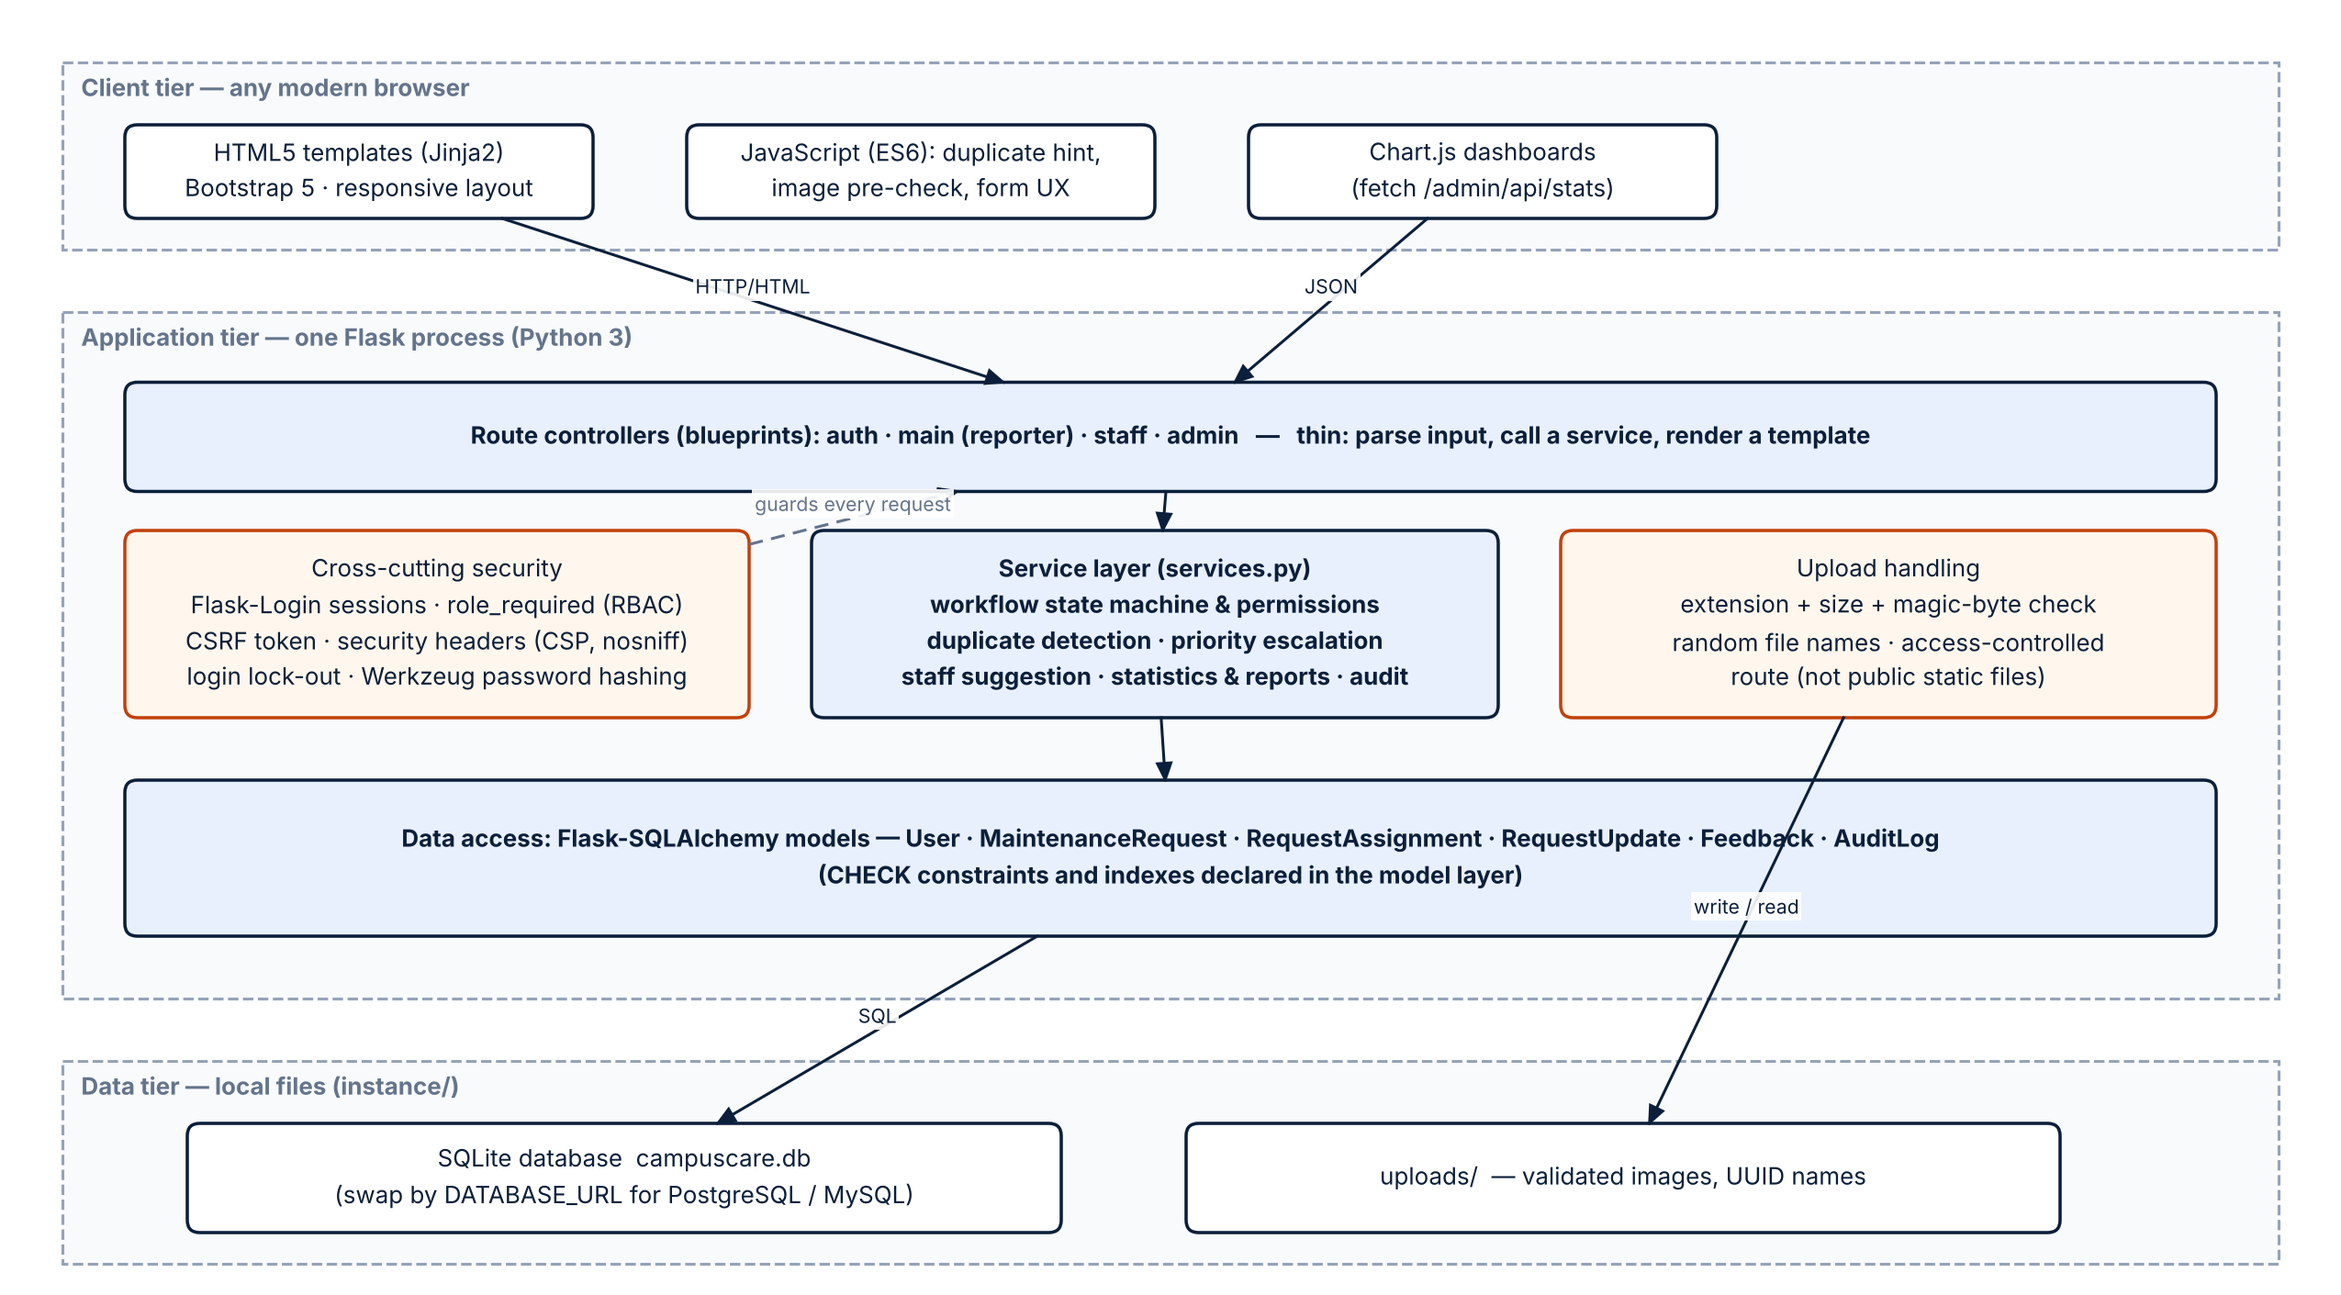
Figure 1: System architecture of CampusCare

6.2 Use case diagram
The use case diagram (Figure 2) lists what each actor can do. It shows the three actors and their use cases, the include relationships for duplicate detection and input validation inside “Submit Maintenance Request”, the optional image upload (extend), and the resolution notes included in “Update Task Status”. Every use case corresponds to a functional requirement in Table 5 and to an implemented screen.
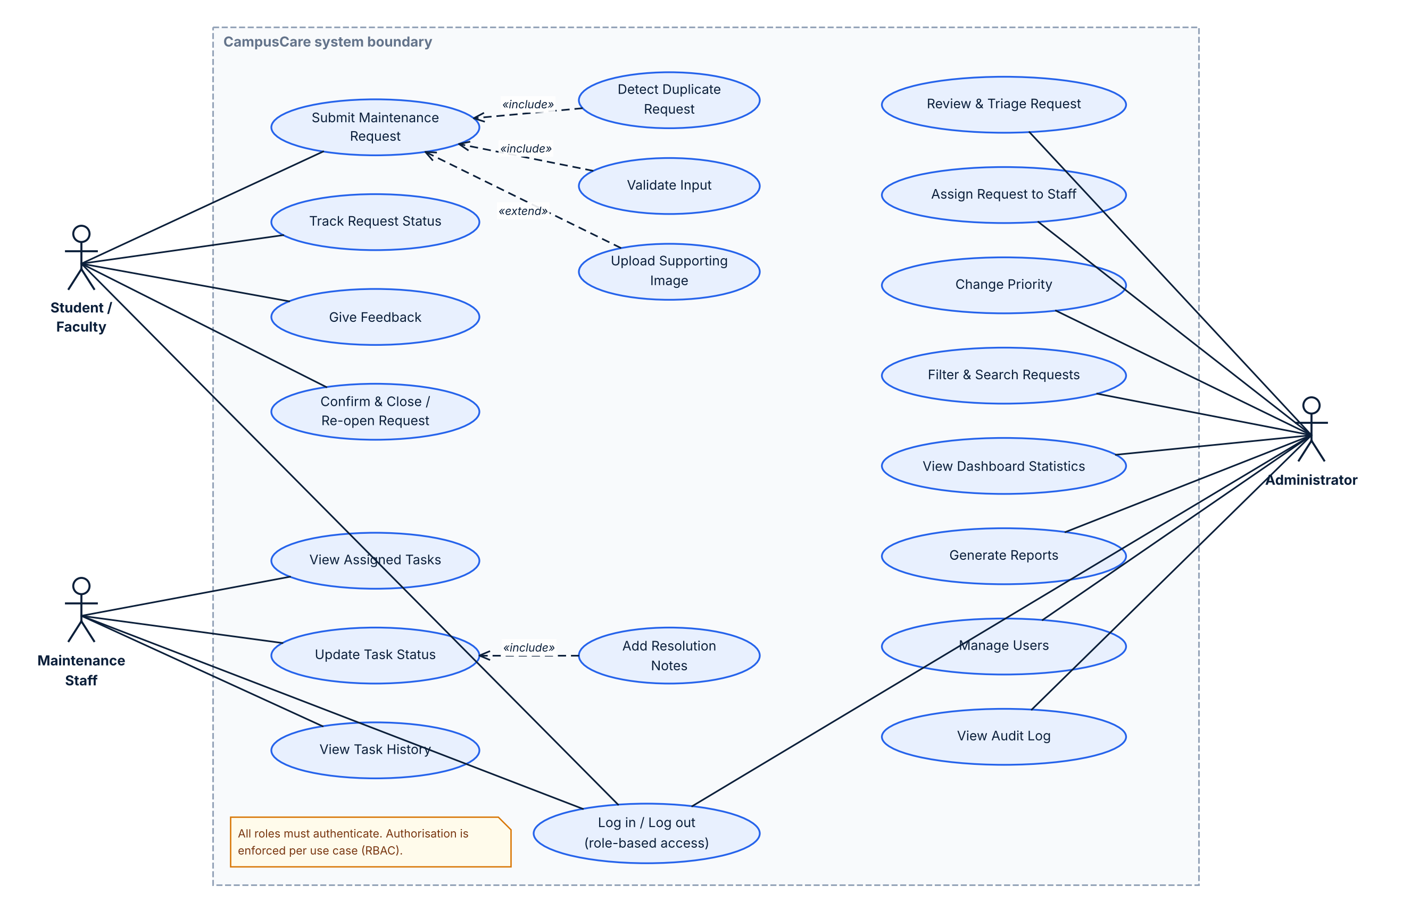
Figure 2: Use case diagram

6.3 Class diagram
The class diagram (Figures 3 and 4) shows the real application structure rather than an idealised domain model. Figure 3 covers the presentation and business layers: four blueprints, the RBAC and security hooks, the two service groups (request actions and queries) and the workflow policy. Figure 4 covers the six persistence classes with their attributes, key relationships and multiplicities. Composition is used for assignments and history because they cannot exist without their request.
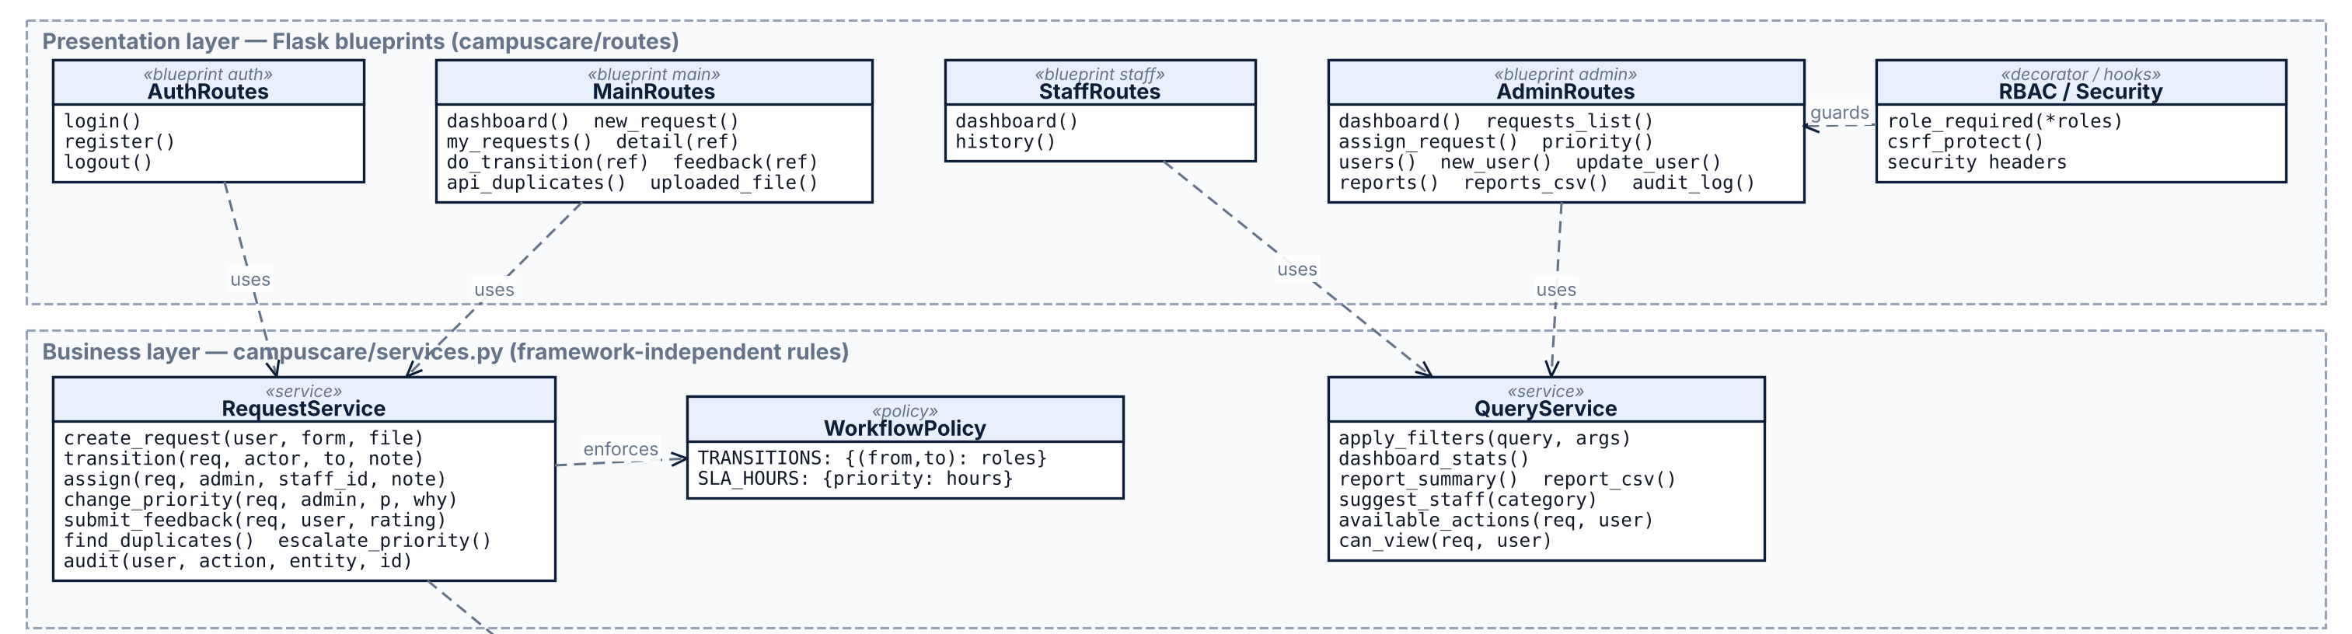
Figure 3: Class diagram (1/2): presentation and business layers

Figure 4 continues the class diagram with the persistence layer. Attribute lists follow the implemented models; multiplicities are shown at the association ends.
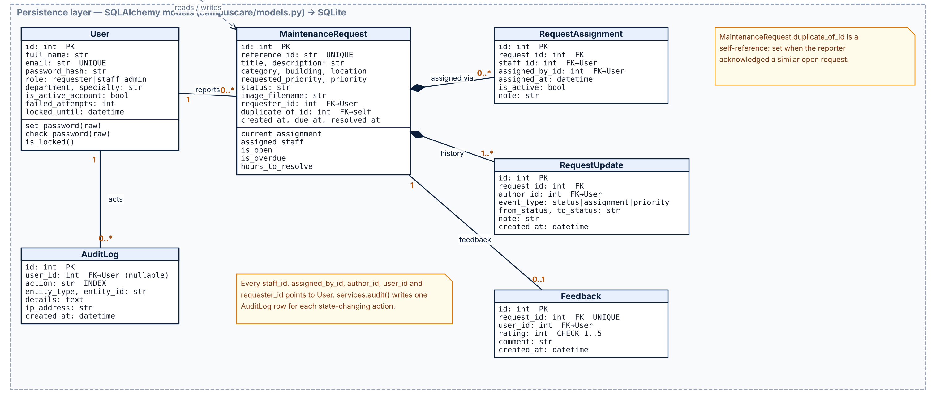
Figure 4: Class diagram (2/2): persistence layer

6.4 Sequence diagrams
Figures 5 and 6 show the submission and assignment workflow requested by the brief. Part A covers submission: the route hands the form to create_request, which validates the input, looks for duplicates and either raises DuplicateFound (the reporter sees a warning with links) or applies priority escalation and stores the request, its first history row and an audit entry in one commit. Part B covers the administrator starting the review and assigning the request: the service checks the transition table, the role and the ownership, then validates the chosen staff member before recording the assignment.
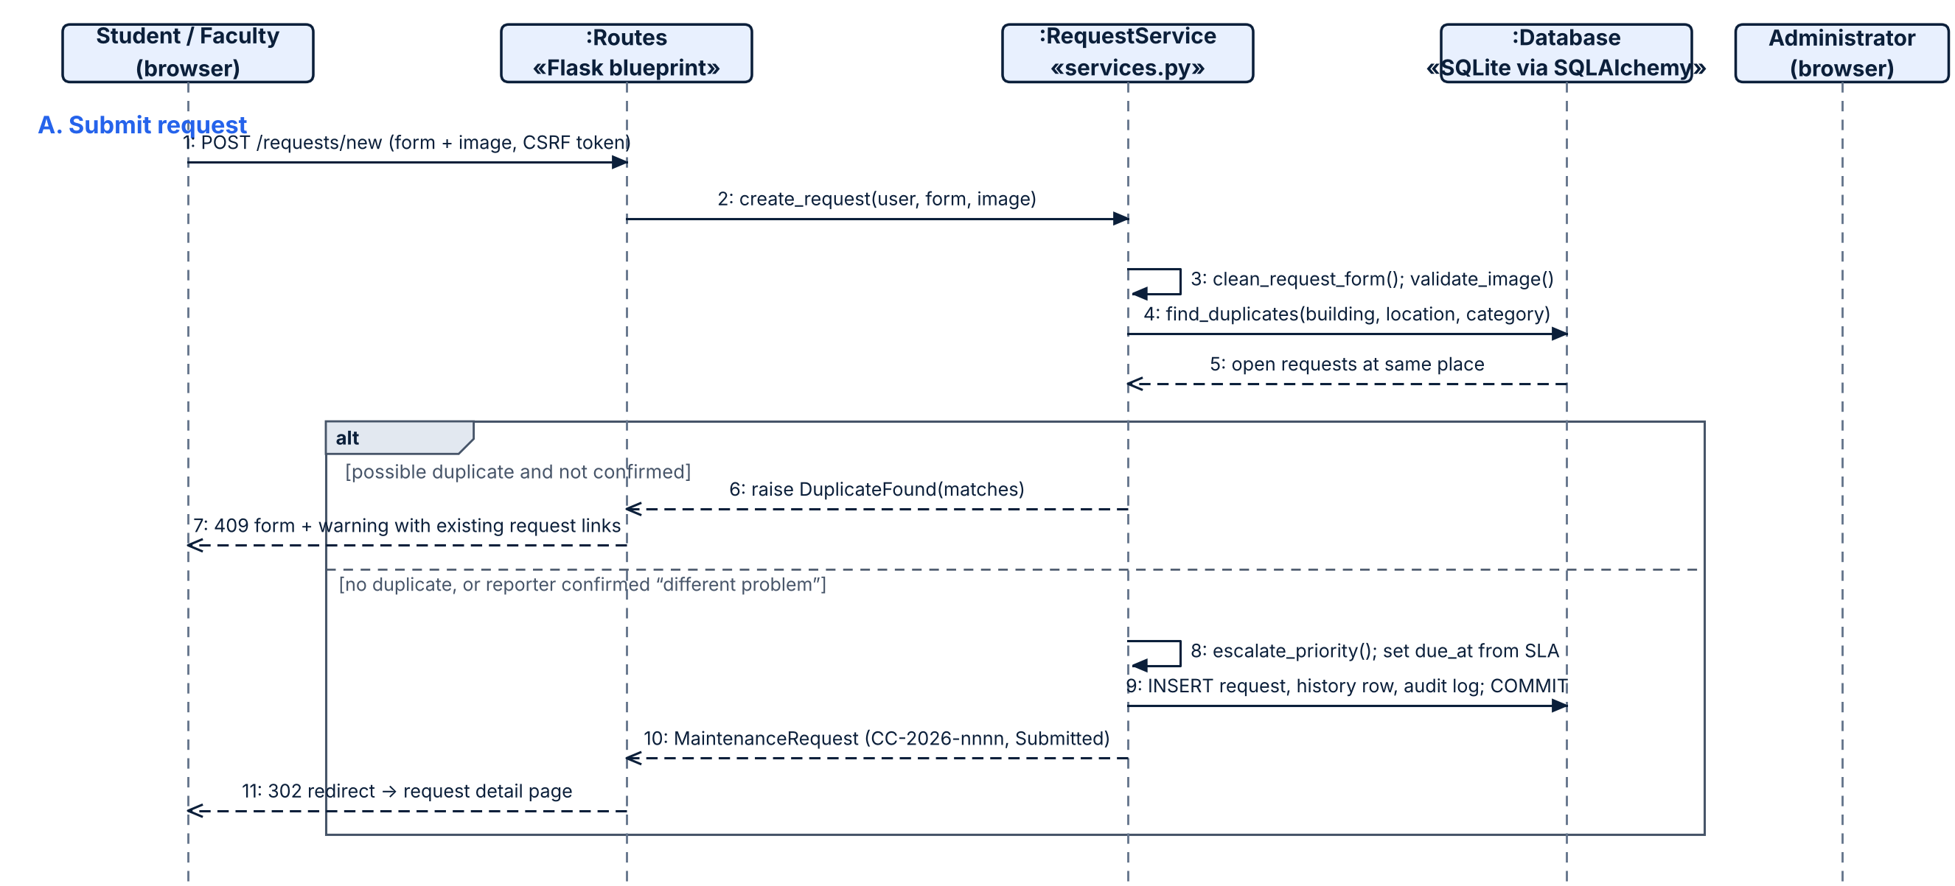
Figure 5: Sequence diagram (A): submitting a request, including the duplicate branch

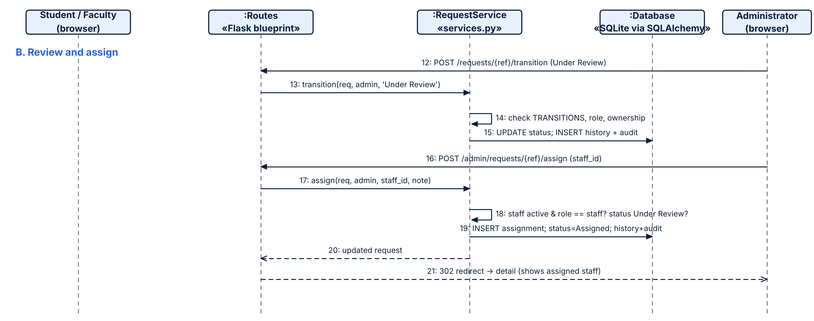
Figure 6: Sequence diagram (B): administrator review and assignment

6.5 Workflow state diagram
Figure 7 shows the request life-cycle. This diagram is a direct picture of the TRANSITIONS table in services.py. The role in brackets is who may perform the step; “Assigned” can only be reached by assigning to a staff member, which guarantees that every assigned request has an assignee. Rejected and Closed are terminal.
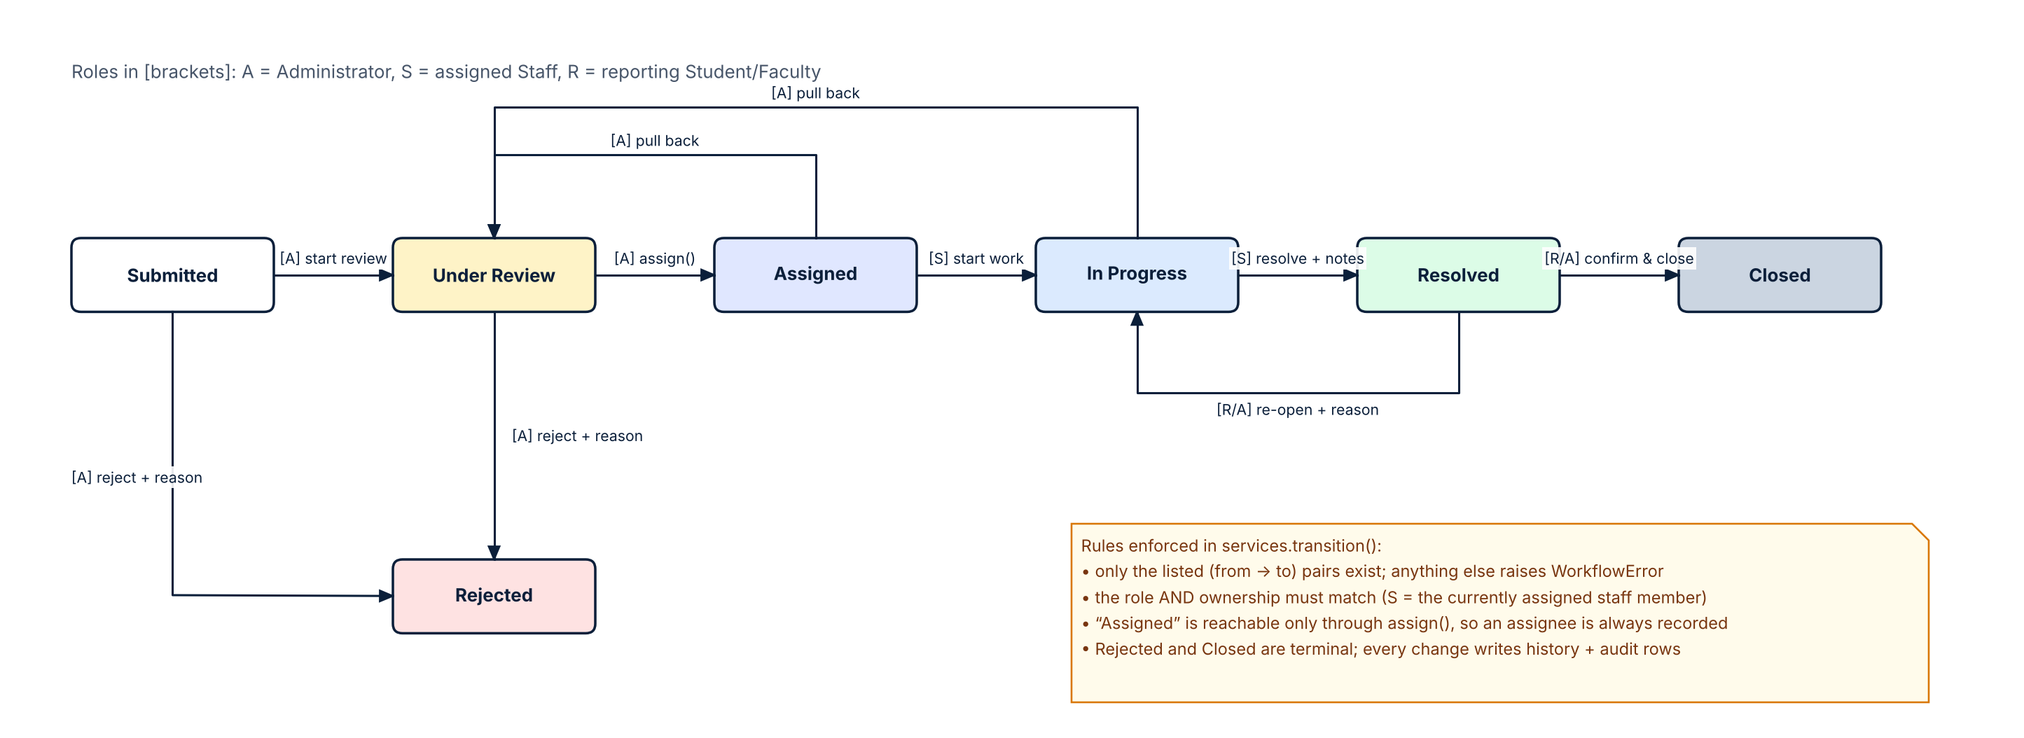
Figure 7: Request workflow state diagram

6.6 Database design
The schema has six tables in third normal form (Figure 8, Table 12). Reporter, staff and administrator details exist only in users. Assignments, status history and feedback are separate tables, so re-assigning or re-opening a request never overwrites earlier facts. maintenance_requests stores both requested_priority and priority so that automatic escalation remains visible. The current assignee is the single active row in request_assignments. The implemented models in models.py are the source of the diagram; the descriptions are repeated in docs/DATABASE.md.
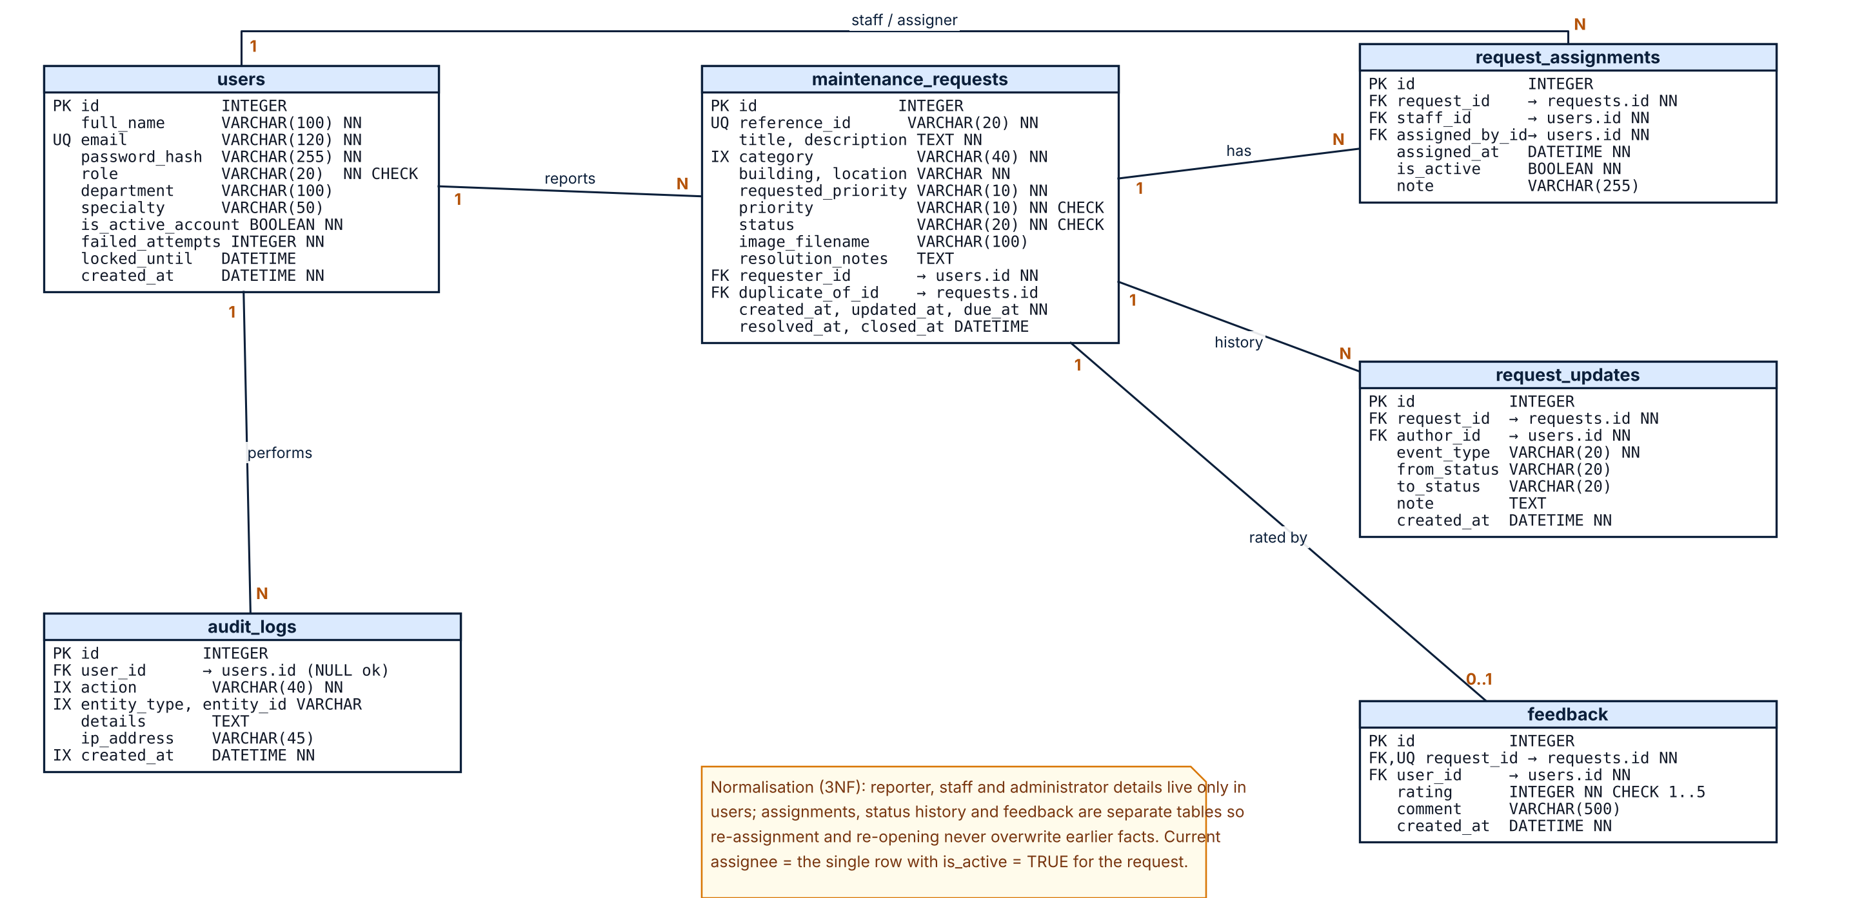
Figure 8: Entity–relationship diagram

Table 12: Tables, keys and constraints
Table | Keys and constraints | Indexes (reason)
users | PK id; UNIQUE email; CHECK role in (requester, staff, admin) | email (login lookup), role (staff lists)
maintenance_requests | PK id; UNIQUE reference_id; FK requester_id, duplicate_of_id; CHECK status, priority, requested_priority | (status, priority) for queues; (building, category, status) for duplicate search; category, requester_id
request_assignments | PK id; FK request_id, staff_id, assigned_by_id | request_id, staff_id (current assignee and workload)
request_updates | PK id; FK request_id, author_id | request_id (history display)
feedback | PK id; UNIQUE FK request_id; CHECK rating 1–5 | unique request_id (one rating per request)
audit_logs | PK id; FK user_id (nullable for unknown e-mail) | action, created_at, (entity_type, entity_id)

A demonstration data set of 8 users and 15 requests in different states is created by seed.py. All names and e-mail addresses are fictional.

7. Implementation

7.1 Technology and structure
The prototype uses Python 3, Flask, Flask-SQLAlchemy, Flask-Login and Werkzeug on the server, SQLite for data, and HTML5, CSS3, ES6 JavaScript, Bootstrap 5 and Chart.js on the client. Bootstrap, Bootstrap Icons and Chart.js are copied into static/vendor so the application works without internet access. The code base is about 2,460 lines (roughly 1,900 lines of Python including tests, 430 lines of templates, plus CSS and JavaScript) and exposes 25 routes.
Table 13: Main modules
Module | Responsibility
app.py, config.py | Entry point and configuration (secret key, database URL, upload limits, lock-out settings, test configuration).
campuscare/models.py | SQLAlchemy models, constraints, derived properties such as is_overdue and current_assignment.
campuscare/services.py | All business rules: workflow, permissions, duplicate detection, priority escalation, assignment, feedback, statistics, reports, user creation, audit.
campuscare/routes/ | Thin blueprints for authentication, reporter pages, staff pages and administrator pages; role_required decorator.
campuscare/templates, static | Role-aware layout, pages, CSS theme, form scripts, chart scripts.
seed.py | Creates the database and demonstration data (uses the same service functions as the application).
tests/ | Pytest suite with a recording plugin that writes real results to test-results/results.json.

7.2 Key mechanisms
Workflow enforcement. The permitted transitions are data, not scattered conditions:
TRANSITIONS = {
("Submitted","Under Review"): {ADMIN}, ("Submitted","Rejected"): {ADMIN},
("Under Review","Assigned"): {ADMIN}, ("Under Review","Rejected"): {ADMIN},
("Assigned","In Progress"): {STAFF}, ("Assigned","Under Review"): {ADMIN},
("In Progress","Resolved"): {STAFF}, ("In Progress","Under Review"): {ADMIN},
("Resolved","Closed"): {REQUESTER, ADMIN}, ("Resolved","In Progress"): {REQUESTER, ADMIN},
}
transition() rejects unknown pairs, checks the role, then checks ownership (the reporter must own the request; staff must be the current assignee), then checks that required notes are present. The web interface uses available_actions() from the same table to decide which buttons to show, so the interface cannot offer something the server would refuse.
Duplicate detection. Among open requests with the same building and category, the new location is compared to existing ones after normalisation (lower case, punctuation removed); equal strings, or one containing the other, count as a match. The check runs live while the form is filled and again on submit, where an unconfirmed duplicate stops the submission.
Priority escalation. escalate_priority() raises the Safety & Security category to at least High and any text containing a danger keyword to Critical, ignoring the phrase “fire extinguisher”. The reporter’s choice stays in requested_priority; the history records why the priority changed. The due time is created from the effective priority.
Assignment support. suggest_staff() ranks active staff by specialty match and then by the number of open assigned tasks, and the administrator’s drop-down shows both, which is how limited resources are balanced without removing the administrator’s decision.
Security measures. Werkzeug password hashing; five failed logins lock an account for 15 minutes and every attempt is audited; the login error message is identical for unknown users, wrong passwords and locked accounts; all POST requests need a CSRF token; responses carry Content-Security-Policy, X-Frame-Options and X-Content-Type-Options; uploads are checked for extension, size (2 MB) and real file signature, and stored under random names in a directory that is not publicly served.

8. User Interface and Main Features
The interface uses a dark navy sidebar, white cards, blue accents and colour-coded status and priority badges. The sidebar changes with the role, so each of the three user types sees only its own navigation. All screenshots in this section were captured from the running application with a scripted browser session over the seeded demonstration data and the flow described in the captions; none are mock-ups.
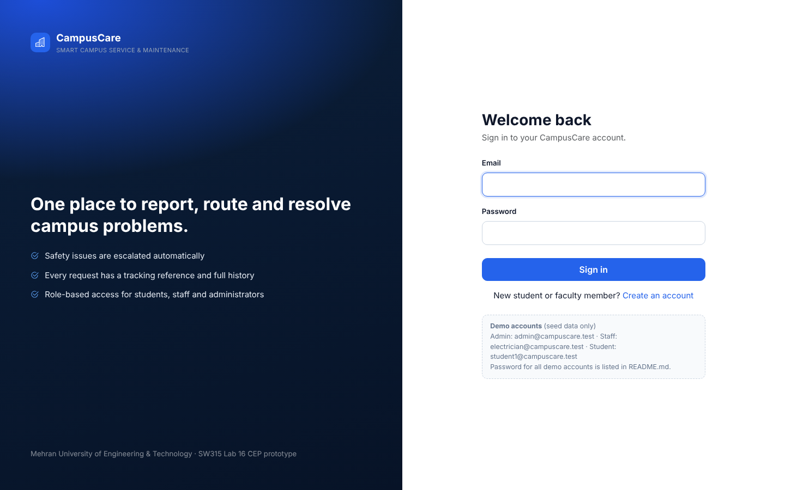
Figure 9: Login page
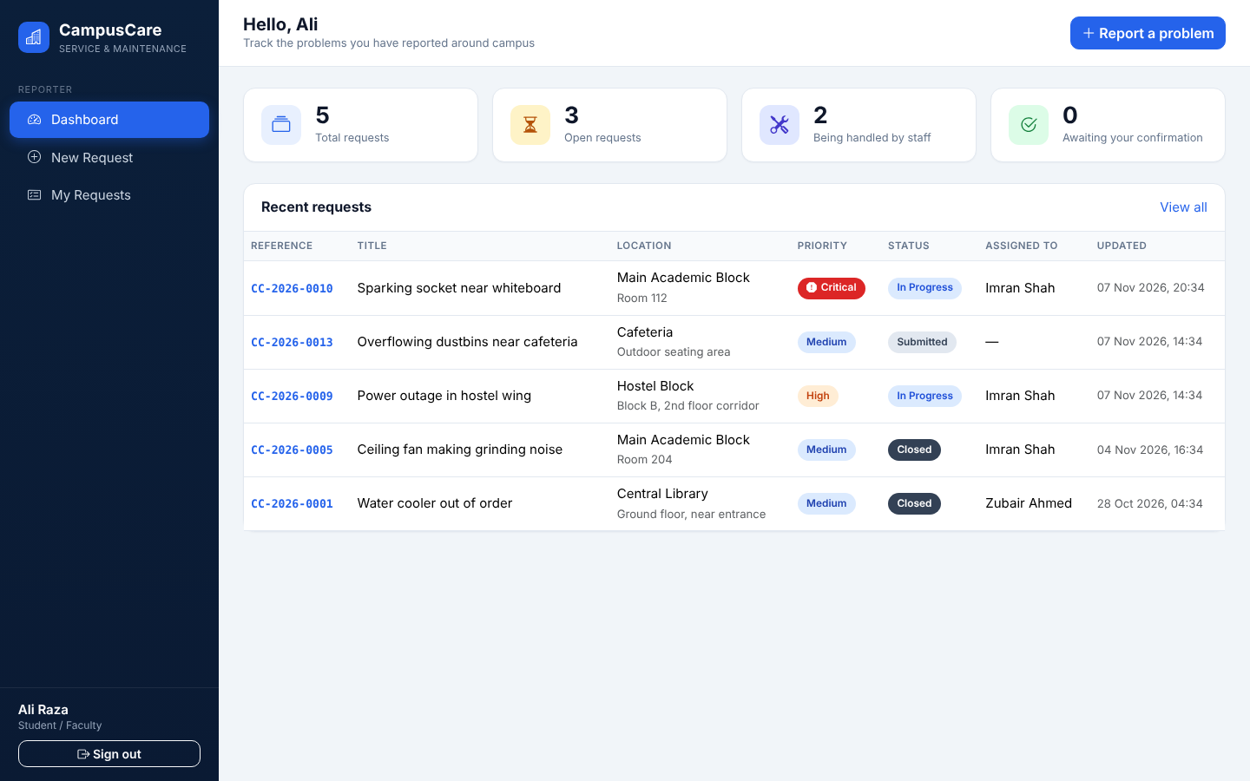
Figure 10: Student / faculty dashboard
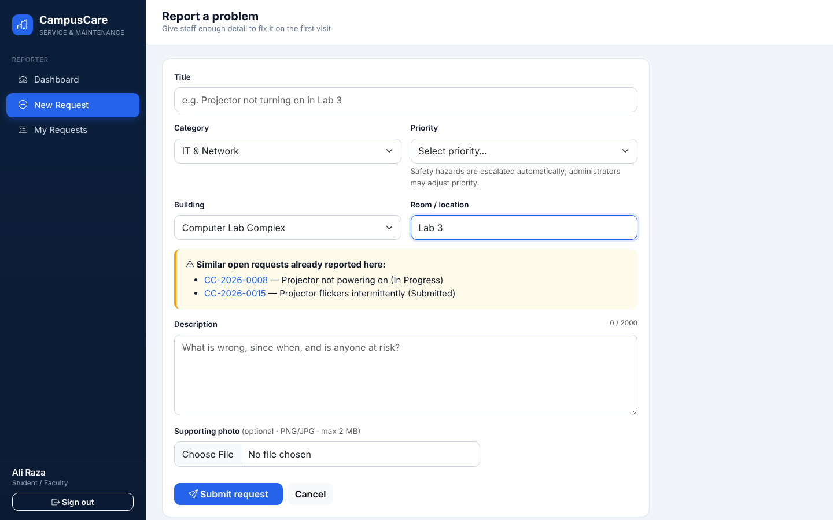
Figure 11: Request form showing the live duplicate hint for Lab 3
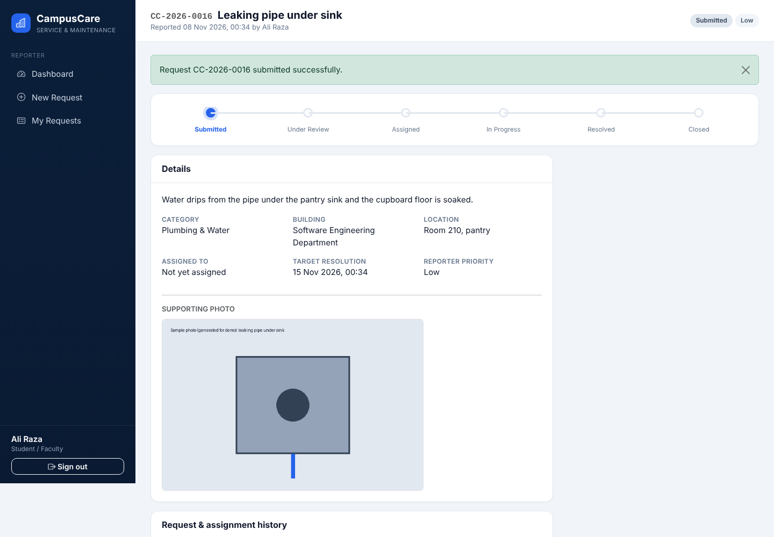
Figure 12: Request tracking page with status stepper, photo and history
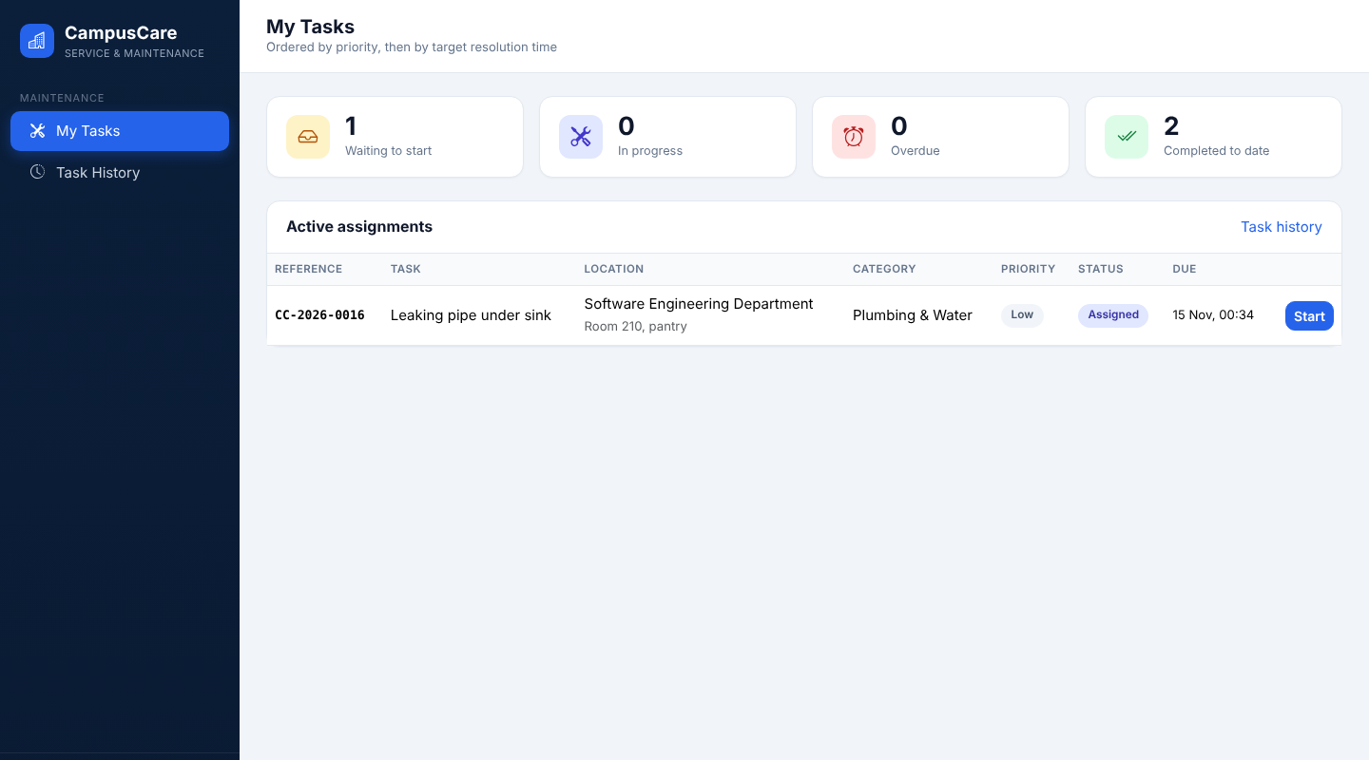
Figure 13: Maintenance staff dashboard (tasks ordered by priority and due time)
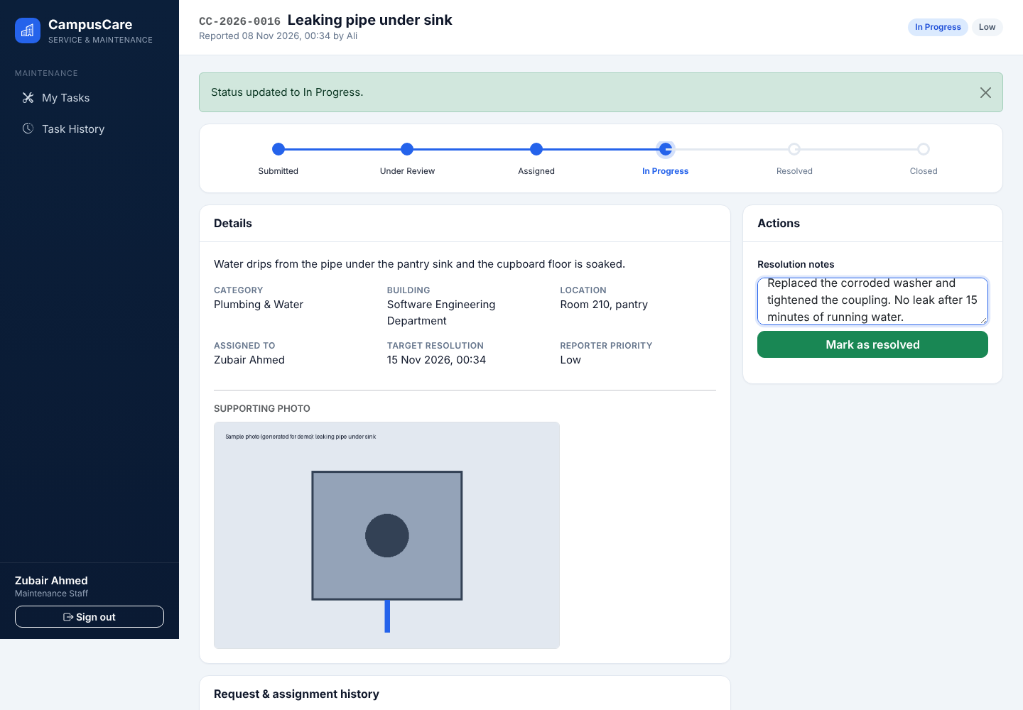
Figure 14: Staff resolving a task with resolution notes
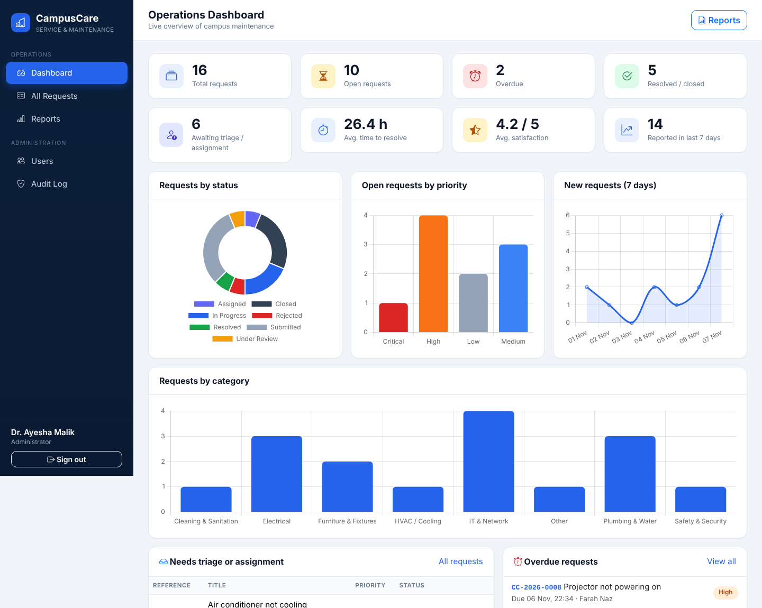
Figure 15: Administrator dashboard with statistics and Chart.js charts
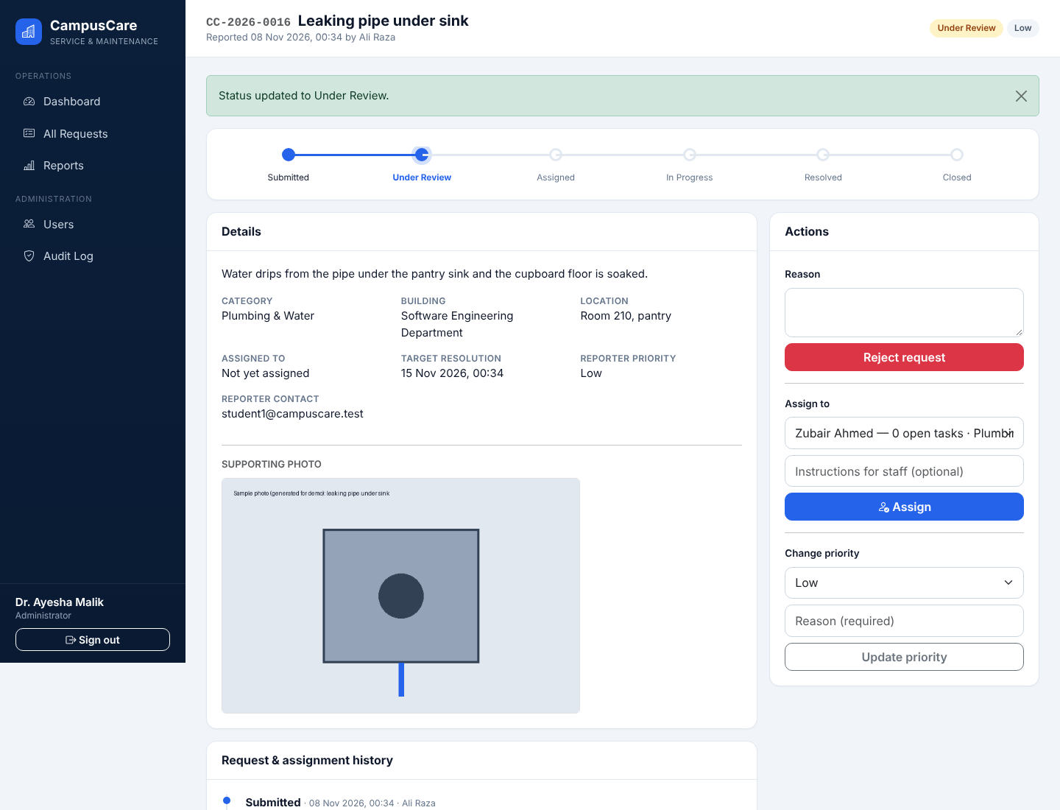
Figure 16: Administrator assignment interface with specialty and workload hints
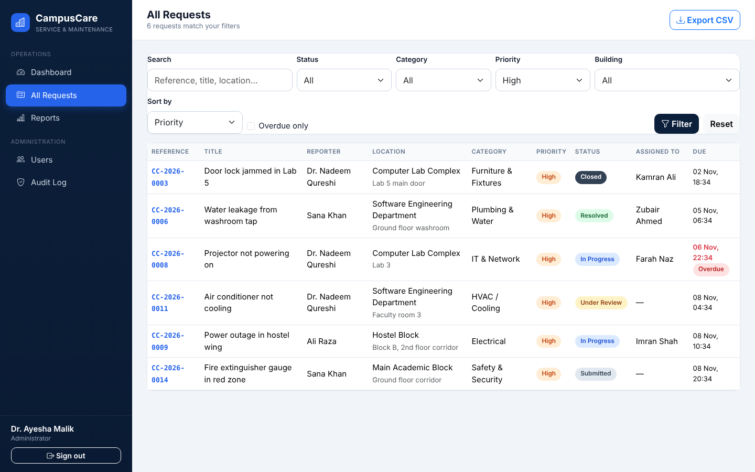
Figure 17: Administrator request list filtered by priority and sorted by priority
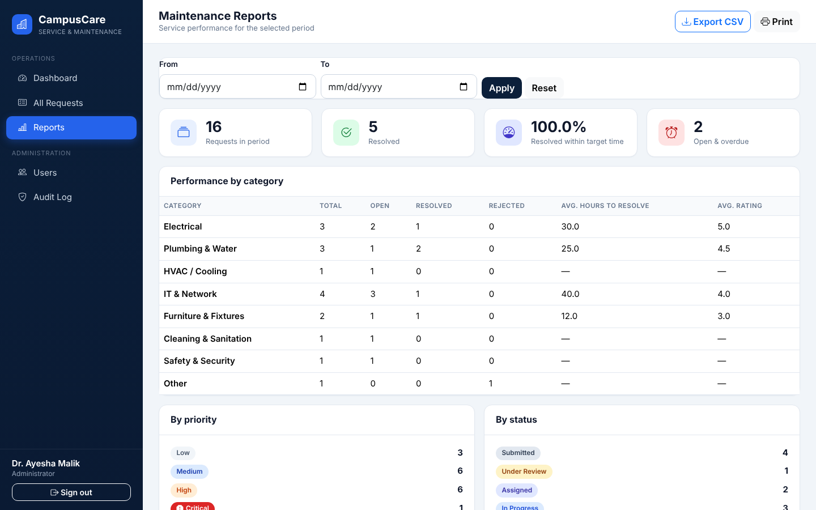
Figure 18: Maintenance report with performance by category
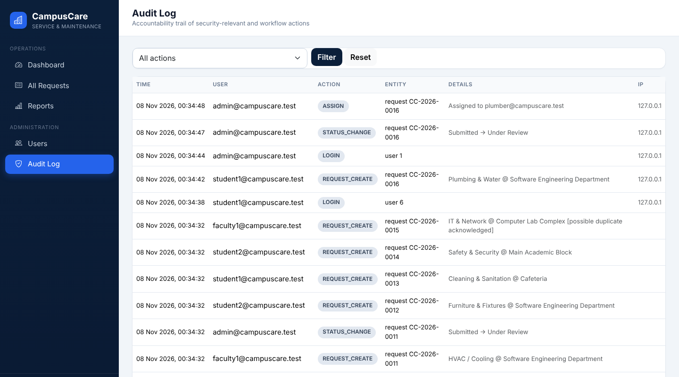
Figure 19: Audit log
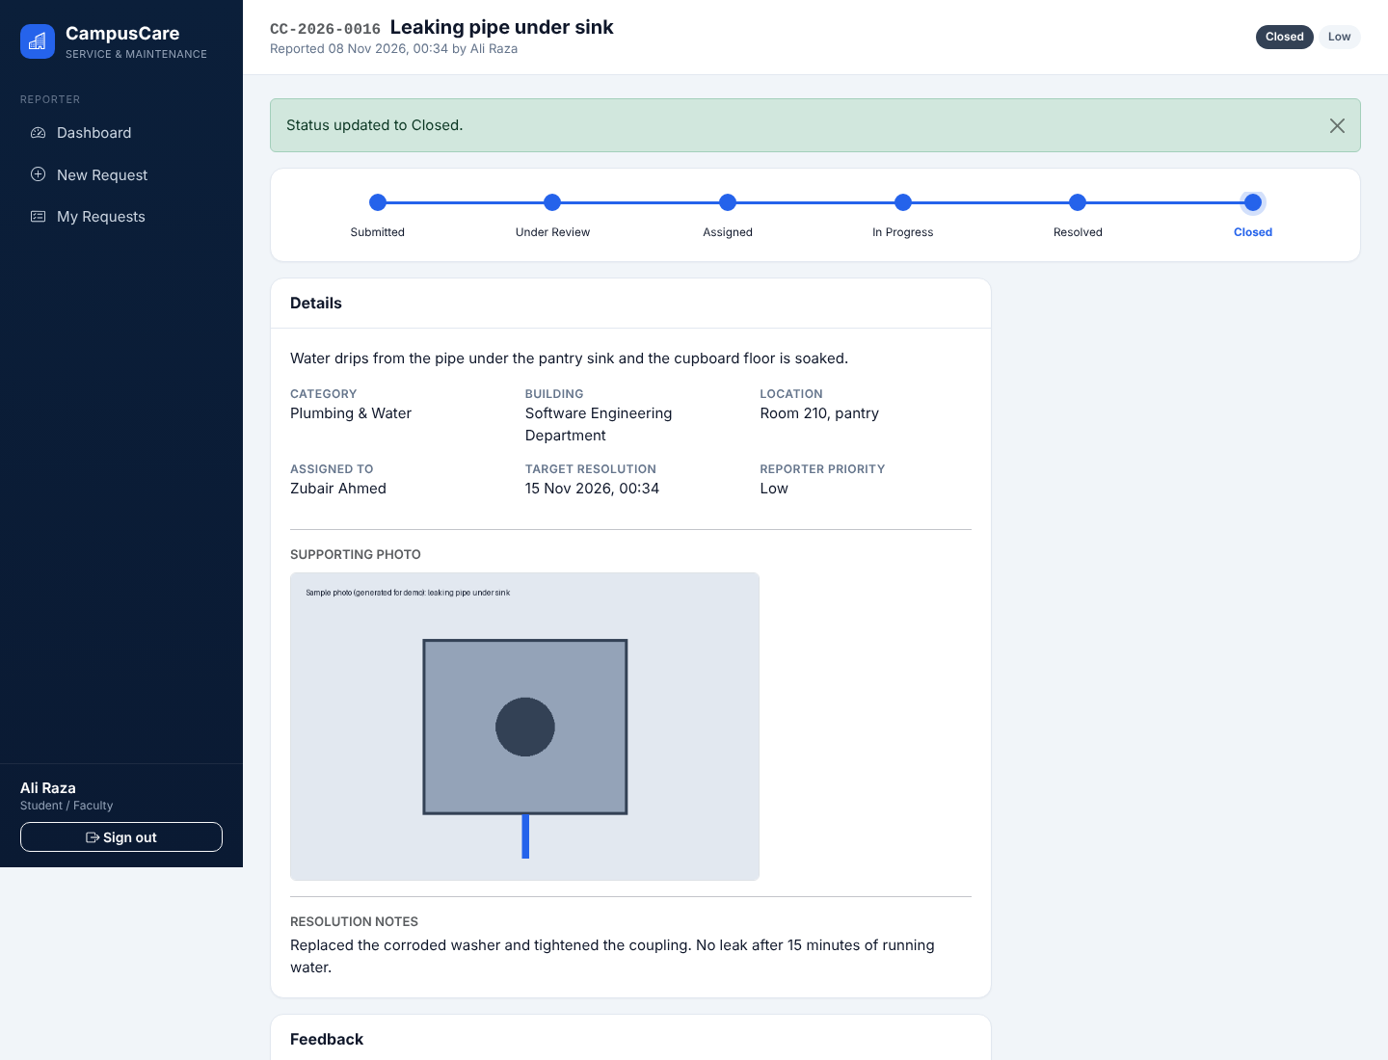
Figure 20: Closed request with full history
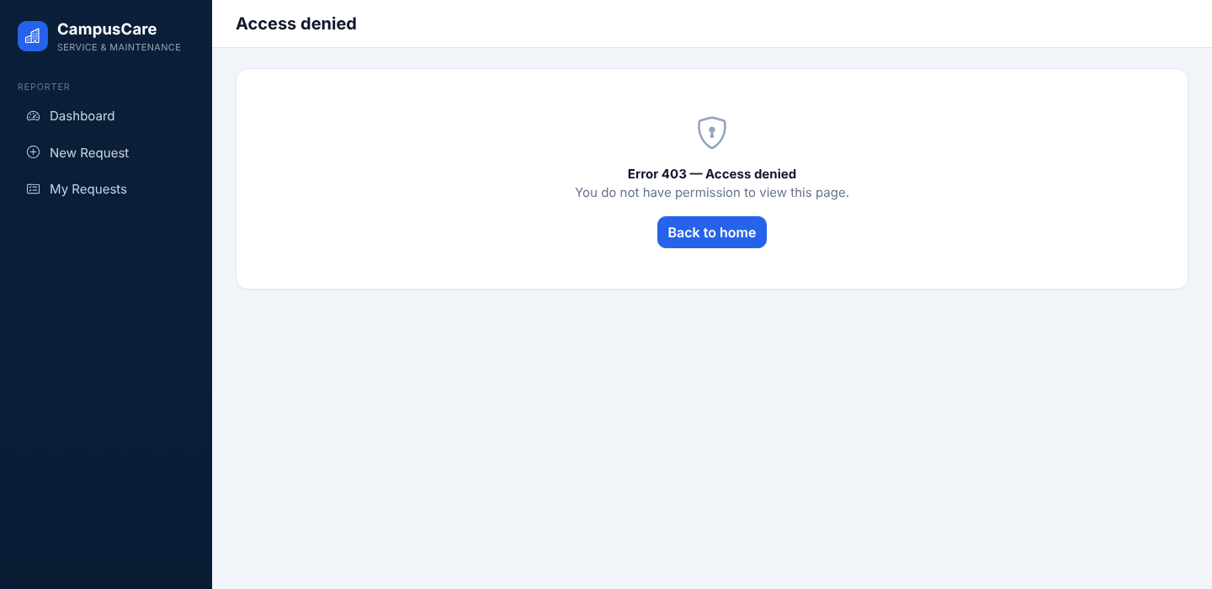
Figure 21: Unauthorised access: a student opening an administrator URL receives 403
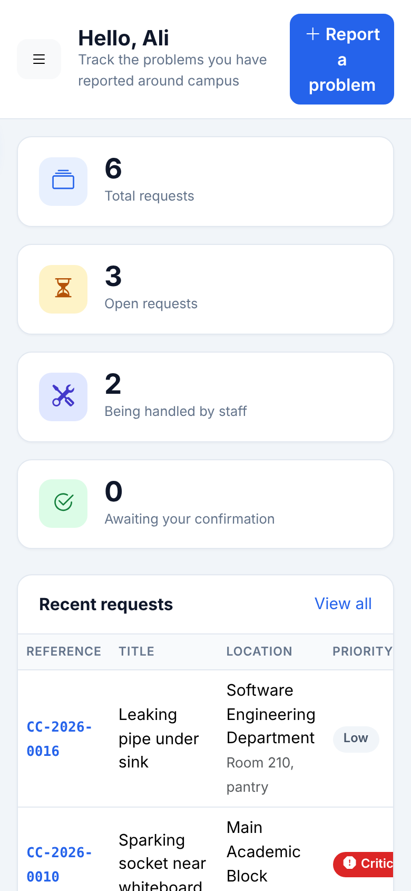
Figure 22: Responsive layout at phone width (390 px)

9. Development and DevOps

9.1 Version control
The project directory is structured for Git and contains a .gitignore (virtual environments, database, uploads, test output), .env.example, requirements.txt and a README with set-up instructions. Repository status: the repository has not been created yet, because the commit history must be produced by the group members themselves to be authentic. docs/DEVOPS.md contains the initialisation commands and a suggested sequence of eleven commits.
Repository link: [to be inserted by the group after pushing the project]

9.2 Continuous integration
.github/workflows/ci.yml runs on every push to main and every pull request. It sets up Python 3.10 and 3.12, installs the dependencies, compiles all Python files as a build check, runs the full pytest suite, and uploads the machine-readable test results. The same two commands were run locally to produce the results in Section 10; the workflow itself has not yet run on GitHub, so no screenshot of a green run exists yet (see Appendix C).

9.3 Deployment considerations
For a real deployment the application should run under a WSGI server such as Gunicorn behind a reverse proxy with HTTPS, with SECRET_KEY and DATABASE_URL supplied as environment variables, a server database instead of SQLite, uploads on persistent storage, scheduled backups, and cookies marked Secure. These items are not implemented or tested here.

10. Testing and Evaluation

10.1 Methodology
We used automated pytest tests against an in-memory SQLite database that is rebuilt for every test. Tests work at two levels: service-level tests call the business functions directly (fast, precise, ideal for workflow rules), and HTTP-level tests use the Flask test client with real logins to check routing, permissions, CSRF, uploads and responses. Negative tests are as numerous as positive ones. A small pytest plugin records the outcome and an observed-result string for each test into test-results/results.json; the “actual result” columns below are taken from that file, not typed by hand. Some tests (TC-18) run with several inputs and are reported as one case.

10.2 Results
The final run executed 37 pytest items covering 35 numbered test cases; 35 of 35 cases passed and none failed (22.8 s). Table 14 gives the 15 most important cases in full; Appendix A lists all 35. Figure 23 shows the terminal output of the final run.
Table 14: Key test cases with expected and actual results
ID | Req. | Description / precondition | Input | Expected result | Actual result (recorded) | Status
TC-01 | FR-01, FR-02 | Valid login opens the role dashboard  Pre: Student account exists | Correct e-mail and password | Redirect (302) to home; dashboard returns 200 | HTTP 302, redirected to / | Pass
TC-02 | FR-01, NFR-01 | Wrong password is rejected with a generic message  Pre: Student account exists | Correct e-mail, wrong password | HTTP 401; generic error; user still anonymous | HTTP 401; generic error shown; no session created | Pass
TC-03 | NFR-01 | Account locks after repeated failures  Pre: Student account exists | 5 wrong passwords, then the correct password | Correct password refused while the account is locked | After 5 failures correct password gives HTTP 401; locked_until set=True | Pass
TC-04 | FR-02, NFR-01 | Self-registration cannot create a privileged role  Pre: Anonymous visitor | Registration form with extra field role=admin | Account is created with role “requester” | Account created with role='requester' although role=admin was posted | Pass
TC-07 | FR-02 | Student cannot open administrator pages  Pre: Student logged in | GET /admin/dashboard, /admin/users, /admin/reports, /admin/audit | HTTP 403 for all four | HTTP codes for 4 admin URLs: [403, 403, 403, 403] | Pass
TC-09 | FR-02, NFR-06 | Student cannot view another student’s request  Pre: Request owned by student A; student B logged in | GET /requests/<ref> | HTTP 403 | HTTP 403 for another user's request | Pass
TC-12 | FR-03 | Missing or too-short fields are rejected  Pre: Student logged in | Empty title/category/building/location/priority, 5-character description | HTTP 422; messages shown; no row created | HTTP 422; rows created=0 | Pass
TC-13 | FR-10 | Danger keyword escalates priority to Critical  Pre: Student logged in | Category Electrical, priority Low, text mentions “sparks” | Effective priority Critical; due time 8 h after creation | Requested=Low, effective=Critical, due in 8 h | Pass
TC-15 | FR-09 | Duplicate request is detected and needs confirmation  Pre: Open request exists for Lab 3 / IT & Network | Second request for “lab 3 ” in same building and category | DuplicateFound raised; confirmed copy stored with duplicate_of set | Duplicate warning listed CC-2026-0001; confirmed copy flagged duplicate_of=CC-2026-0001 | Pass
TC-18 | FR-03, NFR-01 | Invalid uploads are rejected  Pre: Student logged in | (a) .exe file, (b) text file named .png, (c) PNG data named .jpg | HTTP 422 each time; no request created | evil.exe: HTTP 422; requests created=0 | note.png: HTTP 422; requests created=0 | a.jpg: HTTP 422; requests created=0 | Pass
TC-20 | FR-05, FR-06, FR-15 | Admin starts review, then assigns to staff  Pre: Submitted request; admin logged in | Transition to Under Review; POST assign with staff_id and note | Status Assigned; assignment, history and audit rows written | HTTP 302; status=Assigned; assigned_to=Test Electrician; history=3; audit ASSIGN=1 | Pass
TC-21 | FR-05 | Invalid transitions are refused  Pre: Submitted request; admin logged in | Submitted→Closed, Submitted→Assigned, Submitted→Resolved | WorkflowError each time; status unchanged; message shown | Submitted→Closed, Submitted→Assigned, Submitted→Resolved all refused; status still Submitted; message shown=True | Pass
TC-23 | FR-05, FR-07 | Staff cannot act on another member’s task  Pre: Task assigned to staff A; staff B exists | Staff B tries Start work and Resolve | PermissionDenied both times | Unassigned staff blocked from Start and Resolve with PermissionDenied | Pass
TC-28 | FR-11 | Feedback only after resolution, once, valid rating, by owner  Pre: Assigned request | Early feedback; rating 9; other student; duplicate feedback | All four refused; valid rating 4 stored | Early, out-of-range, foreign and duplicate feedback refused; stored rating=4 | Pass
TC-29 | FR-08 | Filters and search return the expected subset  Pre: Three requests of mixed category/priority | category=Electrical; priority=Low; both; q=Fan | 2, 2, 1 and 1 rows respectively | category=Electrical→2; priority=Low→2; both→1; search 'Fan'→1 | Pass

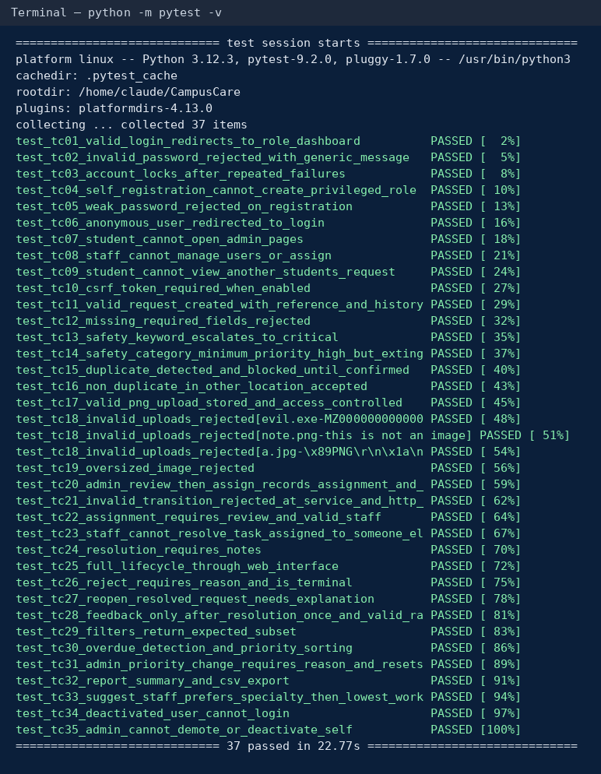
Figure 23: Terminal output of the final test run (python -m pytest -v)

10.3 Interpretation
All 35 cases pass in the final run, but the first complete run did not: 34 of 37 items passed and 3 failed. Two of the failures (TC-17 and TC-25) were caused by the test set-up, not by the application: our fixture kept one Flask application context open for the whole test, so Flask-Login cached the first logged-in user and several test clients behaved as the same person. The third failure (TC-29) was a counting mistake in the test, which counted each reference twice because it appears in both a link and its text. We fixed the test code (isolating the client and counting table rows) and left the application unchanged. We report this because it shows the value of the negative tests: the access-control assertions in TC-17 failed loudly when the test harness was wrong. To be sure the issue was not hiding a real flaw, the screenshot session used separate browser contexts per role and confirmed that a student receives 403 on an administrator URL (Figure 21).

10.4 Security testing considerations
Automated tests cover authentication failure and lock-out, privilege escalation through registration, role-based access, object-level access to requests and uploaded images, CSRF, and upload validation. They do not replace a security review: we did not test session fixation, brute-force limits across many accounts, HTTP header behaviour behind a proxy, file-parsing exploits, SQL injection beyond relying on the ORM’s parameter binding, or cross-site scripting beyond Jinja2’s automatic escaping.

10.5 Limitations, failure risks and improvements
Table 15: Limitations and recommended improvements
Limitation / failure risk | Consequence | Recommended improvement
Keyword-based escalation (RISK-01) | False positives overload the Critical queue; non-English or misspelt hazards (e.g. Urdu text) are missed. | Add a configurable keyword list, Urdu and Roman-Urdu terms, and review the false-positive rate on real requests.
Location matching is string-based (RISK-06) | Reports such as “Lab 3” and “Computer Lab three” are not matched. | Replace free text with a managed list of rooms per building.
No notifications (RISK-07) | Reporters and staff must open the site to see changes; a Critical request could wait unseen. | E-mail or push alerts for assignment, resolution and overdue Critical items.
SQLite and one process (RISK-02) | Write contention and no horizontal scaling. | PostgreSQL, several workers, connection pooling.
Lock-out is per account | An attacker can lock out a known user (denial of service). | Add per-IP throttling and an administrator unlock.
Uploads are validated, not re-encoded or scanned | A crafted valid image could still carry unexpected content. | Re-encode images on upload; add antivirus scanning.
Automated tests do not drive the browser | Layout and chart errors are found only by manual review. | Add browser-based tests for the main journeys.

10.6 Tests not executed
Table 16: Checks that were not performed
Check | Status
Load and concurrency testing | Not executed. Only a single-user timing check was made (Section 11).
Cross-browser and accessibility (screen reader, contrast audit) | Not executed. Pages were reviewed in Chromium only.
GitHub Actions run | Not executed yet; the workflow exists but the repository has not been pushed.
Penetration test / dependency vulnerability scan | Not executed.
Usability test with real users | Not executed.

11. System Evaluation
Measured on the development container with the 16-request demonstration data set and 30 repeated requests per page through the test client (so the figures include template rendering but not network time): administrator dashboard 7.3 ms, request list 7.1 ms, reports 6.6 ms, request detail 5.1 ms and the statistics API 5.4 ms on average. These numbers show that nothing in the prototype is accidentally slow; they say nothing about behaviour with thousands of requests or concurrent users, which we did not test.
Against the requirements: all fifteen functional requirements are implemented and each has at least one automated test, except FR-04 and FR-12, which are verified by logic tests and screenshots only. NFR-01 and NFR-06 are covered by tests; NFR-02 (usability) was judged by inspection and has not been tested with users; NFR-03 was measured only as described above; NFR-04, NFR-05 and NFR-07 are properties of the code and schema.
The design choices that gave the most value for their size were the single transition table (it removed duplicated permission logic and made the tests simple), the separate assignment and history tables (the audit view and re-assignment came almost free) and the requested/effective priority split (it made the escalation rule explainable). The weakest parts are the keyword heuristic and the free-text location, both listed as risks.

12. Compliance with Lab 16 and Assessment Criteria
Table 17: Lab 16 requirement checklist
Lab 16 requirement | Evidence | Section | Status
Problem statement / SRS; ≥3 FR, ≥2 NFR, ≥2 constraints or risks, ≥2 stakeholder groups | 15 FR, 7 NFR, 4 CR, 7 RISK, 4 stakeholder groups | 3, 4 | Done
≥2 engineering alternatives, comparison, justified selection and trade-off | Approach A vs B, 9-criterion table, trade-off, smaller decisions | 5 | Done
Use case, class and sequence diagrams, consistent with requirements | Use case, class, sequence, architecture, state and ER diagrams; Draw.io sources | 6 | Done
Working prototype | Flask application, 25 routes, screenshots | 7, 8 | Done
Source code on GitHub/GitLab with meaningful commits | Repository-ready project and commit plan | 9 | Group action required: push and generate real commits
Automated build/test or described DevOps pipeline | GitHub Actions workflow (not yet run on GitHub) | 9 | Done (workflow written); run evidence pending
≥5 test cases, positive and negative, expected/actual/pass-fail | 35 cases, 37 test items, actual results recorded | 10, App. A | Done
Interpretation, limitation and improvement | Sections 10.3–10.5 | 10 | Done
Screenshots / evidence of diagrams, features, repository, tests | 22 screenshots, 2 terminal captures, 6 diagrams | 6, 8, 10 | Repository and Actions screenshots pending
Constraints, risks, alternatives, reason for design, lessons learned | Sections 4, 5, 14 | 4, 5, 14 | Done

Table 18: Evidence for the five assessment criteria
Criterion | Where the evidence is
R1 Constraints, requirements, stakeholder demands | Sections 2–4: CEP analysis, stakeholder conflicts with design responses, numbered FR/NFR/CR/RISK, traceability matrix.
R2 Originality and contribution | Problem-specific decisions: requested versus effective priority with safety escalation, target resolution times, duplicate detection with reporter override, workload-aware assignment suggestions, privacy-limited staff view, access-controlled photos (Sections 3, 5.3, 7.2).
R3 Engineering knowledge, design and standards | Layered architecture, state machine, normalised schema with constraints, UML models that match the code (Sections 5–6); ISO/IEC/IEEE 29148 structure and OWASP-based security measures.
R4 Efficiency and practical implementation | Working prototype with 25 routes, seed data, CI workflow, vendored libraries, timing measurements (Sections 7–9, 11).
R5 Testing, evaluation and reporting | 35 recorded test cases with actual results, an honest account of the first failing run, limitations, risks, untested areas and improvements (Section 10).

13. Limitations and Future Improvements
- Notifications and integration: e-mail or push notifications and single sign-on with university accounts were left out; they are the most valuable next step because they close the loop with reporters.
- Scale: a server database, several workers, caching of dashboard statistics (currently computed per request in Python) and pagination of the dashboard queries are needed beyond a department-size deployment.
- Smarter triage: a managed room list, tunable keyword lists including Urdu, and (with real data) a classifier that proposes priorities for an administrator to confirm.
- Staff features: shift calendars, parts and cost tracking, and mobile-friendly task views.
- Quality: browser-based tests, accessibility review, dependency scanning and a proper penetration test.

14. Lessons Learned and Team Contributions

14.1 Lessons learned
- Making the workflow a table first paid off repeatedly: the permissions, the buttons in the interface, the state diagram and the tests all came from one source.
- Stakeholder conflicts are easier to resolve when each one becomes a visible rule with a constant (target hours, minimum priority) than when it stays an opinion.
- Heuristics need examples that break them. The “fire extinguisher” case, found while writing tests, changed the escalation rule.
- A failing test is not always a failing product: our first run showed two harness problems and one test bug, and we fixed the tests without changing the application. Reading failures before “fixing” them avoided hiding a real defect.
- Generating the diagrams and the report tables from the same data as the code (the diagram script, the recorded test results) keeps documents consistent with the implementation.
- We underestimated how much of the effort goes into evidence: screenshots, repository history and CI runs must be produced by doing the work, not at the end.

14.2 Team and proposed responsibilities
The allocation below is a proposed division of responsibilities. It has not been confirmed against the actual commit history, and the group should correct it so that it states what each member really did before submission.
Table 19: Group members and proposed responsibilities
Member | Roll no. | Proposed responsibility
Shariyar | 24SW028 | Requirements and problem analysis: SRS, stakeholder analysis, CEP characteristics, traceability matrix.
Saqib Anwar | 24SW046 | Backend: authentication, RBAC, workflow service and transition rules.
Bansi | 24SW052 | Frontend: templates, CSS theme, form scripts, dashboard charts.
Safiullah | 24SW107 | Database design: models, constraints, indexes, seed data, ER diagram.
Saifullah | 24SW137 | UML and architecture: use case, class, sequence and state diagrams; engineering alternatives.
Janak | 24SW155 | Testing, DevOps and integration: pytest suite, CI workflow, repository, final report assembly.

15. Conclusion
CampusCare shows that a modest, well-structured Flask application can address a real campus problem while exposing the engineering questions behind it: who may do what, how scarce capacity is shared, how safety overrides convenience, and how accountability is kept without exposing personal data. The group compared a monolith with a distributed design and chose the monolith for scope, security simplicity and time, accepting limits on scale that are documented. The prototype implements the full request life-cycle for three roles, is covered by 35 recorded test cases that pass in the final run, and is packaged with a CI workflow. Three items remain for the group: pushing the project to a repository with genuine commits, running the CI workflow once, and confirming the contribution table. The main technical weaknesses, keyword-based escalation and free-text locations, are identified with concrete improvements.

References
- ISO/IEC/IEEE 29148:2018, Systems and software engineering — Life cycle processes — Requirements engineering.
- Object Management Group, Unified Modeling Language Specification, version 2.5.1, 2017.
- OWASP Foundation, OWASP Top 10:2021 and OWASP Application Security Verification Standard 4.0.
- Pallets Projects, Flask documentation, https://flask.palletsprojects.com.
- SQLAlchemy documentation, https://docs.sqlalchemy.org.
- Sommerville, I., Software Engineering, 10th ed., Pearson, 2016.
- Fowler, M., Patterns of Enterprise Application Architecture, Addison-Wesley, 2002.
- Department of Software Engineering, MUET Jamshoro, SW315 Lab 16 — Open-Ended Lab: Complex Engineering Problem (CEP), 2026.

Appendix A: All Test Cases and Recorded Results
Table 20: All test cases (results from test-results/results.json of the final run)
ID | Req. | Test | Actual result (recorded) | Status
TC-01 | FR-01, FR-02 | Valid login opens the role dashboard | HTTP 302, redirected to / | Pass
TC-02 | FR-01, NFR-01 | Wrong password is rejected with a generic message | HTTP 401; generic error shown; no session created | Pass
TC-03 | NFR-01 | Account locks after repeated failures | After 5 failures correct password gives HTTP 401; locked_until set=True | Pass
TC-04 | FR-02, NFR-01 | Self-registration cannot create a privileged role | Account created with role='requester' although role=admin was posted | Pass
TC-05 | FR-01, NFR-01 | Weak password rejected at registration | HTTP 422; user created=False | Pass
TC-06 | FR-02 | Anonymous user is redirected to the login page | HTTP 302 → /login?next=%2Fdashboard | Pass
TC-07 | FR-02 | Student cannot open administrator pages | HTTP codes for 4 admin URLs: [403, 403, 403, 403] | Pass
TC-08 | FR-02, FR-06 | Staff cannot manage users or assign requests | /admin/users → 403; POST assign → 403 | Pass
TC-09 | FR-02, NFR-06 | Student cannot view another student’s request | HTTP 403 for another user's request | Pass
TC-10 | NFR-01 | POST without CSRF token is refused | POST without CSRF token → HTTP 400 | Pass
TC-11 | FR-03, FR-15 | Valid request is stored with reference ID and history | HTTP 302; ref=CC-2026-0001; status=Submitted; history rows=1 | Pass
TC-12 | FR-03 | Missing or too-short fields are rejected | HTTP 422; rows created=0 | Pass
TC-13 | FR-10 | Danger keyword escalates priority to Critical | Requested=Low, effective=Critical, due in 8 h | Pass
TC-14 | FR-10 | Safety category has minimum priority High | Requested=Low, effective=High | Pass
TC-15 | FR-09 | Duplicate request is detected and needs confirmation | Duplicate warning listed CC-2026-0001; confirmed copy flagged duplicate_of=CC-2026-0001 | Pass
TC-16 | FR-09 | Same category in a different room is not a duplicate | Different room accepted: CC-2026-0002, duplicate_of=None | Pass
TC-17 | FR-03, NFR-01 | Valid PNG stored under random name; access controlled | Stored as random name 642bb594562d4f4aaa78fa8a50241a2c.png; owner → 200; other student → 403 | Pass
TC-18 | FR-03, NFR-01 | Invalid uploads are rejected | evil.exe: HTTP 422; requests created=0 | note.png: HTTP 422; requests created=0 | a.jpg: HTTP 422; requests created=0 | Pass
TC-19 | FR-03, NFR-01 | Oversized image rejected | 2 MB+ image: HTTP 422 | Pass
TC-20 | FR-05, FR-06, FR-15 | Admin starts review, then assigns to staff | HTTP 302; status=Assigned; assigned_to=Test Electrician; history=3; audit ASSIGN=1 | Pass
TC-21 | FR-05 | Invalid transitions are refused | Submitted→Closed, Submitted→Assigned, Submitted→Resolved all refused; status still Submitted; message shown=True | Pass
TC-22 | FR-06 | Assignment needs Under Review status and a real staff user | Assign refused while Submitted; refused for a student account; status unchanged | Pass
TC-23 | FR-05, FR-07 | Staff cannot act on another member’s task | Unassigned staff blocked from Start and Resolve with PermissionDenied | Pass
TC-24 | FR-07 | Resolution requires meaningful notes | Note 'ok' refused; full note accepted; status=Resolved; resolved_at set=True | Pass
TC-25 | FR-04 – FR-07 | Full lifecycle through the web interface | Final status Closed; path: Submitted → Under Review → Assigned → In Progress → Resolved → Closed | Pass
TC-26 | FR-05 | Reject needs a reason and is terminal | Reject without reason refused; with reason accepted; no transitions out of Rejected | Pass
TC-27 | FR-05 | Re-opening a resolved request needs an explanation | Re-open accepted with reason; status=In Progress; resolved_at cleared=True | Pass
TC-28 | FR-11 | Feedback only after resolution, once, valid rating, by owner | Early, out-of-range, foreign and duplicate feedback refused; stored rating=4 | Pass
TC-29 | FR-08 | Filters and search return the expected subset | category=Electrical→2; priority=Low→2; both→1; search 'Fan'→1 | Pass
TC-30 | FR-08, FR-10, FR-12 | Overdue detection and priority sorting | Priority order: ['Critical', 'Low']; overdue list: ['CC-2026-0001'] | Pass
TC-31 | FR-08, FR-10 | Priority change needs a reason and resets the due time | Priority Low→High; due moved from +168h to +24h | Pass
TC-32 | FR-13 | Report summary and CSV export | Report: total=2, resolved=1; CSV HTTP 200, 2 data rows, type=text/csv | Pass
TC-33 | FR-06 | Staff suggestion prefers specialty, then lowest workload | Ranking for Electrical: [('Test Electrician', True, 0), ('Test Plumber', False, 0)] | Pass
TC-34 | FR-01, FR-14 | Deactivated account cannot sign in | Deactivated account login → HTTP 401 | Pass
TC-35 | FR-14 | Administrator cannot demote or deactivate self | Own role after attempt: admin; active=True | Pass

Appendix B: Running the Project
python -m venv .venv && source .venv/bin/activate
pip install -r requirements.txt
python seed.py --reset # demo data; password for all demo users: Demo@1234
python app.py # http://127.0.0.1:5000
python -m pytest -v # automated tests
python tools/make_uml.py # regenerate diagrams (needs matplotlib, pillow)
Demo accounts: admin@campuscare.test; electrician@, plumber@, it.support@, general@campuscare.test (staff); student1@, student2@, faculty1@campuscare.test (reporters). Database evidence from the screenshot session is shown below.
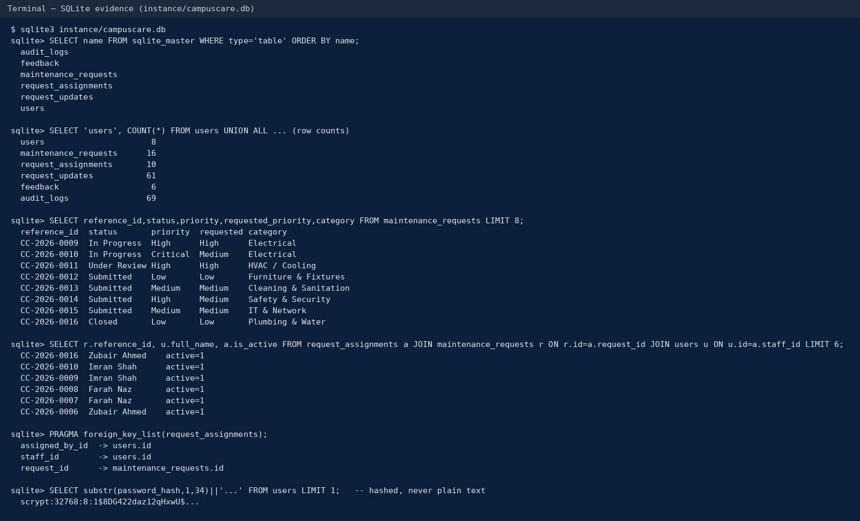
Figure 24: SQLite evidence: tables, row counts, sample rows, foreign keys, hashed password

Appendix C: Evidence the Group Must Still Produce
Table 21: Missing evidence checklist
# | Evidence | How to produce it
1 | Repository URL and commit history | Create the repository, follow docs/DEVOPS.md, make real commits from each member’s account; screenshot the Commits page.
2 | Green GitHub Actions run | Push to main; open the Actions tab after the workflow finishes; screenshot it.
3 | Confirmed contribution table | Compare Section 14.2 with the commit history and edit the table.
4 | Instructor name and submission details on the cover | Fill in the placeholder on the cover page.
5 | Rename the file | SCD_Open-EndedLab_<Names>_<RollNos>.pdf before submitting.

