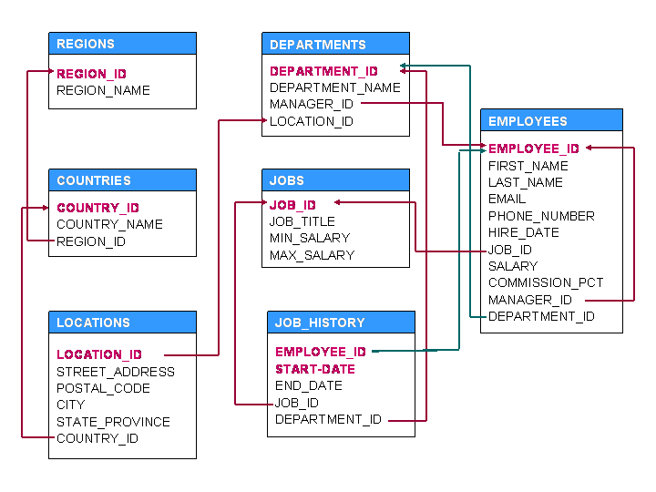

**Set B**

1. For every manager print his name, the name and experience of least experienced employee working under him. Sort your output by <manager name, most experienced employee name> in ascending order.
2. For every city print it’s name, average salary of that city and number of employee having higher salary than the average salary of that city. Sort output in ascending order of <city name>.
3. For each employee, find his rank, i.e., position with respect to salary. The highest salaried employee should get rank 1 and lowest salaried employee should get the last rank. Employees with same salary should get same rank value. Print employees’ last names and his/he rank. Sort output in ascending order of <rank>.
4. Display first name, job title and experience of employees who have less than 5 senior colleagues having same job id. Sort output by <first name>.
5. Display the bottommost department name, number of hired employees within last 5yrs. Ranking is done in the basis of number of employees hired within last 5yrs.