Machine Learning Ensemble Learning Report

Name: Md. Saqib Hasan

Student-ID: 1305057

Date: 27/04/2018

For this sessional offline, we were asked to implement the ensemble learning algorithm AdaBoosting and then verify the algorithm using k-fold cross validation. The weak learner to be used in AdaBoosting algorithm is decision stump.

This report includes the data from the simulations of different k-folds of the k-fold cross validation for the various values we were told to simulate.

Below are the accuracy and f1 score for the simulations ran for the k-fold cross validation for 5,10 and 20. Boosting is kept constant at 5.

K_fold = 5:

Acc = 0.858867924528302

F1 score = 0.8627135405810687

K_fold = 10:

Acc = 0.8594390507011866

F1 score = 0.8617179899147953

K_fold = 20:

Acc = 0.8577753779697623

F1 score = 0.8597427221996503

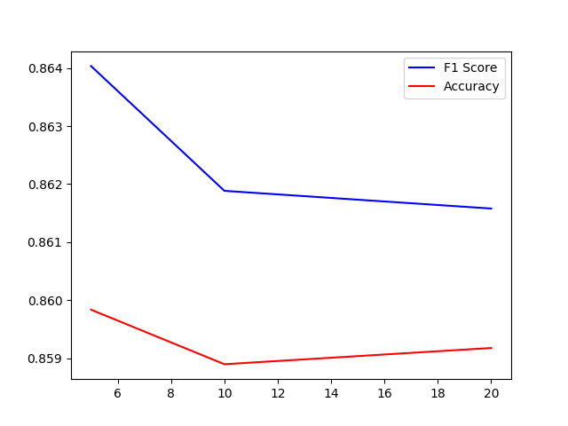

Below are the accuracy and f1 score for the simulations ran for the boosting for 5,10 ,20 and 30. K-fold cross validation is kept at 5.

Boosting 5:

Acc = 0.858867924528302

F1 score = 0.8627135405810687

Boosting 10:

Acc= 0.8591913746630727

F1 score = 0.8622323218228318

Boosting 20:

Acc = 0.8605929919137466

F1 score = 0.8626896401378776

Boosting 30:

Acc = 0.8618867924528301

F1 score = 0.863442305675037

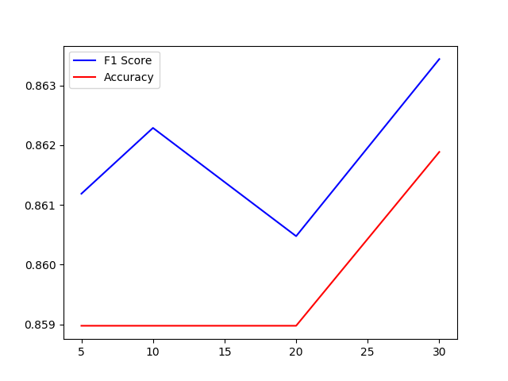

x—The End—x