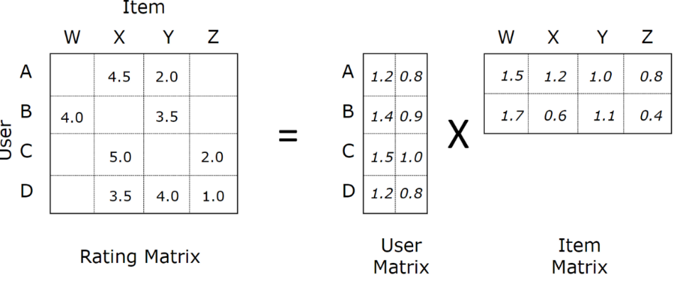

$$X_{N×M}≈U_{N×K}×V_{K×M}^{T}$$

$$x_{n,m}=u_{n}^{T}v_{m}=\sum_{k=1}^{K}{u_{n,k}v_{m,k}}$$

$$L=\sum_{\left(m,n\right)∈Ω}{{\left(x_{n,m}-u_{n}^{T}v_{m}\right)}^{2}}$$

$$L^{reg}=\sum_{\left(m,n\right)∈Ω}{{\left(x_{n,m}-u_{n}^{T}v_{m}\right)}^{2}}+\sum_{n=1}^{N}{λ_{u}{\left\|u_{n}\right\|}_{2}^{2}}+\sum_{m=1}^{M}{λ_{v}{\left\|v_{m}\right\|}_{2}^{2}}$$

$$w={\left(X^{T}X+λI_{d+1}\right)}^{-1} X^{T}y$$

$$\arg{\min_{v_{m}}{\sum_{n∈Ω_{c_{m}}}{{\left(x_{n,m}-u_{n}^{T}v_{m}\right)}^{2}}+λ_{v}{\left\|v_{m}\right\|}_{2}^{2}}}$$

$v_{m}^{*}={\left(U^{T}U+λ_{v}I_{K}\right)}^{-1} U^{T}x_{m}$ Dimensions are given below,

$$[K×1]=\left(\left[K×N\right]×\left[N×K\right]+[K×K]\right)×\left[K×N\right]×[N×1]$$

But we cannot take all of $U^{T}U$ as there are missing entries.

$$[K×1]=\left(\left[K×\left|{Ω_{c}}_{m}\right|\right]×\left[\left|{Ω_{c}}_{m}\right|×K\right]+[K×K]\right)×\left[K×\left|{Ω_{c}}_{m}\right|\right]×[\left|{Ω_{c}}_{m}\right|×1]$$

This is equivalent to,

$$v_{m}^{*}={\left(\sum_{n∈{Ω_{c}}_{m}}{u_{n}u_{n}^{T}}+λ_{v}I_{K}\right)}^{-1} \sum_{n∈{Ω_{c}}_{m}}{x_{n,m}u_{n}}$$

$$[K×1]=\left(\sum_{n∈{Ω_{c}}_{m}}{\left[K×1\right]×\left[1×K\right]}+[K×K]\right)\sum_{n∈{Ω_{c}}_{m}}{x_{n,m}\left[K×1\right]}$$

Similarly,

$$\arg{\min_{u_{n}}{\sum_{m∈Ω_{r_{n}}}{{\left(x_{n,m}-u_{n}^{T}v_{m}\right)}^{2}}+λ_{u}{\left\|u_{n}\right\|}_{2}^{2}}}$$

$$u_{n}^{*}={\left(V^{T}V+λ_{u}I_{K}\right)}^{-1} V^{T}x_{n}$$

$$u_{n}^{*}={\left(\sum_{m∈{Ω_{r}}_{n}}{v_{m}v_{m}^{T}}+λ_{u}I_{K}\right)}^{-1} \sum_{m∈{Ω_{r}}_{n}}{x_{n,m}v_{m}}$$

Dyadic data, each

$$L_{reg}=\left\|\begin{matrix}y-Xw\end{matrix}\right\|+λ{\left\|\begin{matrix}w\end{matrix}\right\|}_{2}^{2}$$

$$\frac{∂L_{reg}}{∂w}=-2\sum_{i=1}^{n}{\left(y_{i}-x_{i}^{T}w\right)x_{i}}+2λw$$

2 will be absorbed into $η$

If no analytical solution

Gradient descent

1. Start with an initial value of $w=w^{(0)}$
2. Update $w$ by moving along the gradient of the loss function $L$
$$w^{(t)}=w^{(t-1)}-η\frac{∂L}{∂w}$$

3. Repeat until converge