API calls to demonstrate Rest API End Points:

Login:

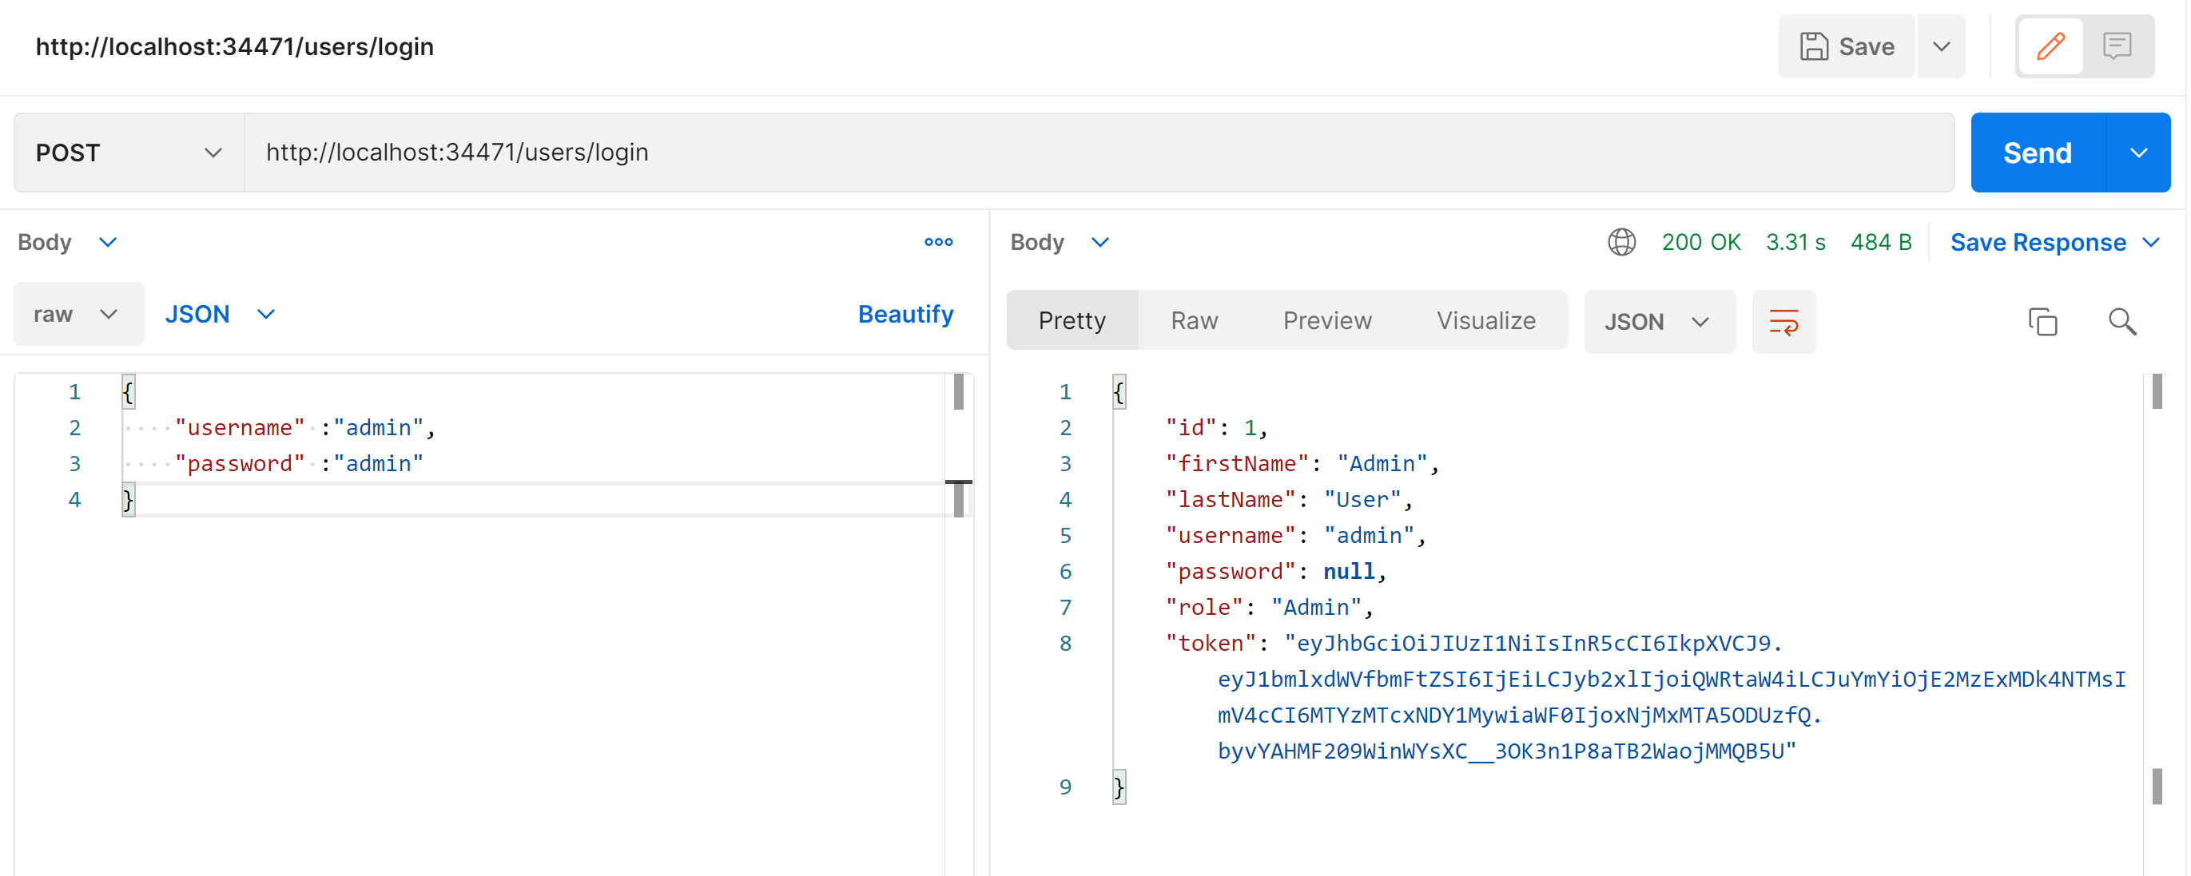

Users :

Authorized:

{

    "username" :"admin",

    "password" :"admin"

}

UnAuthorized :

{

    "username" :"user",

    "password" :"user"

}

Call the Azure function API end point by Bearer token:

1. Use bearer token received in Step 1.

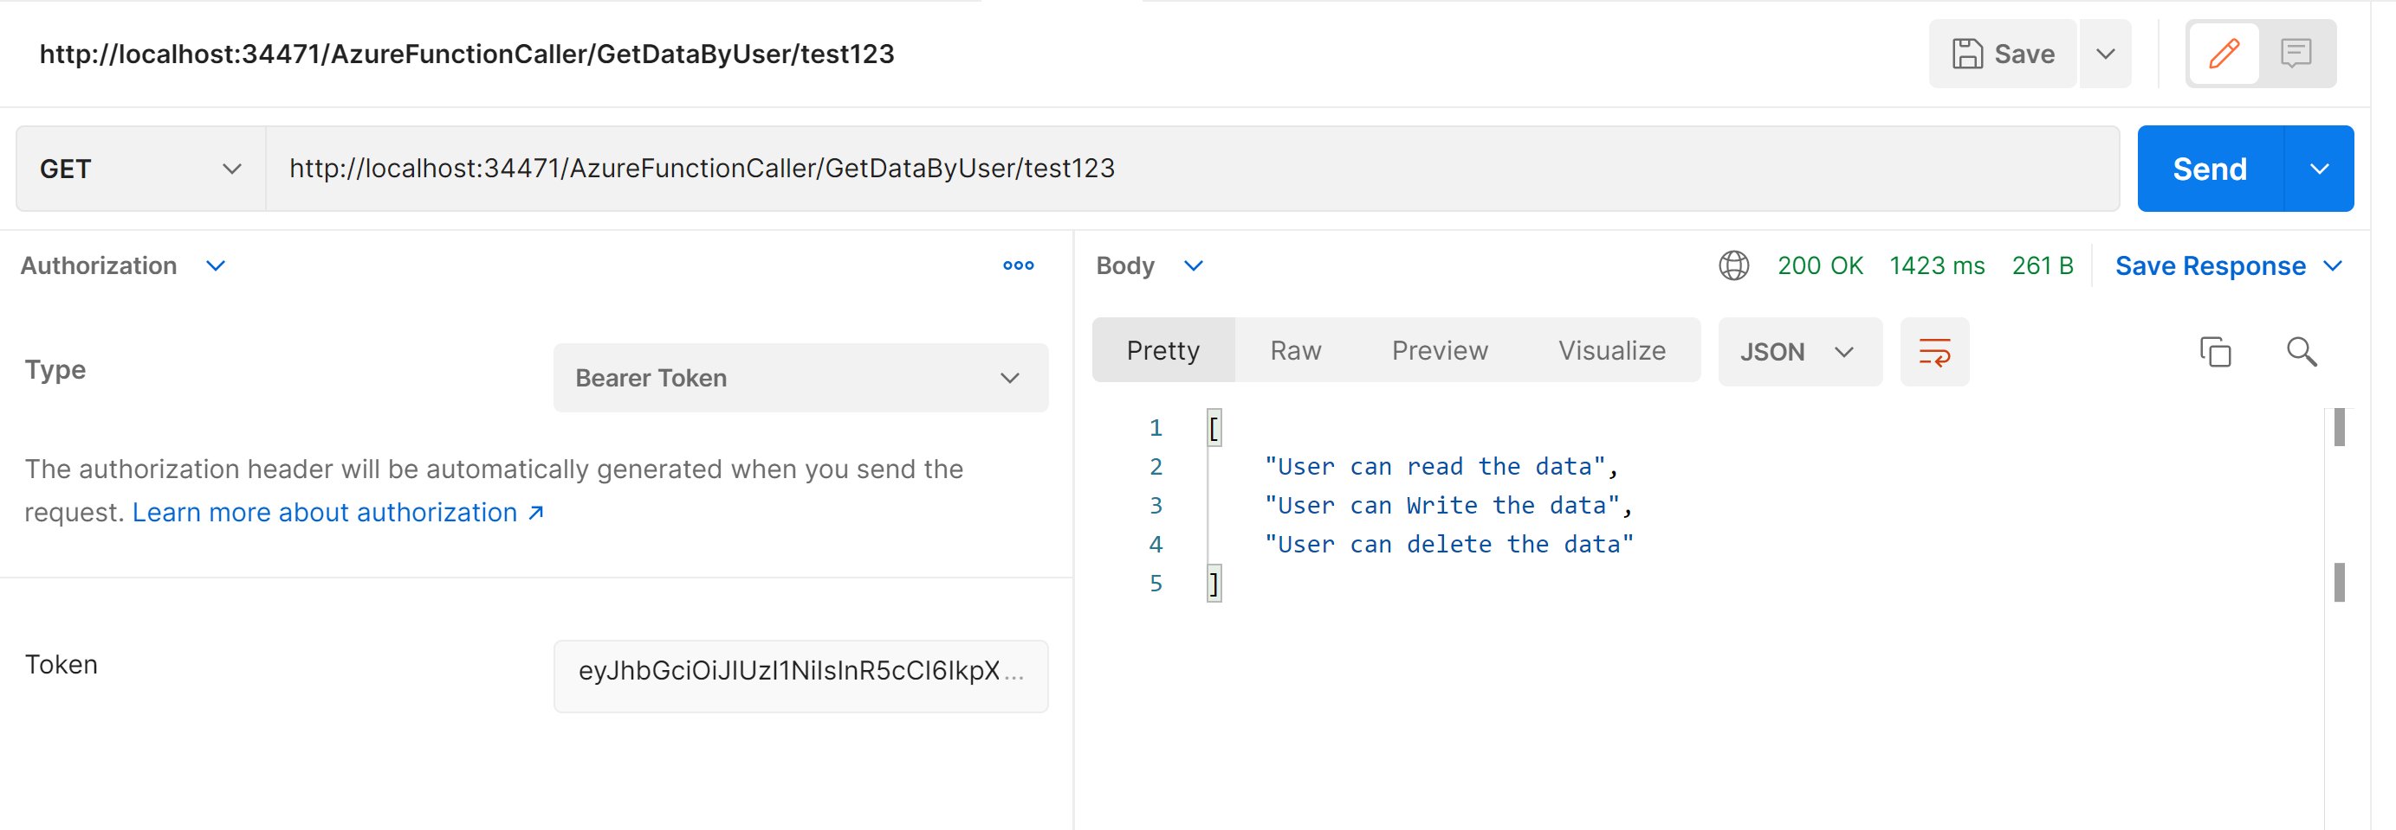

Output of consecutive request within 1 seconds ( cab be changes

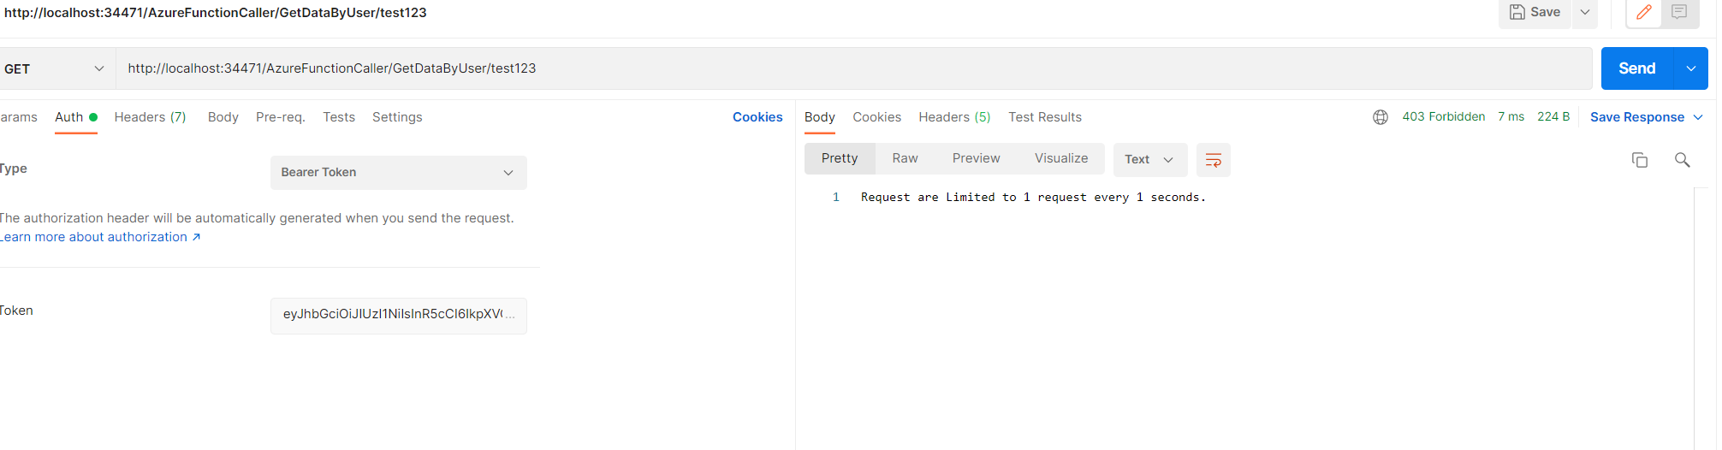

Log for API calls:

