**Name: Saqib Maqbool**

**Assignment 1: Visualization**

**Data Source: WLD_RTFP_country**

Git Link:

1. **Scatter Plot**

I have created a scatter plot that visualizes the relationship between two financial variables, 'Open' and 'Close' stock prices, using the 'Inflation' variable to add meaningful context to the plot. Each data point is represented as a dot on the scatter plot, and the color of each dot indicates the inflation rate associated with the data point.

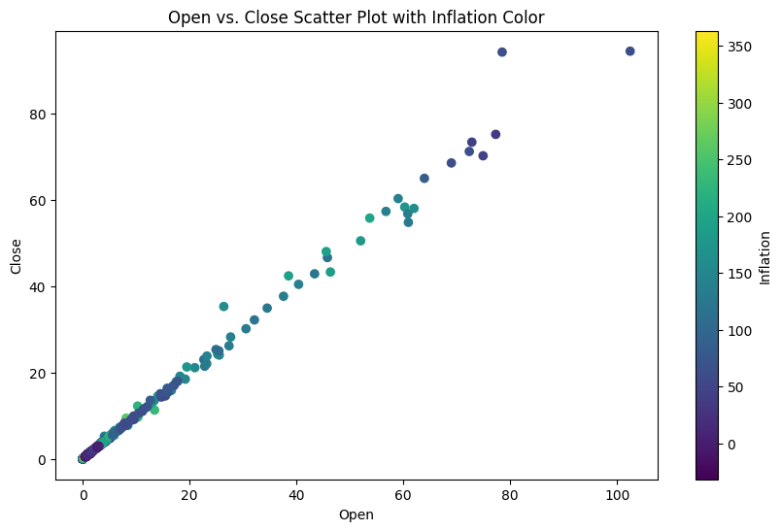

**Data Description:**

My dataset used contains financial and economic data for various countries or areas. Each row in the dataset represents a specific time point, and the columns provide information on stock prices ('Open' and 'Close') and economic indicators such as 'Inflation.' For the scatter plot, we chose to compare 'Open' and 'Close' stock prices while incorporating the 'Inflation' variable to provide additional insight into the relationship.

**Benefits of Scatter Plot:**

Scatter plots are well-suited for visualizing the relationship between two numerical variables. In this case, it helps us understand how the 'Open' and 'Close' stock prices are related and whether there is any correlation with the inflation rate. The use of color adds an extra dimension to the plot, allowing us to explore the impact of inflation.

**Conclusions:**

Here scatter plot effectively visualizes the relationship between 'Open' and 'Close' stock prices. By incorporating the 'Inflation' variable as a color indicator, it provides insight into how inflation rates may influence the relationship between these financial variables. We can identify any potential patterns or trends in stock prices concerning inflation. Additionally, the color bar provides a clear legend for interpreting the meaning of the colors.

**Flow of Data:**

This scatter plot presents a clear representation of how 'Open' and 'Close' stock prices relate to each other. The x-axis represents 'Open' prices, the y-axis represents 'Close' prices, and the color of each point corresponds to the 'Inflation' rate. By utilizing color as an additional variable, it offers a deeper understanding of the potential impact of inflation on the financial data.

**2. Bar Chart**

I have used bar chart, which is a suitable choice when we want to compare values across categories, in this case, countries or areas. A bar chart represents data with rectangular bars, where the length or height of each bar is proportional to the value it represents.

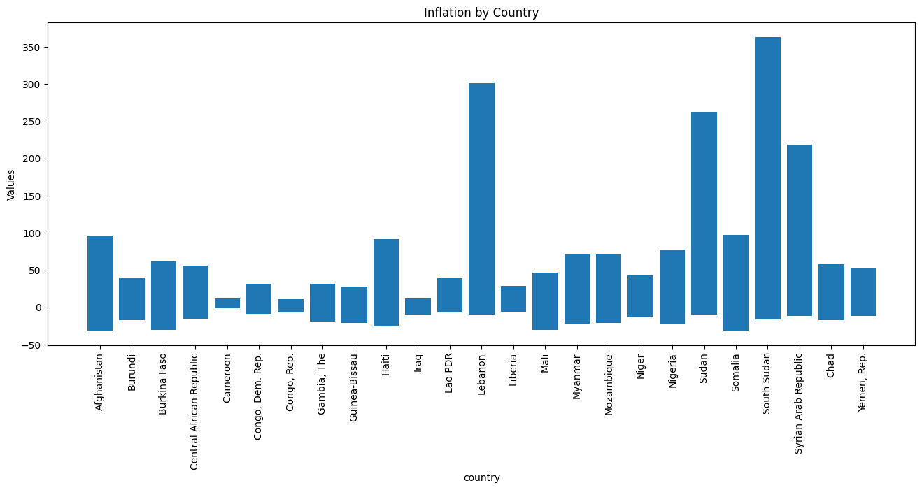

**Data Description:**

The dataset for the bar chart consists of categorical data, such as different countries or regions, and their corresponding values for a specific parameter (e.g., inflation rates, population, GDP).

**Benefits of Using Bar Chart:**

Bar charts are excellent for comparing values or categories. Bar charts are ideal for comparing values between different categories or groups. They provide a clear and straightforward way to visualize the differences or similarities among categories.

**Conclusion:**

The bar chart effectively compares the parameter (e.g., inflation rate) across different countries or regions. It allows for easy identification of which countries have the highest or lowest values for the parameter. This visualization can be used for benchmarking or making regional comparisons.

**3. Line Plot**

Line plots are well-suited for representing continuous data over a range of categories or values. The dataset used for the line plot contains historical data for a specific economic indicator (e.g., GDP, stock prices) over time. Each row represents a unique time point, and the columns include the date and the indicator's values. I have visualized a line plot, which is suitable for showing how the stock prices are going high and low over the period of time of a specific country her Afghanistan. We can chose any country from our dataset and visualize it.

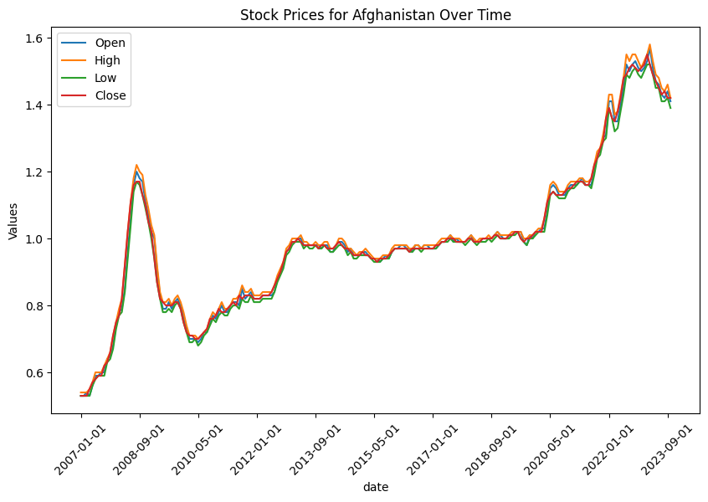

**Data Description:**

My dataset contains information of multiple countries from which I have shown one of them here. Each row represents stock prices rates. The dataset includes information of multiple countries stock prices of multiple dates .

**Benefits of Using Line Plot:**

The line plot is well-suited for visualizing the trends and changes in a continuous variable over time. It helps in identifying patterns, fluctuations, and trends in the data.

**Conclusion:**

The line plot effectively displays the historical changes in the economic indicator, providing insights into how it has evolved over time. This visualization can help identify long-term trends, seasonality, or sudden changes in the economic indicator.

The flow of data is like, time is the x-axis, and stock prices are plotted over time, illustrating how stock values change over a specific period.