25.04.2019

KUNTALA SHABNAM PARAMA

Business Communication

American International University Bangladesh

**Subject: Submission of our report**

Dear Madam,

We have the pleasure to submit our report titled ‘Technology in Urban Waterlogging Prevention’. The report gave us opportunity to know what kind of problems people face due to waterlogging.

It is a bit odd to see parts of many streets and roads in urban areas being waterlogged just after a few hours of continuous rains. This shows a major problem with the drainage system in the urban areas.

Our research was on the prevention of urban waterlogging using technology. We examined many people from different areas including Mirpur, Bashundhara and Kuratoli .We collected data by both questionnaire and interview.

From the research we found out that, the prevention technique using our app might be helpful to reduce the level of water logging that we are currently facing.

We thank you for giving us the chance to do this report.

Yours sincerely,

Hameem, Md. Asir (17-33856-1)

Das, Nishan (17-34166-1)

Islam, Lamia (17-33875-1)

Nabila, Sazida Islam (17-33860-1)

Tabid, Md. Tarek Lehaz (17-34240-1)

**Preface**

In this report, we tried to find out how our app can help the people in urban areas.

Firstly we did research on the causes and effects of waterlogging. Mainly we did research on the Dhaka dwellers. Our participants were Mirpur, Bosundhara and kuratoli dwellers. In our research we went to people- 20 from Mirpur,10 from Basundhara and 10 from Kuratoli. We gave them questionnaire and interviewed them also. We collected all qualitative and quantitative data from all the participants. Causes and effects of waterlogging are almost same in these areas .Only one or two hours rain is enough to cause water-logging that brings a lot of sufferings to people. Although rainy season has not yet set, continuous rain for a few days may cause severe water logging triggering immense sufferings for these area people. From the analysis we made a statistic report and the statistical data’s showed the overall scenario that our system design might helpful if it can be properly implemented.

**Acknowledgement:**

We are heartily thankful to our course instructor, whose encouragement, supervision and support from the preliminary to the concluding level enabled us to develop an understanding of the subject.

We are thankful to all the people who participated of this study. We greatly appreciate their sincere co-operation.

Also we want to thank some of our friends who helped us with collecting all analytical data and interviewing all the sectors.

Lastly, we offer our regards and blessings to all of those who supported us in any respect during the completion of the study.

**Abstract:**

Waterlogging in the urban area is not a new problem. It has become a part of our problem but the situation is being worse day by day. If we do nothing to prevent this problem, we might be not able to live in urban areas. Our technology has introduced prevention method of waterlogging. Through the monitoring center flood control decision can be made and urban area’s flood control capacity can be improved. It provides monitoring services as well as operating services. If our system technology is used properly with proper monitoring and equipment’s, we hope that the problems due to waterlogging can be prevented and rate of waterlogging can be reduced.

**Table of Contents**

|  |
| --- |
| **Chapter Title Page no.** |
| Forwarding letter i  Preface ii  Acknowledgement iii  Abstract iv  Table of contents v  1.0 Introduction 1  1.1 Current situation of Bangladesh in waterlogging 1  1.2 Problems due to waterlogging 1  1.3 Technology in waterlogging 2  1.4 Overview of the research report 2  1.5 Rationale of research report 3  1.6 Chapters of the research report. 4  2.0 Chapter 2: Methodology 5  2.1 Method used 5  2.2 Selection of subjects/participants 7  2.3 Waterlogged Area 7  2.4 Design Criteria 9  2.5 Proposed System 10  3.0 Chapter: Findings and Analysis 11  3.1 The study Area 11  3.2 Findings 12  3.3Analysis of the result 13  4.0 Chapter: Conclusion 14  4.1Summery 14  4.2 Limitation 14  4.3Future direction 14  5.0Recommendation 15  References vi  Appendix vii |

**1.0 Chapter 1: Introduction**

**1.1 Current Situation of Bangladesh in Waterlogging**

Bangladesh is a developing country facing as well as overcoming a lot of problems. It is a country of huge population where the people have become burden on their own country, as the land is unable to support them with the primary needs.Nevertheless, Bangladesh has a very under developed sewerage system and people lack the sense of sanitization. Moreover, existing pipes are getting clogged due to insufficient collection of solid wastes, street sweepings and lack of maintenance. Therefore, as a matter of fact Bangladesh is facing a lot of waterlogging problems.

**1.2 Problems Due to Waterlogging**

People of Bangladesh face many problems due to waterlogging. Since Bangladesh faces high rainfalls in rainy season every year, it needs proper sewerage system. Most common problems due to waterlogging are

* Water pollution
* Water borne diseases
* Damage of trees and vegetation
* Disruption in Traffic Movement
* Damage of roads and houses
* Death and damage of fisheries
* Increase of construction and maintenance cost
* Other
* Due to waterlogging above-mentioned problems occur every now and then.

**Page no. 1**

**1.3 Technology in Waterlogging**

As present, the cautioning on urban's waterlogging depend much on the data gathered from weather forecast. It has the defects of slow speed, little data, poor continuity and time lag. Since people are facing a lot of problems due to waterlogging in urban cities, we propose a technology that can be used to face this problem. The main components that is needed to make the system work are:

* Ultrasonic flowmeter
* Rainfall sensor
* Water level indicator

As flash flood frequencies have increased in urban cities due to global warming, but using our system people can know when the ground will be filled with water and can do alternative arrangement for that. So that we wish this system will help the people of all classes.

**1.4 Overview of the research report**

This research report is on the technologies which can be used to prevent the problem of urban waterlogging in Bangladesh. We tried to find out the quantitative data on how much heavy rainfall Dhaka faces and due to pipes’ maintenance problems which areas are more affected by waterlogging problems. Many technologies have been used before, what were their safety measures, comparison of previous technologies with our proposed technologies.

We approached to 50 individual subjects with questionnaire and also interviewed some of them personally. I collected all the quantitative and qualitative data and made a statistical analysis.

**1.5 Rationale of research report**

From the analysis of this report we can come down to some factual conclusion about all the technologies working for urban waterlogging in Bangladesh. We can find out some problems and reasons behind it from this report. This report will help us to point out the problems all the people are facing and the reason behind it. Such as-

* What are the main facts in order to prevent waterlogging
* Why the people are facing problems in the first place
* Why less technologies are introduced in Bangladesh
* Reasons behind failures of previously introduced technologies
* What are the reasons people get sick from water

All this information would be much helpful to overcome all the problems we are facing in waterlogging. This analytical report would be helpful to all sectors of people who are facing problems due to waterlogging. This report will also be helpful to people of all ages to overcome some problems and also all the big authorities can gather information from this report to enrich the technologies of Bangladesh and make our country technologically developed.

**1.6 Chapters of the research report**

* Chapter 1: The introduction about the full report. What is the report about, how we did the report and how the reason behind doing this report.
* Chapter 2: Methodology of the report. How we did the analysis, which method we used, why I used & how I used. In addition, the analysis of data is shown in this chapter.
* Chapter 3: Findings and analysis. The resultant data and findings are in this chapter.
* Chapter 4: The conclusion of the report.
* Chapter 5: Personal recommendation based on the result of the report.

**Page no.2**

**2.0 Chapter 2: Methodology**

**2.1 Method used**

In this report we used our system prevention working method.

**2.1.1 Procedure**

At first drainage flow is calculated by ultrasonic flowmeter.After that rainfall and water level is detected .Then collected information is sent for analyzing and monitoring. If there is any possibility of waterlogging, the monitoring center sends an alert to the city corporation.

**2.1.2 Working Algorithm**

In first case, if the new flow rate is greater than the previous flow rate, then rain sensor and water level is checked. In second case: If the new flow rate is equal to the previous flow rate, then the system is notified that drainage capacity has been full or there is obstacle in drainage system .In third case: If the new water level is greater than the previous water level, then probability of flood is calculated and City Corporation is informed.

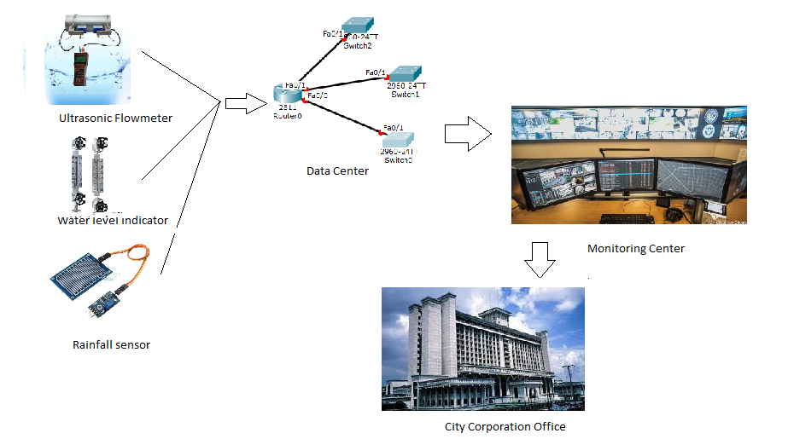

**2.2 Selection of subjects/participants**

As this report is on the people of urban areas, all of our subjects are related to urban area (Mainly Dhaka). We took data from 20 people from Mirpur, 10 from Bashundhara and 10 from Kuratoli.

# The reason of choosing these area that the people from these areas suffer a lot due to waterlogging. We choose Mirpur as there has become a saying that when it rains, it pours (and clogs) in Mirpur. For Mirpur residents, it has become very hard to cope with the poor situation of waterlogging. The situation has become so bad that the area of Mirpur has become subject to mass criticism online as many believe that it is rapidly becoming an uninhabitable place.

# We choose Bashundhara as this area gets waterlogged even when it rains just a little heavily. We found there is a saying like that rainwater in Bashundhara is a curse. Dwellers of this area say that this area has been getting waterlogged for the last several rainy seasons.

# We choose Kuratoli as this area gets waterlogged so bad due to just a little continuous rain and people have to be stuck for hours and hours.

**2.3 Waterlogged Area**

People of low lying areas are the most sufferers due to waterlogging. Due to increasing urban developments, sufficient drainage system is not provided .As a result, people have to suffer for this problem. In Dhaka, Baridhara,Mirpur,Motijheel,Kuratoli etc. have been marked as waterlogged areas. The most possible reason for these areas may be the improper drainage system. People of every corner in Dhaka (east, west,south) are affected with this problem.

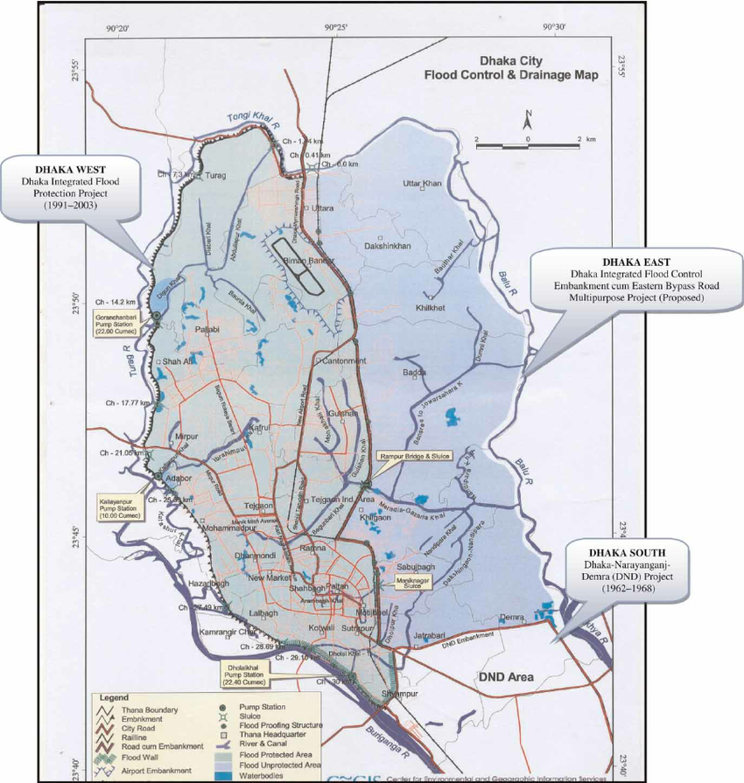

# Fig 2.3: Waterlogging Areas

# 2.4 Design Criteria:

# The three basic components are the main design criteria for our system design. Ultrasonic flow meter is used to detect the flow of water. Rain Sensor is used to sense if there is any possibility of raining or not. Water level Indicator is used to indicate the water level. The system is designed by combining the variables like-water flow, water level, possibility of raining and also including the monitoring center along with City Corporation.

# 2.5 Proposed System:

# A three dimensional perception of drainage and waterlogging prevention information should be conducted by Urban waterlogging prevention management system. At the same time, the effective monitoring on them shall also be conducted.

**3.0 Chapter: Findings and Analysis**

**3.1 The Study Area**

The study area was Kallayanpur Khal catchments, which is one of the major drainage channels in the city. The khal includes the most important commercial areas and the government offices of Dhaka City, hence most of areas are impervious due to commercial and mixed (residential and commercial) land uses. The khal drains storm water from an upstream drainage catchments area of 4.54 km2. The elevation of the area is 2 to 13 meters above the mean sea level (msl)

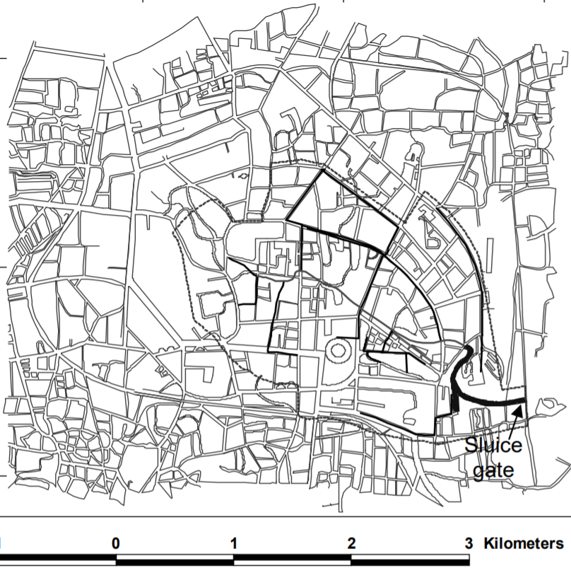

**Figure 3.1: The study area (Mirpur,Bashundhara,Kuratoli)**

**3.2 Findings**

As it is mentioned earlier that the main causes of water logging in Dhaka city can be classified into two types. The first one is rainfall and the other one is high water level of peripheral river system. In 2017, water logging in Dhaka city caused by local high rainfall occurred in the built-up areas of the city.

|  |  |  |  |
| --- | --- | --- | --- |
| Date | Rainfall (mm) | Duration (hours) | Remark |
| March 27,1017 | 65 | 2 | 37 mm in 1st hour |
| March 28,2017 | 32 | 2 | 28 mm in 1st hour |
| March 29,2017 | 05 | 1 | - |
| March 30,2017 | 85 | 4 | 41.5mm in 1sthour |

*Source: SWMC,2017*

|  |  |  |  |  |  |  |  |  |
| --- | --- | --- | --- | --- | --- | --- | --- | --- |
| Month/year | 2015 | | 2016 | | 2017 | | 2018 | |
|  | Highest | Lowest | Highest | Lowest | Highest | Lowest | Highest | Lowest |
| May | 152 | 01 | 155 | 01 | 88 | 01 | 185 | 01 |
| June | 28 | 01 | 128 | 01 | 104 | 01 | 93 | 01 |
| July | 47 | 01 | 40 | 01 | 73 | 01 | 30 | 01 |
| August | 178 | 01 | 72 | 01 | 46 | 01 | 67 | 01 |
| September | 73 | 01 | 54 | 01 | 42 | 01 | 61 | 01 |
| October | 158 | 01 | 54 | 01 | 17 | 01 | 79 | 01 |

Highest and lowest rainfall between May to October

Source: Meteorological department of Bangladesh ,2018

**3.3 Analysis of the result**

From the data we can see that in every year during the rainy season the severe water logging originate from insufficient drainage capacity and blockage of the drainage system due to huge volume of garbage and polyethylene bags. The areas of Mirpur, Banani includes many of the important business and government offices of the country, suffered most. The researchers think that rapid growing urbanization also a main cause. We can see that in the year of 2000 the population of Dhaka city was 10 million but within 10 years its became more than double 25-30 million. Because of this rapid growing population our environment position also day by day decreasing. In our survey we found that more than 80% people of Dhaka city faces the water logging problem. We also find that some of them suffer in this disaster for the whole months in rainy seasons.

* Low lands and flood flow zones are filling up rapidly for housing development.
* Illegal encroachment on lakes and khal in the city is also responsible for this problem.
* Disposals of solid waste on to the roads are also a reason for blocking the drain.
* Development works in the rainy season by DWASA and DCC also leads to water logging.

**4.0 Chapter: Conclusion**

**4.1 Summary**

With everything taken into account, the urban waterlogging prevention management system based on technologies considers more about the monitoring, checking and management of urban drainage and waterlogging prevention. It also directs the observing and early warning management regarding flood control and drainage. Using the application, we wish urban flood prevention and control will be improved and traffic jam, property loss, wasting valuable times will be reduced.

**4.2 Limitation**

The limitation of our research is we could not reach all the people who can help us with my data. In addition, the time of research was very short to cover such a vast subject. Therefore, we could not study enough in internet to know more about waterlogging. Besides, we only discuss about the common urban problems due to waterlogging and its solution. There are more causes of waterlogging and our system will not work outside of any city.

**4.3 Future direction**

In future if someone does this research, our advice will be to collect more data not only for the urban cities but also for the other areas outside of the cities where waterlogging causes serious impact on people’s daily lives.

**5.0 Chapter: Recommendation**

Raising low land above the flood level is a pre-requisite for preventing waterlogging. It is recommended that such land be raised to the similar level of high land of the urban area. The existing drains and also those will be constructed shall have to cleaned at regular interval. Maintenance and cleaning of drains shall have to done at least once in every year specially before starting of monsoon season. The city corporation officials shall take necessary steps as soon as possible after getting an alert about waterlogging and after that, they shall do necessary arrangement for not causing that over and over again.

**REFERENCES**

**Journal Article**

1. Kabir, S., Khan, N.M.E.A, Water sensitive urban design: Dhaka city, Second International Workshop on Design in Civil and Environmental Engineering, June 28-29, 2013, WPI
2. Khalequzzaman, M. 2001. Flood Control in Bangladesh through Best Management Practices. Department of Geology & Physics, Georgia Southwestern State University. Americus, GA 31709. USA.

**Electronic Online Articles**

1. Water Logging in Satkhira District an Analysis of Gaps between Needs and Response, Early Recovery Facility, UNDP Bangladesh,2011
2. Flooding & Prolonged Water-logging in South West Bangladesh, Coordinated Assessment in 10 Uppazillas of Satkhira, Jessore and, Khulna, September 2011.

**Appendix**

Questions for reporting

Topic: Technology in Urban Waterlogging prevention

**Name: __________________________________________________________**

**Student ID: __________________**

**Sex: Male: ( ) Female: ( )**

**Email/Phone:_____________________________________________________**

**University: _______________________________________________________**

**1.About how many time have you faced water logging in your area this year?**

a. More than 30 time

b. Less than 20 time

c. Equals to 20 time

**2. Have you been stuck at home due to waterlogging?**

a. Yes

b. No

**If you have,for how many days water stucked in your area?**

a. a week

b. more than one week

c. less than a week

3. **Was any prevention method introduced in your area to reduce the sufferings?**

a. Yes

b. No

**If any, was it effective?**

a. agrees

b. disagrees

c. strongly agree

d. moderately agree

4.**Do you think our system prevention method will be helpful to your area?**

a. agree

b. disagree

c. strongly agree

d. moderately agree

5.**Do you think our system will be able to reduce your sufferings due to waterlogging?**

a. agree

b. disagree

c. strongly agree

d. moderately agree

6.**Do you think our system design is complex?**

a. Yes

b. No

7.**Do you think our system is user friendly?**

a. agrees

b. disagrees

c.no saying

**8. When was the last time you faced water logging problem?**

a. Between 10 days

b. Between 1 to 6 months

c. Between 6 to 10 months

If you faced, how was the affects?

a. severe

b. like other rainy days

c. not so much

9.  **During the past 30 days (1 month) on how many days you faced water logging problem?**

a. Every day or almost every day

b. Some days

c. No days

**10. What is the main reason you think for water logging problem?**

a. Over rain

b. Poor drainage system

c. Less awareness

d. Over population

**11. Do you find it difficult to refrain water logging problem?**

a. Yes

b. No

**12.Which Areas seemed to be bad situation after rainfall because of water logging**?

a. Mirpur

b. Kuril

c. Bosundhara

d. others

**13.Is there any action which is taken by the government in your area for this problem?**

a. No

b. Yes

14.**Do you think technologies are useful to reduce the sufferings of this problem?**

a. Yes

b. No