# **Smart Homes**

# Submitted to

Sir Rashid Rasheed

# Submitted by

Daniyal Imam 193352

Areej Anwar 193330

Saqlain Haider 193319

**Table of contents page no.**

1. Introduction…………………………………………….3
2. Development process model……………………………4
3. Risk management(table)………………………………..5
4. Time estimation (figure)………………………………..6
5. Cost estimation (figure)………………………………...7
6. SRS user requirements…………………………………8
7. SRS system requirements………………………………9
8. Use case diagram (figure)……………………………....10
9. Sequence diagram (figure)……………………………...11
10. UML class diagram (figure)…………………………….12
11. Data flow diagram(figure)………………………………13
12. Glossary…………………………………………………14

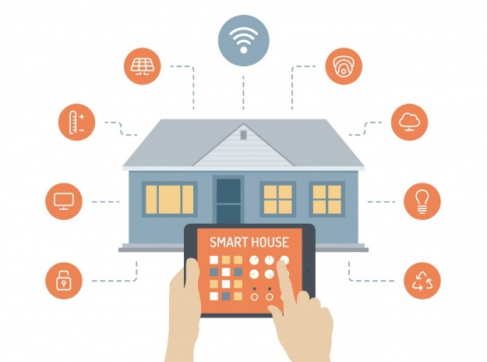

**Introduction: -** A smart home allows homeowners to control appliances, thermostats, lights, and other devices remotely using a smartphone or tablet through an internet connection or Bluetooth. Smart homes can be set up through wireless or hardwired systems. Smart homes provides homeowners great convenience and a lot of cost saving.

The main theme is that, it is a low cost smart home system. It will consist of a device which will be applied to the main switch of the house and that device will be really low in cost and it will be easy for everyone to have a technology like this in such a low cost. That device will consist of an Integrated circuit with having multiple small antennas which will help throw signals through Wi-Fi or Bluetooth on your phone. All the devices will be then connected onto smart phone and you can easily control home appliances with less human effort which will save time and money.

**Development process model**

**Which model is most suitable for this Idea? Why?**

Waterfall, Agile and Spiral models are most suitable for this idea which is “Smart Homes”. The reasons are mentioned below:

* Requirements are very well documented, clear and fixed.
* Low cost due to less customer interaction(less changes).
* Requirements are specified, which is necessary for water fall model and we can easily distinct project in different stages.
* Technology is understood and is not dynamic.
* Easy to manage due to the rigidity of the model. Each phase has specific deliverables and a review process.
* Works well for smaller projects where requirements are very well understood.
* Phases are processed and completed one at a time.
* There are no ambiguous requirements.
* It will focus on collaboration and cooperation which will help lead this idea to great success.
* The efficient communication will not lead the task to failure.

**Risk Management**

|  |  |  |  |
| --- | --- | --- | --- |
|  | **Risk Identification** | **Risk**  **Analysis** | **Risk**  **Planning** |
| **Technology** | Electronic equipment that produce  Interaction between  Software and  Hardware. | **Catastrophic**  Cannot be developed | Import the  equipment |
| **People** | Lack of skilled  People for  Hardware  Construction. | **Moderate**  Can also be developed by unskilled people | Work with team B. |
| **Organization** | Restructure of new workers | **Low**  Unpredictable scenario | Documentation |
| **Tools** | Unavailability of  Components that we  Use to develop  Such software. | **Low**  Components already available | Change and search  Required tools. |
| **Requirements** | User demand more and more changes  That need to change  Whole design. | **Catastrophic**  Almost all processes has to be repeat again | Use spiral process  Model for  Development. |
| **Estimation** | Cost, time | **Moderate**  Unpunctuality of staff | Estimate more from  Expectation. |

**Time estimation**



**Cost estimation**

**Hardware and Software**

**User Requirements**

**Functional:**

1. Software shall control all electrical equipment’s as we turn on specific device i.e. water motor pump etc. then it shall turn on and turn off on turning off the device through software that shall pass on/off signals to hardware (controller).
2. The device shall turn on and off automatically with the help of timer set by the user.
3. The device shall optimize the system, though which we will be able to set the speed of any equipment.

**Non-functional:**

1. Should be reliable
2. Should be responsive
3. Should be maintainable
4. Should be portable
5. Should be platform independent

**Hardware and Software**

**System Requirements**

**Functional:**

1. As we give on/off command to software it shall generate signals that shall be received by the controller, which shall further turn on/off the required electrical device.
2. As the user turn on the electrical device and set the timer in a software, then the electrical device should automatically turn on/off. There is a function that shall automatically turn on a device from its sleep mode.
3. The device shall optimize the system, though which we will be able to set the speed of any equipment.

**Non-functional:**

1. Equipment should be of good quality and low cost.
2. Software and Hardware response time should be efficient.
3. Software and Hardware should be of great ease that can be easily maintained by the user.
4. Hardware (controller) should be easily portable with any electrical equipment.
5. Software will easily run on multiplatform such as iOS, android, Microsoft etc.

**Use-Case Diagram**



**Sequence Diagram**



**UML Class Diagram**



**Data flow diagram**



**Glossary**

**Electrical Equipment’s**: Electrical equipment includes any machine powered by electricity. It usually consists of an enclosure, a variety of electrical components, and often a power switch.

**Controller:** A controller, is a hardware device or a software program that manages or directs the flow of data between two entities. Controllers may be cards microchips or separate hardware devices for the control of a peripheral device.

**Reliability:** Reliability is defined as the probability that a product, system, or service will perform its intended function adequately for a specified period of time, or will operate in a defined environment without failure.

**Response time:** The time taken for a circuit or measuring device, when subjected to a change in input signal, to change its state by a specified fraction of its total response to that change.

**Portability:** The ability of software to be transferred from one machine or system to another.

**Efficiency:** Efficiency signifies a peak level of performance that uses the least amount of inputs to achieve the highest amount of output.

**Sleep mode:** a power-saving mode of operation in which devices or parts of devices are switched off until needed.

**UML:** UML is stands for unified modeling language.

**DFD:** DFD is stands for data flow diagram.