FREIGHT RATE PREDICTION
Name: M Saqlain
Role: ML Engineer
Submitted to: Ena - Spotter
Prepared from the model evaluation results and scoring output provided during the project.

1. Executive Summary
This project builds a regression workflow to estimate freight load rates from shipment attributes, route information, equipment, weight, and date-derived features. Multiple regression algorithms were compared. Ridge Regression was reported as the best model in the available evaluation output, with MAE = 142.76, RMSE = 637.58, and R² = 0.8252. The provided scoring script successfully validated 12,000 validation predictions and 31 December predictions, and generated the December chart.

2. Problem Statement and Objective
The objective is to predict the freight rate (posted_rate) for loads not included in the labeled training dataset. The workflow must produce a prediction for every validation load and a daily prediction series for the fixed December 2025 scenario.

3. Data and Features
The labeled development dataset contains 48,000 rows. The target variable is posted_rate. Input fields include pickup, delivery, pickup_lat, pickup_lon, delivery_lat, delivery_lon, distance, equipment, weight, date, market_index, and quote_signal. The load_id field is an identifier and is excluded from model features. Missing values were observed in weight and market_index.
Date features were derived from date: year, month, day, and day_of_week. The raw date and load_id were excluded from the model feature matrix. Numeric missing values were handled with KNN imputation; categorical missing values were handled with most-frequent imputation, followed by one-hot encoding.

4. Training and Evaluation Method
The data was sorted by date and split chronologically into an 80% training set and a 20% test set. This produced 38,400 training rows and 9,600 test rows. A chronological split helps evaluate the model on later observations rather than randomly mixing earlier and later dates.
The model comparison workflow included Linear Regression, Ridge Regression, Random Forest, Extra Trees, and Gradient Boosting. XGBoost was also considered as an optional additional model if installed and run. The available output identifies Ridge Regression as the best model; individual metric values for the other models were not provided for this report and are therefore not invented.

5. Best Model Results
Metric | Reported result
Selected model | Ridge Regression
MAE | 142.76
RMSE | 637.58
R² score | 0.8252
Interpretation: MAE of 142.76 means the mean absolute prediction error was approximately 142.76 rate units on the held-out test set. RMSE is considerably larger than MAE, suggesting that some errors may be substantially larger than the typical absolute error. An R² of 0.8252 indicates that the model explained approximately 82.52% of the target variation in this test split. These metrics do not by themselves guarantee performance on the unseen validation set.

6. Validation Predictions and Scorer Checks
The validation dataset contained 12,000 rows and 13 input columns. The workflow generated 12,000 predictions with zero missing predicted values and saved them to validation_predictions.csv. The scoring script then reported: 'Validated 12,000 final predictions.' This confirms the submission file passed the script's row-count, ID-set, column-order, numeric-value, and positive-rate checks.

7. December 2025 Scenario
The December scenario holds the route and shipment attributes fixed: Lexington to Fort Wayne, 360 miles, Dry Van equipment, and 32,000 lb. Only the date changes across 31 days from 2025-12-01 through 2025-12-31. The scorer validated all 31 daily predictions and generated scorer_results/candidate_december.png.
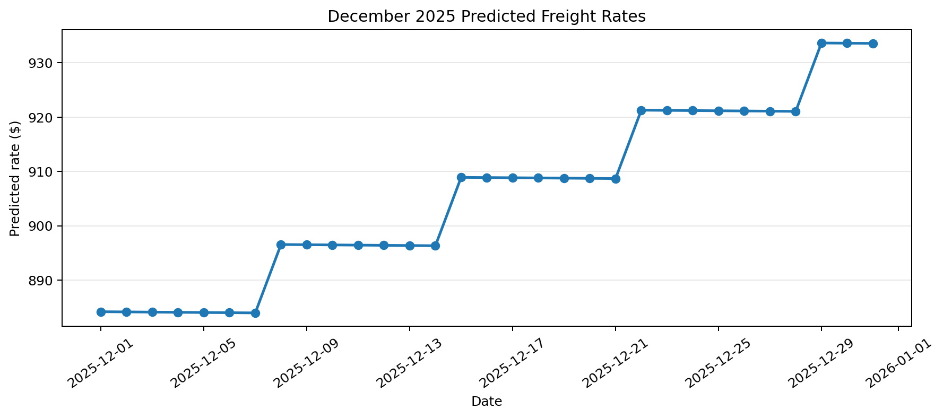
Across the supplied December predictions, the predicted rate ranges from $883.96 to $933.63. This chart describes model outputs for the fixed scenario; it is not a comparison against observed December rates.

8. Output Artifacts
- best_freight_rate_model.pkl — saved fitted pipeline/model.
- validation_predictions.csv — 12,000 load_id and predicted_rate rows.
- Completed December predictions CSV — 31 daily predicted rates in the required seven-column format.
- scorer_results/candidate_december.png — chart generated by score.py.
- main.ipynb — notebook containing data preparation, model training, comparison, and prediction workflow.

9. Limitations and Recommendations
- The scoring script validates output format and required scenario inputs; it does not calculate final validation accuracy. Spotter's final metrics are reported after submission.
- Review the full model comparison table and retain the numeric metrics for all models in the notebook/report.
- Investigate large residuals because RMSE is much larger than MAE.
- Consider tuning Ridge and tree-based models using time-aware validation, and compare with a simple baseline.
- Keep the original December input file unchanged where possible and save the completed prediction file separately for reproducibility.
- Document package versions and add a requirements.txt file so the project can be reproduced.

10. Conclusion
The workflow completed the required prediction and scoring checks: 12,000 validation rows and 31 fixed December rows were accepted by score.py, and the December chart was created. Ridge Regression is the reported selected model based on the available test metrics. Final assessment performance remains subject to the evaluator's post-submission metrics.
End of Report

