 | The University of Azad Jammu and Kashmir Muzaffarabad  Department of Software Engineering  Lab 2 | 

Course Title: Software Construction & Development (Lab)
Course Code: SE-3102
Instructor: Engr. Dr Asma Javaid
Name: Saqlain Mushtaq Roll No: 2024-SE-35 Date: 21-Oct-2026

Q 1: Activity Diagram - foodPanda (Online Food Order App) with Swimlanes
Task: draw an activity diagram that visualises the process of the foodPanda application using swimlanes. Each swimlane is a participant, and every action is placed in the lane of the participant that performs it.

Swimlanes
Swimlane | Responsibility
Customer | Logs in, sets the delivery location, browses the menu, fills the cart, checks out, chooses a payment method, receives the order, pays if cash on delivery, and rates the order.
foodPanda App | Processes the payment, creates the order, assigns the nearest rider, and notifies the customer and refunds the payment if the restaurant rejects the order.
Restaurant | Receives the order notification, accepts or rejects it, then prepares the food and marks the order ready.
Rider | Accepts the delivery, picks up the order from the restaurant and delivers it to the customer.

Flow of the Process
Step | Lane | Activity / decision
1 | Customer | Login / Sign Up & Set Location → Browse Menu & Add Items to Cart → Checkout & Choose Payment Method.
2 | foodPanda App | Process Payment & Create Order. Decision: Payment successful? [No] → back to Checkout; [Yes] → order sent to the restaurant.
3 | Restaurant | Receive Order Notification. Decision: Order accepted?
4 | foodPanda App | [No] → Notify Customer & Refund Payment → activity final (order cancelled).
5 | Restaurant | [Yes] → Prepare Food & Mark Order Ready.
6 | foodPanda App | Assign Nearest Rider.
7 | Rider | Accept Delivery & Pick Up Order → Deliver Order to Customer.
8 | Customer | Receive Order, Pay (COD) & Rate → activity final.

Notation Used
Filled circle = initial node; rounded rectangle = action; diamond = decision with guards [Yes] / [No]; circle with inner dot = activity final node; arrow = control flow; horizontal band = swimlane.

Figure 1: Activity Diagram with Swimlanes – foodPanda
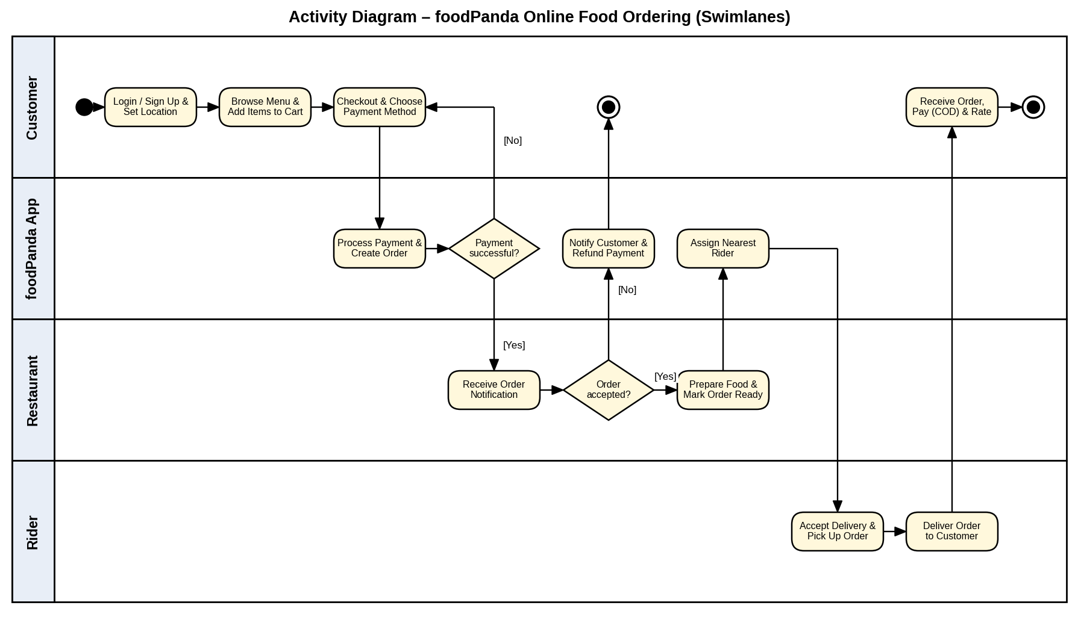

Q 2: State Diagram - Toaster
Task: draw a state diagram for a toaster, list the activities within each state, and identify the triggered and triggerless events/actions.

States and Their Activities
State | Activities within the state
Idle | entry / heater OFF  do / wait for bread
Bread Loaded | entry / detect bread  do / read darkness setting
Toasting | entry / lower carriage  entry / heater ON, start timer  do / heat bread  do / count down timer  exit / heater OFF
Ejecting | entry / release carriage spring  do / pop up toast
Toast Ready | do / wait for toast removal  exit / reset timer

Transitions
From | Event [guard] / action | To | Type
Initial node | – | Idle | Triggerless (initial transition)
Idle | insertBread | Bread Loaded | Triggered
Bread Loaded | removeBread | Idle | Triggered
Bread Loaded | pressLever [bread present] | Toasting | Triggered
Toasting | timerExpired | Ejecting | Triggered (time event)
Toasting | cancelPressed | Ejecting | Triggered
Ejecting | / sound ding | Toast Ready | Triggerless (completion transition)
Toast Ready | removeToast | Idle | Triggered
Idle | unplug | Final state | Triggered

Triggered and Triggerless Events / Actions
Triggered: insertBread, removeBread, pressLever [bread present], timerExpired, cancelPressed, removeToast and unplug. Each of these transitions fires only when its event occurs.
Triggerless: the initial transition into Idle and the transition from Ejecting to Toast Ready. They carry no event; the second one fires automatically when the do-activity of Ejecting (pop up toast) finishes. The entry and exit actions inside every state are also triggerless, because they run automatically on entering and leaving the state.

Figure 2: State Diagram - Toaster
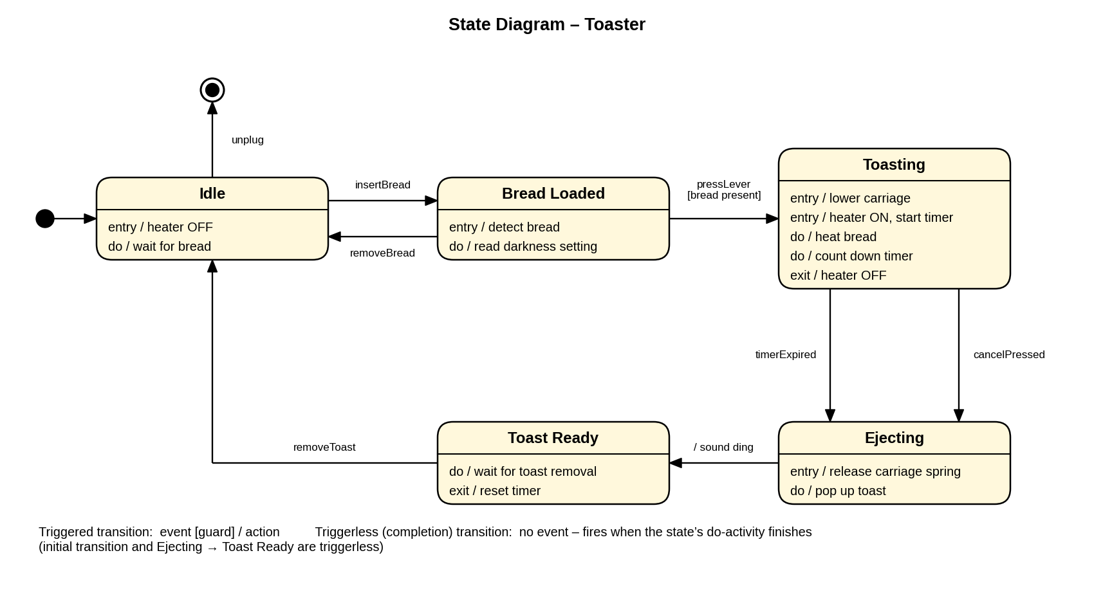

Q 3: State Machine Diagram - Elevator / Lift
Task: draw the state machine diagram of an elevator. The normal states are grouped in a composite state, Operational, so that a single emergency Pressed transition can leave it from any of them.

States and Their Activities
State | Activities within the state
Idle | entry / stop motor  do / wait for floor request  do / display current floor
Moving Up | entry / start motor (up)  do / move up, show floor  exit / stop motor
Moving Down | entry / start motor (down)  do / move down, show floor  exit / stop motor
Door Open | entry / open doors  do / hold open for 5 s  exit / close doors  openButtonPressed / restart timer (internal transition)
Emergency Stop | entry / apply brake, stop motor  do / sound alarm  do / notify control room  exit / silence alarm

Transitions
From | Event [guard] | To | Type
Initial node | – | Idle | Triggerless
Idle | floorRequested [target above] | Moving Up | Triggered
Idle | floorRequested [target below] | Moving Down | Triggered
Idle | floorRequested [same floor] | Door Open | Triggered
Moving Up | floorReached | Door Open | Triggered
Moving Down | floorReached | Door Open | Triggered
Door Open | After (5 s) | closeButtonPressed | Idle | Triggered (time event / button)
Operational | emergencyPressed | Emergency Stop | Triggered
Emergency Stop | resetByTechnician | Operational (Idle) | Triggered

Figure 3: State Machine Diagram – Elevator / Lift
