 | The University of Azad Jammu and Kashmir Muzaffarabad  Department of Software Engineering  Lab 1 | Semester: Fall 2026 | 

Course Title: Software Construction & Development (Lab)
Instructor: Engr. Dr Asma Javaid
Name: Saqlain Mushtaq Roll No: 2024-SE-35 Date: 21st Oct, 26

Q 1: Online Ticket Reservation System
Task: develop a use case diagram that can serve as a basis for understanding the requirements of an online ticket reservation system.

Actors
Actor | Type | Role in the system
Customer | Primary | Registers, searches for tickets, books and pays for a ticket, cancels a booking and views past bookings.
Admin | Primary | Maintains schedules, routes and ticket prices, and views sales reports.
Payment Gateway | Secondary (external system) | Authorizes and verifies the online payment made by the customer.

Use Cases
Use case | Description | Actor
Register Account | New customer creates an account with name, email, phone and password. | Customer
Login | User authenticates before booking or managing tickets. | Customer
Search Tickets | Search available trips/events by source, destination and date, and view fares. | Customer
Book Ticket | Reserve one or more tickets for the chosen trip (main use case). | Customer
Select Seat | Choose seat(s) from the seat map. | Included in Book Ticket
Make Payment | Pay the fare by card or online wallet; payment is verified. | Customer, Payment Gateway
Apply Discount Code | Optional promo code that reduces the fare. | Extends Make Payment
Generate E-Ticket | Issue the ticket with booking ID and QR code. | Included in Book Ticket
Send Confirmation Email / SMS | Notify the customer that the booking is confirmed. | Included in Generate E-Ticket
Cancel Booking | Cancel a confirmed booking. | Customer
Request Refund | Refund of the fare, only when the booking is eligible. | Extends Cancel Booking
View Booking History | See past and upcoming bookings. | Customer
Manage Schedules & Routes | Add, edit or remove schedules and routes. | Admin
Manage Ticket Prices | Set and update fares. | Admin
Generate Reports | Sales and booking reports. | Admin

Relationships
Type | From → To | Reason
«include» | Book Ticket → Login, Select Seat, Make Payment, Generate E-Ticket | Always performed as part of booking.
«include» | Cancel Booking → Login | Login is mandatory.
«include» | Generate E-Ticket → Send Confirmation Email / SMS | Every ticket is notified.
«extend» | Apply Discount Code → Make Payment | Optional behavior.
«extend» | Request Refund → Cancel Booking | Only if refund conditions are met.

Figure 1: Use Case Diagram – Online Ticket Reservation System
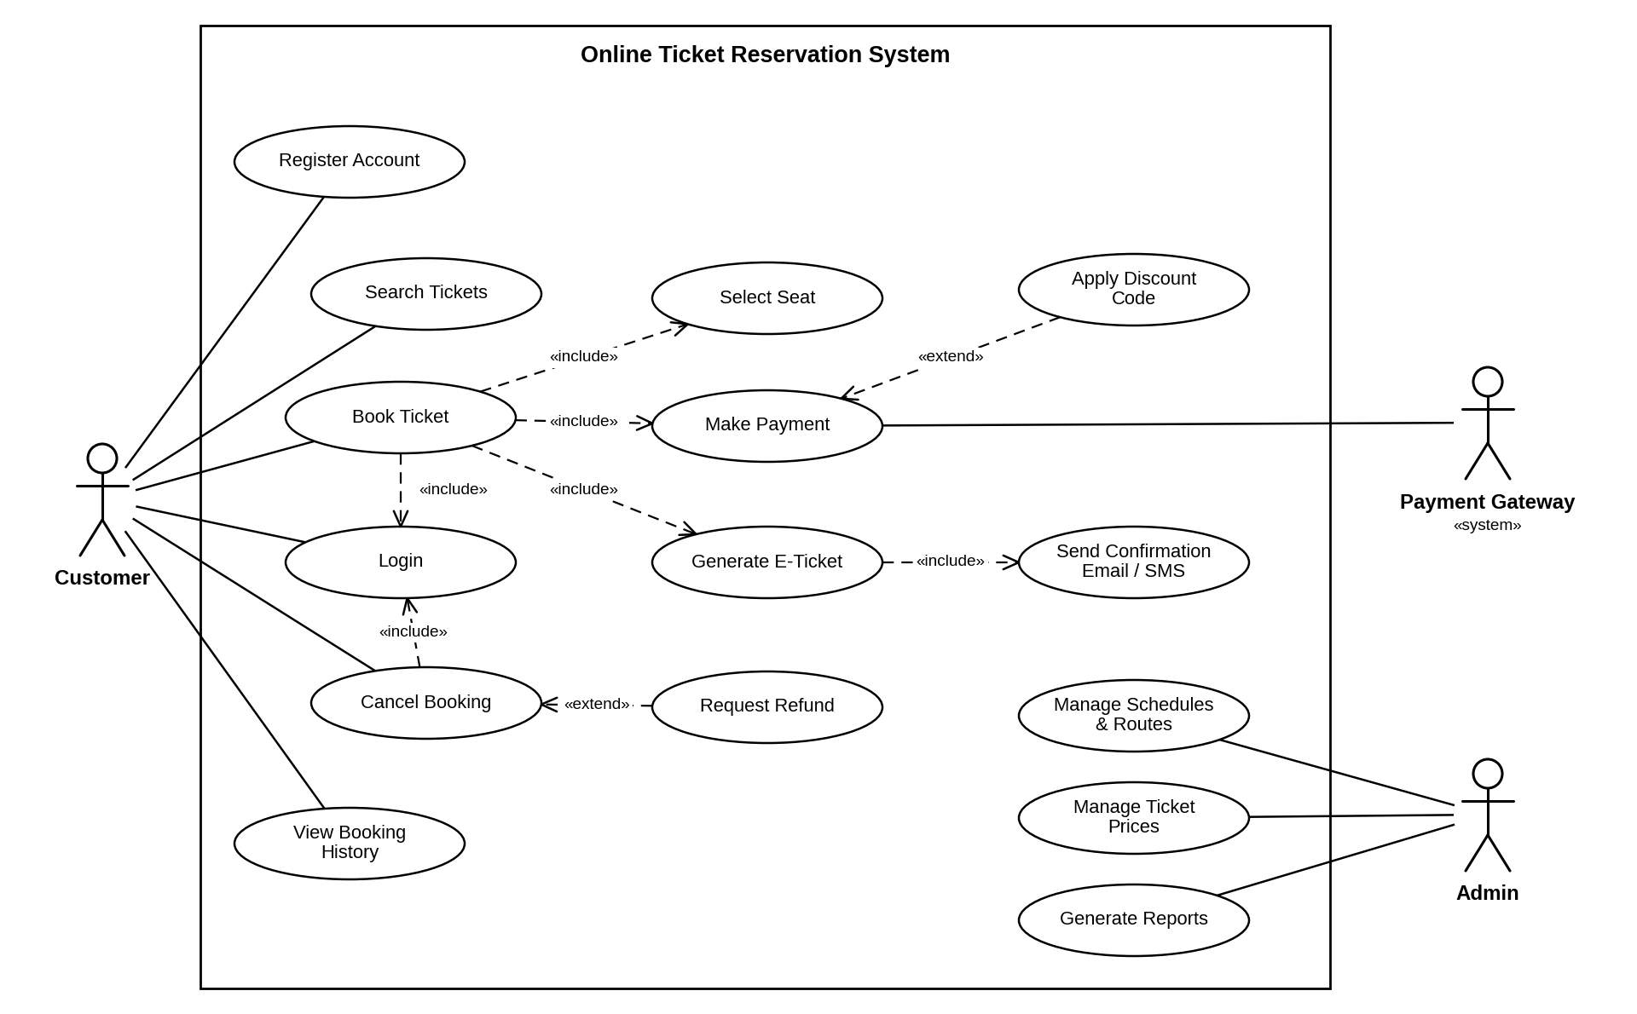

Q 2: Credit Card Processing System

Actors
Actor | Type | Role in the system
Customer | Primary | Selects the item, gives the credit card, requests the transaction amount, signs and returns the receipt.
Vendor | Primary | Makes the bill, swipes the card, issues the balance statement and receives the signed receipt.
Credit Card Machine (Card Reader) | Secondary | Processes the transaction and prints the balance statement / receipt.

Use Cases
Use case | Taken from the case study | Actor
Select Item | Customer selects the item to be purchased from the shop. | Customer
Give Credit Card | Customer gives the credit card to the vendor. | Customer
Request Transaction Amount | Customer requests the kind of amount transaction. | Customer
Create Bill | Vendor makes the bill for the selected item. | Vendor
Swipe Credit Card | Vendor swipes the card. | Vendor
Process Transaction | The required amount transaction is done by the card reader. | Credit Card Machine
Check Credit Limit | The system maintains the limitation of the card balance (derived). | Included in Process Transaction
Update Credit Balance | The transaction process updates the balance (derived). | Included in Process Transaction
Print Balance Statement / Receipt | The machine gives the balance print statement or receipt. | Credit Card Machine
Issue Balance Statement | Vendor issues the balance statement to the customer. | Vendor
Sign Receipt | Customer puts his signature on the receipt. | Included in Return Receipt
Return Receipt | Customer returns the signed receipt to the vendor. | Customer, Vendor

Relationships
Type | From → To | Reason
«include» | Swipe Credit Card → Process Transaction | Swiping always triggers processing.
«include» | Process Transaction → Check Credit Limit, Update Credit Balance, Print Balance Statement / Receipt | Steps always done while processing.
«include» | Return Receipt → Sign Receipt | Receipt must be signed before it is returned.

Figure 2: Use Case Diagram – Credit Card Processing System
