 | The University of Azad Jammu and Kashmir Muzaffarabad  Department of Software Engineering  Lab 3 | Semester: Fall 2026 | 

Course Title: Software Construction & Development (Lab)
Instructor: Engr. Dr Asma Javaid
Name: Saqlain Mushtaq Roll No: 2024-SE-35 Date: 1st Nov, 26

1. Objective
The objective of this lab is to understand and draw UML sequence diagrams. A sequence diagram shows how actors and system components interact with each other, and in which order messages are exchanged over time. In this lab, sequence diagrams are drawn for two systems: cash withdrawal from an ATM and an online ticket reservation system.

2. Notation Used
- Lifeline: a box at the top with a dashed vertical line below it; it represents an actor or a system component.
- Message: a solid arrow from one lifeline to another; it represents a request or a function call.
- Return message: a dashed arrow; it represents a reply or a result sent back.
- Time: flows from top to bottom, so the upper message happens first. Messages are numbered to show the order.

3. Question 1: Sequence Diagram for Cash Withdrawal from an ATM
This diagram models the data processing involved when a customer withdraws cash from an ATM. The lifelines are Customer, ATM, Bank server and Account DB.
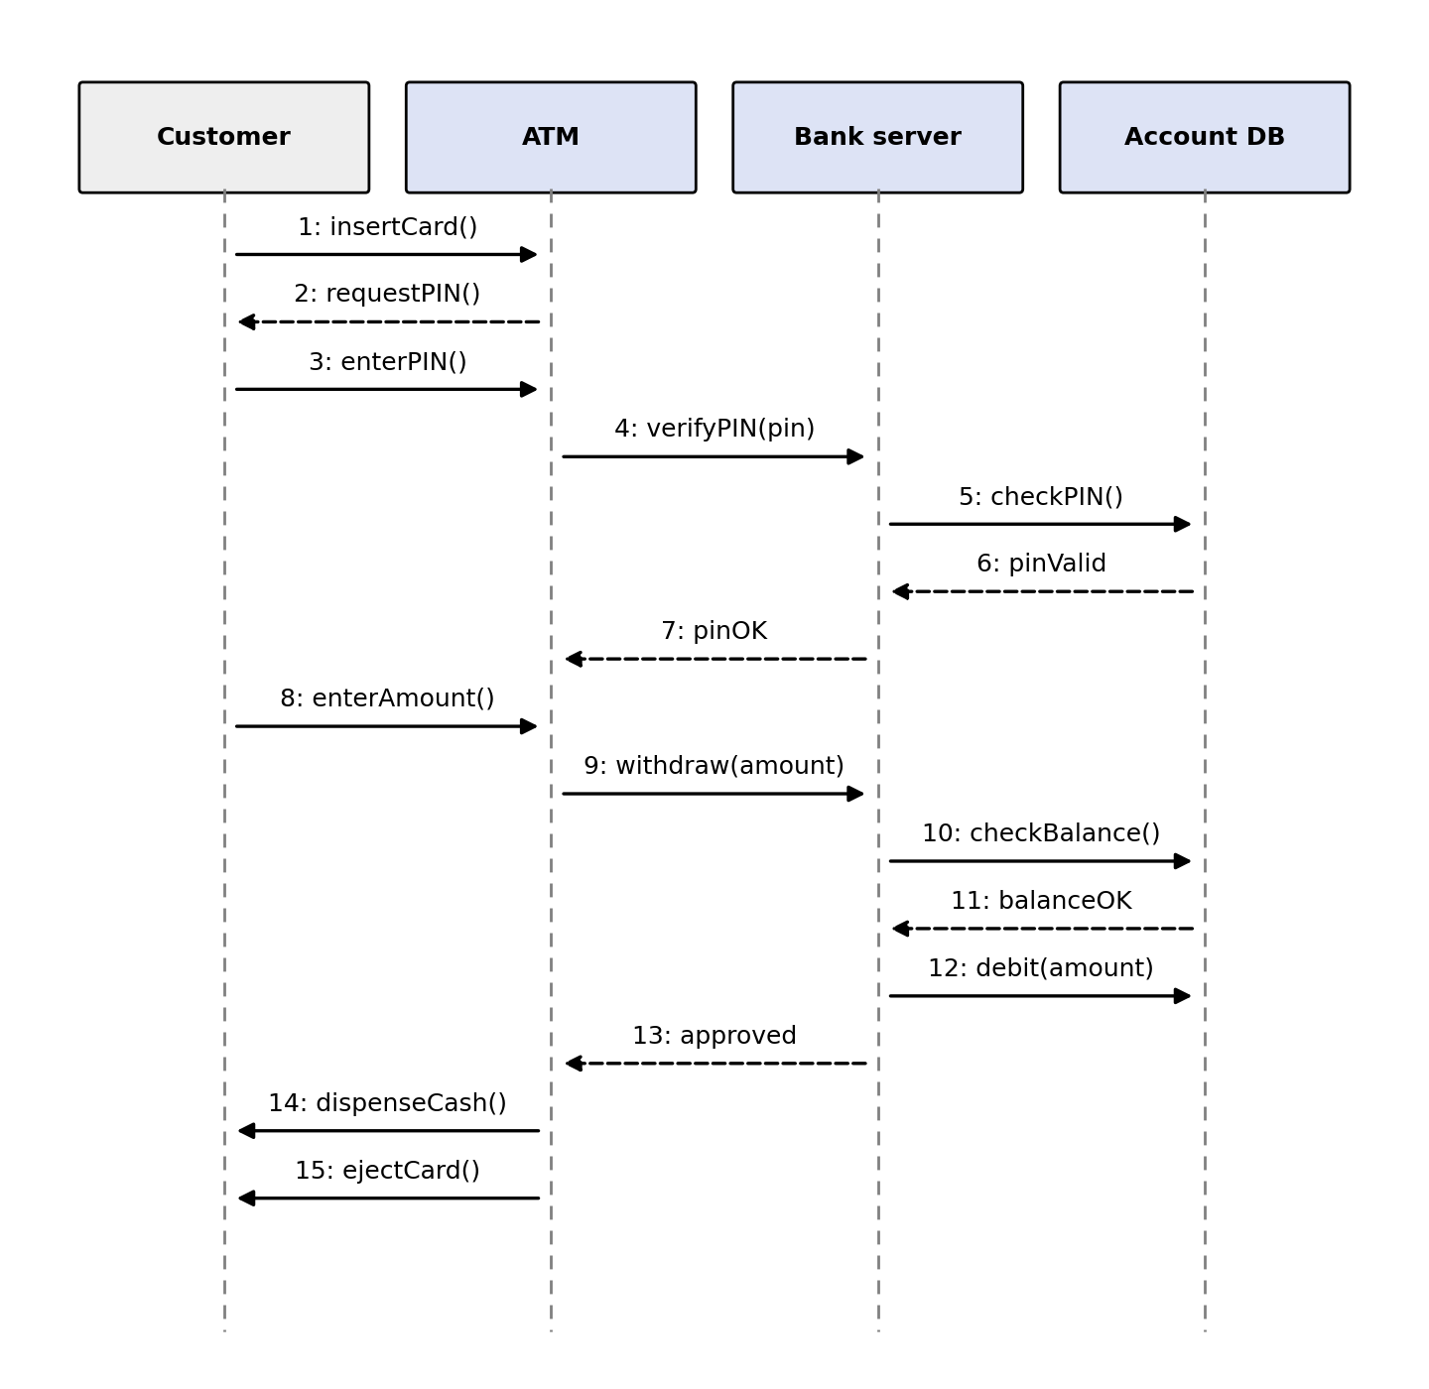
Figure 1: Sequence diagram for cash withdrawal from an ATM

Explanation of the messages
- The customer inserts the ATM card (insertCard()).
- The ATM asks the customer for the PIN (requestPIN()).
- The customer enters the PIN (enterPIN()).
- The ATM sends the PIN to the bank server for verification (verifyPIN(pin)).
- The bank server asks the account database to check the PIN (checkPIN()).
- The account database confirms that the PIN is valid (pinValid).
- The bank server informs the ATM that the PIN is correct (pinOK).
- The customer enters the amount to withdraw (enterAmount()).
- The ATM sends the withdrawal request to the bank server (withdraw(amount)).
- The bank server checks the account balance in the database (checkBalance()).
- The database confirms that the balance is sufficient (balanceOK).
- The bank server deducts the amount from the account (debit(amount)).
- The bank server approves the transaction and informs the ATM (approved).
- The ATM dispenses the cash to the customer (dispenseCash()).
- The ATM ejects the card (ejectCard()) and the transaction ends.
If the PIN is wrong (step 6) or the balance is not enough (step 11), the ATM shows an error message and cash is not dispensed.

4. Question 2: Sequence Diagram for the Online Ticket Reservation System
This diagram models how a customer books a ticket through an online system. The lifelines are Customer, Website, Booking system and Payment system.
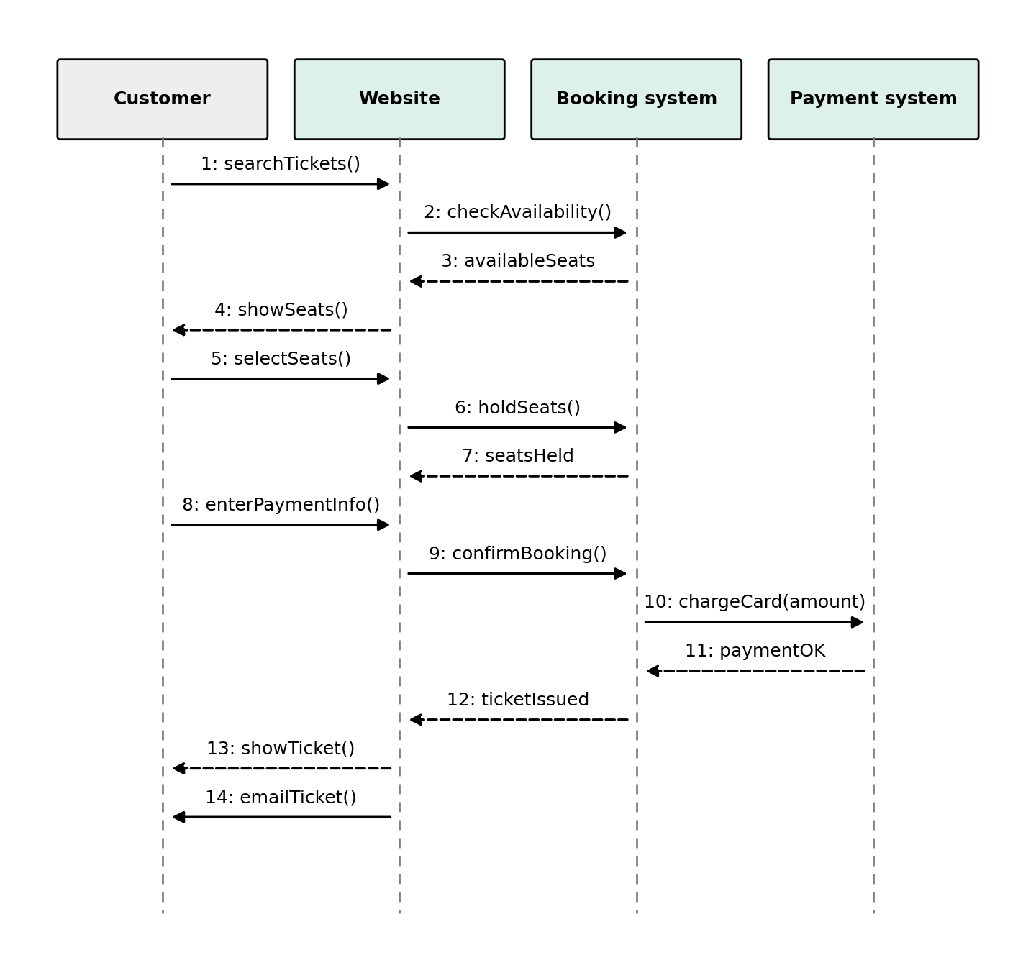
Figure 2: Sequence diagram for the online ticket reservation system

Explanation of the messages
- The customer searches for tickets by route, date or event (searchTickets()).
- The website asks the booking system whether seats are available (checkAvailability()).
- The booking system returns the list of available seats (availableSeats).
- The website displays the available seats to the customer (showSeats()).
- The customer selects the desired seats (selectSeats()).
- The website asks the booking system to hold the selected seats (holdSeats()).
- The booking system confirms that the seats are held (seatsHeld).
- The customer enters the payment information (enterPaymentInfo()).
- The website requests the booking system to confirm the booking (confirmBooking()).
- The booking system asks the payment system to charge the card (chargeCard(amount)).
- The payment system confirms that the payment was successful (paymentOK).
- The booking system issues the ticket and informs the website (ticketIssued).
- The website shows the ticket to the customer (showTicket()).
- The ticket is also sent to the customer by email (emailTicket()).
If the payment fails (step 11), the held seats are released and an error message is shown to the customer.

5. Conclusion
In this lab, sequence diagrams were drawn for the ATM cash withdrawal process and the online ticket reservation system. The diagrams show clearly which component sends which message and in what order, which helps in understanding the flow of data and in designing the system before implementation.

