 | The University of Azad Jammu and Kashmir Muzaffarabad  Department of Software Engineering  Lab 4 | Semester: Fall 2026 | 

Course Title: Software Construction & Development (Lab)
Instructor: Engr. Dr Asma Javaid
Name: Saqlain Mushtaq Roll No: 2024-SE-35 Date: 1st Nov, 26

Question 1: Online Doctor Appointment Management System

1.1 Problem Overview (How the system works)
- A patient creates an account and logs in to the system.
- The patient selects a specialist doctor and sends an appointment request with a date and time.
- The doctor (who has his/her own account) views the incoming appointment requests.
- The system checks the doctor's schedule. If the slot is free, the doctor accepts the request; if the doctor is busy and has no empty slot, the doctor rejects it.
- When the request is accepted, a confirmation is sent to the patient that the appointment is confirmed at the hospital/clinic.

1.2 Identified Classes (Summary)
Class | Role in the system
User | Base class for all account holders (common data and login operations).
Patient | Requests, cancels and views appointments; receives notifications.
Doctor | Views requests, checks availability, accepts or rejects appointments.
Appointment | Connects a patient and a doctor for a date/time; keeps the status.
Schedule | Keeps the doctor's time slots and whether each slot is free or booked.
Notification | Sends the confirmation (or rejection) message to the patient.
Hospital | Hospital/clinic where the doctor meets the patient.

1.3 Explanation and UML Class Diagram of Each Class
(1) User Class
A general (base) class for every person who has an account in the system. It stores the common login and personal information (id, name, email, password, phone) and common operations such as register, login, logout and update profile. Patient and Doctor inherit from it.
User
- userId : int
- name : string
- email : string
- password : string
- phone : string
+ register() : void
+ login() : bool
+ logout() : void
+ updateProfile() : void
Figure 1.1: UML class diagram of User
(2) Patient Class
Represents the person who needs medical care. A patient creates an account, searches for a doctor/specialist, sends an appointment request, can cancel it, and receives the confirmation or rejection message. It inherits from User.
Patient
- age : int
- gender : string
- medicalHistory : string
+ requestAppointment(doctor, date, time) : Appointment
+ cancelAppointment(appointmentId) : void
+ viewAppointments() : list
+ viewNotifications() : list
Figure 1.2: UML class diagram of Patient (Inherits from User)
(3) Doctor Class
Represents the health specialist with his/her own account. A doctor sees the appointment requests, checks whether his/her schedule is free, and then accepts the request (if a slot is free) or rejects it (if he/she is busy). It inherits from User.
Doctor
- specialization : string
- licenseNo : string
- hospitalId : int
+ viewRequests() : list
+ checkAvailability(date, time) : bool
+ acceptAppointment(appointmentId) : void
+ rejectAppointment(appointmentId) : void
+ manageSchedule() : void
Figure 1.3: UML class diagram of Doctor (Inherits from User)
(4) Appointment Class
The central class of the system. It links one patient with one doctor for a given date and time. Its status changes from Pending to Confirmed or Rejected (or Cancelled by the patient).
Appointment
- appointmentId : int
- date : Date
- time : Time
- reason : string
- status : string (Pending / Confirmed / Rejected / Cancelled)
+ create() : void
+ confirm() : void
+ reject() : void
+ cancel() : void
+ getDetails() : string
Figure 1.4: UML class diagram of Appointment
(5) Schedule Class
Stores the available time slots of a doctor at the hospital/clinic. When the doctor receives a request, the system checks the schedule: if the slot is free the request can be accepted, otherwise it is rejected.
Schedule
- scheduleId : int
- date : Date
- startTime : Time
- endTime : Time
- isBooked : bool
+ addSlot() : void
+ isSlotFree() : bool
+ bookSlot() : void
+ releaseSlot() : void
Figure 1.5: UML class diagram of Schedule
(6) Notification Class
Used to send messages to the patient. When the doctor accepts an appointment, a confirmation notification is sent to the patient; for a rejection, a rejection message is sent.
Notification
- notificationId : int
- message : string
- sentDate : Date
- isRead : bool
+ sendConfirmation() : void
+ sendRejection() : void
+ markAsRead() : void
Figure 1.6: UML class diagram of Notification
(7) Hospital Class
Represents the hospital/clinic where the meeting takes place. It keeps the hospital details and the list of doctors who work there.
Hospital
- hospitalId : int
- name : string
- address : string
- phone : string
+ addDoctor(doctor) : void
+ getDoctors() : list
+ getLocation() : string
Figure 1.7: UML class diagram of Hospital

1.4 Complete UML Class Diagram (Relationships)
The diagram below shows all seven classes with their attributes, methods and the relationships between them (inheritance, association, aggregation and composition, with multiplicities).
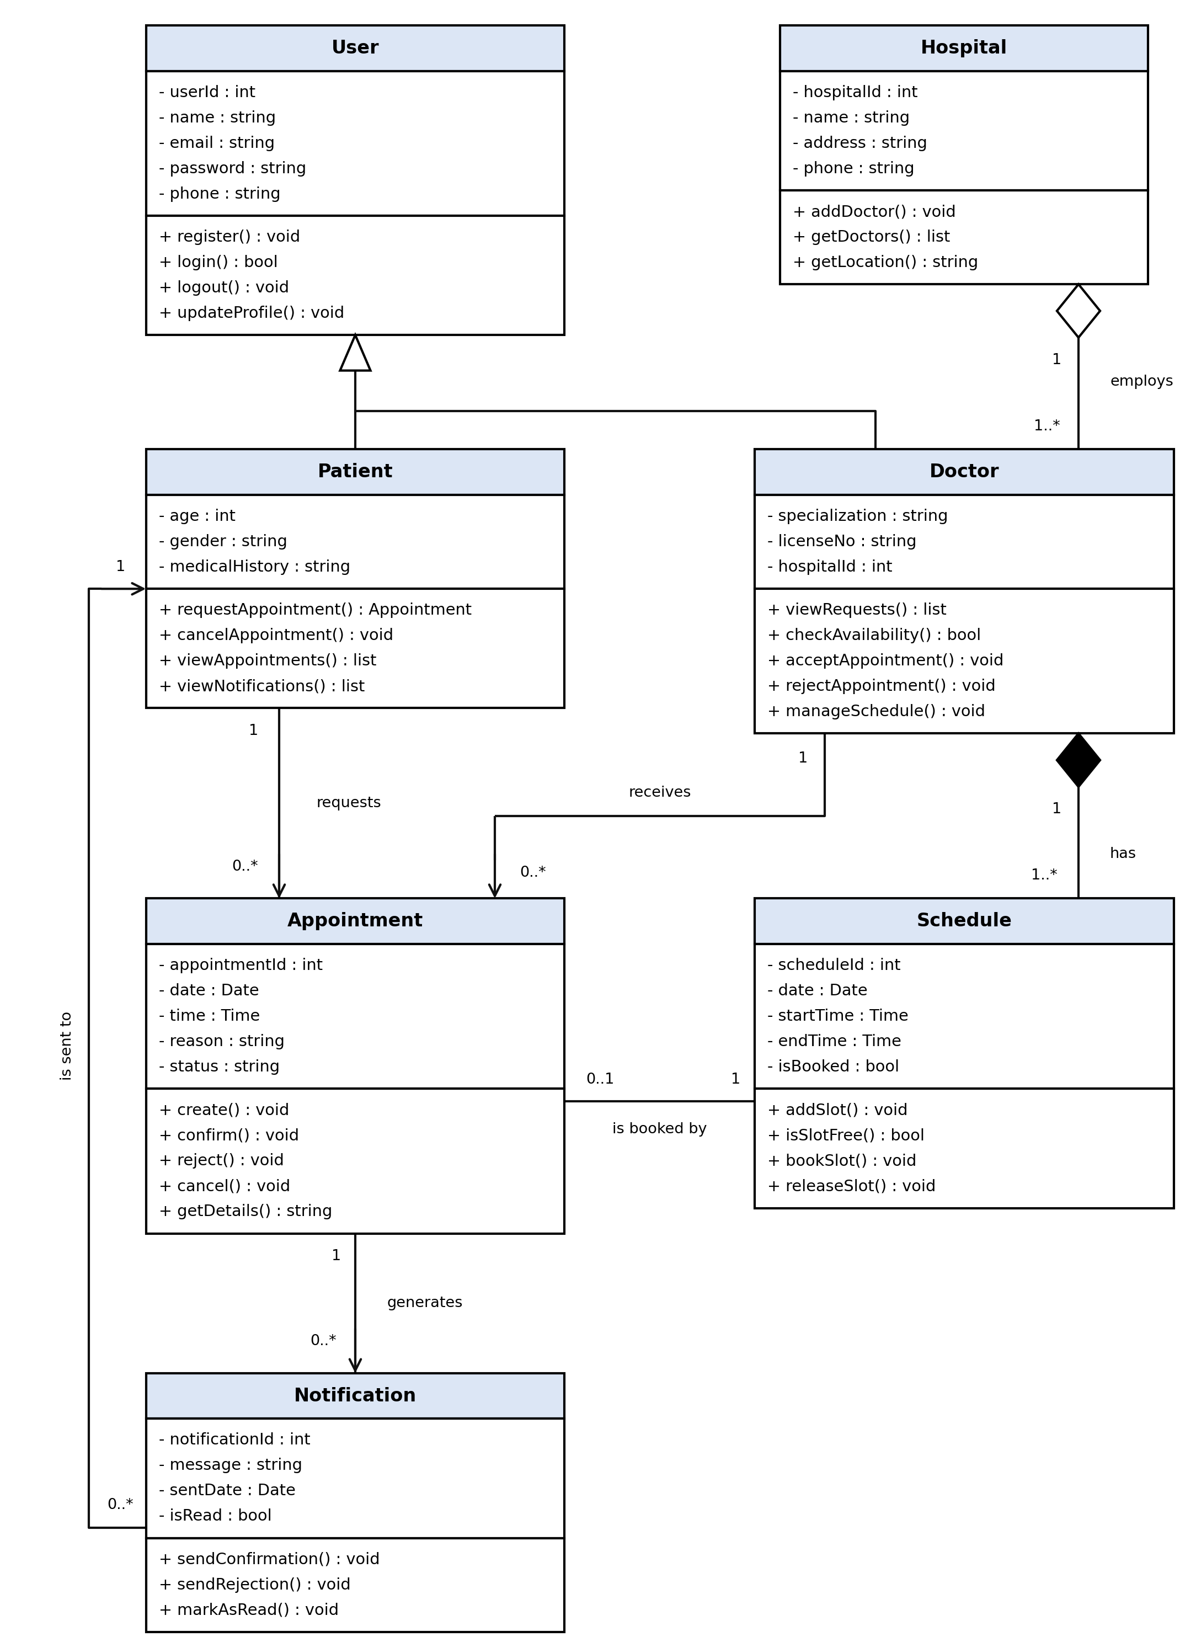
Figure 1.8: Complete UML class diagram of the Online Doctor Appointment Management System
Relationships between the classes
Class A | Relationship | Class B | Multiplicity (A : B)
User | Generalization (is-a) | Patient, Doctor | Patient and Doctor are kinds of User
Patient | requests (association) | Appointment | 1 : 0..*
Doctor | receives (association) | Appointment | 1 : 0..*
Doctor | has (composition) | Schedule | 1 : 1..*
Schedule | is booked by (association) | Appointment | 1 : 0..1
Appointment | generates (association) | Notification | 1 : 0..*
Notification | is sent to (association) | Patient | 0..* : 1
Hospital | employs (aggregation) | Doctor | 1 : 1..*

Visibility symbols: + public, - private, # protected.

Question 2: Animal, Cat and Dog (Inheritance)

2.1 Explanation
Animal is the superclass. It has the common behaviours eat() and sleep(). Cat and Dog are subclasses that inherit these behaviours from Animal and add their own: Cat can meow() and Dog can bark(). This is an example of single inheritance (is-a relationship).

2.2 Class Diagram
Animal
# name : string
+ Animal(n : string)
+ ~Animal()
+ eat() : void
+ sleep() : void

△
  Cat
  + Cat(n : string)
  + meow() : void
  Dog
  + Dog(n : string)
  + bark() : void
Figure 2.1: Class diagram of Animal, Cat and Dog

2.3 C++ Code
#include <iostream>
#include <string>
using namespace std;

// Superclass
class Animal {
protected:
string name;
public:
Animal(string n) : name(n) {}
virtual ~Animal() {}

void eat() {
cout << name << " is eating." << endl;
}
void sleep() {
cout << name << " is sleeping." << endl;
}
};

// Subclass Cat
class Cat : public Animal {
public:
Cat(string n) : Animal(n) {}

void meow() {
cout << name << " says: Meow! Meow!" << endl;
}
};

// Subclass Dog
class Dog : public Animal {
public:
Dog(string n) : Animal(n) {}

void bark() {
cout << name << " says: Woof! Woof!" << endl;
}
};

int main() {
Cat c("Tom");
Dog d("Bruno");

cout << "----- Cat -----" << endl;
c.eat();
c.sleep();
c.meow();

cout << "----- Dog -----" << endl;
d.eat();
d.sleep();
d.bark();

return 0;
}

2.4 Output
----- Cat -----
Tom is eating.
Tom is sleeping.
Tom says: Meow! Meow!
----- Dog -----
Bruno is eating.
Bruno is sleeping.
Bruno says: Woof! Woof!

Question 3: Shape, Triangle and Rectangle (Area)

3.1 Explanation
Shape is the superclass (abstract class) with two pure virtual functions: input() to take the dimensions from the user and area() to calculate the area. Triangle and Rectangle inherit from Shape and each provides its own implementation.
- Triangle area = 1/2 × base × height
- Rectangle area = length × width

3.2 Class Diagram
{abstract}
Shape
+ input() : void {abstract}
+ area() : double {abstract}
+ ~Shape()

△
  Triangle
  - base : double
  - height : double
  + input() : void
  + area() : double
  Rectangle
  - length : double
  - width : double
  + input() : void
  + area() : double
Figure 3.1: Class diagram of Shape, Triangle and Rectangle

3.3 C++ Code
#include <iostream>
using namespace std;

// Superclass (abstract)
class Shape {
public:
virtual void input() = 0; // take dimensions from user
virtual double area() = 0; // calculate area
virtual ~Shape() {}
};

// Subclass Triangle
class Triangle : public Shape {
private:
double base, height;
public:
void input() {
cout << "Enter base of triangle: ";
cin >> base;
cout << "Enter height of triangle: ";
cin >> height;
}
double area() {
return 0.5 * base * height;
}
};

// Subclass Rectangle
class Rectangle : public Shape {
private:
double length, width;
public:
void input() {
cout << "Enter length of rectangle: ";
cin >> length;
cout << "Enter width of rectangle: ";
cin >> width;
}
double area() {
return length * width;
}
};

int main() {
Triangle t;
Rectangle r;
Shape *s;

s = &t;
s->input();
cout << "Area of Triangle = " << s->area() << endl << endl;

s = &r;
s->input();
cout << "Area of Rectangle = " << s->area() << endl;

return 0;
}

3.4 Sample Output
Enter base of triangle: 10
Enter height of triangle: 5
Area of Triangle = 25

Enter length of rectangle: 8
Enter width of rectangle: 4
Area of Rectangle = 32

