LAB MANUAL 05: INTERCONNECTING TWO SWITCHES WITH 6 PCS (SIMULATION)

Connecting Two Switches with Multiple PCs and Testing using Simulation Mode in Cisco Packet Tracer

Apparatus / Requirements
- 2 × 2960 Switches
- 6 × PCs
- Copper Straight-Through cables
- Cisco Packet Tracer

Theory
A switch is a networking device used to connect multiple devices in a Local Area Network (LAN). When two switches are connected, they allow communication between devices connected to different switches.
Switches forward data using MAC addresses. In this lab, ICMP protocol (ping) is used to test connectivity. Also, Spanning Tree Protocol (STP) runs in the background to prevent loops.

PROCEDURE

Step 1: Create Topology
- Open Cisco Packet Tracer
- Place:
- 2 switches
- 6 PCS

Step 2: Connect Devices
PC Connections:
- PC0 → Switch0 (Fa0/1)
- PC1 → Switch0 (Fa0/2)
- PC2 → Switch0 (Fa0/3)
- PC3 → Switch1 (Fa0/1)
- PC4 → Switch1 (Fa0/2)
- PC5 → Switch1 (Fa0/3)
Switch-to-Switch Connection:
- Switch0 (Fa0/24) → Switch1 (Fa0/24)

Step 3: Assign IP Addresses

PC | IPAddress | SubnetMask
PC0 | 192.168.1.1 | 255.255.255.0
PC1 | 192.168.1.2 | 255.255.255.0
PC2 | 192.168.1.3 | 255.255.255.0
PC3 | 192.168.1.4 | 255.255.255.0
PC4 | 192.168.1.5 | 255.255.255.0
PC5 | 192.168.1.6 | 255.255.255.0

Step 4: Simulation Testing
1. Switch to Simulation Mode
2. Use Add Simple PDU (envelope icon)
3. Send packet from:
o PC5 → PC1 (as shown in screenshot)
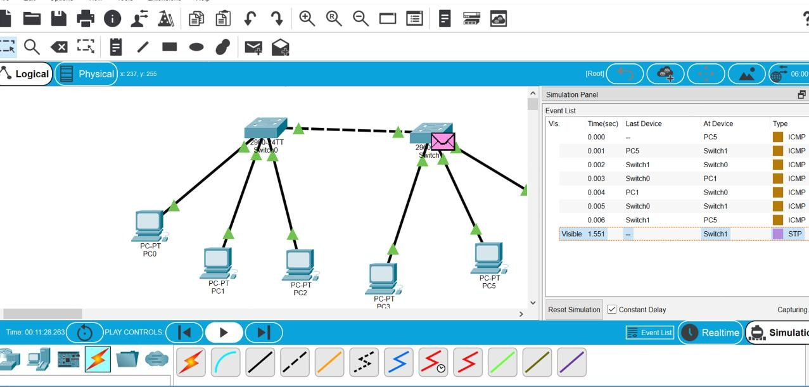
Step5: observe packet flow
From Simulation Event List:
PC5 → Switch1 → Switch0 → PC1 → Switch0 → Switch1 → PC5
This shows:
- Request reached destination
- Reply returned successfully

Observations
- Successful ICMP packets confirm connectivity
- Data travels through both switches
- STP protocol is visible in simulation (normal behaviour)
- Green indicators show active links

Precautions
- Ensure all PCs are in same network
- Use correct cable type
- Wait for links to turn green
- Avoid duplicate IP addresses

Result
The two switches were successfully interconnected, and communication between six PCs was verified using simulation mode and ICMP protocol.

Conclusion
The experiment demonstrated that multiple PCs connected to different switches can communicate successfully when switches are interconnected, and data transmission was verified using ICMP in simulation mod

