

University of Azad Jammu and Kashmir
Department of Software Engineering
Digital Image Processing (Lab)
LAB REPORT 02
Digital Image Fundamentals Using NumPy, OpenCV and Matplotlib
Loading, Inspecting, Transforming and Analyzing Digital Images
Name | Saqlain Mushtaq
Roll No. | 2024-SE-35
Semester | Fifth
Session | 2024–28 (SE)
Submitted to | Engr. Fahad Nisar
Date of Submission | 29th Oct, 2026

1. Objective
The objective of this lab is to use NumPy, OpenCV and Matplotlib to load, inspect, display, analyze, transform and save digital images, while correctly handling pixel coordinates, color channels, histograms, resolution and bit depth.

2. Tools and Requirements
- Python 3 with a project-specific virtual environment (.venv)
- Visual Studio Code as the code editor
- Libraries: numpy, opencv-python (cv2) and matplotlib
- One personally selected color JPG or PNG image of at least 300 × 300 pixels

3. Theory

3.1 Digital Image
A digital image is a two-dimensional grid of small elements called pixels. Each pixel stores a numeric intensity value. In a grayscale image every pixel has one value, while in a color image every pixel has three values (one per color channel). In NumPy, an 8-bit color image is stored as an array of shape (height, width, channels) with data type uint8, so every value lies between 0 (black) and 255 (full intensity).

3.2 Coordinate System and Indexing
The origin (0, 0) of an image is its top-left corner. Rows (the y-axis) increase downward and columns (the x-axis) increase to the right. NumPy indexing follows the order image[row, column], that is image[y, x], and all indices start at zero. A region is cropped with image[y_start:y_end, x_start:x_end]; the end index is exclusive, so a crop of exactly 100 × 100 pixels requires y_end − y_start = 100 and x_end − x_start = 100.

3.3 Color Channels and Color Spaces
OpenCV loads color images in BGR (Blue, Green, Red) order, whereas Matplotlib expects RGB. If a BGR image is passed directly to Matplotlib, the red and blue channels are swapped and the colors look wrong. The function cv.cvtColor() is therefore used to convert between color spaces. A grayscale image is computed as a weighted sum of the channels, Y = 0.299 R + 0.587 G + 0.114 B, because the human eye is most sensitive to green. When a single channel is displayed with a gray colormap, regions where that color is strong appear bright. A color can also be written in HEX form as #RRGGBB, where each pair of hexadecimal digits represents the value of one channel.

3.4 Resizing and Interpolation
Resizing changes the number of pixels in an image. New pixel values are estimated from neighboring pixels by interpolation; cv.resize() uses bilinear interpolation (INTER_LINEAR) by default. Note that cv.resize() takes the size as (width, height), whereas the .shape attribute reports (height, width, channels).

3.5 Histogram
An image histogram counts how many pixels have each intensity value. For an 8-bit grayscale image it has 256 bins (0 to 255), with the horizontal axis showing intensity and the vertical axis showing the number of pixels. A histogram concentrated on the left indicates a dark image, one concentrated on the right indicates a bright image, and one spread across the range indicates a balanced image with good contrast.

3.6 Resolution and Bit Depth
Resolution is the number of pixels in an image (for example 640 × 480) and determines how much spatial detail it can represent. Bit depth is the number of bits used to store each pixel and determines how many intensity levels exist: an n-bit pixel can take 2ⁿ different values (1-bit = 2, 2-bit = 4, 4-bit = 16, 8-bit = 256 levels). Reducing the bit depth is called quantization; it produces visible bands (false contours) in smooth areas because many neighboring values are merged into one.

3.7 Virtual Environment
A virtual environment is an isolated Python installation created for one project. Packages installed in it do not affect other projects or the system Python, which prevents version conflicts. The environment folder (.venv) is excluded from version control and from submission through the .gitignore file.

4. Procedure

Step 1: Create the Project and Virtual Environment
A folder named dip-lab-02 was created and opened in VS Code. A virtual environment was created with python -m venv .venv and activated. NumPy, OpenCV and Matplotlib were then installed inside it. The imports and the Python executable path were checked to confirm that the environment is active, and the line .venv/ was added to a .gitignore file.
mkdir dip-lab-02
cd dip-lab-02
python -m venv .venv
.venv\Scripts\activate.bat (Command Prompt)
.venv\Scripts\Activate.ps1 (PowerShell)
python -m pip install numpy opencv-python matplotlib
python -c "import numpy, cv2, matplotlib; print('imports ok')"
python -c "import sys; print(sys.executable)"
The output of the last command shows a path ending in lab-02_dip_2024-SE-35\.venv\Scripts\Activated.ps1, which confirms that the virtual environment is being used.
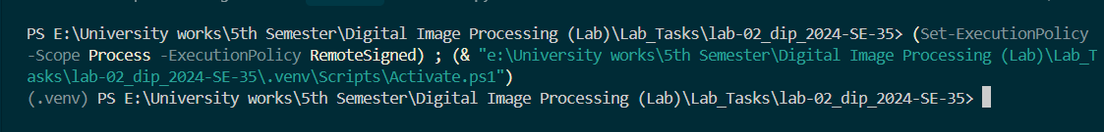

Step 2: Load the Image
The selected image was placed in the dip-lab-02 folder and the script lab02.py was created. The libraries were imported with the standard aliases cv, np and plt. The image was loaded with cv.imread(), which returns None instead of raising an error when the file is missing, so an explicit check raises FileNotFoundError.
import cv2 as cv
import numpy as np
import matplotlib.pyplot as plt

IMAGE_PATH = "my_photo.jpg"
image_bgr = cv.imread(IMAGE_PATH)
if image_bgr is None:
raise FileNotFoundError(f"Image not found: {IMAGE_PATH}")

print("Image shape:", image_bgr.shape)
print("Data type:", image_bgr.dtype)

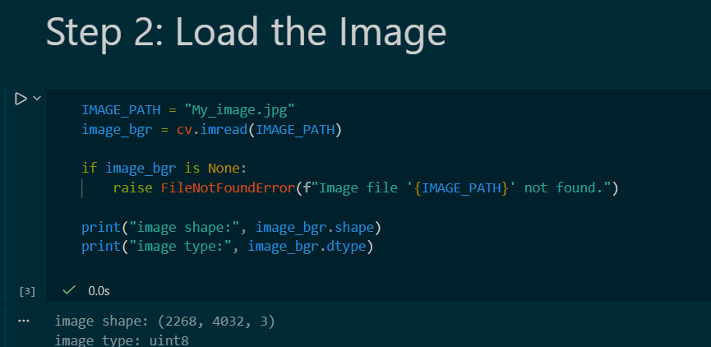

Step 3: Inspect the Image
The height, width and number of channels were obtained from the shape. The top-left pixel and the center pixel were printed using [row, column] indexing, and the global and per-channel minimum and maximum values were calculated. Because the image is still in BGR order at this stage, pixel values are printed as (B, G, R).
height, width, channels = image_bgr.shape
print(f"Image dimensions: {height} x {width} x {channels}")

cy, cx = height // 2, width // 2
print("Top-left pixel [0,0] (B,G,R):", image_bgr[0, 0])
print(f"Center pixel [{cy},{cx}] (B,G,R):", image_bgr[cy, cx])

print("Global min:", image_bgr.min(), " Global max:", image_bgr.max())
for i, name in enumerate(["Blue", "Green", "Red"]):
print(f"{name} channel -> min: {image_bgr[:, :, i].min()}, max: {image_bgr[:, :, i].max()}")

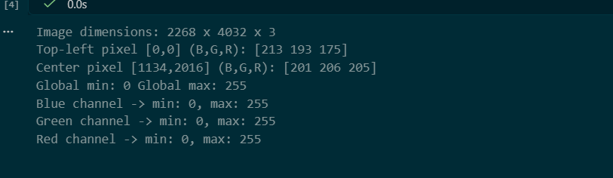

Step 4: Convert Colors and Separate Channels
The image was converted from BGR to RGB for correct display, and a grayscale version was created. The red, green and blue channels were separated and displayed together with the RGB, grayscale and unconverted BGR images in a 2 × 3 figure. A gray colormap was used for single-channel images, and axes were hidden. Finally, the RGB value of the center pixel was converted to HEX.
image_rgb = cv.cvtColor(image_bgr, cv.COLOR_BGR2RGB)
gray = cv.cvtColor(image_bgr, cv.COLOR_BGR2GRAY)
R, G, B = image_rgb[:, :, 0], image_rgb[:, :, 1], image_rgb[:, :, 2]

fig, axes = plt.subplots(2, 3, figsize=(12, 8))
items = [
(image_rgb, "RGB (correct)", None),
(R, "Red channel", "gray"),
(G, "Green channel", "gray"),
(B, "Blue channel", "gray"),
(gray, "Grayscale", "gray"),
(image_bgr, "BGR shown as RGB (wrong colors)", None),
]
for ax, (img, title, cmap) in zip(axes.ravel(), items):
ax.imshow(img, cmap=cmap)
ax.set_title(title)
ax.axis("off")
plt.tight_layout()
plt.show()

r, g, b = (int(v) for v in image_rgb[cy, cx])
print("Center pixel RGB:", (r, g, b), " HEX:", f"#{r:02X}{g:02X}{b:02X}")

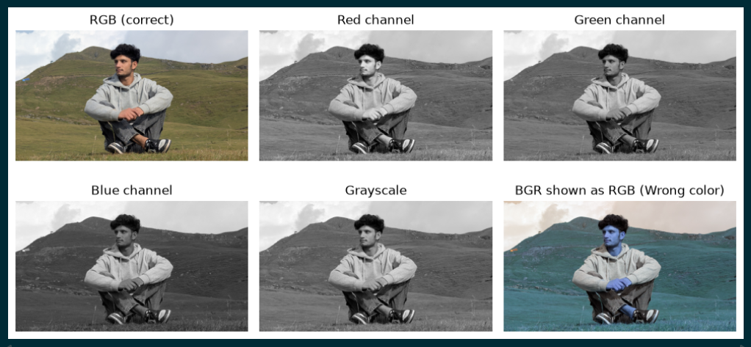

Center pixel RGB: (205, 206, 201) HEX: #cdcec9

Step 5: Crop, Resize and Save
An exact 100 × 100 pixel region around the center of the image was cropped using slicing, then enlarged to 200 × 200 pixels with cv.resize(). The original, the crop and the resized image were shown side by side. Since cv.imwrite() expects BGR order, the resized RGB image was converted back to BGR before being saved as resized_crop.png.
y_start, x_start = cy - 50, cx - 50
y_end, x_end = y_start + 100, x_start + 100

crop = image_rgb[y_start:y_end, x_start:x_end]
print("Crop shape:", crop.shape)

resized = cv.resize(crop, (200, 200), interpolation=cv.INTER_LINEAR)
print("Resized shape:", resized.shape)

fig, axes = plt.subplots(1, 3, figsize=(12, 4))
for ax, img, t in zip(axes, [image_rgb, crop, resized],
["Original", "Crop 100x100", "Resized 200x200"]):
ax.imshow(img)
ax.set_title(t)
ax.axis("off")
plt.show()

resized_bgr = cv.cvtColor(resized, cv.COLOR_RGB2BGR)
ok = cv.imwrite("resized_crop.png", resized_bgr)
print("resized_crop.png saved:", ok)
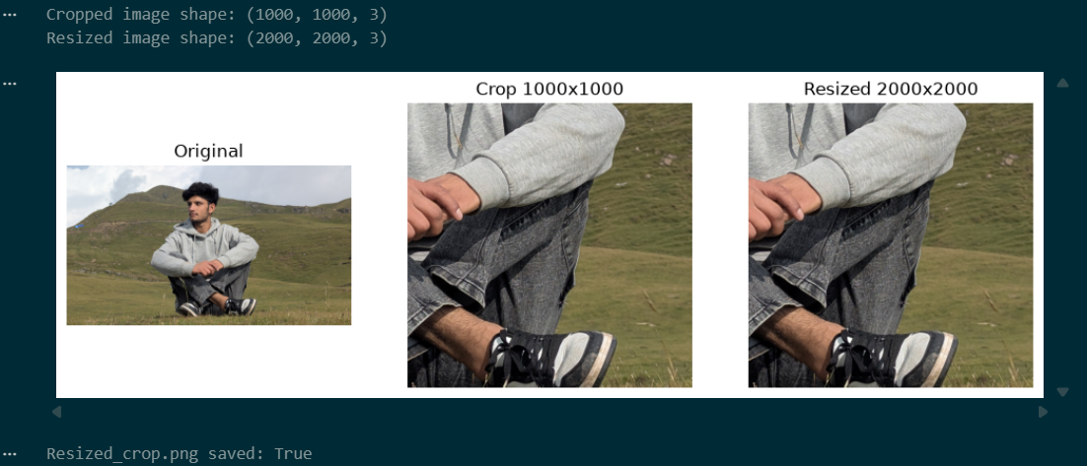

Step 6: Create a Histogram
The grayscale image was flattened to a one-dimensional array with ravel(), and a 256-bin histogram was plotted over the range 0–256 (the upper limit is exclusive, so intensity 255 is included). The plot was given a title and axis labels and saved as grayscale_histogram.png before calling plt.show().
plt.figure(figsize=(8, 4))
plt.hist(gray.ravel(), bins=256, range=(0, 256))
plt.title("Grayscale Histogram")
plt.xlabel("Pixel intensity (0-255)")
plt.ylabel("Number of pixels")
plt.savefig("grayscale_histogram.png")
plt.show()

print("Mean gray value:", round(float(gray.mean()), 1))

Mean gray value: 129.7
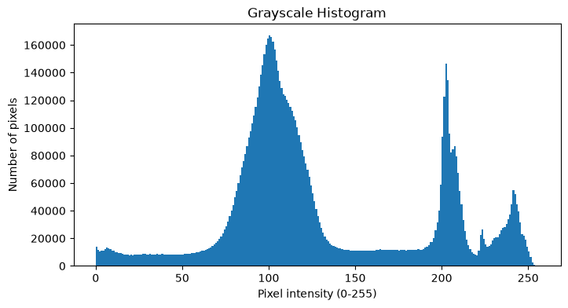

Step 7: Demonstrate Bit Depth
An 8-bit horizontal gradient from 0 to 255 was created by repeating one row of 256 values 100 times. It was quantized to 1, 2 and 4 bits by dividing the intensity range into 2, 4 and 16 equal groups and mapping each group to one value spread over 0–255. The original and the three quantized gradients were displayed in one figure with fixed display limits (vmin = 0, vmax = 255), and the number of unique values in each was printed.
gradient = np.tile(np.arange(256, dtype=np.uint8), (100, 1))

def quantize(img, bits):
levels = 2 ** bits
step = 256 // levels
return ((img // step) * (255 // (levels - 1))).astype(np.uint8)

versions = [(gradient, "8-bit (256 levels)")]
for k in (1, 2, 4):
versions.append((quantize(gradient, k), f"{k}-bit ({2**k} levels)"))

fig, axes = plt.subplots(1, 4, figsize=(8, 6))
for ax, (img, t) in zip(axes, versions):
ax.imshow(img, cmap="gray", vmin=0, vmax=255)
ax.set_title(t)
ax.axis("off")
plt.tight_layout()
plt.show()

for img, t in versions:
print(t, "unique values:", len(np.unique(img)))

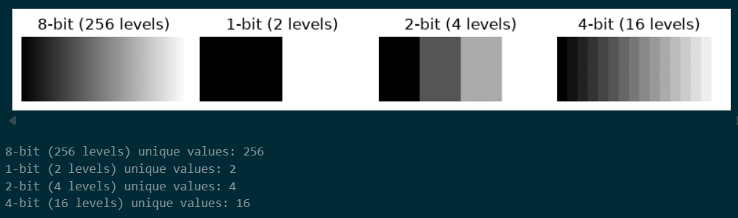

Step 8: Run and Complete the Project
The script was run from the activated environment and all errors were corrected. The environment was then deactivated.
python lab02.py
deactivate
Files kept for submission: lab02.py, the input image, resized_crop.png, grayscale_histogram.png, .gitignore and this report. The .venv folder is not submitted.

5. Results and Discussion

5.1 Image Properties
Property | Value
Image file name | My_image.jpg
Height × Width (pixels) | 2268, 4032
Number of channels | 3
Data type | uint8
Center pixel (R, G, B) | 205, 206, 201
Center pixel HEX | #cdcec9
Global minimum / maximum | Global min: 0 Global max: 255
Crop shape | (100, 100, 3)
Resized crop shape | (200, 200, 3)
resized_crop.png saved | True

5.2 Grayscale Histogram
Figure 1: Grayscale histogram of the selected image
The histogram shows that most pixels are concentrated in one large peak around intensity 100, mainly between 70 and 135, so the image is dominated by mid-tone gray values. A smaller group of bright pixels appears near 200 and 240, while very few pixels are close to black (0–50). Overall, the image is mainly balanced, leaning slightly toward darker mid-tones, with a mean intensity of about 129.7 and some bright highlights.

5.3 Bit Depth
Bit depth | Expected number of levels | Unique values measured
8-bit | 256 | 256
1-bit | 2 | 2
2-bit | 4 | 4
4-bit | 16 | 16

As the bit depth decreases, the smooth gradient is divided into fewer and wider steps. The 4-bit gradient still looks fairly smooth with 16 visible bands, the 2-bit gradient shows only four distinct bands, and the 1-bit gradient contains only black and white.

5.4 Resolution versus Bit Depth
Resolution is the number of pixels in the image, which controls how much spatial detail can be shown. Bit depth is the number of intensity levels each pixel can take, which controls how finely brightness and color can be represented. In this lab, resizing the crop from 100 × 100 to 200 × 200 changed the resolution, while quantizing the gradient to 1, 2 and 4 bits changed the bit depth without changing the image size.

6. Conclusion
In this lab, a project-specific virtual environment was set up and a personal color image was loaded, inspected, displayed, transformed and saved using NumPy, OpenCV and Matplotlib. It was observed that OpenCV uses BGR order and therefore requires conversion to RGB for correct display, that NumPy indexing uses [row, column] with the origin at the top-left corner, and that cropping with slicing excludes the end index. The grayscale histogram described the overall brightness distribution of the image, and the bit-depth experiment showed that fewer intensity levels cause visible banding, which is different from changing the image resolution.

