 | The University of Azad Jammu and Kashmir Muzaffarabad  Department of Software Engineering  Lab 1 | Semester: Fall 2026 | 
Course Title: Digital Image Processing (Lab)
Instructor: Engr. Fahad Nisar
Name: Saqlain Mushtaq Roll No: 2024-SE-35 Date: 23rd Oct, 26

Step 1–2: Install Python and Verify Python and pip
Commands run in Command Prompt:
python --version
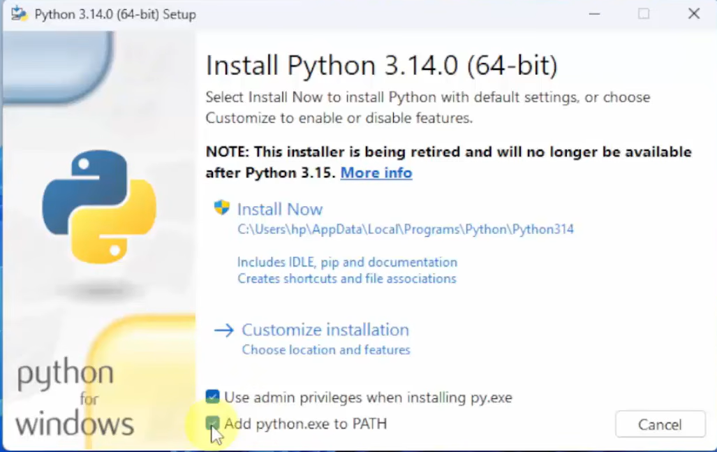
python -m pip –version
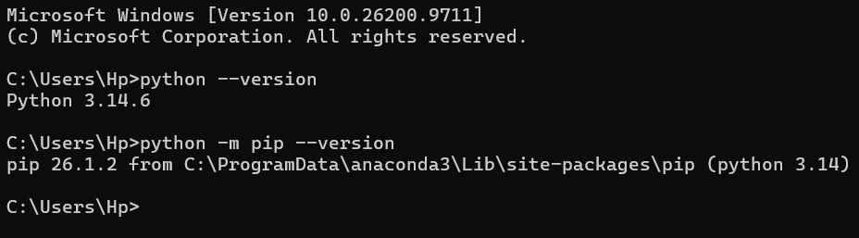

Step 3: VS Code and Python Interpreter
Installed VS Code, added the Python extension by Microsoft (Ctrl+Shift+X), then selected the Python 3 interpreter using Ctrl+Shift+P > Python: Select Interpreter.
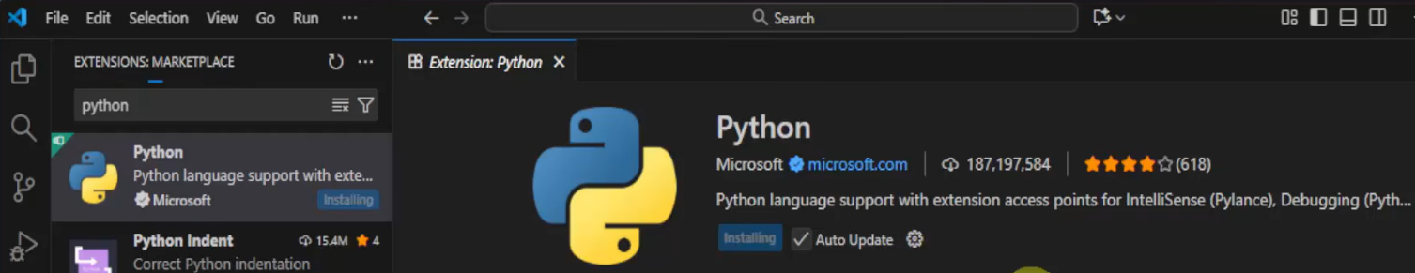
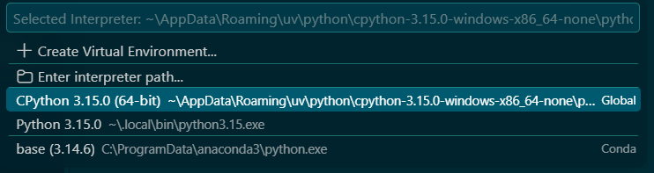

Step 4: hello.py
# My first Python program
print('Hello, Digital Image Processing!')
Command and output:
python hello.py
Hello, Digital Image Processing!

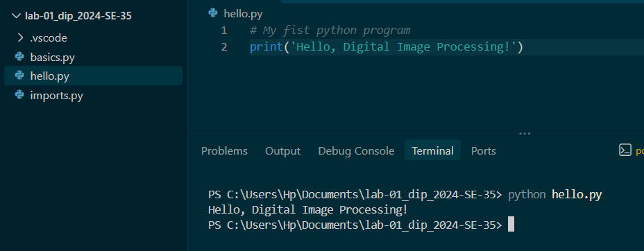

Step 5: Basic Python Exercises (basics.py)
Command: python basics.py

Exercise 1: Variables and Data Types
# ===== Exercise 1: Variables and Data Types =====
print("--- Exercise 1: Variables and Data Types ---")
width = 640
height = 480
image_name = "sample.png"
is_color = True

print(width, type(width))
print(height, type(height))
print(image_name, type(image_name))
print(is_color, type(is_color))

total_pixels = width * height
print("Total pixels:", total_pixels)

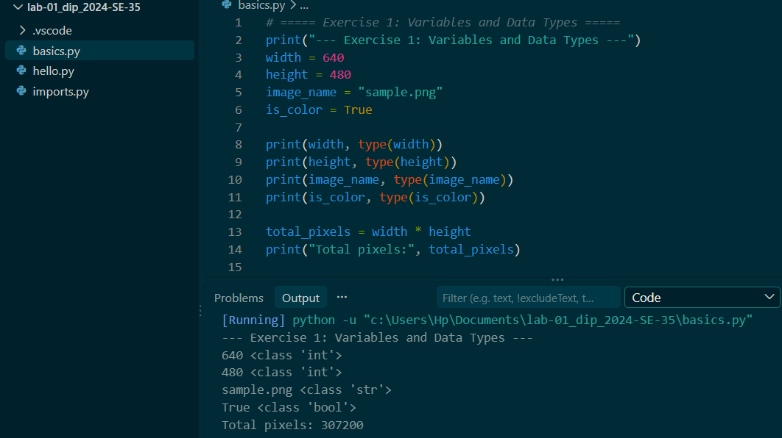

Exercise 2: if, elif, and else
# ===== Exercise 2: if, elif, and else =====
print("\n--- Exercise 2: if, elif, and else ---")
for intensity in [-1, 0, 127, 128, 255, 256]:
if intensity < 0 or intensity > 255:
label = "Invalid"
elif intensity >= 128:
label = "Bright pixel"
else:
label = "Dark pixel"
print(intensity, "->", label)

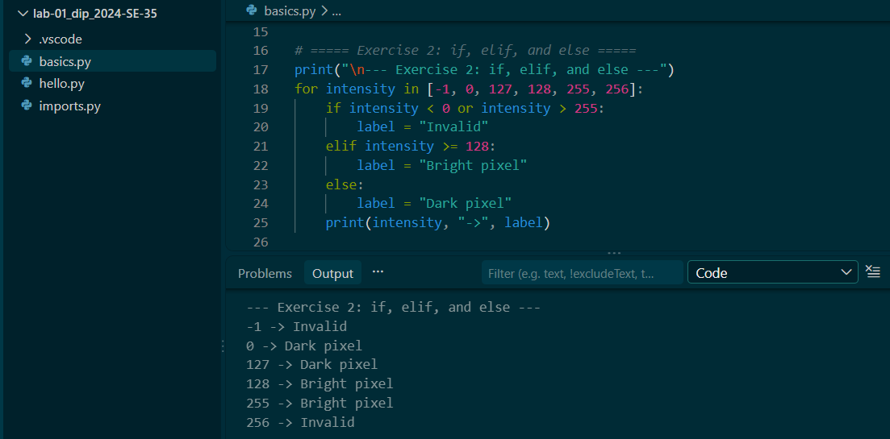

Exercise 3: for and while Loops
# ===== Exercise 3: for and while Loops =====
print("\n--- Exercise 3: for and while Loops ---")
# for loop with threshold 128
for value in [20, 130, 255]:
if value >= 128:
print(value, "-> Bright pixel")
else:
print(value, "-> Dark pixel")

# while loop: prints 0, 1, 2 and stops before 3
counter = 0
while counter < 3:
print(counter)
counter = counter + 1 # update the loop counter

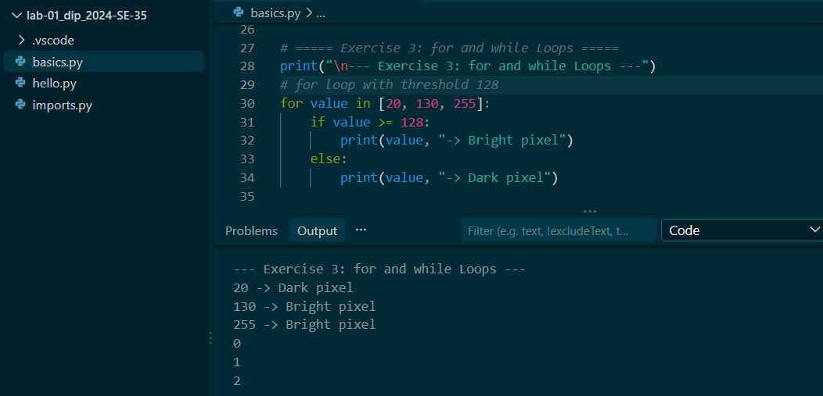

Exercise 4: Functions
# ===== Exercise 4: Functions =====
print("\n--- Exercise 4: Functions ---")
def is_bright(pixel, threshold=128):
if pixel >= threshold:
return True
else:
return False

print(is_bright(127))
print(is_bright(128))
print(is_bright(200, 210))

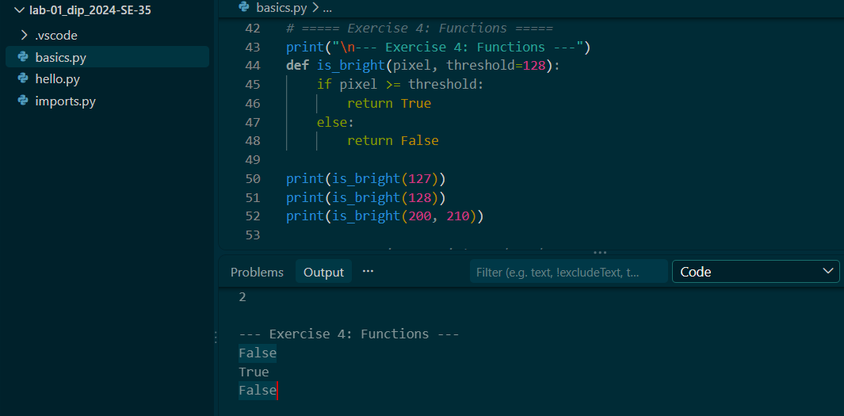

Exercise 5: Lists and Tuples
# ===== Exercise 5: Lists and Tuples =====
print("\n--- Exercise 5: Lists and Tuples ---")
pixels = [0, 128, 255]
print("First item:", pixels[0])
pixels[1] = 150 # replace the middle item
pixels.append(64) # add a new item at the end
print("List:", pixels)
print("Length:", len(pixels))

size = (640, 480)
width, height = size # tuple unpacking
print("Width:", width)
print("Height:", height)
# A list is mutable, so its items can be changed in place (assignment, append).
# A tuple is immutable, so its items cannot be changed after creation.

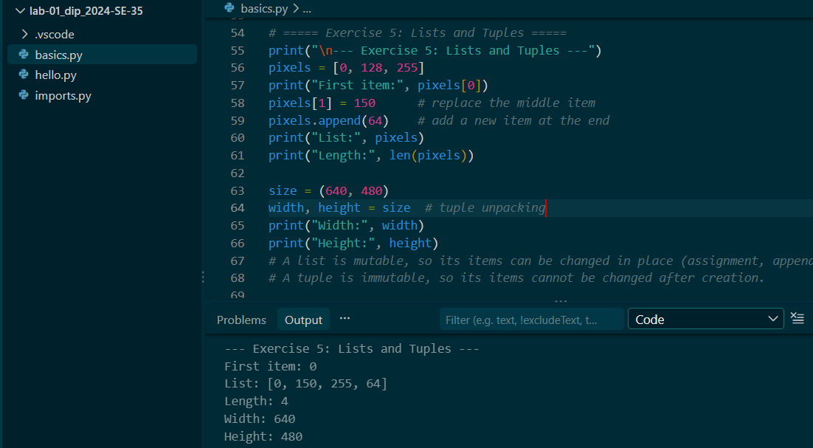

Exercise 6: Dictionaries and Sets
# ===== Exercise 6: Dictionaries and Sets =====
print("\n--- Exercise 6: Dictionaries and Sets ---")
image = {"width": 640, "height": 480}
image["mode"] = "RGB"
print("Width:", image["width"])
print("Mode:", image["mode"])

labels = set(["cat", "dog", "cat", "bird"])
print("Unique labels:", len(labels))
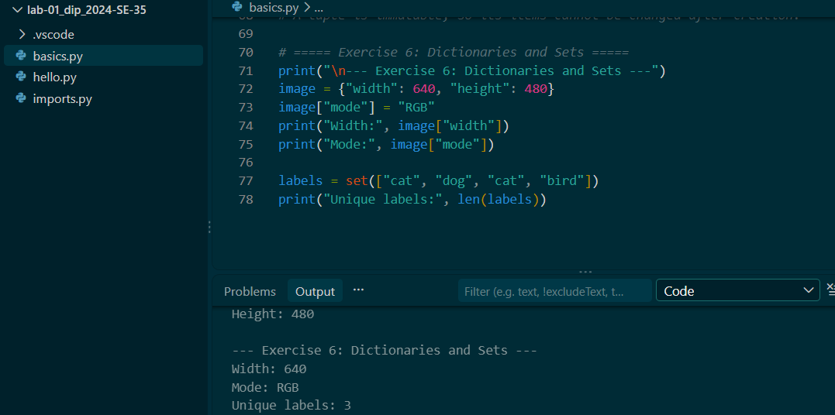
Complete output of python basics.py:
--- Exercise 1: Variables and Data Types ---
640 <class 'int'>
480 <class 'int'>
sample.png <class 'str'>
True <class 'bool'>
Total pixels: 307200

--- Exercise 2: if, elif, and else ---
-1 -> Invalid
0 -> Dark pixel
127 -> Dark pixel
128 -> Bright pixel
255 -> Bright pixel
256 -> Invalid

--- Exercise 3: for and while Loops ---
20 -> Dark pixel
130 -> Bright pixel
255 -> Bright pixel
0
1
2

--- Exercise 4: Functions ---
False
True
False

--- Exercise 5: Lists and Tuples ---
First item: 0
List: [0, 150, 255, 64]
Length: 4
Width: 640
Height: 480

--- Exercise 6: Dictionaries and Sets ---
Width: 640
Mode: RGB
Unique labels: 3

Step 6: Install the Required Packages
python -m pip install numpy pillow matplotlib
python -m pip show numpy pillow matplotlib

Step 8: Write and Verify Import Statements (lab01_imports.py)
import numpy as np
from PIL import Image
import matplotlib.pyplot as plt
Command run from the same project folder (finishes with no output and no errors):
python lab01_imports.py

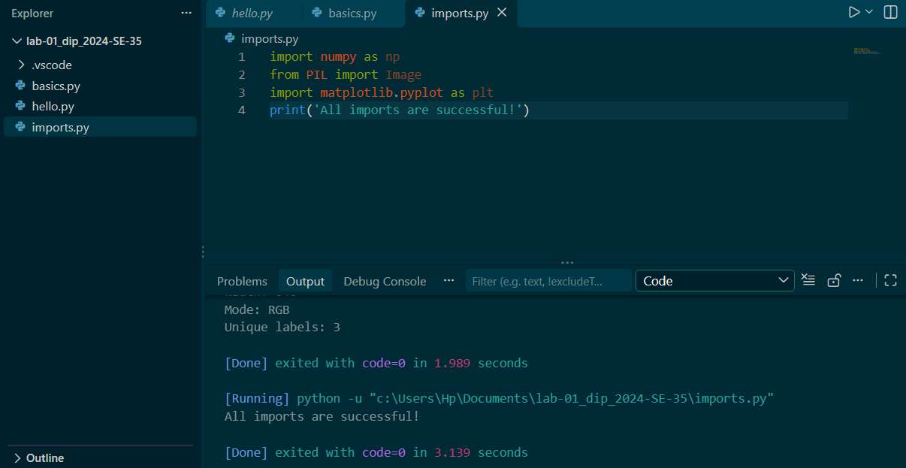

Explanation: Python vs pip, and Imports
Python is the programming language and interpreter that runs our .py programs, while pip is the package manager that downloads and installs extra libraries such as NumPy, Pillow, and Matplotlib for Python. The import statements load these installed libraries into a program so their functions can be used: NumPy for numerical arrays, Pillow (Image) for opening and handling images, and Matplotlib (pyplot) for plotting. Running lab01_imports.py with no errors confirms the packages are installed correctly.

