The University of Azad Jammu and Kashmir
Department of Software Engineering
Digital Image Processing Lab
Lab Task # 03
Image Enhancement and Intensity Transformations
Student name | Saqlain Mushtaq
Roll number | 2024-SE-35
Lab instructor | Engr. Fahad Nisar
Semester | Fifth
Session | 2024-28 (SE)
Assigned on | November 02, 2026
Due date | November 09, 2026, 11:59 PM

Objective
To calculate, implement and compare grayscale intensity transformations, histogram enhancement and thresholding while preventing overflow and interpreting their effects. Every operation starts with a typed dry run that is verified in Python, followed by the result on the selected image.
Student: YOUR NAME Roll number: 2024-SET-YOUR_ROLL_NO

Input image
Property | Value
File | input_image.png
Shape (rows, columns) | (512, 512)
dtype | uint8
Minimum | 0
Maximum | 255
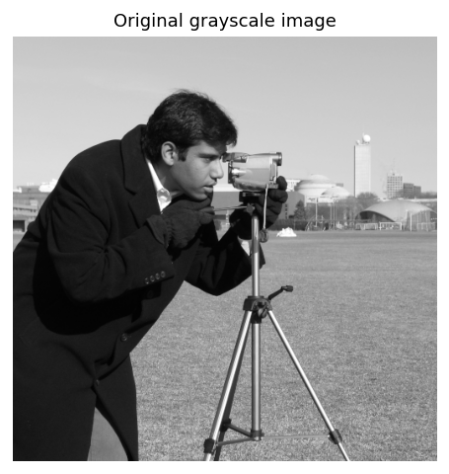
Input image (8-bit grayscale)
The image was loaded as 8-bit grayscale, validated (2-D, uint8, at least 300 x 300) and kept unchanged; every operation works on a copy. All images are displayed with grayscale limits 0-255.

1. Brightness adjustment

Dry run
Raw value, clipping to 0-255 and final uint8 value
r | raw (+40) | clipped | uint8 | raw (-40) | clipped | uint8
30 | 30 + 40 = 70 | 70 | 70 | 30 - 40 = -10 | 0 | 0
80 | 80 + 40 = 120 | 120 | 120 | 80 - 40 = 40 | 40 | 40
128 | 128 + 40 = 168 | 168 | 168 | 128 - 40 = 88 | 88 | 88
180 | 180 + 40 = 220 | 220 | 220 | 180 - 40 = 140 | 140 | 140
240 | 240 + 40 = 280 | 255 | 255 | 240 - 40 = 200 | 200 | 200

What would happen WITHOUT clipping (uint8 wrap-around = overflow)
r | (r + 40) mod 256 | (r - 40) mod 256
30 | 70 | 246
80 | 120 | 40
128 | 168 | 88
180 | 220 | 140
240 | 24 | 200

- Lost detail: 240 + 40 = 280 is clipped to 255, and 180 + 40 = 220 stays distinct, but every input from 215 to 255 ends up at 255, so bright differences vanish. In the darker image 30 - 40 = -10 is clipped to 0, so all inputs from 0 to 40 merge into 0. Clipping is irreversible: the information is gone.

Python result on the input image
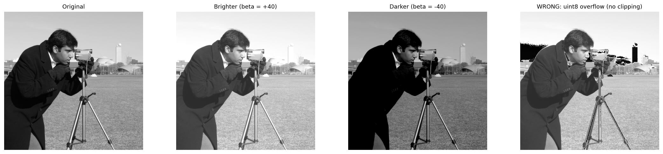
Brightness adjustment compared with the original
Image | Mean | Std. dev. | Min | Max | % pixels = 0 | % pixels = 255
Original | 129.06 | 73.64 | 0 | 255 | 0.00 | 0.10
beta = +40 | 168.65 | 73.10 | 40 | 255 | 0.00 | 3.96
beta = -40 | 93.68 | 66.89 | 0 | 215 | 26.68 | 0.00
Observation: beta = +40 raised the mean intensity from 129.1 to 168.6 and beta = -40 lowered it to 93.7. After +40, 3.96% of the pixels sit at 255, and after -40, 26.68% sit at 0; those pixels lost detail because different inputs were clipped to the same value. The standard deviation changes only slightly (73.6 -> 73.1 / 66.9), which shows brightness shifts the histogram but does not stretch it. The naive uint8 version wraps bright pixels to dark values.

2. Linear contrast from zero

Dry run
1.5r, clipped to 0-255 and truncated
r | 1.5 x r | clipped | uint8 | saturated?
30 | 1.5 x 30 = 45 | 45 | 45 | no
80 | 1.5 x 80 = 120 | 120 | 120 | no
128 | 1.5 x 128 = 192 | 192 | 192 | no
180 | 1.5 x 180 = 270 | 255 | 255 | YES
240 | 1.5 x 240 = 360 | 255 | 255 | YES

- Saturated pixels: [180, 240]. Their raw values (270 and 360) exceed 255 and are clipped to 255, so 180 and 240 can no longer be told apart. In general every input r > 170 saturates when alpha = 1.5.

Python result on the input image
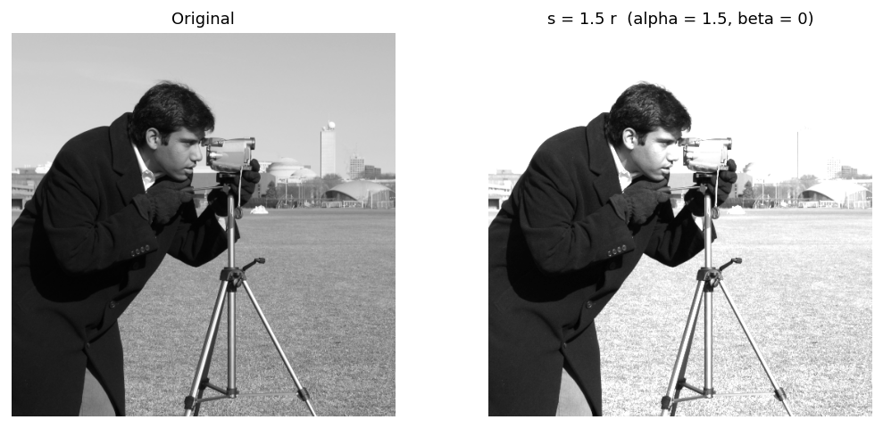
Linear contrast from zero compared with the original
Image | Mean | Std. dev. | Min | Max | % pixels = 0 | % pixels = 255
Original | 129.06 | 73.64 | 0 | 255 | 0.00 | 0.10
1.5 r | 176.31 | 93.99 | 0 | 255 | 0.00 | 34.83
Observation: Because the line passes through the origin, multiplying by 1.5 makes the image brighter as well as more contrasty: the mean rises from 129.1 to 176.3. 34.42% of the pixels (r > 170) overflow 255 and are clipped, so highlight detail is lost (34.83% of the result is pure white).

3. Contrast centered at 128

Dry run
alpha = 1.5
r | r - 128 | x alpha | + 128 (raw) | clipped | uint8
30 | 30 - 128 = -98 | -98 x 1.5 = -147 | -147 + 128 = -19 | 0 | 0
80 | 80 - 128 = -48 | -48 x 1.5 = -72 | -72 + 128 = 56 | 56 | 56
128 | 128 - 128 = 0 | 0 x 1.5 = 0 | 0 + 128 = 128 | 128 | 128
180 | 180 - 128 = 52 | 52 x 1.5 = 78 | 78 + 128 = 206 | 206 | 206
240 | 240 - 128 = 112 | 112 x 1.5 = 168 | 168 + 128 = 296 | 255 | 255

alpha = 0.5
r | r - 128 | x alpha | + 128 (raw) | clipped | uint8
30 | 30 - 128 = -98 | -98 x 0.5 = -49 | -49 + 128 = 79 | 79 | 79
80 | 80 - 128 = -48 | -48 x 0.5 = -24 | -24 + 128 = 104 | 104 | 104
128 | 128 - 128 = 0 | 0 x 0.5 = 0 | 0 + 128 = 128 | 128 | 128
180 | 180 - 128 = 52 | 52 x 0.5 = 26 | 26 + 128 = 154 | 154 | 154
240 | 240 - 128 = 112 | 112 x 0.5 = 56 | 56 + 128 = 184 | 184 | 184

- At r = 128 the term (r - 128) is 0, so the output is 128 for ANY alpha: 128 is the fixed pivot. With alpha = 1.5, the raw values -19 and 296 are clipped to 0 and 255. With alpha = 0.5 nothing is clipped and all values move toward 128, so contrast is reduced.

Python result on the input image
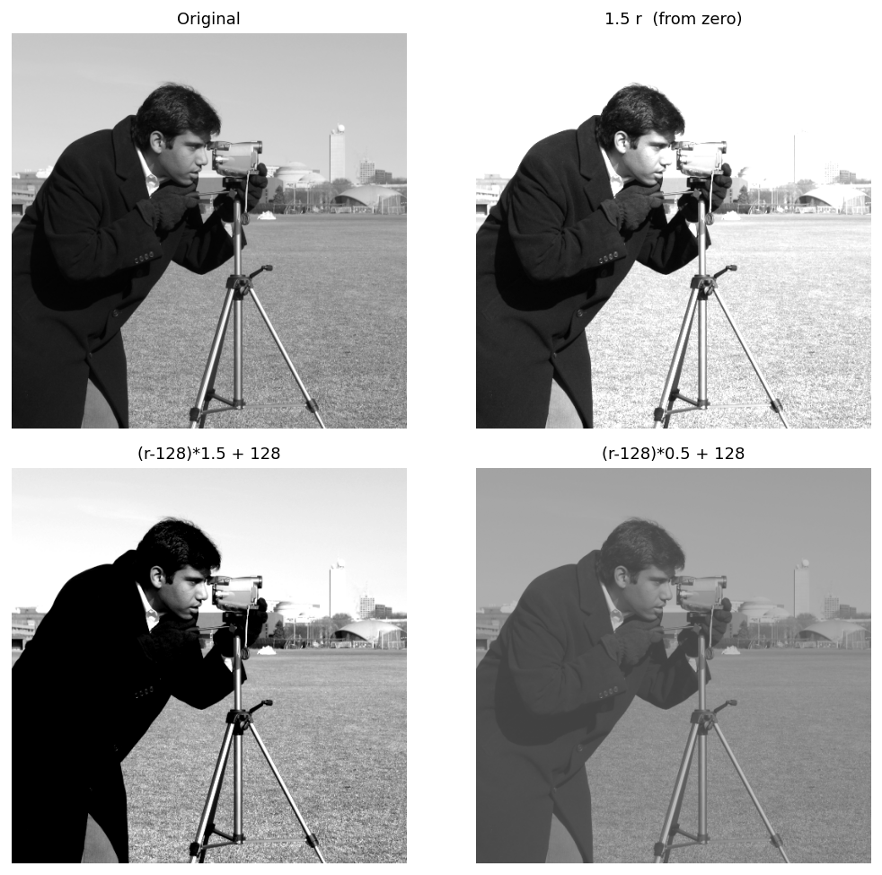
Centered contrast compared with the original and with contrast from zero
Image | Mean | Std. dev. | Min | Max | % pixels = 0 | % pixels = 255
Original | 129.06 | 73.64 | 0 | 255 | 0.00 | 0.10
1.5 r (from zero) | 176.31 | 93.99 | 0 | 255 | 0.00 | 34.83
Centered, alpha = 1.5 | 136.65 | 97.70 | 0 | 255 | 27.20 | 5.85
Centered, alpha = 0.5 | 128.28 | 36.82 | 64 | 191 | 0.00 | 0.00

Observation: Centered contrast changes the spread without shifting the overall level much: alpha = 1.5 gives mean 136.7 and std 97.7, alpha = 0.5 gives mean 128.3 and std 36.8 (original 129.1 / 73.6). Contrast from zero lifted the mean to 176.3, so it mixes a brightness increase with the contrast increase. Centered alpha = 1.5 clips 27.20% of pixels to 0 and 5.85% to 255; alpha = 0.5 produces a flat, washed-out image.

4. Image negative

Dry run
Negative and negative of the negative
r | first negative | second negative | equals original?
30 | 255 - 30 = 225 | 255 - 225 = 30 | same
80 | 255 - 80 = 175 | 255 - 175 = 80 | same
128 | 255 - 128 = 127 | 255 - 127 = 128 | same
180 | 255 - 180 = 75 | 255 - 75 = 180 | same
240 | 255 - 240 = 15 | 255 - 15 = 240 | same

- Applying the negative twice gives 255 - (255 - r) = r, so the original values are recovered exactly. No information is lost because the operation is a one-to-one mapping and nothing is clipped.

Python result on the input image
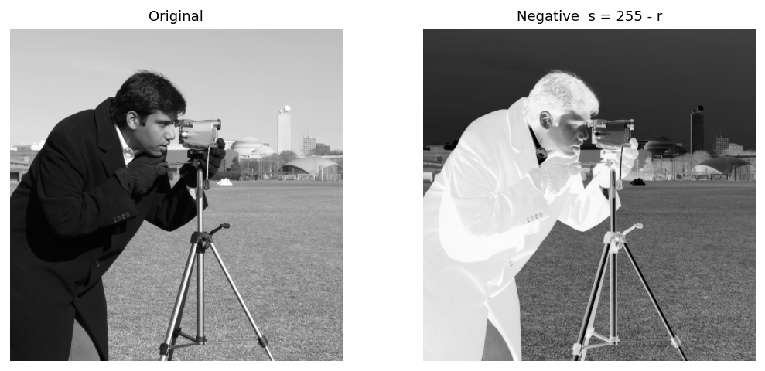
Image negative compared with the original
Image | Mean | Std. dev. | Min | Max | % pixels = 0 | % pixels = 255
Original | 129.06 | 73.64 | 0 | 255 | 0.00 | 0.10
Negative | 125.94 | 73.64 | 0 | 255 | 0.10 | 0.00

Observation: The negative maps the mean 129.1 to 125.9 and keeps the standard deviation (73.6 -> 73.6); only the polarity is reversed. A useful situation is inspecting small dark details inside a large bright area, for example dark tissue or lesions in an X-ray or mammogram: after inversion they become bright on a dark background, where small intensity differences are easier to see.

5. Gamma correction

Dry run
gamma = 0.5
r | normalization | power | scaling | uint8 (truncated)
0 | 0/255 = 0.000000 | 0.000000^0.5 = 0.000000 | 255 x 0.000000 = 0.0000 | 0
64 | 64/255 = 0.250980 | 0.250980^0.5 = 0.500979 | 255 x 0.500979 = 127.7498 | 127
128 | 128/255 = 0.501961 | 0.501961^0.5 = 0.708492 | 255 x 0.708492 = 180.6654 | 180
192 | 192/255 = 0.752941 | 0.752941^0.5 = 0.867722 | 255 x 0.867722 = 221.2691 | 221
255 | 255/255 = 1.000000 | 1.000000^0.5 = 1.000000 | 255 x 1.000000 = 255.0000 | 255

gamma = 2.0
r | normalization | power | scaling | uint8 (truncated)
0 | 0/255 = 0.000000 | 0.000000^2.0 = 0.000000 | 255 x 0.000000 = 0.0000 | 0
64 | 64/255 = 0.250980 | 0.250980^2.0 = 0.062991 | 255 x 0.062991 = 16.0627 | 16
128 | 128/255 = 0.501961 | 0.501961^2.0 = 0.251965 | 255 x 0.251965 = 64.2510 | 64
192 | 192/255 = 0.752941 | 0.752941^2.0 = 0.566920 | 255 x 0.566920 = 144.5647 | 144
255 | 255/255 = 1.000000 | 1.000000^2.0 = 1.000000 | 255 x 1.000000 = 255.0000 | 255

Full precision versus a slide-style calculation with r/255 rounded to 2 decimals
gamma | r | full precision | uint8 | rounded norm. | uint8 | difference
0.5 | 0 | 0.0000 | 0 | 0.0000 | 0 | 0
0.5 | 64 | 127.7498 | 127 | 127.5000 | 127 | 0
0.5 | 128 | 180.6654 | 180 | 180.3122 | 180 | 0
0.5 | 192 | 221.2691 | 221 | 220.8365 | 220 | 1
0.5 | 255 | 255.0000 | 255 | 255.0000 | 255 | 0
2.0 | 0 | 0.0000 | 0 | 0.0000 | 0 | 0
2.0 | 64 | 16.0627 | 16 | 15.9375 | 15 | 1
2.0 | 128 | 64.2510 | 64 | 63.7500 | 63 | 1
2.0 | 192 | 144.5647 | 144 | 143.4375 | 143 | 1
2.0 | 255 | 255.0000 | 255 | 255.0000 | 255 | 0

- Difference from the rounded slide example: if the slide rounds 64/255 to 0.25, 128/255 to 0.50 and 192/255 to 0.75, the results differ slightly. The true values are 0.250980, 0.501961 and 0.752941. This small input error is carried through the power and the x255 scaling, and after truncation it can change the output by one grey level (for example 16 vs 15 and 144 vs 143 for gamma = 2). The values in this report keep full precision and truncate only the final output, as required.

Python result on the input image
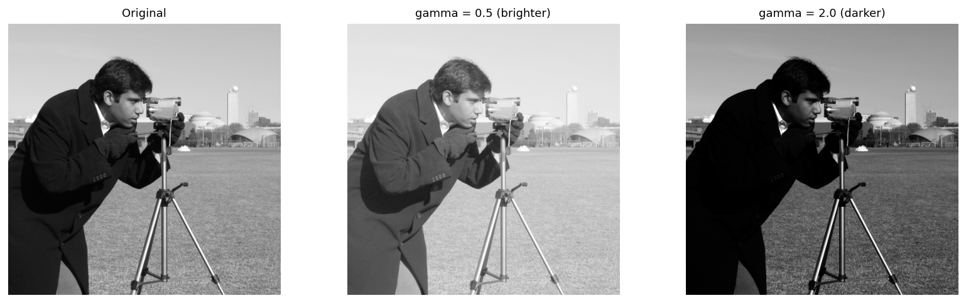
Gamma correction compared with the original
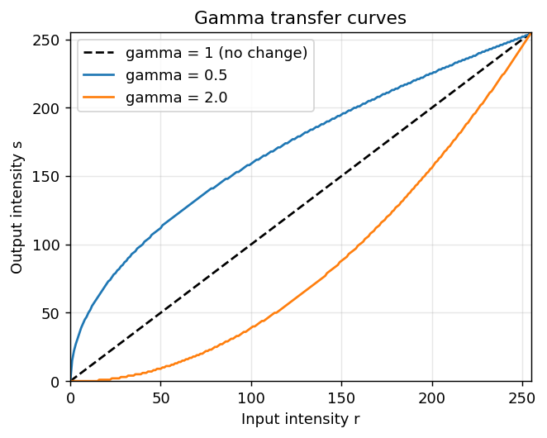Transfer curves: 0 and 255 are fixed for every gamma
Image | Mean of the darkest of pixels r < 64
Original | 25.4
gamma = 0.5 | 76.9
gamma = 2.0 | 2.7

Image | Mean | Std. dev. | Min | Max | % pixels = 0 | % pixels = 255
Original | 129.06 | 73.64 | 0 | 255 | 0.00 | 0.10
gamma = 0.5 | 169.28 | 63.80 | 0 | 255 | 0.00 | 0.10
gamma = 2.0 | 86.14 | 66.18 | 0 | 255 | 6.10 | 0.10
Observation: In the darkest quarter of the image the mean intensity is 21.9; gamma = 0.5 lifts it to 71.8 (dark detail is expanded and easier to see), while gamma = 2.0 pushes it down to 1.8 (dark regions are compressed). Unlike a constant shift, gamma is non-linear, so 0 and 255 stay fixed and only the mid-tones move.

6. Grayscale histogram

Dry run
Non-zero frequencies (total pixels = 2 x 4 = 8)
intensity | frequency | probability | decimal
0 | 1 | 1/8 | 0.125
50 | 2 | 2/8 | 0.25
100 | 2 | 2/8 | 0.25
150 | 1 | 1/8 | 0.125
200 | 1 | 1/8 | 0.125
255 | 1 | 1/8 | 0.125

- Total pixel count = 8 (sum of frequencies). Probabilities add up to 1.
- A histogram does not show positions: A = [[0, 50, 50, 100], [100, 150, 200, 255]], the same pixels rotated by 180 degrees = [[255, 200, 150, 100], [100, 50, 50, 0]] and a random shuffle = [[50, 100, 100, 200], [150, 0, 50, 255]] all give exactly the same histogram, because the histogram only counts values and discards where they were.

Python result on the input image
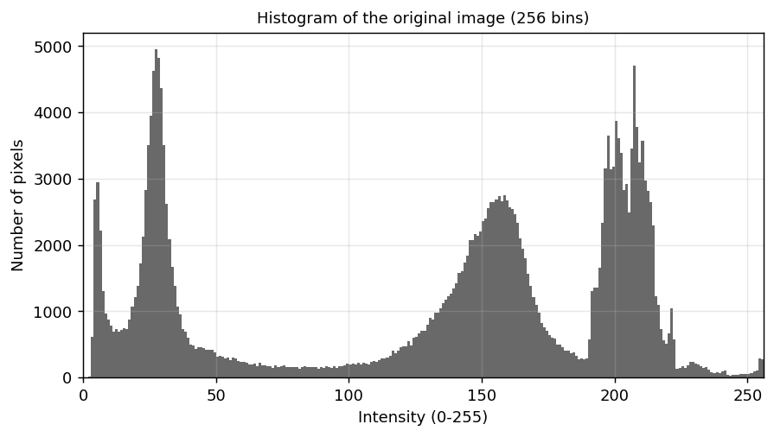
256-bin grayscale histogram of the original image
Observation: The histogram is centred on a mid-tone mean of 129.1 (median 152), with 30.9% of the pixels in the dark range 0-84, 34.6% in the mid range 85-170 and 34.4% in the bright range 171-255. The pixels occupy intensities 0-255 with a wide spread (std. dev. 73.6), so the global contrast is high.

7. Global histogram equalization

Dry run
Frequencies, cumulative counts and CDF (n = 4, CDFmin = 1/2 = 0.5)
intensity | frequency | cumulative count | CDF
50 | 2 | 2 | 2/4 = 0.5
100 | 1 | 3 | 3/4 = 0.75
150 | 1 | 4 | 4/4 = 1

Mapping (rounded to nearest, .5 rounds up)
intensity | A: 255 x CDF | A rounded | B: 255 x (CDF - CDFmin) / (1 - CDFmin) | B rounded
50 | 255 x 0.5 = 127.5 | 128 | 255 x (0.5 - 0.5) / (1 - 0.5) = 0 | 0
100 | 255 x 0.75 = 191.25 | 191 | 255 x (0.75 - 0.5) / (1 - 0.5) = 127.5 | 128
150 | 255 x 1 = 255 | 255 | 255 x (1 - 0.5) / (1 - 0.5) = 255 | 255

- Output with formula A (255 x CDF): [128, 128, 191, 255]
- Output with formula B (CDFmin version): [0, 0, 128, 255]
- OpenCV cv2.equalizeHist gives [0, 0, 128, 255], identical to formula B. Formula A never maps the darkest level to 0 (here 50 becomes 128), while B uses CDFmin so the lowest input maps to 0 and the highest to 255, using the full range.

Python result on the input image
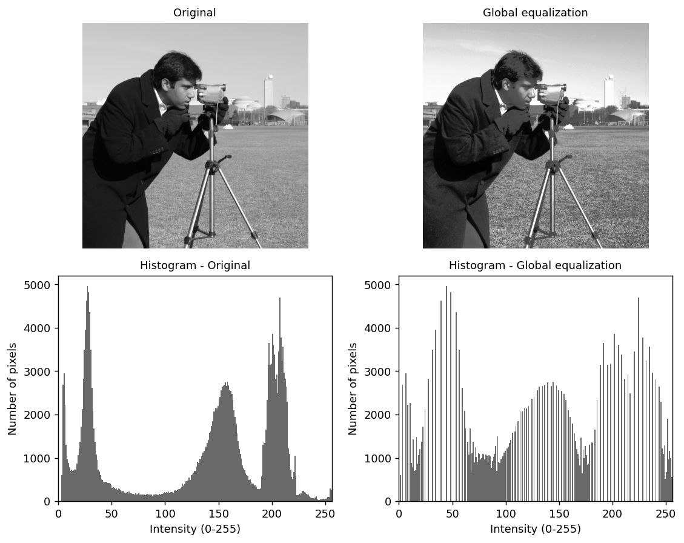
Original versus globally equalized image with their histograms
Image | Mean | Std. dev. | Min | Max | % pixels = 0 | % pixels = 255
Original | 129.06 | 73.64 | 0 | 255 | 0.00 | 0.10
Equalized | 128.60 | 73.67 | 0 | 255 | 0.01 | 0.22

Observation: Equalization changed the standard deviation from 73.6 to 73.7 and the entropy from 7.23 to 6.94 bits: the overall spread is almost unchanged because this image already uses the full 0-255 range, so the visible change is mainly a redistribution of mid-tones. Neighbouring grey levels are merged where the histogram was sparse and spread apart where it was crowded, so detail improves mainly in the crowded intensity ranges. The Laplacian variance (a fine-detail and noise measure) went from 1133.2 to 2753.4 (x2.43), which means noise and fine texture are also amplified. Global equalization uses one mapping for the whole image, so it can look harsh in regions that were already well exposed.

8. CLAHE

Dry run
Clip at 4, redistribute the excess equally
step | bin 0 | bin 1 | bin 2 | bin 3 | total
original | 6 | 2 | 0 | 0 | 8
clipped at 4 | 4 | 2 | 0 | 0 | 6
excess = 2, share = 2/4 = 0.5 | +0.5 | +0.5 | +0.5 | +0.5 | 2
new histogram | 4.5 | 2.5 | 0.5 | 0.5 | 8

Cumulative distribution before and after (CDF = cumulative count / 8)
bin | old cumulative count | old CDF | new cumulative count | new CDF | 255 x new CDF
0 | 6 | 3/4 = 0.75 | 4.5 | 9/16 = 0.5625 | 143.44
1 | 8 | 1 = 1 | 7 | 7/8 = 0.875 | 223.12
2 | 8 | 1 = 1 | 7.5 | 15/16 = 0.9375 | 239.06
3 | 8 | 1 = 1 | 8 | 1 = 1 | 255.00

- After clipping, the first CDF step falls from 0.75 to 0.5625: the steepest part of the mapping is flattened, which limits how strongly contrast (and noise) is amplified.
- Neighbouring tiles have different histograms and therefore different mappings. Applying each tile's mapping only inside its own tile would produce visible brightness jumps at the tile borders, so every pixel is bilinearly interpolated between the mappings of the nearest tile centres.
- This simplified model differs from OpenCV, which redistributes integer counts (and the leftover residue). The absolute cap of 4 used here is not the clipLimit parameter, which is a multiple of the average bin count.

Python result on the input image
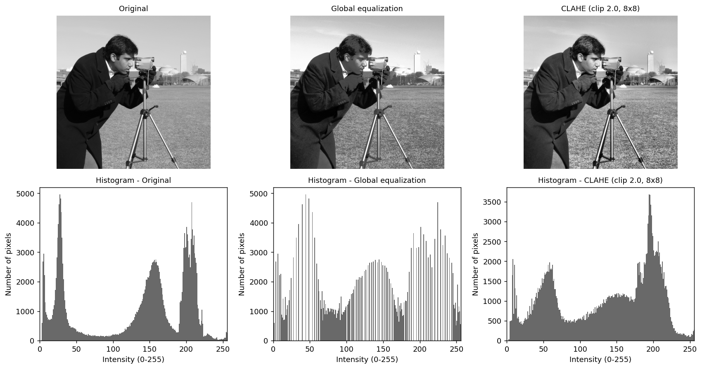
Original, global equalization and CLAHE with their histograms
Image | Mean | Std. dev. | Min | Max | % pixels = 0 | % pixels = 255
Original | 129.06 | 73.64 | 0 | 255 | 0.00 | 0.10
Global equalization | 128.60 | 73.67 | 0 | 255 | 0.01 | 0.22
CLAHE | 132.75 | 67.64 | 1 | 255 | 0.00 | 0.10

Local std. dev. in | Original | Global equalization | CLAHE
darkest tile | 10.36 | 17.11 | 23.54
brightest tile | 15.45 | 24.96 | 22.69

Observation: In the darkest tile the local std. dev. is 10.4 (original), 17.1 (global) and 23.5 (CLAHE); in the brightest tile it is 15.5, 25.0 and 22.7. CLAHE gives more local contrast than global equalization in the dark region. CLAHE builds a separate, clipped mapping for each of the 64 tiles, so it copes better with uneven lighting than one global mapping. Laplacian variance: original 1133.2, global 2753.4, CLAHE 4200.0; CLAHE still amplifies fine detail and noise (even more than global equalization here), so the clip limit reduces but does not remove this side effect. Remember that (8, 8) is the number of tiles, not their size in pixels.

9. Fixed binary thresholding

Dry run
Result for T = 127 and T = 180
r | test (T = 127) | output | test (T = 180) | output
0 | 0 > 127 ? false | 0 | 0 > 180 ? false | 0
80 | 80 > 127 ? false | 0 | 80 > 180 ? false | 0
127 | 127 > 127 ? false | 0 | 127 > 180 ? false | 0
128 | 128 > 127 ? true | 255 | 128 > 180 ? false | 0
180 | 180 > 127 ? true | 255 | 180 > 180 ? false | 0
255 | 255 > 127 ? true | 255 | 255 > 180 ? true | 255

- White pixels: 3 for T = 127 and 1 for T = 180. Raising the threshold turns fewer pixels white. Pixels exactly equal to T (127 and 180 here) become 0 because the test is r > T.

Python result on the input image
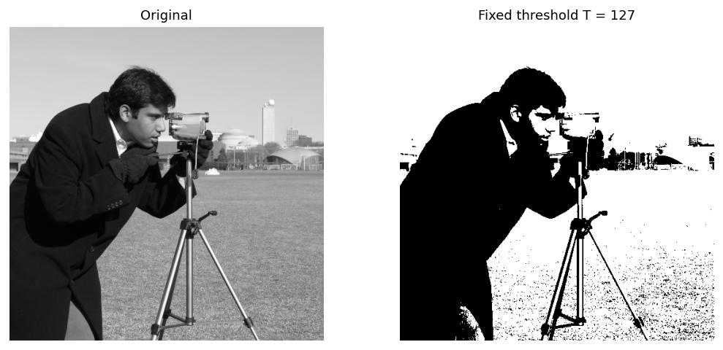
Fixed binary threshold compared with the original
Observation: The binary image contains the unique values [0, 255]; 64.30% of the pixels are white (r > 127). A single global T of 127 ignores the actual histogram, so if the image is mostly dark or mostly bright the result can lose the object of interest.

10. Otsu thresholding

Dry run
Between-class variance for every candidate T
T | class 0 (r <= T) | class 1 (r > T) | w0 | w1 | mu0 | mu1 | w0 w1 (mu0 - mu1)^2
0 | {0} | {1,4,5} | 0.25 | 0.75 | 0 | 3.3333 | 0.25 x 0.75 x (0 - 3.3333)^2 = 2.0833
1 | {0,1} | {4,5} | 0.5 | 0.5 | 0.5 | 4.5 | 0.5 x 0.5 x (0.5 - 4.5)^2 = 4
2 | {0,1} | {4,5} | 0.5 | 0.5 | 0.5 | 4.5 | 0.5 x 0.5 x (0.5 - 4.5)^2 = 4
3 | {0,1} | {4,5} | 0.5 | 0.5 | 0.5 | 4.5 | 0.5 x 0.5 x (0.5 - 4.5)^2 = 4
4 | {0,1,4} | {5} | 0.75 | 0.25 | 1.6667 | 5 | 0.75 x 0.25 x (1.6667 - 5)^2 = 2.0833

- Maximum value 4 occurs at T = [1, 2, 3]. The smallest tied T is chosen: T = 1. Predicted mask (r > 1): [0, 0, 255, 255].
- OpenCV returned threshold 1 and mask [0, 0, 255, 255], which matches the prediction.

Python result on the input image
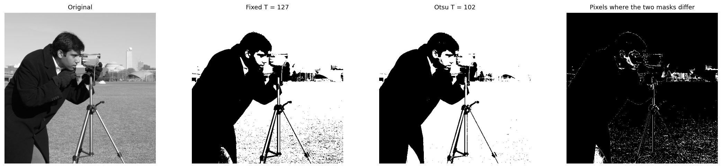
Otsu mask compared with the fixed-threshold mask
Observation: Otsu returned T = 102 computed from the histogram, while the fixed threshold was 127. The masks agree on 96.40% of the pixels; white pixels are 67.90% for Otsu and 64.30% for the fixed threshold. Otsu adapts to the intensity distribution automatically, but it is still one global threshold and works best when the histogram is roughly bimodal.

11. Adaptive Gaussian thresholding

Dry run
Weights x pixels (weights / 16)
row | w x r, left to right | row sum
1 | 1x100=100 , 2x100=200 , 1x100=100 | 400
2 | 2x100=200 , 4x120=480 , 2x140=280 | 960
3 | 1x140=140 , 2x140=280 , 1x140=140 | 560

- Weighted mean = 1920 / 16 = 120. T = mean - C = 120 - 2 = 118.
- Center pixel r = 120: is 120 > 118? Yes -> output 255.
- A pixel equal to T (r = 118): is 118 > 118? No -> output 0. The comparison is strict, so equality gives black.
- Extra check for equality: with neighbours [[120,121,120],[121,_,121],[120,121,120]] and centre 118 the weighted mean is 120, T = 118, centre = 118 = T, so the output is 0.

Python result on the input image
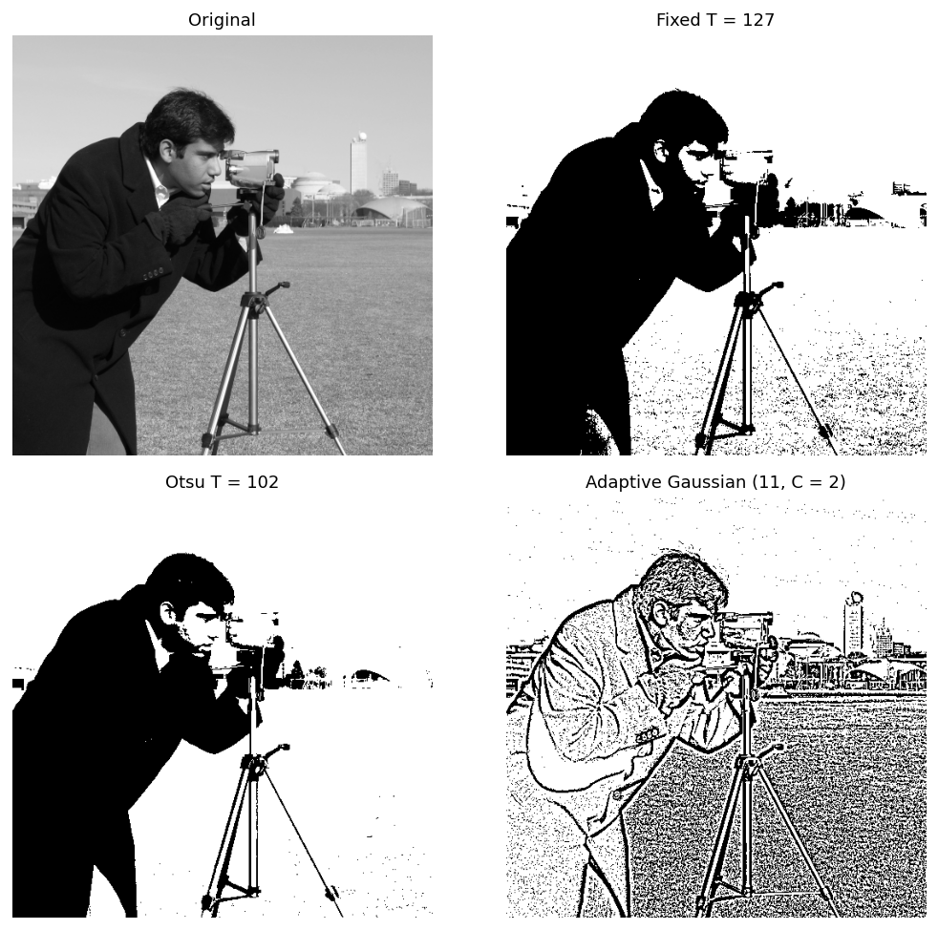
Fixed, Otsu and adaptive Gaussian thresholds
White pixels in | Fixed (127) | Otsu (102) | Adaptive (11, C=2)
darkest tile | 0.0% | 0.0% | 89.7%
brightest tile | 99.9% | 100.0% | 87.0%
whole image | 64.3% | 67.9% | 73.2%

Observation: The adaptive mask agrees with the fixed mask on 63.8% of the pixels and with the Otsu mask on 62.3%. Inside the darkest tile the white fraction is 0.0% (fixed), 0.0% (Otsu) and 89.7% (adaptive); in the brightest tile it is 99.9%, 100.0% and 87.0%. Local thresholds help when the illumination changes across the image (shadows, gradients, uneven lighting, documents photographed under a lamp) because each pixel is judged against its own 11 x 11 neighbourhood; the price is that flat regions and noise can turn speckled, since a small difference from the local mean is enough to flip a pixel.

Explanations
Clipping. Clipping forces values outside 0-255 to the nearest valid limit (below 0 becomes 0, above 255 becomes 255). It is needed because uint8 cannot hold other values, but it is irreversible: different inputs end up with the same output, so detail is lost.
Overflow. uint8 arithmetic wraps around modulo 256 (for example 240 + 40 = 24 and 30 - 40 = 246), which turns bright pixels dark and vice versa. To prevent it, the image is converted to a wider type (int16 or float64), the calculation is done, values are clipped to 0-255, fractions are truncated, and only then is the result converted to uint8.
Brightness versus contrast. Brightness (s = r + beta) shifts the whole histogram left or right without changing its spread. Contrast (s = alpha r, or centered s = (r - 128) alpha + 128) stretches or compresses the spread. Contrast from zero also changes the mean, while contrast centered at 128 keeps the mid-grey value fixed.
Gamma convention. This report uses s = 255 (r / 255)^gamma. Gamma below 1 brightens the image and expands dark regions, gamma above 1 darkens it, and the values 0 and 255 never change. Some sources use r^(1/gamma), which reverses the meaning, so the convention must always be stated.
Global versus local enhancement and thresholding. Global methods (histogram equalization, fixed and Otsu thresholds) use one mapping for the whole image; they are simple and fast and work well when the lighting is even. Local methods (CLAHE and adaptive thresholding) compute the mapping or threshold from each neighbourhood, so they cope with uneven lighting and local detail, at the cost of more computation, more parameters and possible noise amplification.

Verification summary
The notebook ran 51 automatic checks and all of them passed:
- image is 2-D uint8 (8-bit grayscale)
- image is at least 300 x 300
- original array is locked read-only
- dry run 1: +40 matches Python
- dry run 1: -40 matches Python
- dry run 1: uint8 wrap-around values match NumPy
- nested-loop +40 equals NumPy +40
- naive uint8 addition differs exactly where r > 215 (overflow)
- dry run 2 matches Python
- dry run 3 (alpha = 1.5) matches Python
- dry run 3 (alpha = 0.5) matches Python
- dry run 4: negative matches Python
- dry run 4: double negative equals original
- image: negative of negative equals original
- dry run 5 (gamma = 0.5) matches Python
- dry run 5 (gamma = 0.5): 0 and 255 stay fixed
- dry run 5 (gamma = 2.0) matches Python
- dry run 5 (gamma = 2.0): 0 and 255 stay fixed
- gamma 0.5 table keeps 0 and 255 fixed
- gamma 2.0 table keeps 0 and 255 fixed
- image pixels equal to 0 or 255 are unchanged by both gammas
- dry run 6: frequencies match np.bincount
- dry run 6: rotated and shuffled arrays have the same histogram
- histogram has 256 bins and counts every pixel
- np.bincount agrees with cv2.calcHist
- dry run 7: formula B equals cv2.equalizeHist
- manual CDF formula differs from cv2.equalizeHist by at most 1 grey level (rounding)
- dry run 8: new histogram is [9/2, 5/2, 1/2, 1/2]
- dry run 8: total count is preserved
- dry run 8: new CDF is [9/16, 7/8, 15/16, 1]
- CLAHE output is uint8 with the same shape
- dry run 9: T = 127 matches cv2.threshold
- dry run 9: T = 180 matches cv2.threshold
- fixed threshold equals the rule r > 127
- fixed-threshold output only contains 0 and/or 255
- dry run 10: tied maxima are T = 1, 2, 3 and the smallest (1) is chosen
- dry run 10: OpenCV threshold equals the hand-calculated T
- dry run 10: OpenCV mask equals the predicted mask
- OpenCV's Otsu threshold reaches the maximum between-class variance
- Otsu mask equals the rule r > returned threshold
- dry run 11: weighted mean is 120 and T is 118
- dry run 11: centre pixel (120 > 118) becomes 255
- dry run 11: a pixel equal to T becomes 0
- dry run 11: OpenCV agrees for the given neighbourhood
- dry run 11: OpenCV agrees for the pixel-equals-T case
- adaptive result matches 'r > Gaussian mean - C' except pixels within 1 grey level of T
- adaptive output only contains 0 and/or 255
- original image is unchanged after all operations
- original array is still read-only
- all 11 dry runs were recorded
- every operation has at least one figure

