**Final Project**

**Compiler Construction**



**Name: Junaid Ali , Muhammad Yaseen**

**Regno: FA20-BCS-008, FA20-BCS-076**

**Submitted to: Sir Bilal Haider Bukhari**

**Dated: 26-Dec-23**

**Subject: Compiler Construction**

**COMSATS UNIVERSITY ISLAMABAD ATTOCK CAMPUS**

**Brief of the Project**

In this Lab terminal project, we have a semantic analyzer is developed so that errors in the code block could be identified, the SemanticAnalyzer() function takes the list of tokens identified by the Scanner, and checks if the tokens sequence follow any of the three rules provided in the project description using Top-Down Parsing, then it return a list of the errors found.

The three rules:

An overview of the SemanticAnalyzer() function with collapsed code:

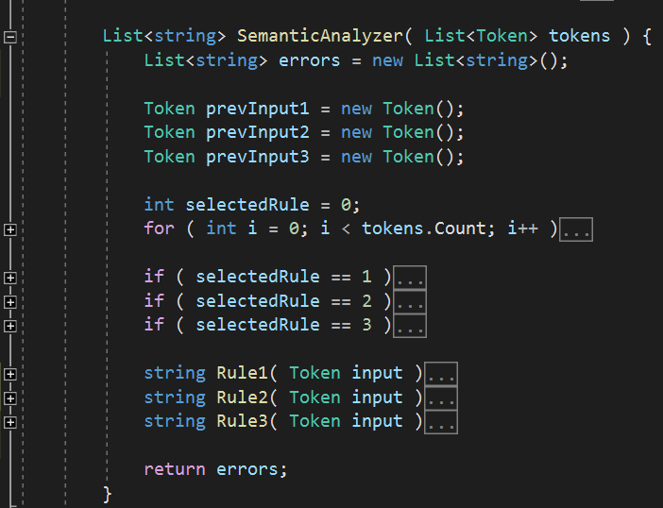

The SemanticAnalyzer() function has a main “for” loop that iterates over the given list of tokens, it test which of the three rules will start accepting the i-th token, once a rule starts accepting, this rule becomes the selected rule, it will remain selected until it either returns an error or returns an “Ok”, which means the last sequence of tokens did follow the rule correctly:

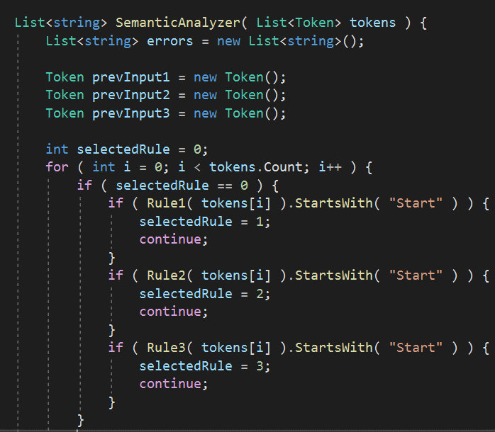

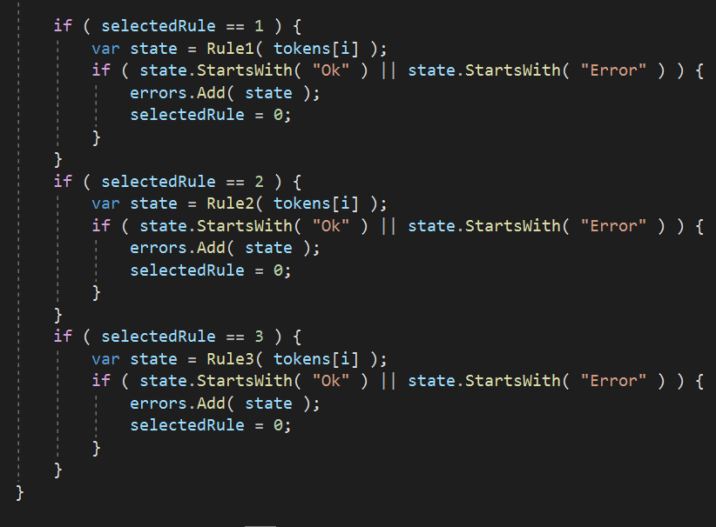

In Each rule takes a token from each loop iteration and stores the previous token it has seen inside previous Input. Inside each rule, the upper half contains the conditions that begin, ends and continues the application of that rule, the lower half catches the errors and returns what the rule expected instead.

Role 1,2,3:

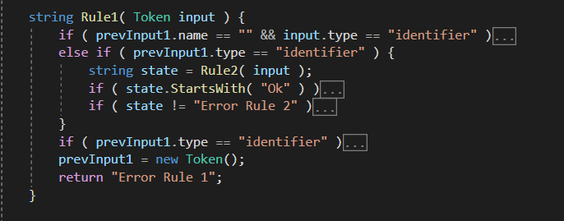

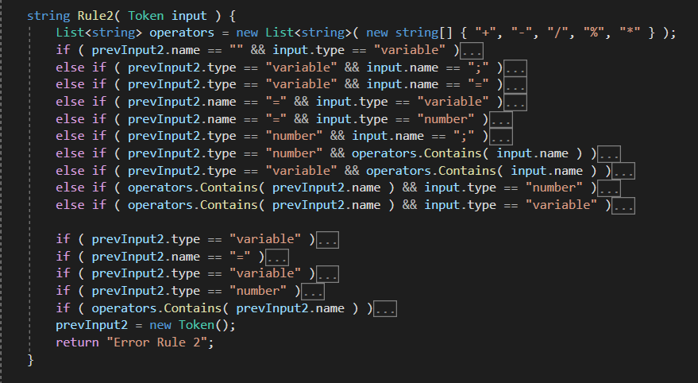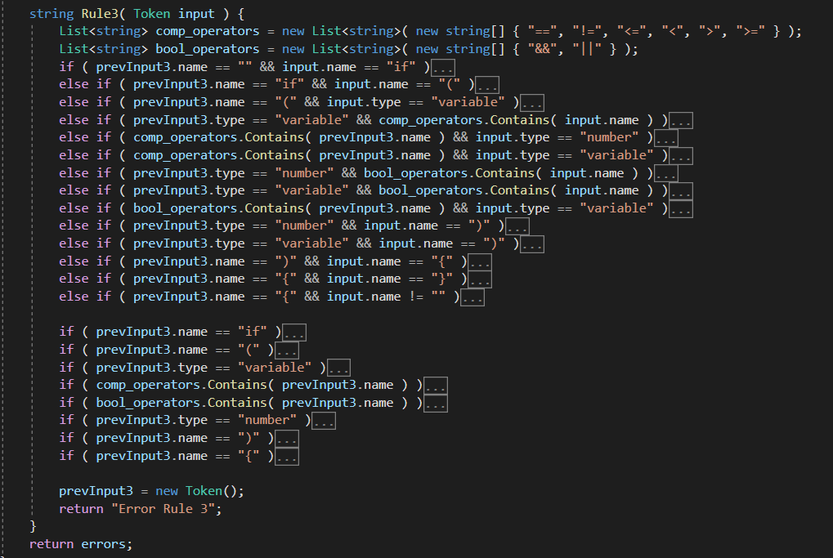

**Function Explanations Along with Screenshot:**

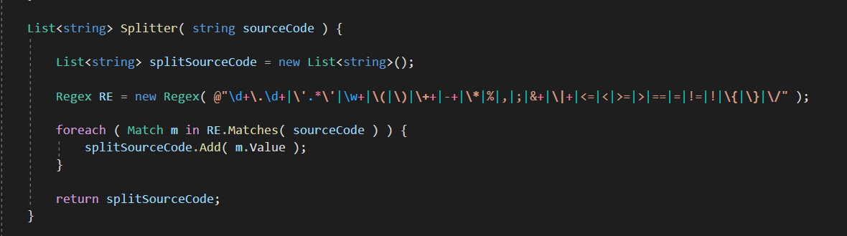

As this Function is used to process of converting a sequence of characters (Code Block) input by user into a sequence of tokens.

Instead of DFA or split, we have decided to use regular expression match method because it allows you to specify the tokens you are looking for like the image and it is very simple.

Splitter : return list of matches strings.

Create class Token to store name and type of token that we will use later.

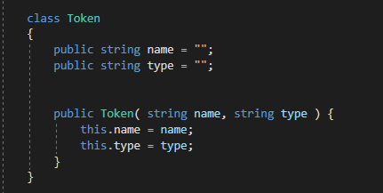

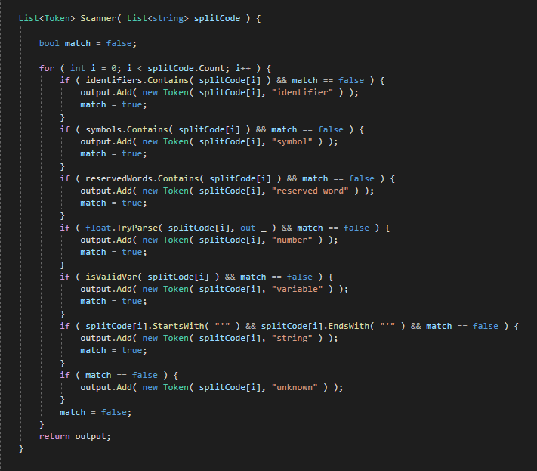Scanner: take the list of matches strings, get the type of each string and store it in the List of Nodes (Token).

**How Function Works step by step:**

In this phase we save the variable value in the memory and every variable shows on the data grid view.

Our class variable and list of class variables.

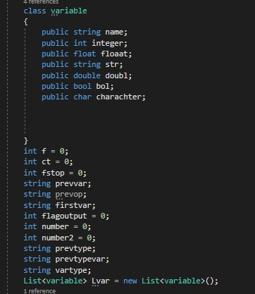

First in rule1 function we put a flag (f=1) to know that the identifier is integer

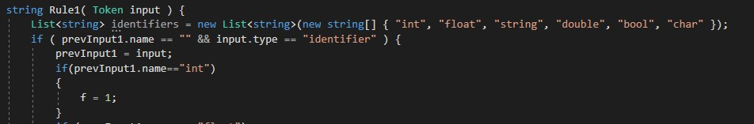

In rule 2 function We made first var to catch the variable before “=”

prevvar to catch the first variable after “=”

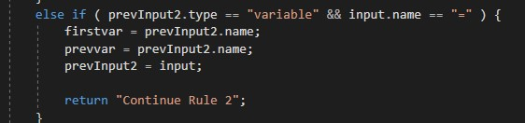

In this condition the variable becomes any integer value

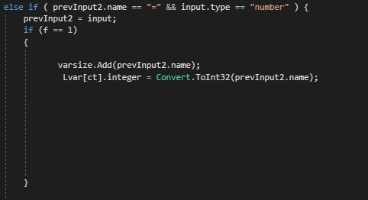

Ex: int x=3;

In this condition integer variable becomes another integer variable

Ex: int x= y;

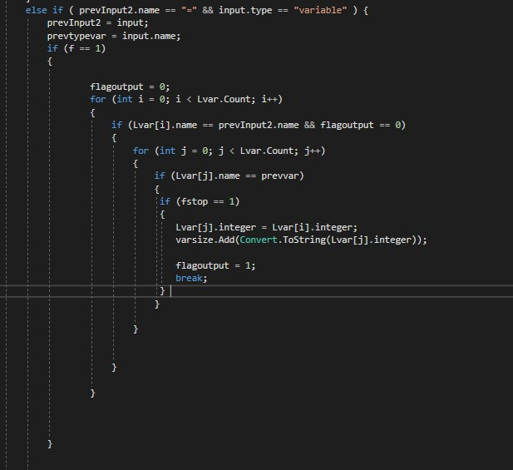

In this condition we catch the number before the operator.

Number becomes this number.

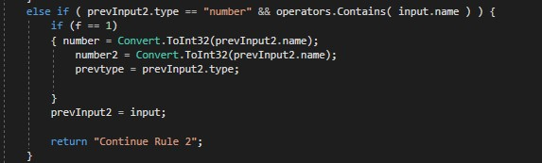

In this condition we catch the variable before the operator.

Prevvar becomes this variable.

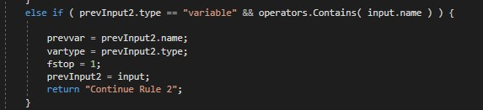

In this condition we take the values of “+” operator when

Num+ num

And

Integer variable + num

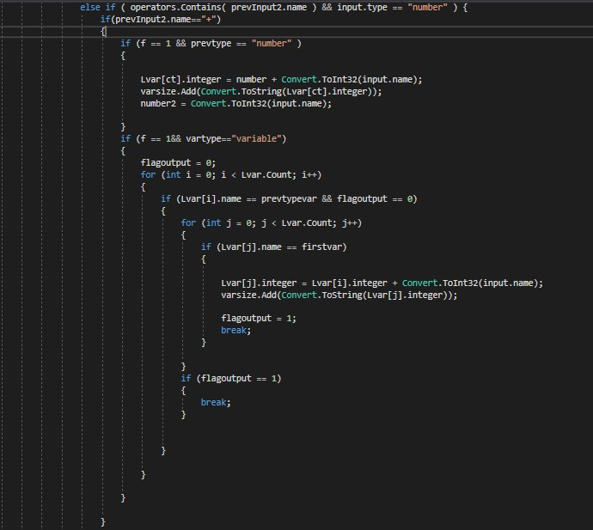

In this condition we take the values of “-” operator when

Num-num

And

Integer variable-num

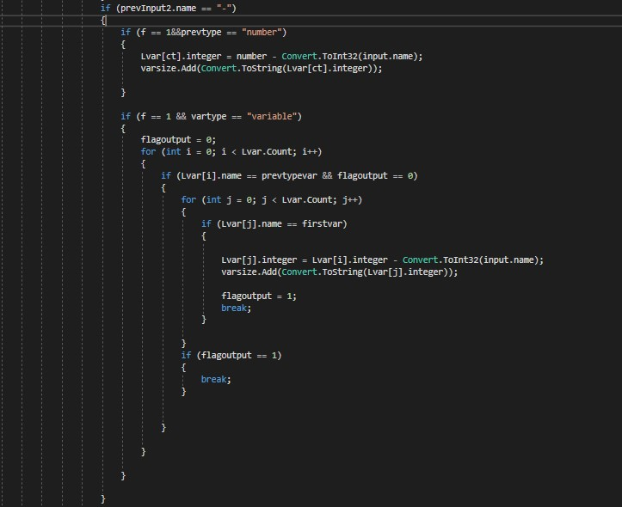

In this condition we take the values of “*” operator when

Num*num

And

Integer variable*num

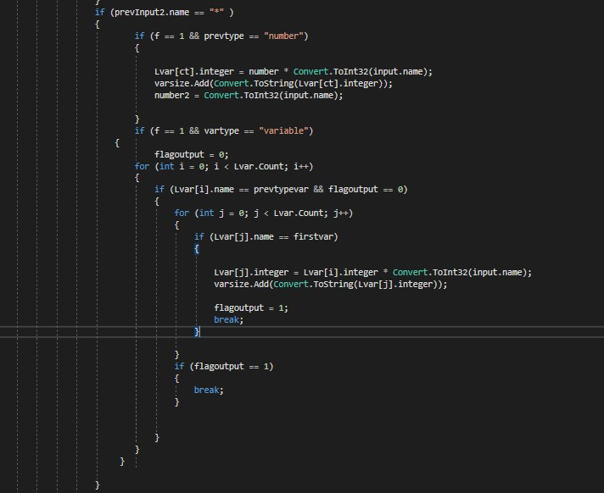

In this condition we take the values of “/” operator when

Num/num

And

Integer variable/num

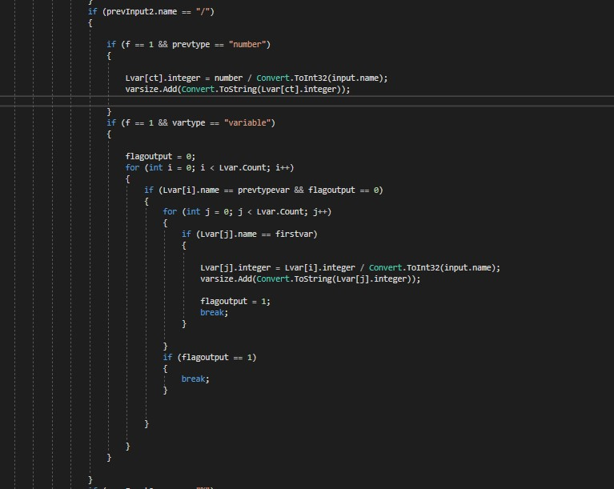

In this condition we take the values of “%” operator when

Num % num

And

Integer variable % num

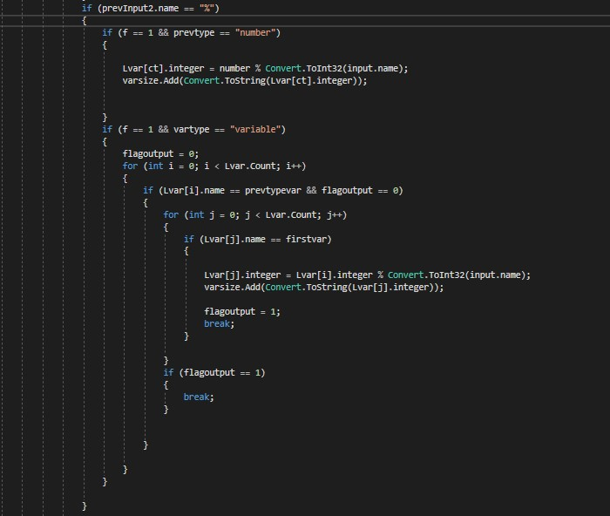

In this condition we take the values of “+” operator when

Integer variable+ Integer variable

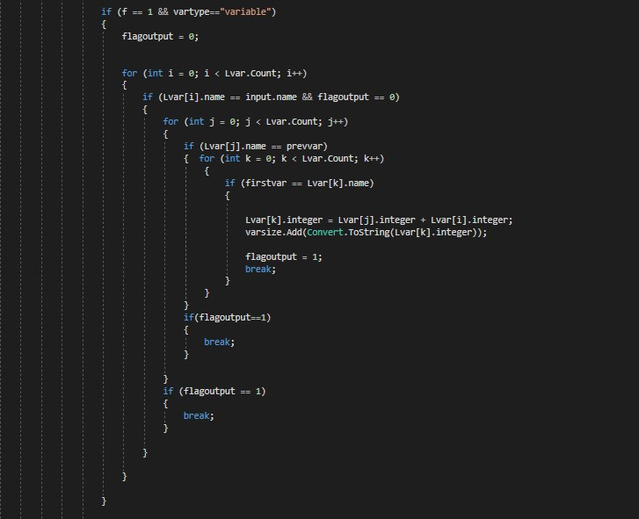

In this condition we take the values of “-” operator when

Integer variable- Integer variable

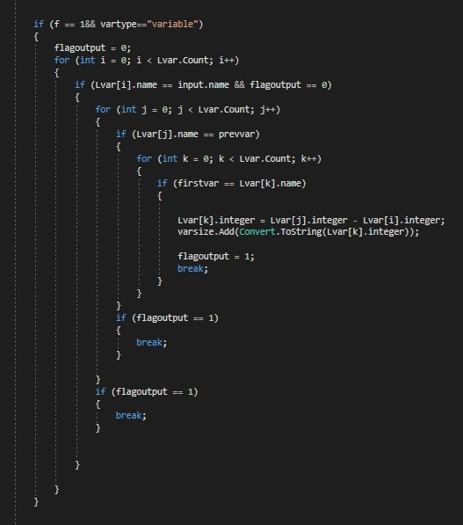

In this condition we take the values of “*” operator when

Integer variable*Integer variable

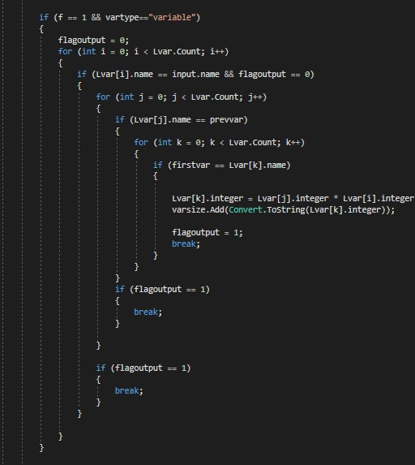

In this condition we take the values of “/” operator when

Integer variable/Integer variable

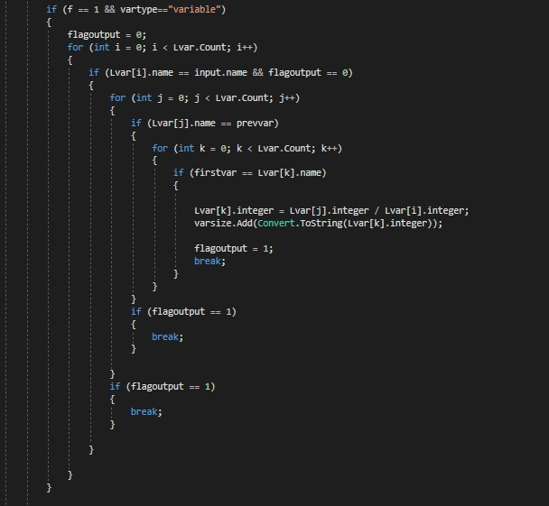

In this condition we take the values of “%” operator when

Integer variable% Integer variable

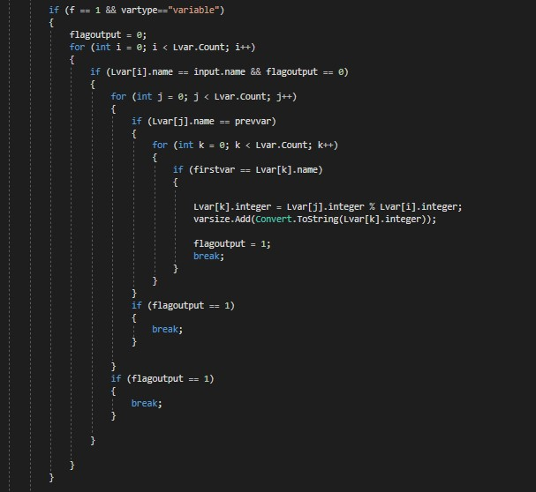

Test Case :

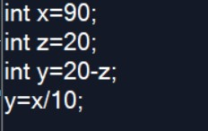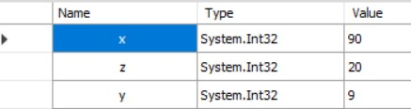

**User Input Phase:**

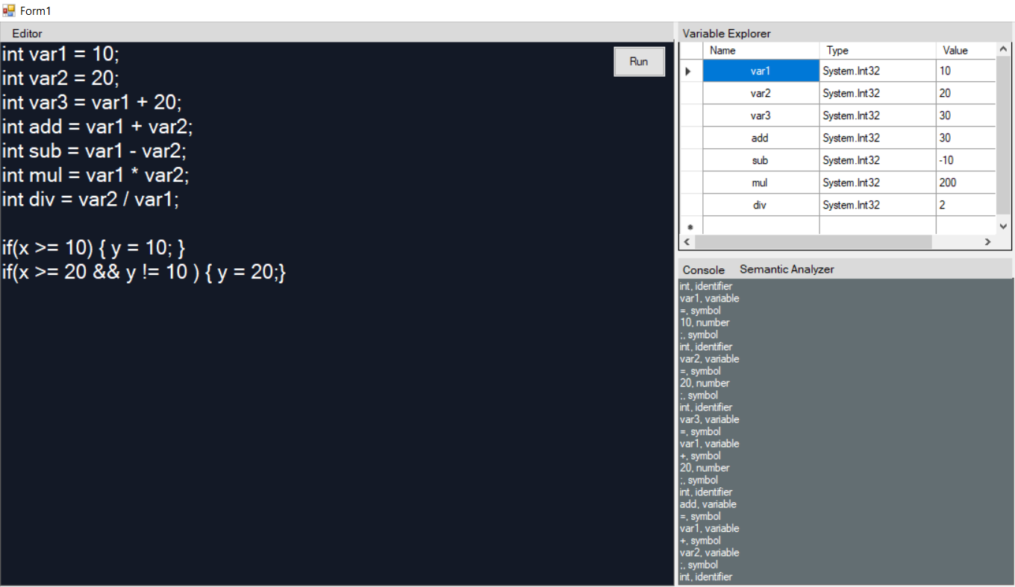

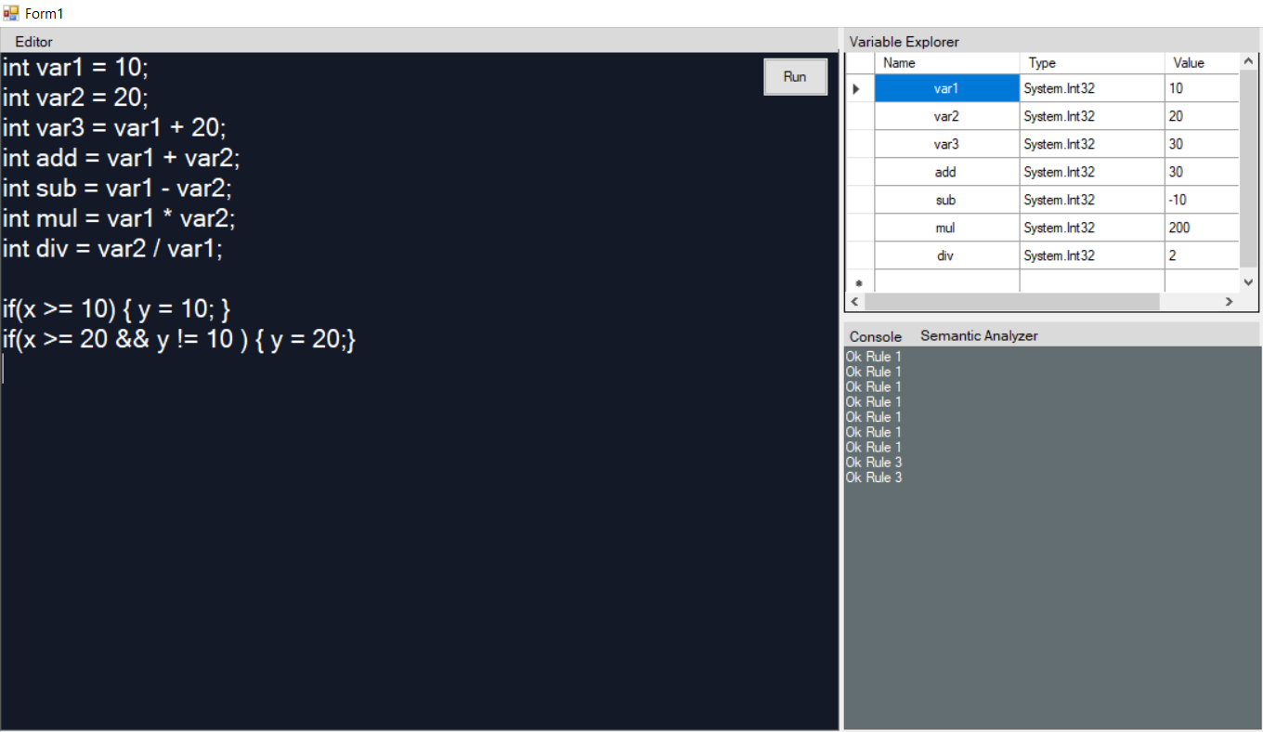

**Output(generated by compiler) :**

Console : int, identifier var1, variable =, symbol 10, number ;, symbol int, identifier var2, variable =, symbol 20, number ;, symbol int, identifier var3, variable =, symbol var1, variable +, symbol 20, number ;, symbol int, identifier add, variable =, symbol var1, variable +, symbol var2, variable ;, symbol int, identifier sub, variable =, symbol var1, variable -, symbol var2, variable ;, symbol int, identifier mul, variable =, symbol var1, variable *, symbol var2, variable ;, symbol int, identifier div, variable =, symbol var2, variable /, symbol var1, variable ;, symbol if, reserved word (, symbol

**Semantic Analyzer**

Checking the lines with roles

Ok Rule 1 Ok Rule 1 Ok Rule 1 Ok Rule 1 Ok Rule 1 Ok Rule 1 Ok Rule 1 Ok Rule 3 Ok Rule 3

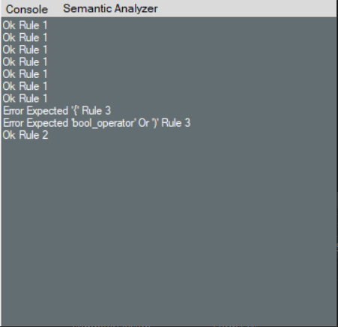If we replace by this input then,

if(x >= 10) {y = 10; }

if(x >= 20 && y != 10) { y = 20;}

with

if(x >= 10) y = 10; }

if(x >= 20 && y != 10 { y = 20;}

**the analyzer output :**

**What Challenges we Faced during the project :**

While creating this project which contain semantic analyzer in which we give input from the user and scans the entire code and informs us wether the given input is correct or not and also tell us a step by step explanations of a given inputs

Statements.

The challenges we faced while creating this project is to dealing with the syntax and logical errors and also understamding the Language grammar, and doing their lexical analysis is difficult job for us so firstly we understood these all and right after that we finally constructed the semantic analyzer and project runs successfully.

**---------------------------------------------------------------**

**---------------------------------------------------------------**