Final Project Compiler Construction



**Name: Ali Ahmed,Saqlian Ali Shah Regno: FA20-BCS-071, FA20-BCS-079**

**Submitted to: Sir Bilal Haider Bukhari Dated: 28-Dec-23**

**Subject: Compiler Construction**

**COMSATS UNIVERSITY ISLAMABAD ATTOCK CAMPUS**

# Brief of the Project

In this Lab terminal project, we have a semantic analyzer is developed so that errors in the code block could be identified, the SemanticAnalyzer() function takes the list of tokens identified by the Scanner, and checks if the tokens sequence follow any of the three rules provided in the project description using Top-Down Parsing, then it return a list of the errors found.

The three rules:

An overview of the SemanticAnalyzer() function with collapsed code:

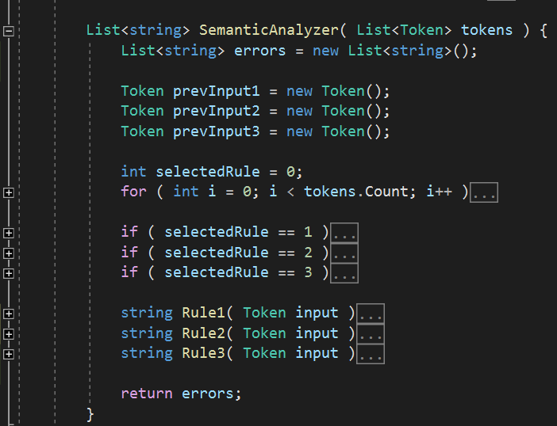

The SemanticAnalyzer() function has a main “for” loop that iterates over the given list of tokens, it test which of the three rules will start accepting the i-th token, once a rule starts accepting, this rule becomes the selected rule, it will remain selected until it either returns an error or returns an “Ok”, which means the last sequence of tokens did follow the rule correctly:

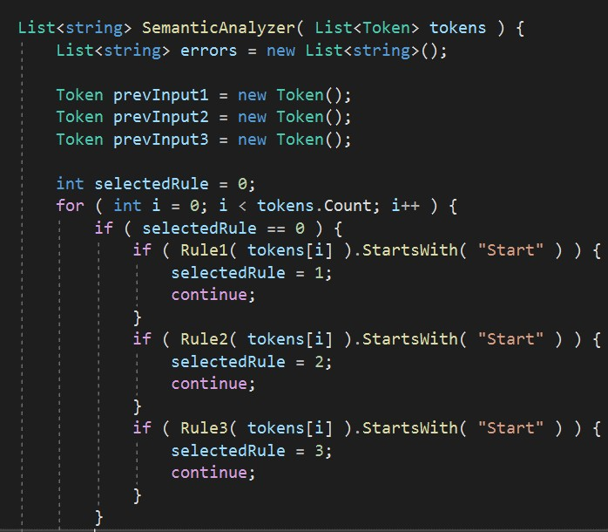

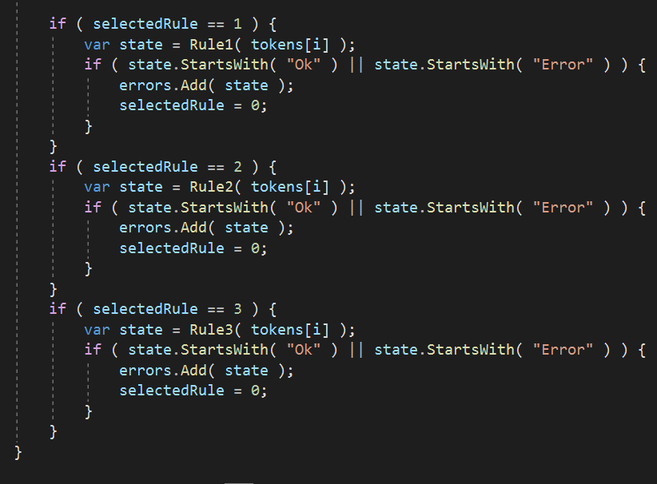

In Each rule takes a token from each loop iteration and stores the previous token it has seen inside previous Input. Inside each rule, the upper half contains the conditions that begin, ends and continues the application of that rule, the lower half catches the errors and returns what the rule expected instead.

Role 1,2,3:

