Final Project Compiler Construction



**Name: Junaid Ali , Muhammad Yaseen Regno: FA20-BCS-008, FA20-BCS-076**

**Submitted to: Sir Bilal Haider Bukhari Dated: 26-Dec-23**

**Subject: Compiler Construction**

**COMSATS UNIVERSITY ISLAMABAD ATTOCK CAMPUS**

# Function Explanations Along with Screenshot:

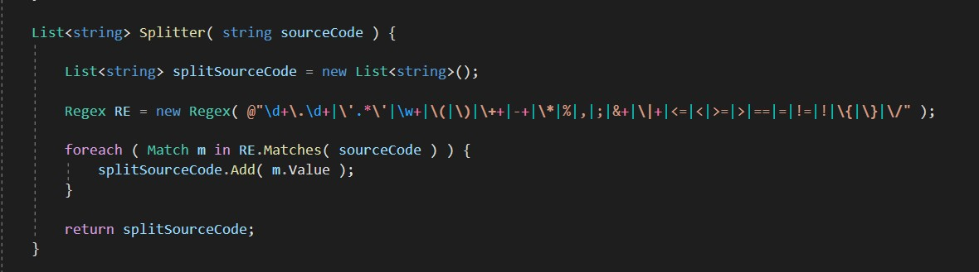

As this Function is used to process of converting a sequence of characters (Code Block) input by user into a sequence of tokens.

Instead of DFA or split, we have decided to use regular expression match method because it allows you to specify the tokens you are looking for like the image and it is very simple.

Splitter : return list of matches strings.

Create class Token to store name and type of token that we will use later.

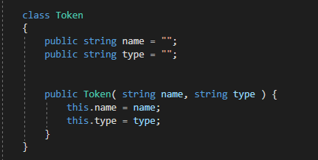

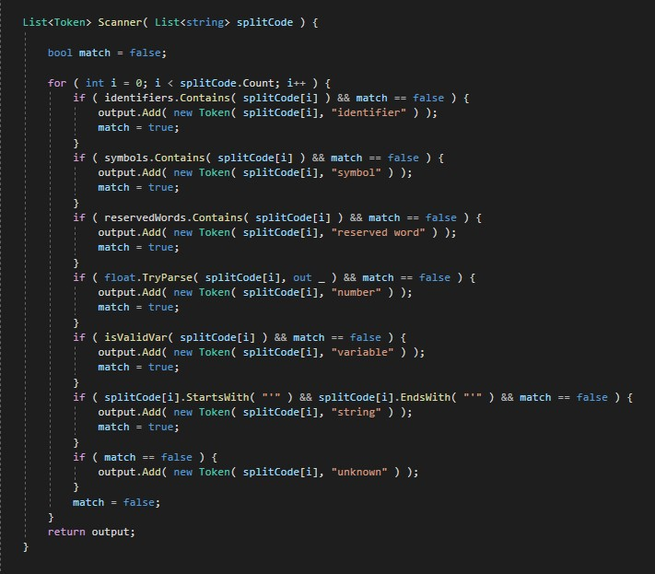

Scanner: take the list of matches strings, get the type of each string and store it in the List of Nodes (Token).