Final Project Compiler Construction



**Name: Junaid Ali , Muhammad Yaseen Regno: FA20-BCS-008, FA20-BCS-076**

**Submitted to: Sir Bilal Haider Bukhari Dated: 26-Dec-23**

**Subject: Compiler Construction**

**COMSATS UNIVERSITY ISLAMABAD ATTOCK CAMPUS**

# User Input Phase:

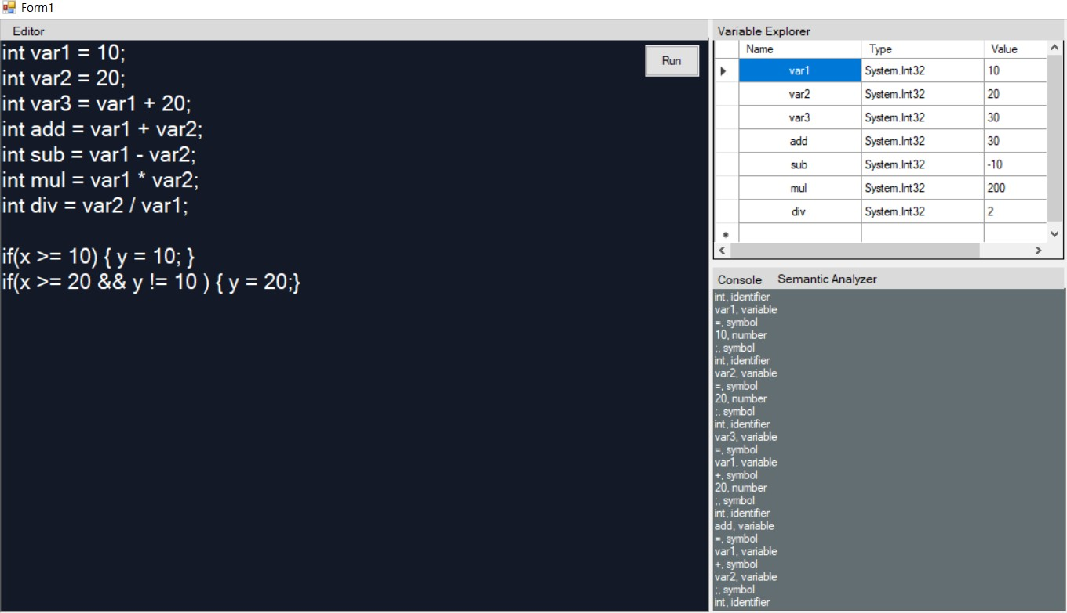

## Output(generated by compiler) :

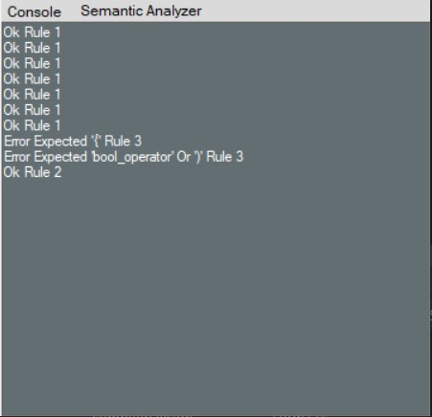Console : int, identifier var1, variable =, symbol 10, number ;, symbol int, identifier var2, variable =, symbol 20, number ;, symbol int, identifier var3, variable =, symbol var1, variable +, symbol 20, number ;, symbol int, identifier add, variable =, symbol var1, variable +, symbol var2, variable ;, symbol int, identifier sub, variable =, symbol var1, variable -, symbol var2, variable ;, symbol int, identifier mul, variable =, symbol var1, variable *, symbol var2, variable ;, symbol int, identifier div, variable =, symbol var2, variable /, symbol var1, variable

;, symbol if, reserved word (, symbol

## Semantic Analyzer

Checking the lines with roles

Ok Rule 1 Ok Rule 1 Ok Rule 1 Ok Rule 1 Ok Rule 1 Ok Rule 1 Ok Rule 1 Ok Rule 3

Ok Rule 3

If we replace by this input then,

if(x >= 10) {y = 10; }

if(x >= 20 && y != 10) { y = 20;} with

if(x >= 10) y = 10; }

if(x >= 20 && y != 10 { y = 20;}

**the analyzer output :**