Final Project Compiler Construction



**Name: Junaid Ali , Muhammad Yaseen Regno: FA20-BCS-008, FA20-BCS-076**

**Submitted to: Sir Bilal Haider Bukhari Dated: 26-Dec-23**

**Subject: Compiler Construction**

**COMSATS UNIVERSITY ISLAMABAD ATTOCK CAMPUS**

# How Function Works step by step:

In this phase we save the variable value in the memory and every variable shows on the data grid view.

Our class variable and list of class variables.

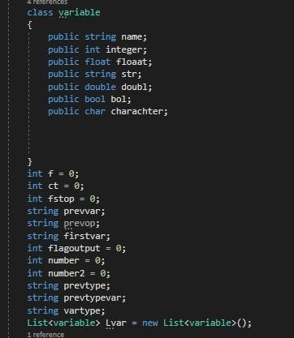

First in rule1 function we put a flag (f=1) to know that the identifier is integer

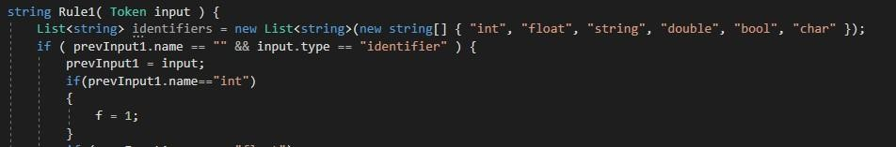

In rule 2 function We made first var to catch the variable before “=”

prevvar to catch the first variable after “=”

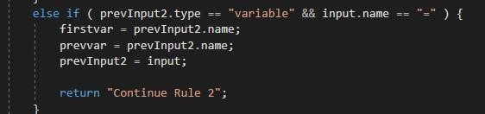

In this condition the variable becomes any integer value

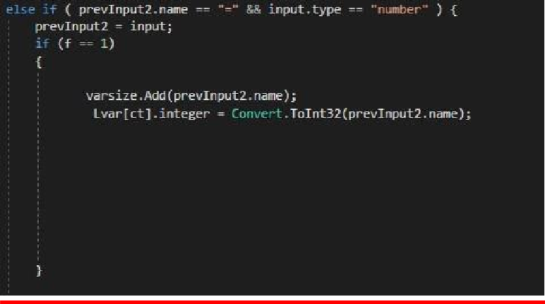

Ex: int x=3;

In this condition integer variable becomes another integer variable Ex: int x= y;

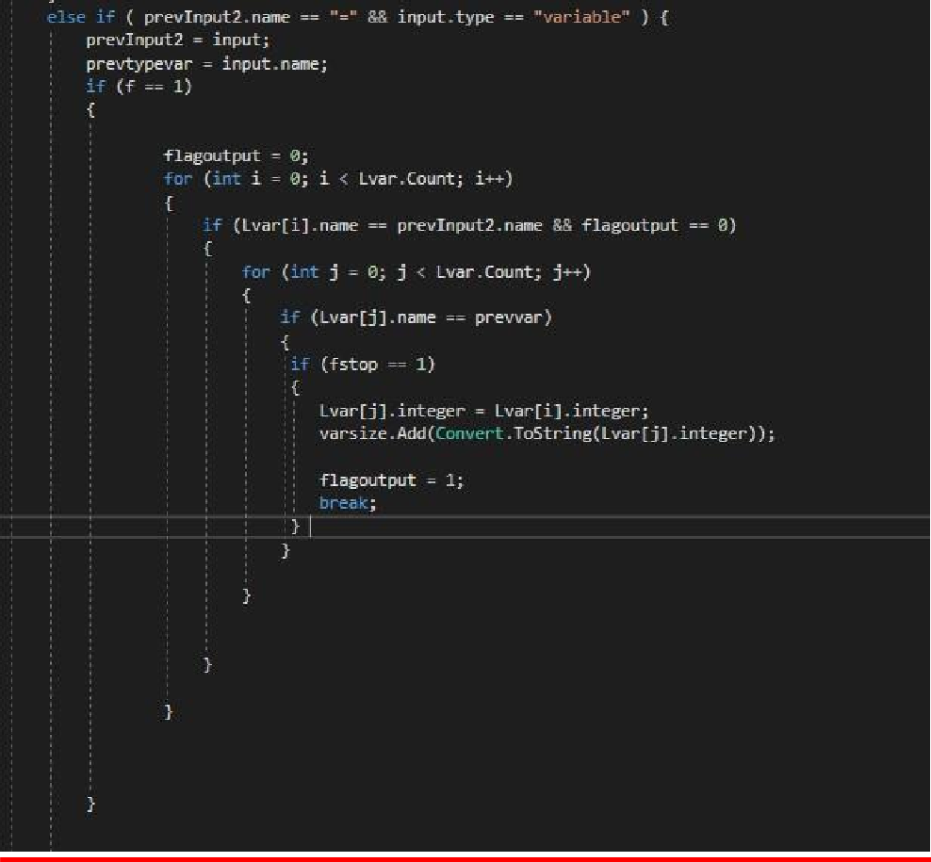

In this condition we catch the number before the operator. Number becomes this number.

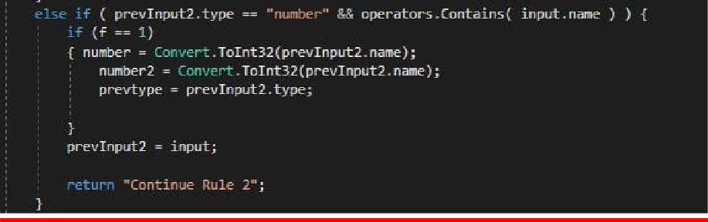

In this condition we catch the variable before the operator. Prevvar becomes this variable.

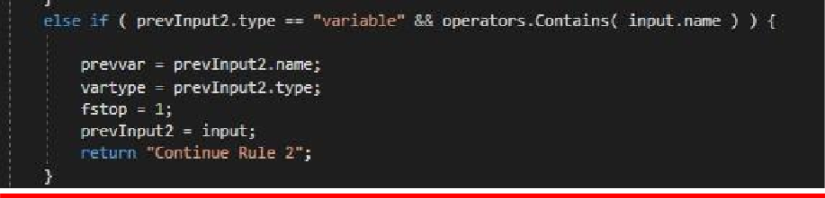

In this condition we take the values of “+” operator when

Num+ num And

Integer variable + num

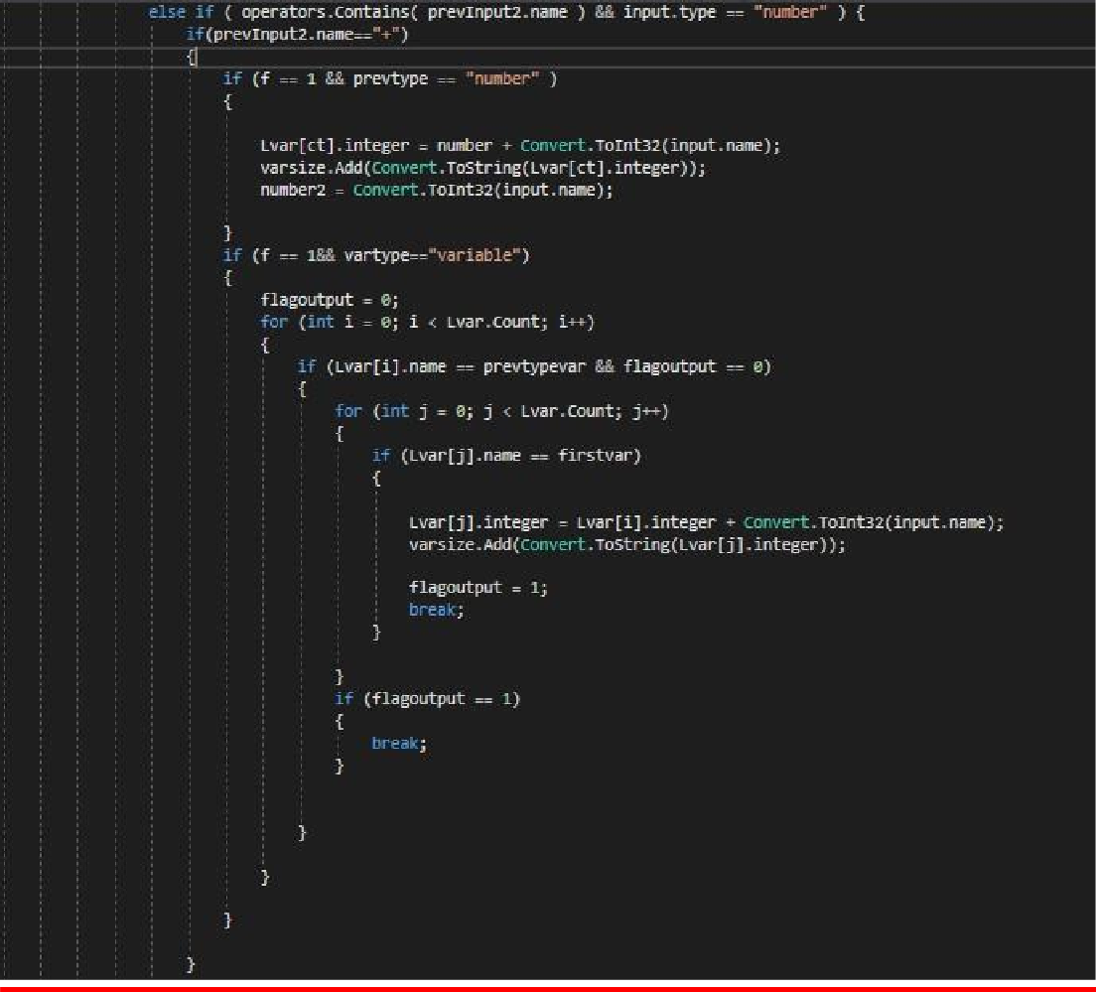

In this condition we take the values of “-” operator when

Num-num And

Integer variable-num

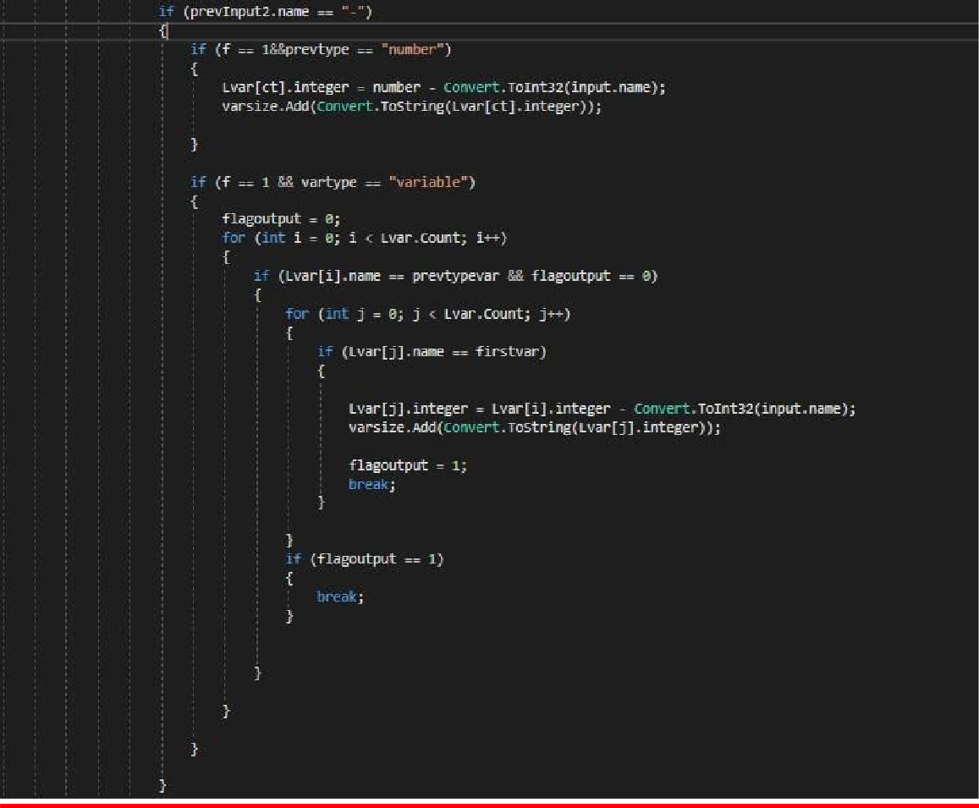

In this condition we take the values of “*” operator when

Num*num And

Integer variable*num

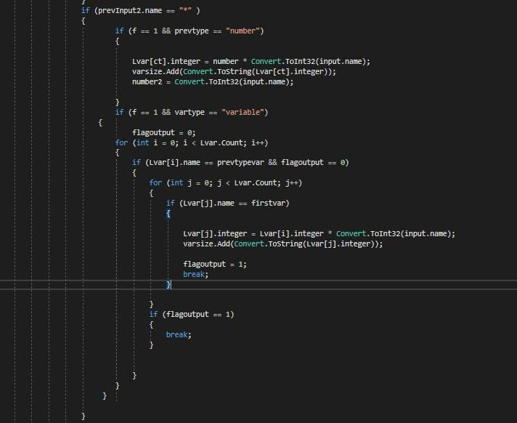

In this condition we take the values of “/” operator when

Num/num And

Integer variable/num

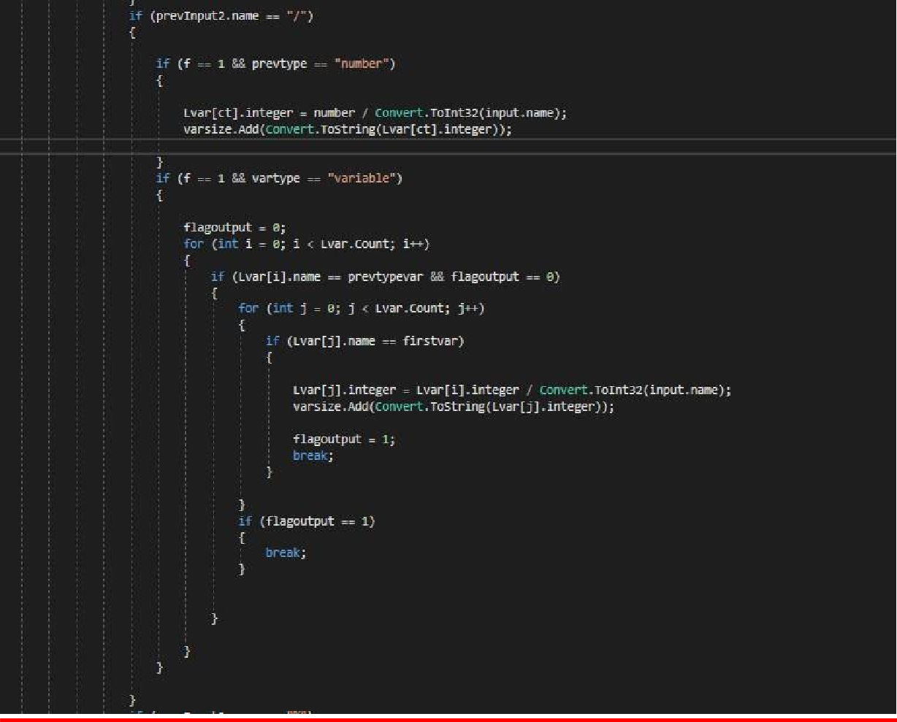

In this condition we take the values of “%” operator when

Num % num And

Integer variable % num

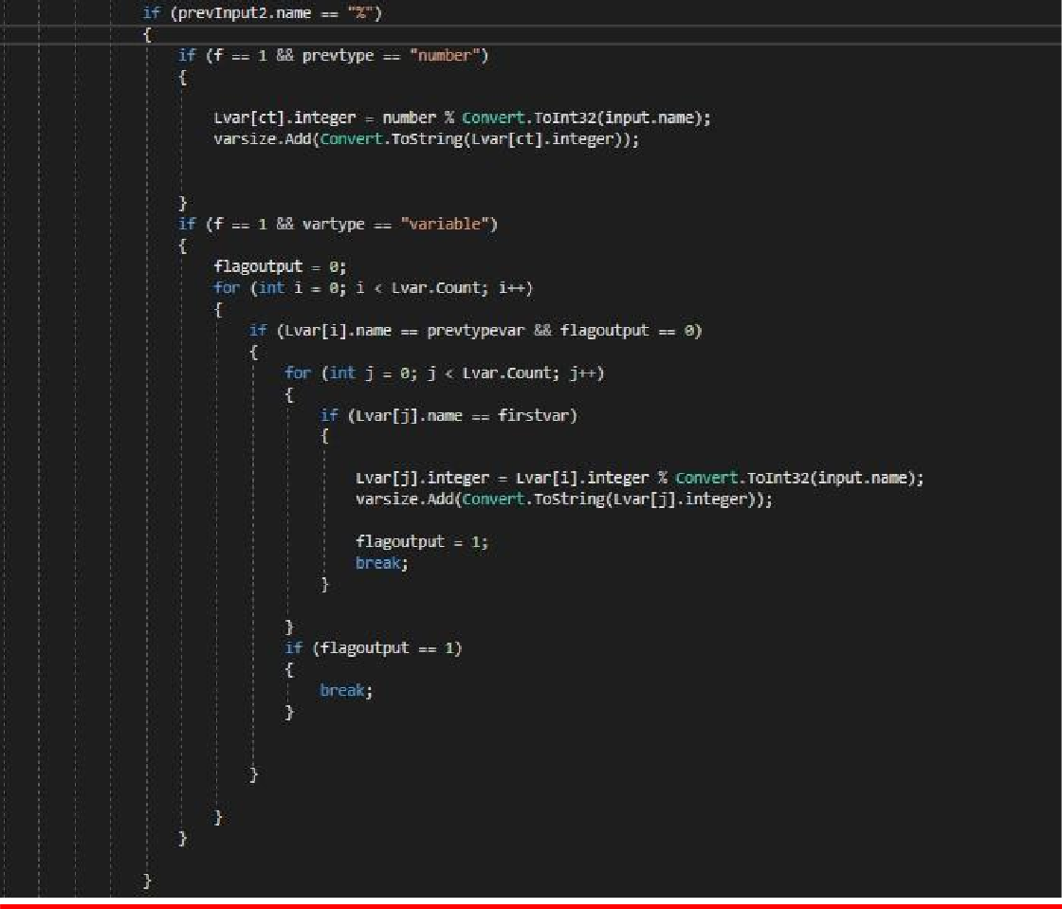

In this condition we take the values of “+” operator when

Integer variable+ Integer variable

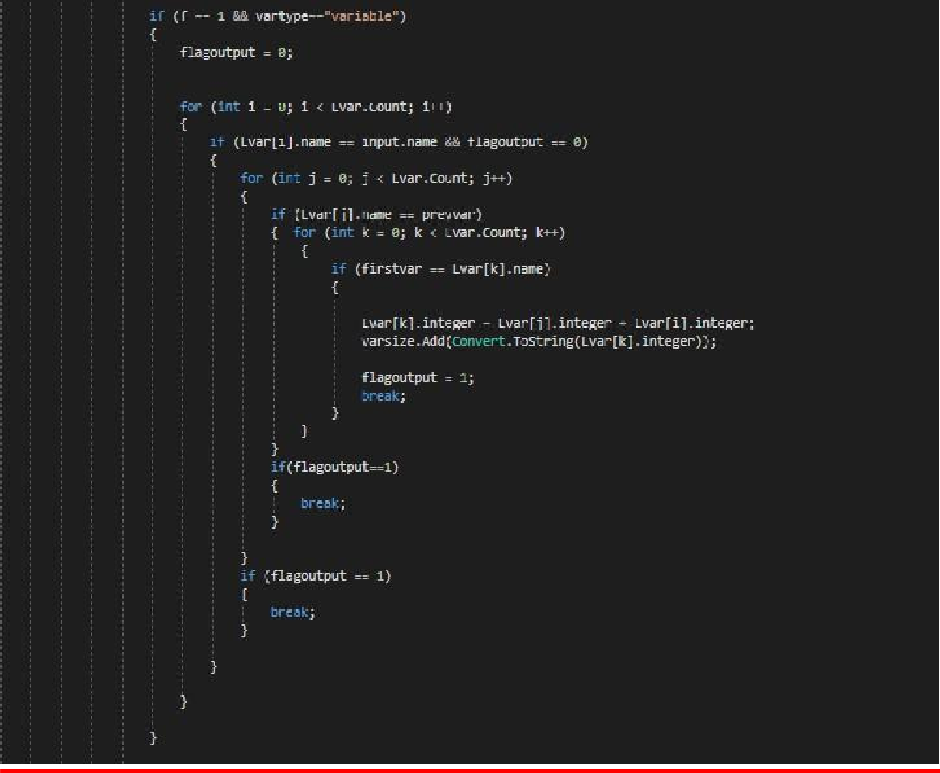

In this condition we take the values of “-” operator when

Integer variable- Integer variable

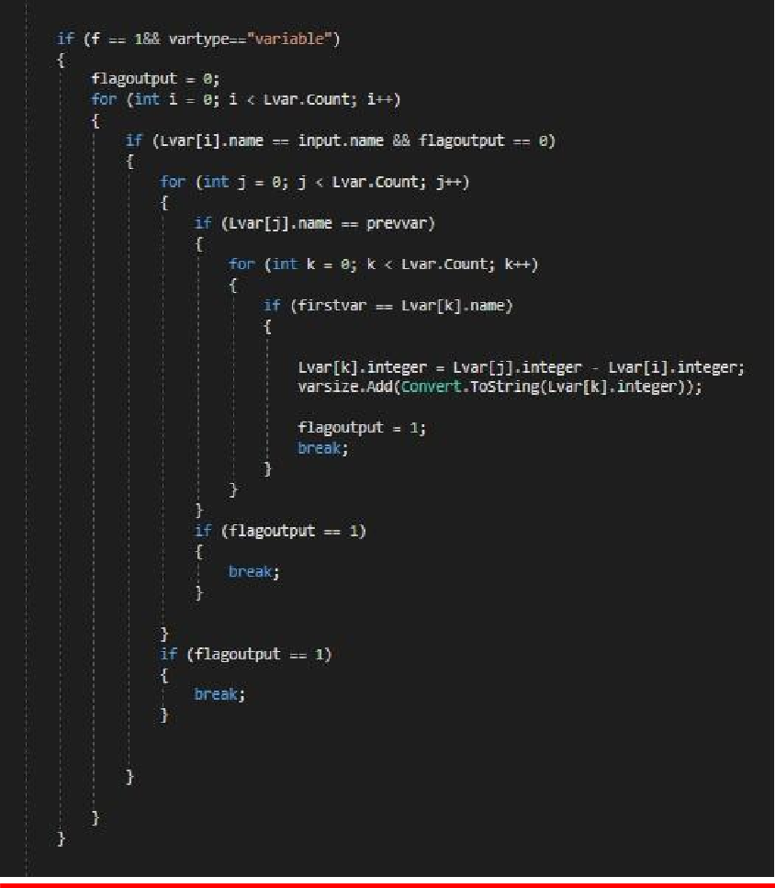

In this condition we take the values of “*” operator when

Integer variable*Integer variable

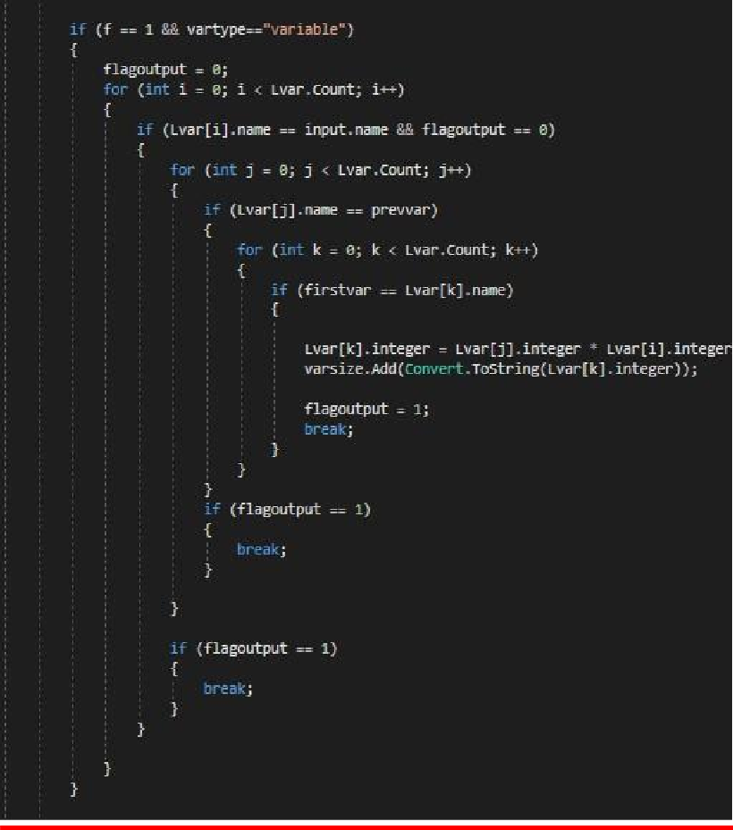

In this condition we take the values of “/” operator when

Integer variable/Integer variable

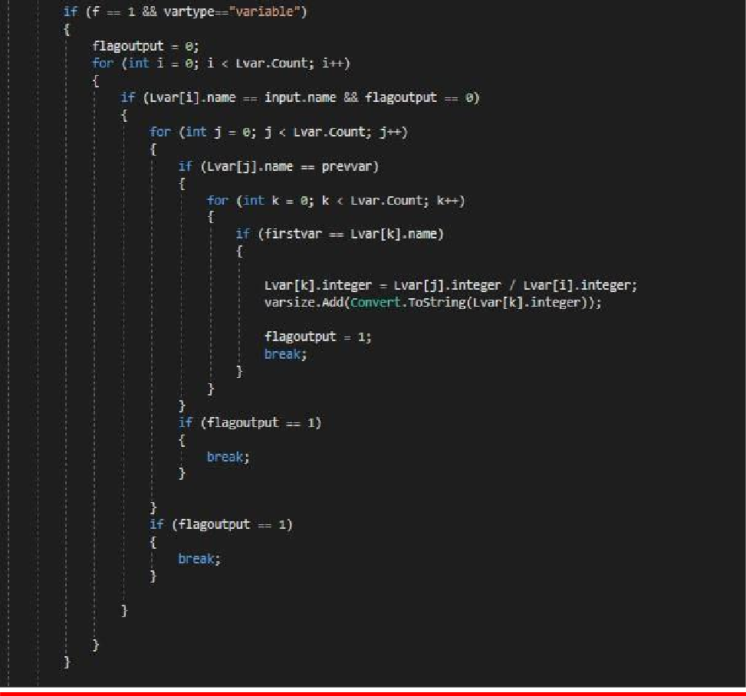

In this condition we take the values of “%” operator when

Integer variable% Integer variable

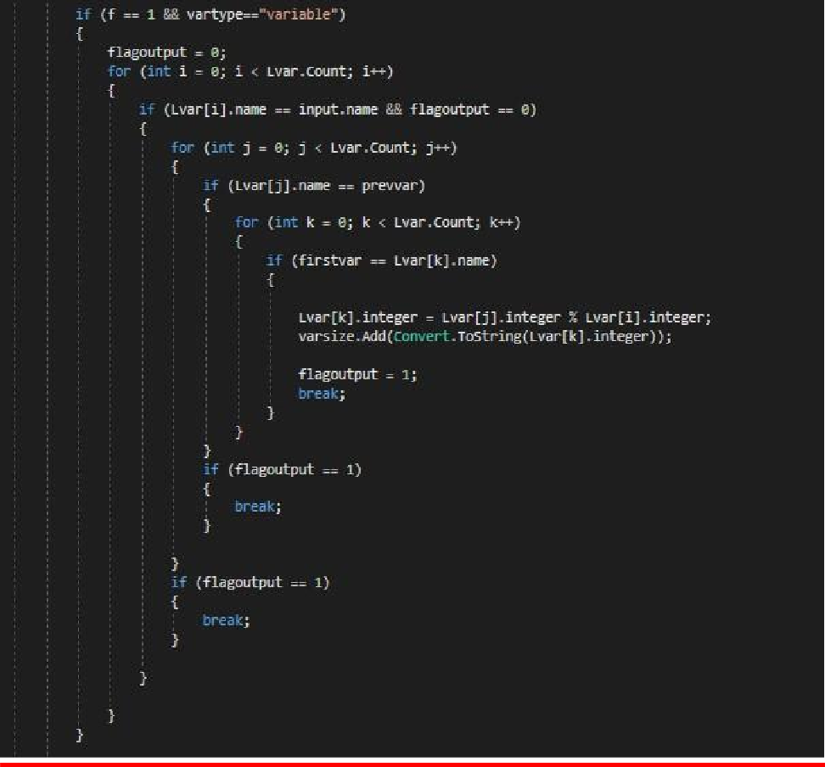

Test Case :

