**API**

**(APPLICATION PROGRAMMING INTERFACE)**



one program interacts with another program

**Rest API**

**(Representational State Transfer)**

Representational State Transfer, is an architectural style for providing standards between computer systems on the web, making it easier for systems to communicate with each other

**Architecture requirements REST**

**.Client should be send request**

**.resource operation**

**.HTTP**

**.Stateless**

**.XML JSON data types**

**HTTP**

**(Hypertext Transfer Protocol)**

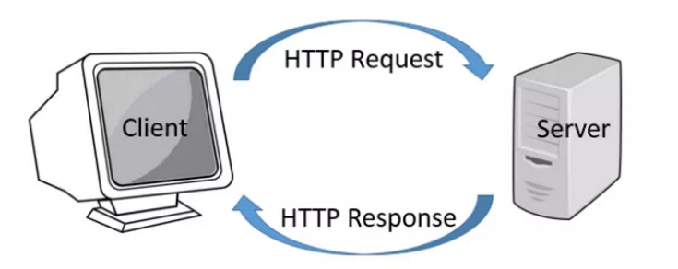

CRUD

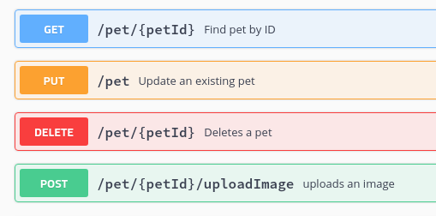

**URL**

**(*Uniform Resource Locator*)**

.Resource

toy.com/search

toy.com/orders

toy.com/products

.Path (parameters)

Toy.com/products/cars

.Query params

Toy.com/products/cars?model=Jeep

.Headers

.Body

**STATUS**

.1xx- Information

.2xx- Successful Information

.3xx-Redirection

.4xx-Client bug

.5xx-Server bug

**XML & JSON**

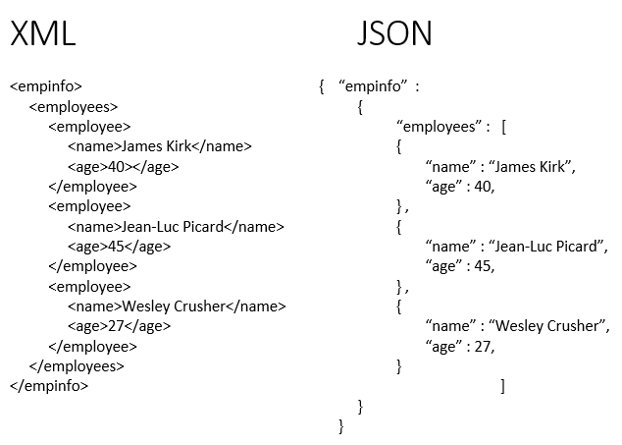

s