1. import java.util.Scanner;

public class PalindromeChecker {

// Function to check if a string is a palindrome

public static boolean checkPalindrome(String str) {

// Convert the string to lowercase to make the check case-insensitive

str = str.toLowerCase();

// Loop through half of the string

for (int i = 0; i < str.length() / 2; i++) {

// Compare characters from both ends of the string

if (str.charAt(i) != str.charAt(str.length() - i - 1)) {

return false; // If characters don't match, it's not a palindrome

}

}

return true; // If all characters match, it's a palindrome

}

public static void main(String[] args) {

// Create a Scanner object to read user input

Scanner scanner = new Scanner(System.in);

// Ask the user for a string

System.out.print("Enter a string: ");

String input = scanner.nextLine();

// Check if the input string is a palindrome and output the result

if (checkPalindrome(input)) {

System.out.println("'" + input + "' is a palindrome.");

} else {

System.out.println("'" + input + "' is not a palindrome.");

}

// Close the scanner object

scanner.close();

}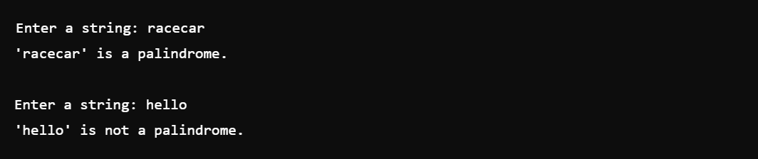

**2)** import java.util.Scanner;

public class ReverseString {

public static void main(String[] args) {

// Create a Scanner object to read user input

Scanner scanner = new Scanner(System.in);

// Ask the user to enter a string

System.out.print("Enter a string: ");

String input = scanner.nextLine();

// Initialize an empty string to store the reversed string

String reversedString = "";

// Use a loop to reverse the string

for (int i = input.length() - 1; i >= 0; i--) {

reversedString += input.charAt(i); // Append each character to the reversed string

}

// Output the reversed string

System.out.println("Reversed string: " + reversedString);

// Close the scanner object

scanner.close();

}

}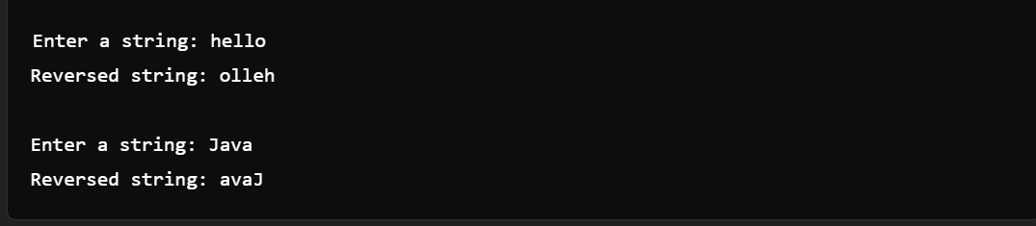

**3)** public class NumberPattern {

public static void main(String[] args) {

// Initialize the starting number for the pattern

int num = 1;

// Loop through rows (1 to 4)

for (int i = 1; i <= 4; i++) {

// Print numbers in each row

for (int j = 1; j <= i; j++) {

System.out.print(num + " ");

num++; // Increment the number for next print

}

System.out.println(); // Move to the next line after each row

}

}

}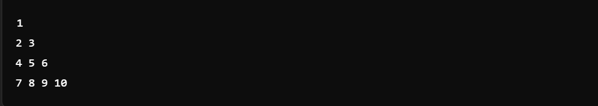

**4**) import java.util.Scanner;

public class StarPattern {

public static void main(String[] args) {

// Create a Scanner object to read user input

Scanner scanner = new Scanner(System.in);

// Ask the user to enter the number of rows

System.out.print("Enter the number of rows (e.g., 5): ");

int n = scanner.nextInt();

// Print the upper part of the pattern (including the middle line)

for (int i = 0; i < n / 2 + 1; i++) {

// Print leading spaces

for (int j = 0; j < i; j++) {

System.out.print(" ");

}

// Print the first star

System.out.print("*");

// Print spaces between the stars (only if it's not the first row)

if (i != 0) {

for (int j = 0; j < 2 * (n / 2 - i) - 1; j++) {

System.out.print(" ");

}

// Print the second star

System.out.print("*");

}

// Move to the next line

System.out.println();

}

// Print the lower part of the pattern

for (int i = n / 2 - 1; i >= 0; i--) {

// Print leading spaces

for (int j = 0; j < i; j++) {

System.out.print(" ");

}

// Print the first star

System.out.print("*");

// Print spaces between the stars (only if it's not the first row)

if (i != 0) {

for (int j = 0; j < 2 * (n / 2 - i) - 1; j++) {

System.out.print(" ");

}

// Print the second star

System.out.print("*");

}

// Move to the next line

System.out.println();

}

// Close the scanner

scanner.close();

}

}

**5)** import java.util.Scanner;

public class GradingSystem {

public static void main(String[] args) {

// Create a scanner object to read input from the user

Scanner scanner = new Scanner(System.in);

// Read the marks scored by the student

int marks = scanner.nextInt();

// Call the method to determine the grade and print the result

System.out.println(determineGrade(marks));

// Close the scanner object

scanner.close();

}

// Method to determine the grade based on marks

public static String determineGrade(int marks) {

// Check if marks are outside the valid range

if (marks > 100 || marks < 0) {

return "Invalid Input";

}

// Determine grade based on the range of marks

if (marks == 100) {

return "S";

} else if (marks >= 90) {

return "A";

} else if (marks >= 80) {

return "B";

} else if (marks >= 70) {

return "C";

} else if (marks >= 60) {

return "D";

} else if (marks >= 50) {

return "E";

} else {

return "F";

}

}

}

**6)** import java.util.Scanner;

public class HotelTariff {

public static void main(String[] args) {

// Create a scanner object to read input

Scanner scanner = new Scanner(System.in);

// Input: month, room rent per day, and number of days stayed

int month = scanner.nextInt();

double roomRentPerDay = scanner.nextDouble();

int numberOfDays = scanner.nextInt();

// Initialize the total tariff

double totalTariff;

// Use a switch construct to check the month and apply peak season logic

switch(month) {

case 4: case 5: case 6: case 11: case 12:

// Peak season: Apply 20% increase in rent

totalTariff = roomRentPerDay * numberOfDays * 1.20;

break;

default:

// Non-peak season: No change in rent

totalTariff = roomRentPerDay * numberOfDays;

break;

}

// Output the total tariff with 2 decimal places

System.out.printf("%.2f\n", totalTariff);

// Close the scanner

scanner.close();

}

}

**7**) import java.util.Scanner;

public class LargestNumber {

public static void main(String[] args) {

// Create a scanner object to read input from the user

Scanner scanner = new Scanner(System.in);

// Input: Three numbers from the user

System.out.print("Enter first number: ");

int num1 = scanner.nextInt();

System.out.print("Enter second number: ");

int num2 = scanner.nextInt();

System.out.print("Enter third number: ");

int num3 = scanner.nextInt();

// Find the largest number using if-else conditions

int largest;

if (num1 >= num2 && num1 >= num3) {

largest = num1;

} else if (num2 >= num1 && num2 >= num3) {

largest = num2;

} else {

largest = num3;

}

// Output: The largest number

System.out.println("The largest number is: " + largest);

// Close the scanner

scanner.close();

}

}