1. public class SumComparison {

public static void main(String[] args) {

// Declare the integer variables

int a = 10;

int b = 5;

int c = 6;

int d = 4;

// Check if the sum of a and b is greater than the sum of c and d

if ((a + b) > (c + d)) {

// If the condition is true, print this message

System.out.println("The sum of a and b is greater than the sum of c and d.");

} else {

// If the condition is false, print this message

System.out.println("The sum of a and b is not greater than the sum of c and d.");

}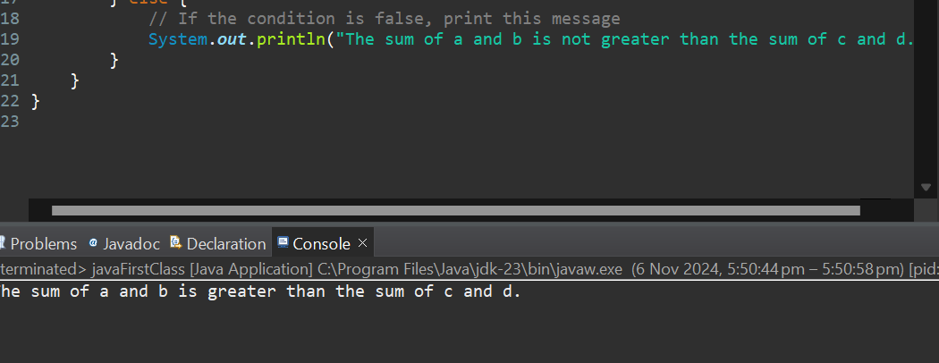

1. public class EvenCheck {

public static void main(String[] args) {

// Declare and initialize the integer variable

int number = 8; // You can change this value to test different numbers

// Use the modulo operator to check if the number is even

if (number % 2 == 0) {

// If the condition is true, the number is even

System.out.println(number + " is an even number.");

} else {

// If the condition is false, the number is odd

System.out.println(number + " is an odd number.");

}

}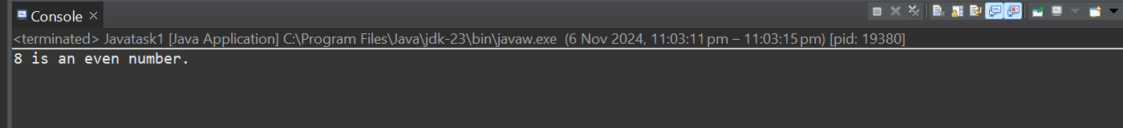

**3)** public class PrintAlphabet {

public static void main(String[] args) {

// Loop through the ASCII values of 'A' to 'Z'

for (char ch = 'A'; ch <= 'Z'; ch++) {

// Print each character on the same line

System.out.print(ch + " ");

}

// Print a newline after the output

System.out.println();

}

}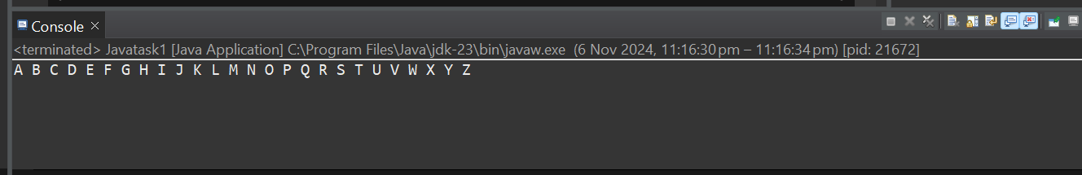

**4)** import java.util.Scanner;

public class SwapNumbers {

public static void main(String[] args) {

// Create a scanner object to read input from the user

Scanner scanner = new Scanner(System.in);

// Prompt the user to enter two numbers

System.out.print("Enter the first number: ");

int num1 = scanner.nextInt();

System.out.print("Enter the second number: ");

int num2 = scanner.nextInt();

// Print the values before swapping

System.out.println("Before swapping:");

System.out.println("First number: " + num1);

System.out.println("Second number: " + num2);

// Use an additional variable to swap the values

int temp = num1;

num1 = num2;

num2 = temp;

// Print the values after swapping

System.out.println("After swapping:");

System.out.println("First number: " + num1);

System.out.println("Second number: " + num2);

// Close the scanner

scanner.close();

}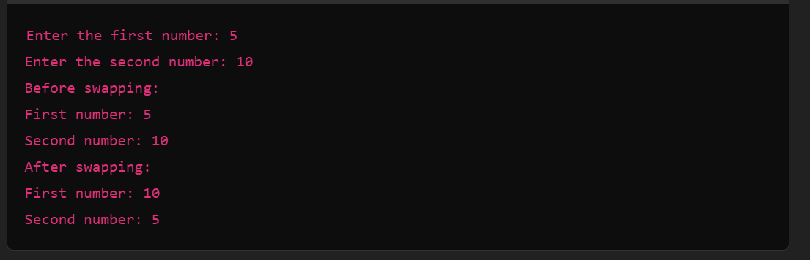

**}**

**5)** import java.util.Scanner;

public class PrimeCheck {

public static void main(String[] args) {

// Create a scanner object to read input from the user

Scanner scanner = new Scanner(System.in);

// Prompt the user to enter a number

System.out.print("Enter a number: ");

int number = scanner.nextInt();

// Check if the number is prime

if (isPrime(number)) {

System.out.println(number + " is a prime number.");

} else {

System.out.println(number + " is not a prime number.");

}

// Close the scanner

scanner.close();

}

// Method to check if a number is prime

public static boolean isPrime(int num) {

// Handle edge cases for numbers less than 2

if (num <= 1) {

return false;

}

// Check divisibility from 2 to the square root of num

for (int i = 2; i * i <= num; i++) {

if (num % i == 0) {

return false; // num is divisible by i, so it's not prime

}

}

return true; // num is prime if no divisors were found

}

}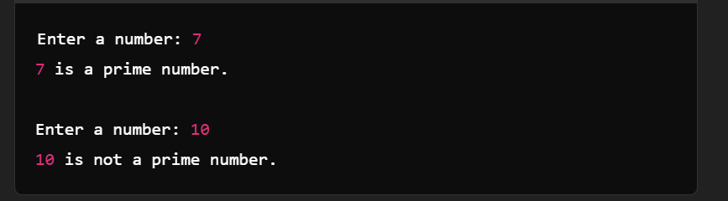

**6)** import java.util.Scanner;

public class Factorial {

public static void main(String[] args) {

// Create a scanner object to read input from the user

Scanner scanner = new Scanner(System.in);

// Prompt the user to enter a number

System.out.print("Enter a number: ");

int number = scanner.nextInt();

// Calculate the factorial of the number

long factorial = calculateFactorial(number);

// Print the result

System.out.println(number + "! = " + factorial);

// Close the scanner

scanner.close();

}

// Method to calculate the factorial of a number

public static long calculateFactorial(int num) {

long result = 1;

// Loop to calculate the factorial by multiplying all numbers from 1 to num

for (int i = 1; i <= num; i++) {

result *= i;

}

return result;

}

}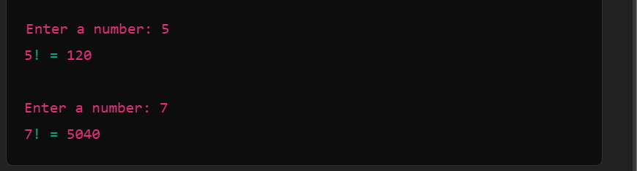

**7)**  public class StringLength {

public static void main(String[] args) {

// Initialize the string

String msg = "GUVI GEEK";

// Get the length of the string using the length() method

int length = msg.length();

// Print the length of the string

System.out.println("The length of the string is: " + length);

}

}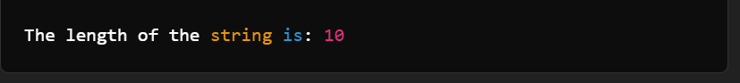

8) public class WelcomeMessage {

public static void main(String[] args) {

// Loop to print the message 10 times

for (int i = 0; i < 10; i++) {

System.out.println("Welcome to guvi");

}

}}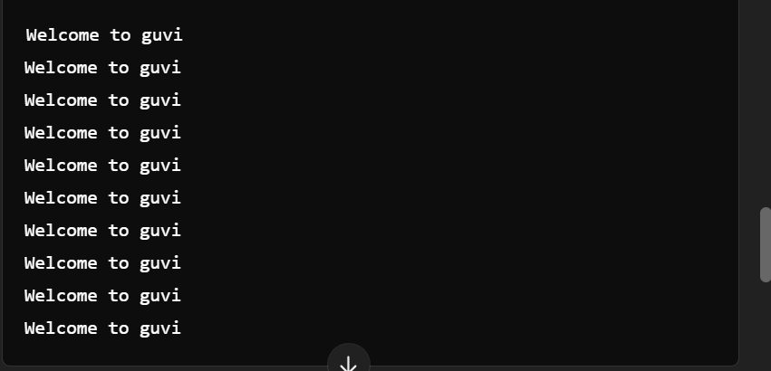

**9)** import java.util.Scanner;

public class SeniorCitizenCheck {

public static void main(String[] args) {

// Create a scanner object to read user input

Scanner scanner = new Scanner(System.in);

// Ask the user to input their age

System.out.print("Please enter your age: ");

int age = scanner.nextInt();

// Check if the person is a senior citizen

if (age >= 60) {

System.out.println("You are a senior citizen.");

} else {

System.out.println("You are not a senior citizen.");

}

// Close the scanner to avoid resource leak

scanner.close();

}

}

**10)** import java.util.Scanner;

public class CountDigits {

public static void main(String[] args) {

// Create a scanner object to read user input

Scanner scanner = new Scanner(System.in);

// Ask the user to input an integer

System.out.print("Enter an integer: ");

int number = scanner.nextInt();

// If the number is negative, make it positive for counting digits

number = Math.abs(number);

// Count the number of digits

int count = 0;

// Special case: If the number is 0, it has 1 digit

if (number == 0) {

count = 1;

} else {

while (number > 0) {

number /= 10; // Remove the last digit by dividing by 10

count++; // Increment the digit count

}

}

// Display the result

System.out.println("The number of digits is: " + count);

// Close the scanner to avoid resource leak

scanner.close();

}

}