Submitted by: Mohammed Saquib

Date: 18/01/2025

Batch no: DevOps SA2412033

L1 - Demonstrate the AWS EC2 Ubuntu Instance Creation steps and connect to EC2 Instance using Mobaxterm.

Step1: Creating an Ubuntu

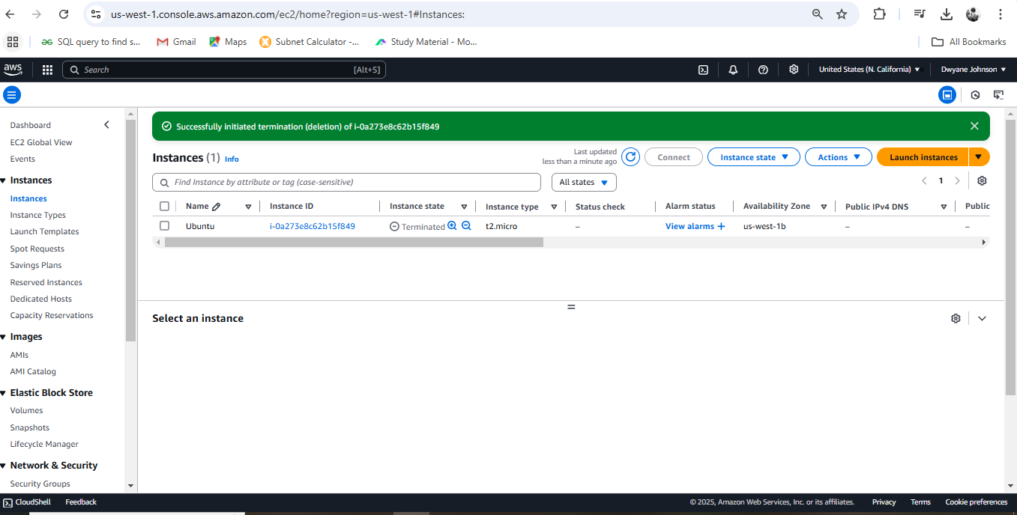

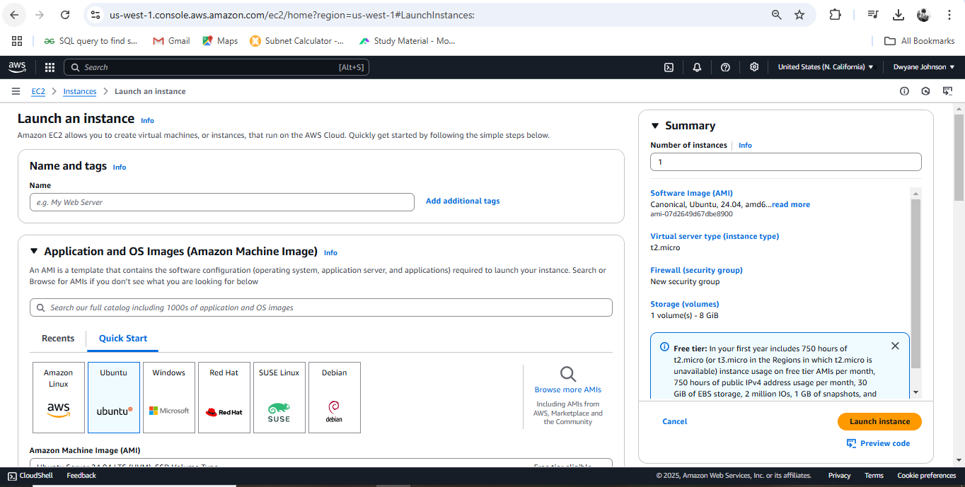

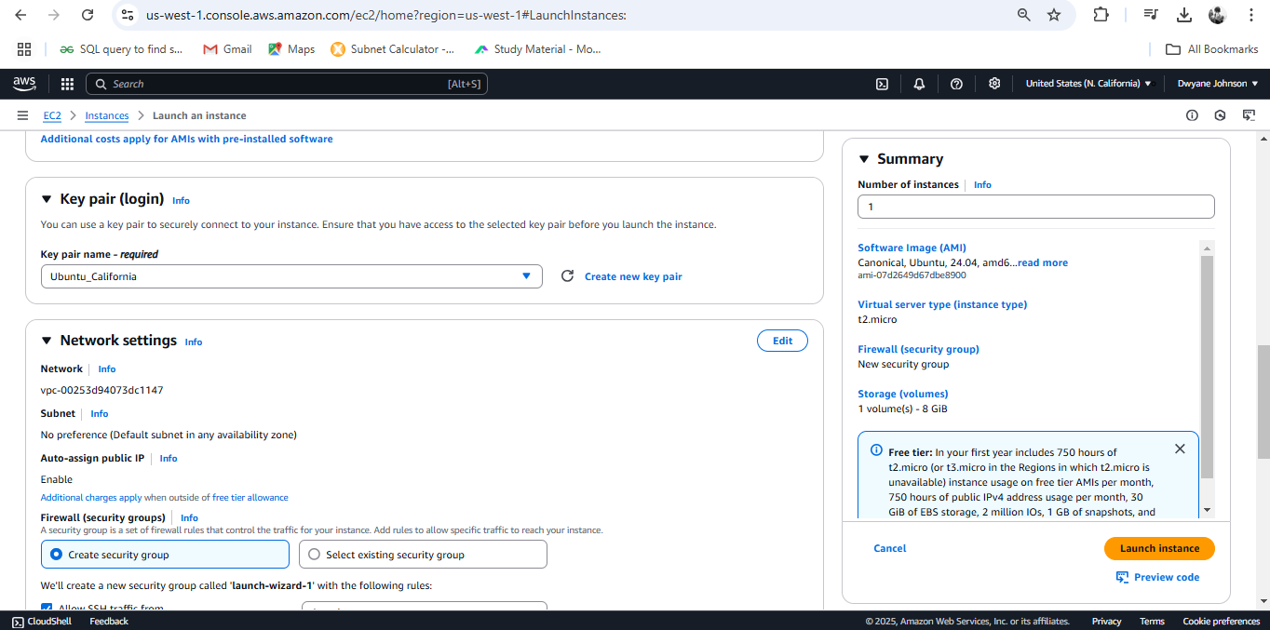

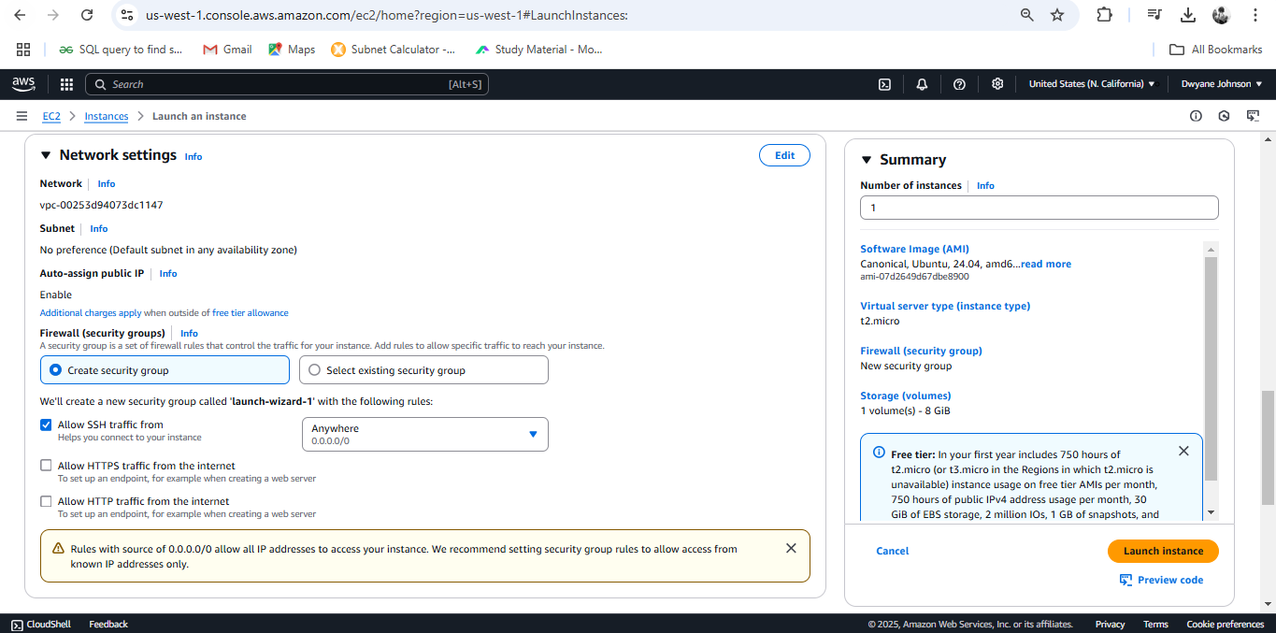

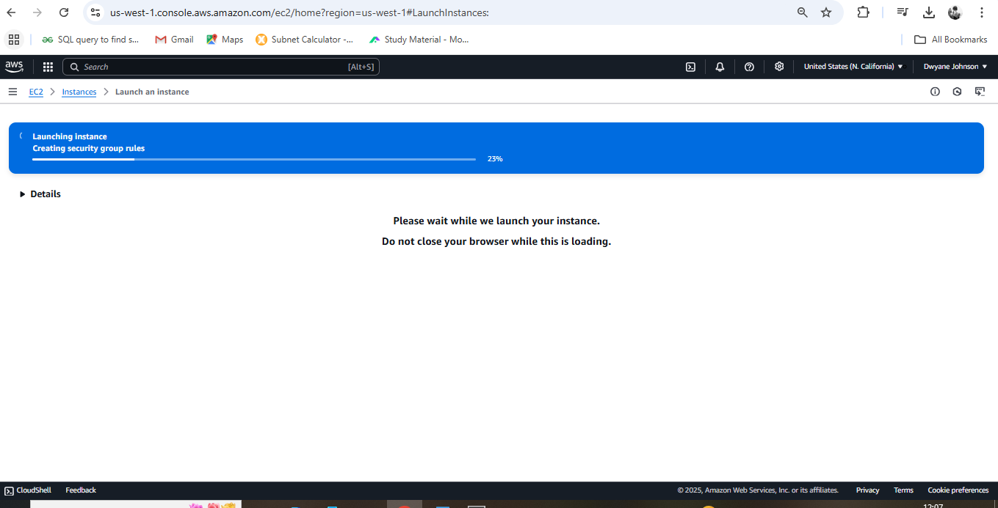

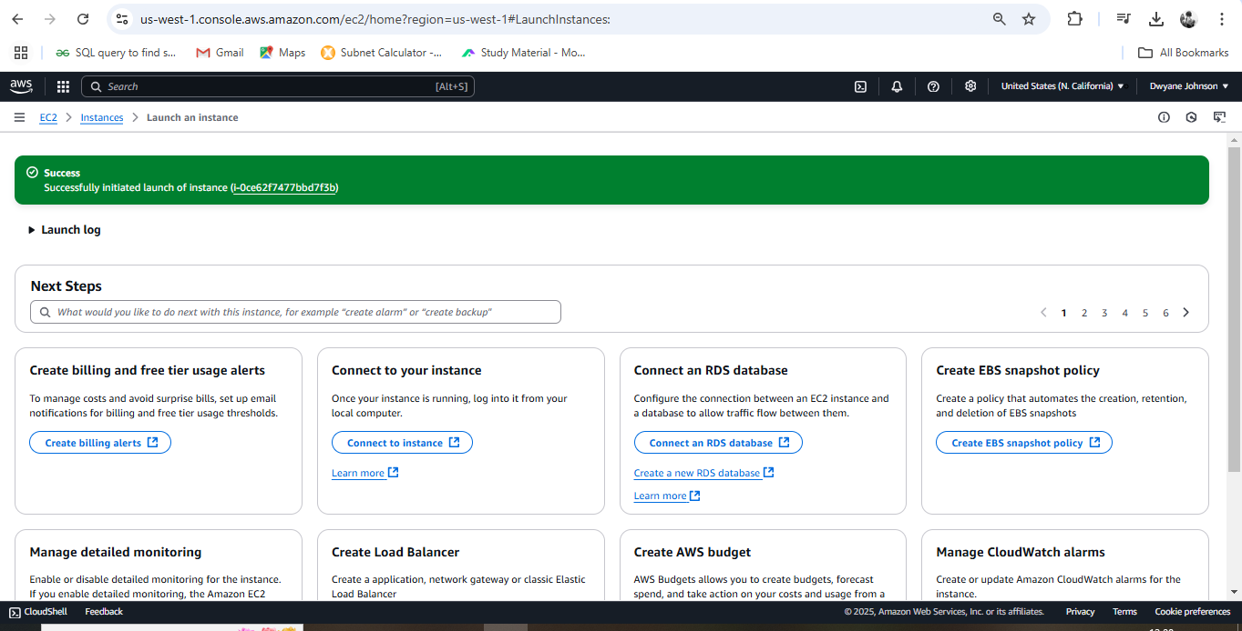

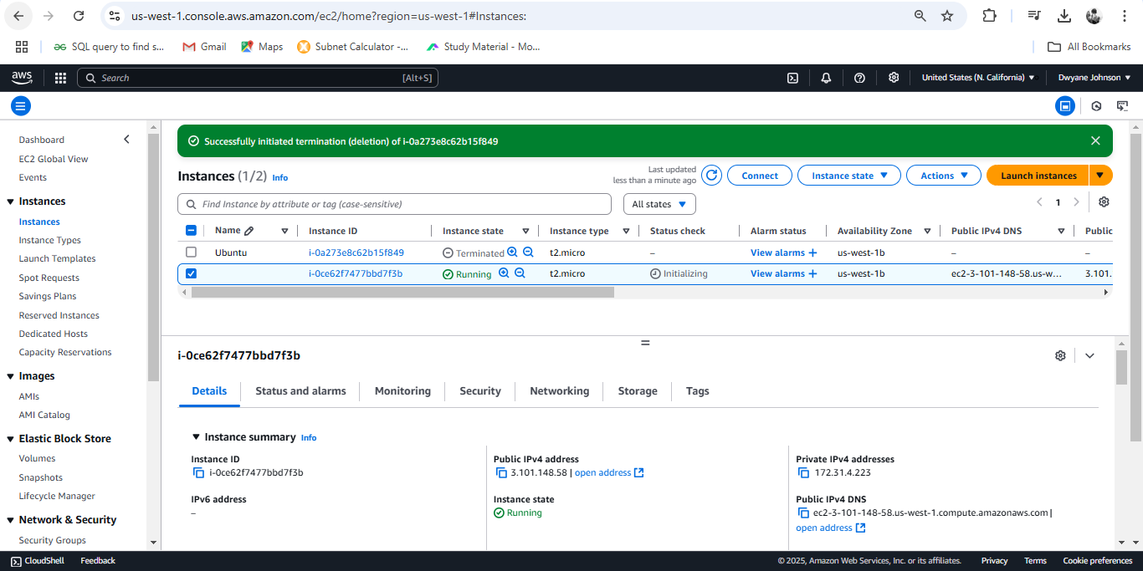

Step 2: Connecting to EC2 Instance using MobaXterm

