Submitted by: Mohammed Saquib

Date: 13/01/2025

Batch no: DevOps SA2412033

L6 - Create S3 Bucket and add folders and files

Step 1: Home page of S3

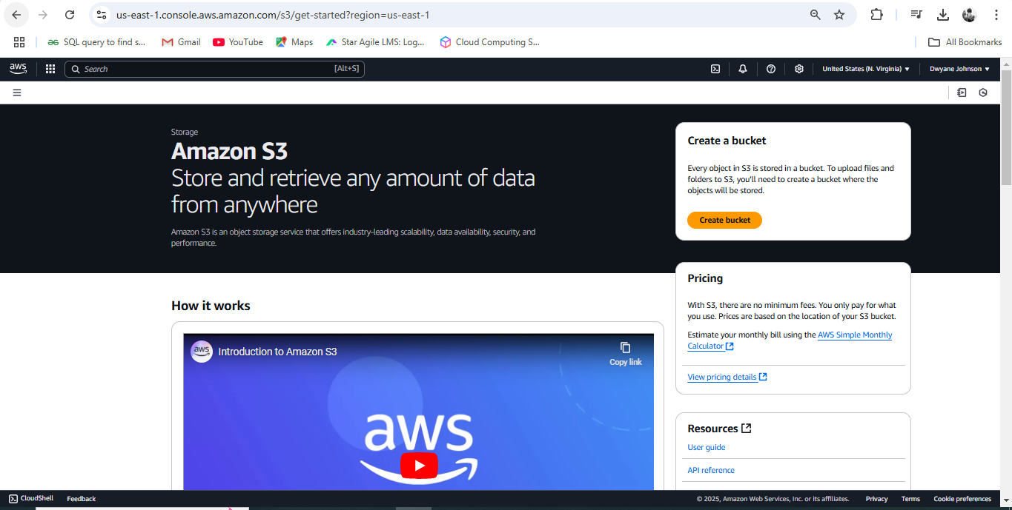

Step 2: Creating S3 Bucket

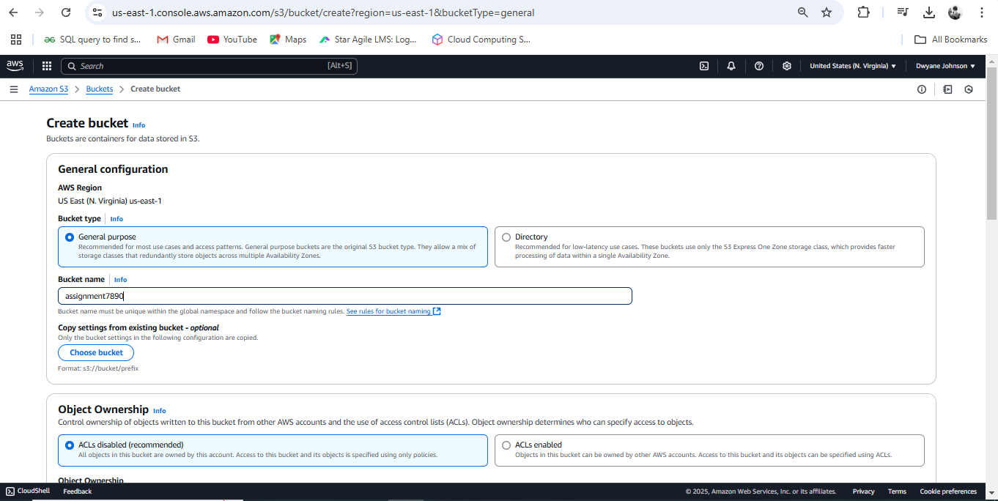

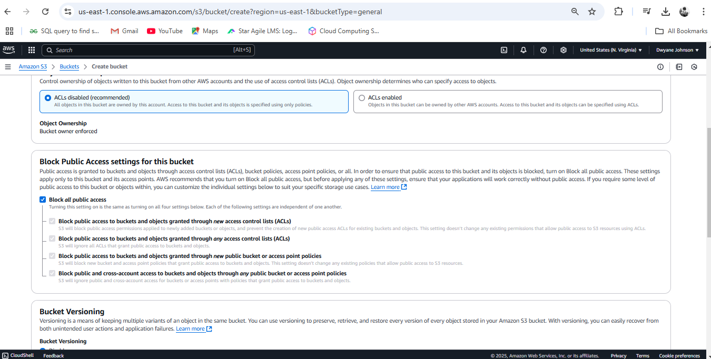

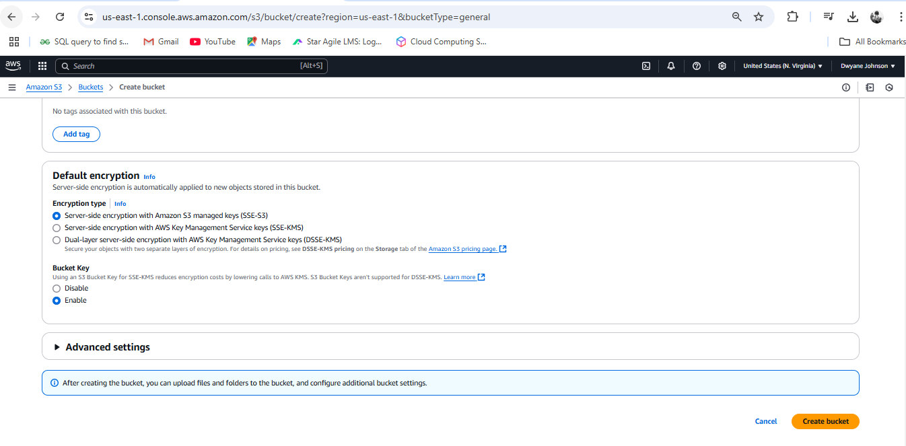

Step 3: S3 bucket got created

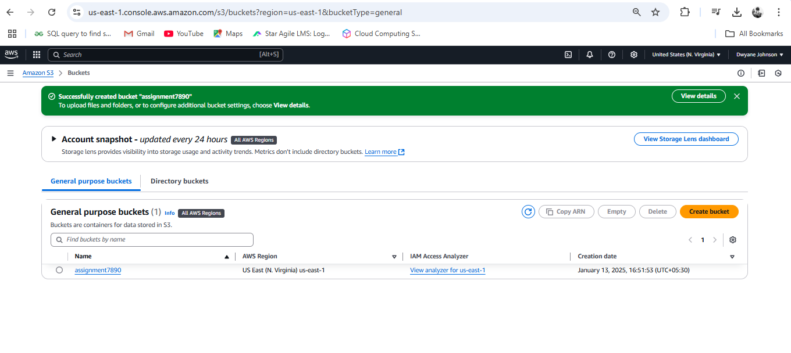

Step 4: Uploading Folder to the bucket

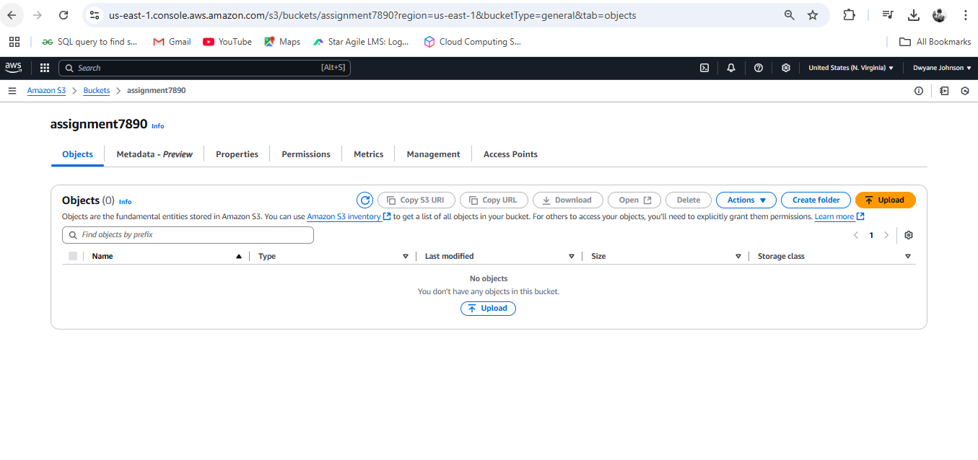

Step 5: Uploaded folder

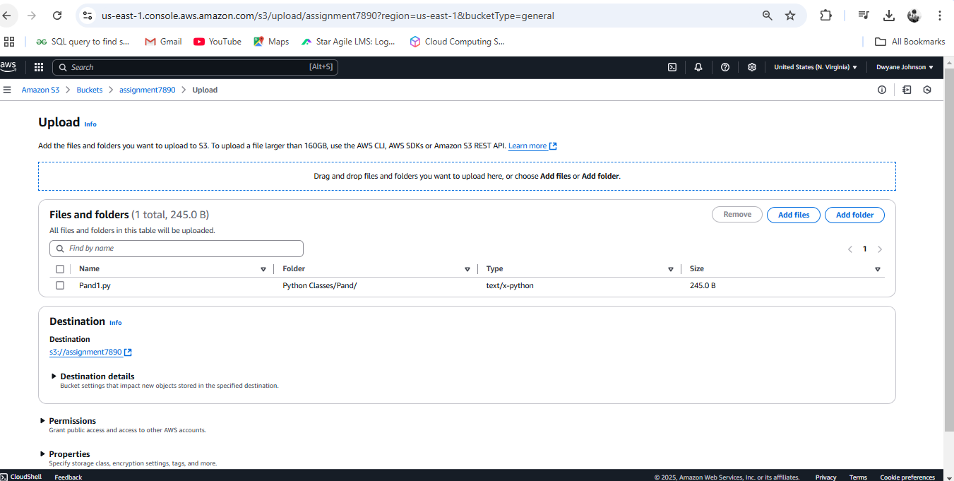

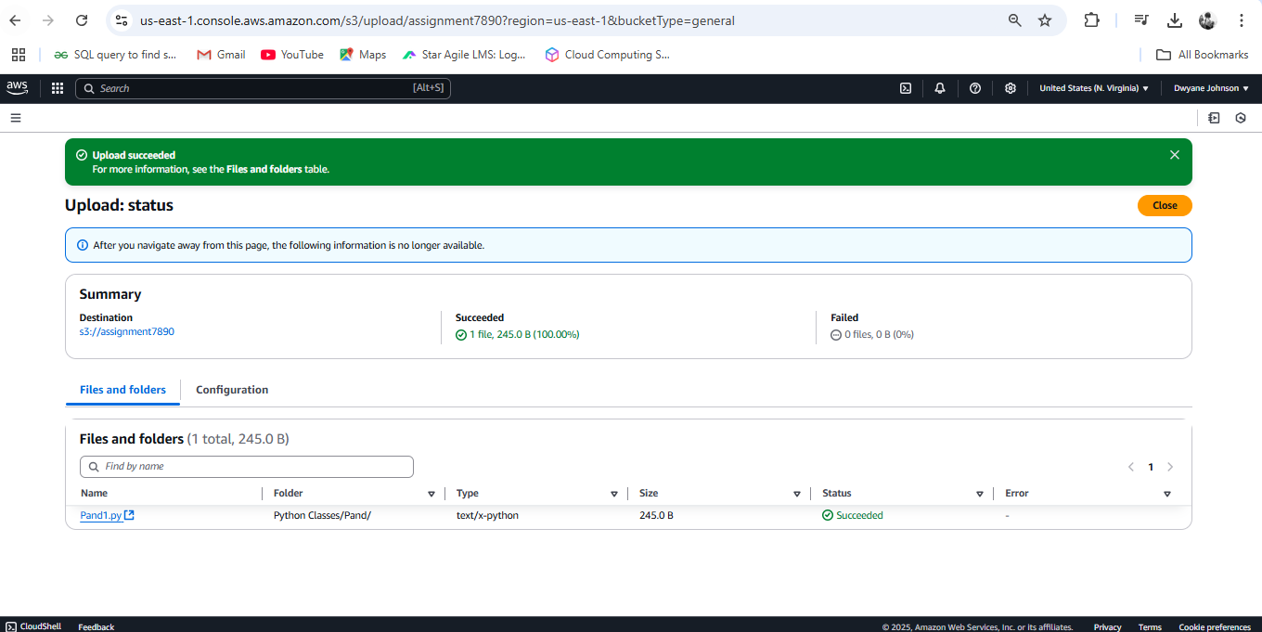

Step 6: Uploading file

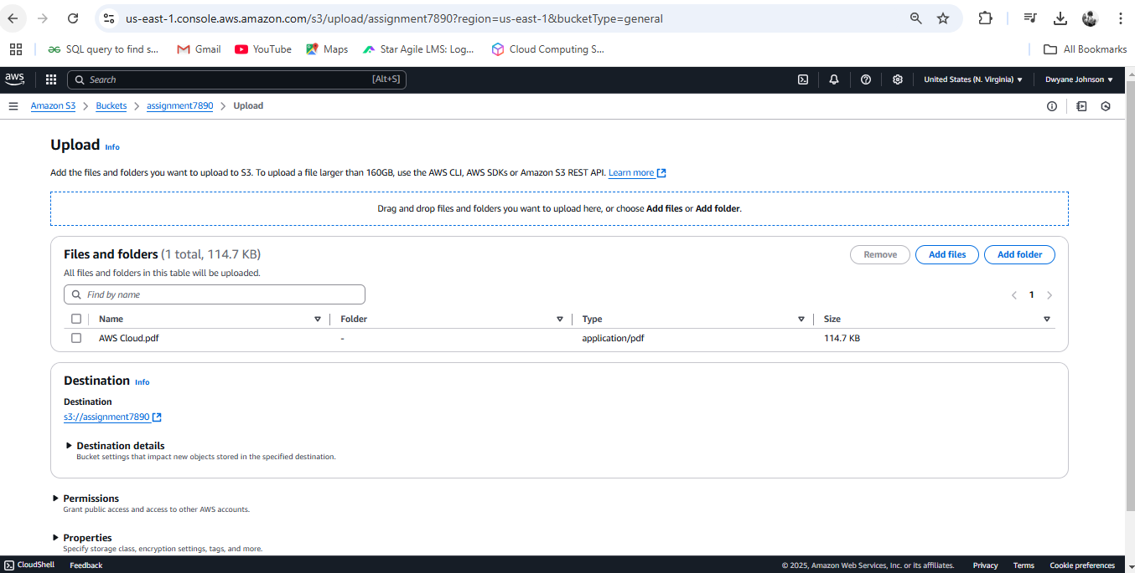

Step 7: Both folders and file has been uploaded in S3 bucket

