QLayout classes:

1.QBoxLayout

\*Vertical Layout

\*Horizontal Layout

2.QFormLayout: QForm Layout is a convenient way to create a form with two columns and multiple rows.

Each row consists of an input field associated with a label. As a convention, the left column contains the label while the right column contains an input field. The QFormLayout class has a setWidget() method. Its usage is:  
*QFormLayout.setWidget(rownum, role, widget)*

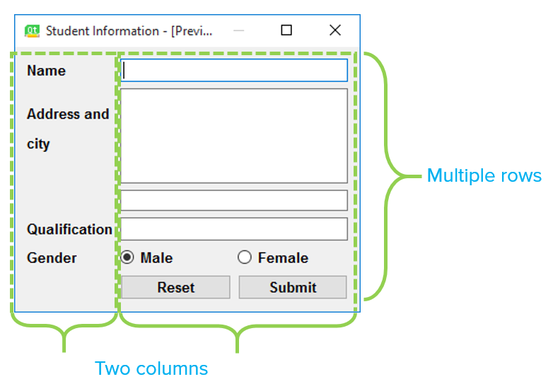

3.QGridLayout

Note-

Convertinng an UI file to PY file using command prompt :

"pyuic5 -x FileName.ui -o FileName.py"