**PROJECT Hotel Reservation System - Retrieve Image File Data with SQL**

**Objective** To design a hotel reservation application that includes image file processing.

***PROJECT DESCRIPTION***

Using a Web application and SQL logic, create tables, populate tables, search for records that include image files and perform other database management activities, according to the instructions that follow.

***Information about this Project***

This lab exercise entails using a database management system and Big Data concepts with SQL.

***Steps to Complete this Project***

**STEP 1**  **Create a Database File**

Launch MS Access on your computer.



Click [ Blank Desktop Database ] , enter the file name **HigginsHotelSystems.accdb** and click [ Create ] to save the database file as an Access accdb file.

You can save the table to your **Desktop** or to your **Documents** folder.

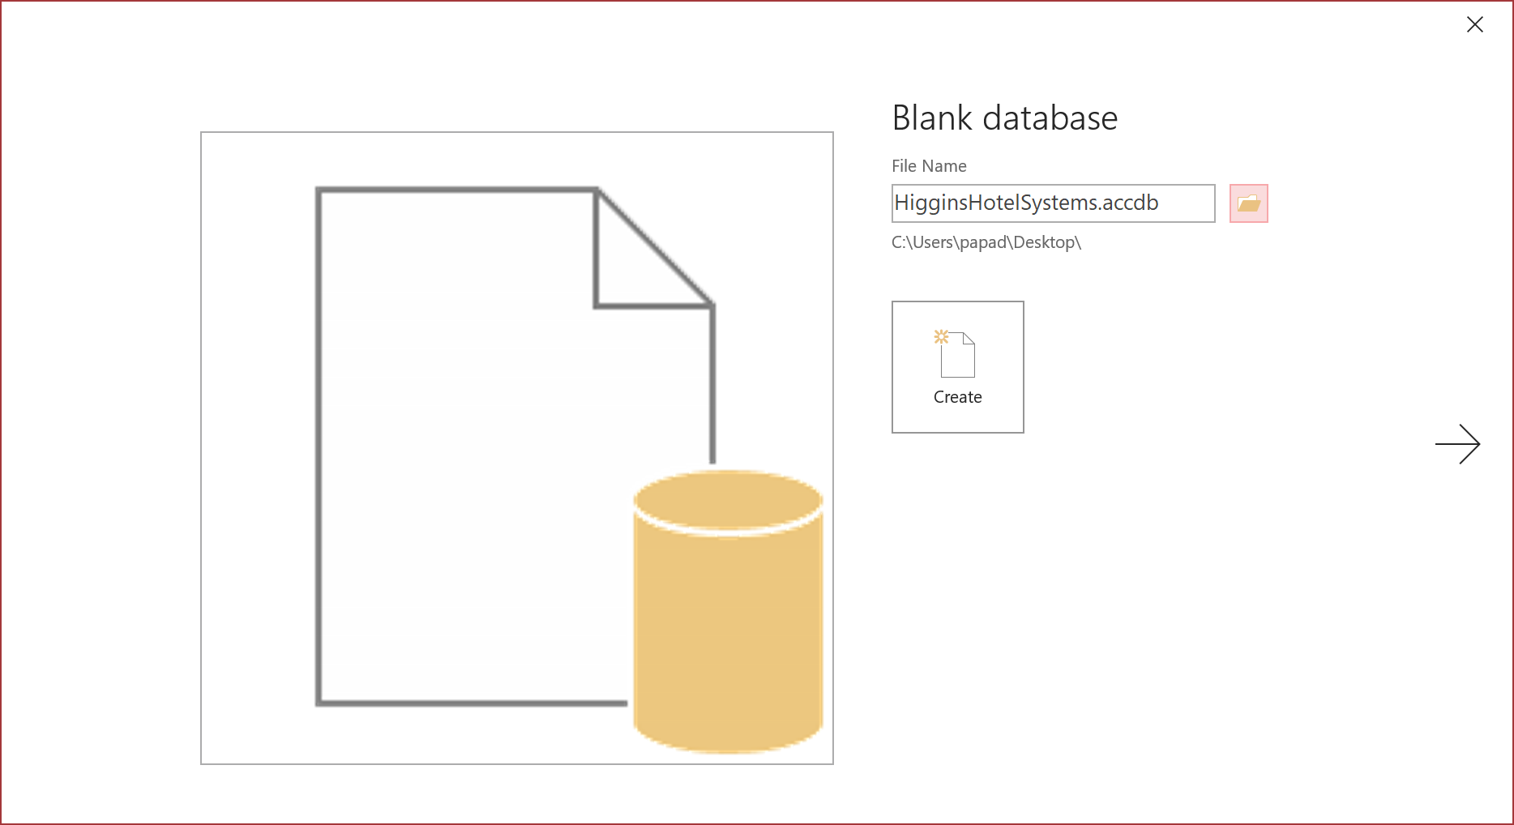

If using MS Access, use an **accdb** file format.

**STEP 2**  **Open a New MS Visual Studio Empty Web Project**

Download a copy of the Visual Studio Community Edition.

[**https://visualstudio.microsoft.com/downloads/**](https://visualstudio.microsoft.com/downloads/)

**PROJECT Hotel Reservation System - Retrieve Image File Data with SQL**

Open Visual Studio .NET and create a new Visual Basic ASP.NET Web Application named: **HotelApp**

To do this, click [ File ] , point to [ New Web Site ] and select the [ Project ... ] .

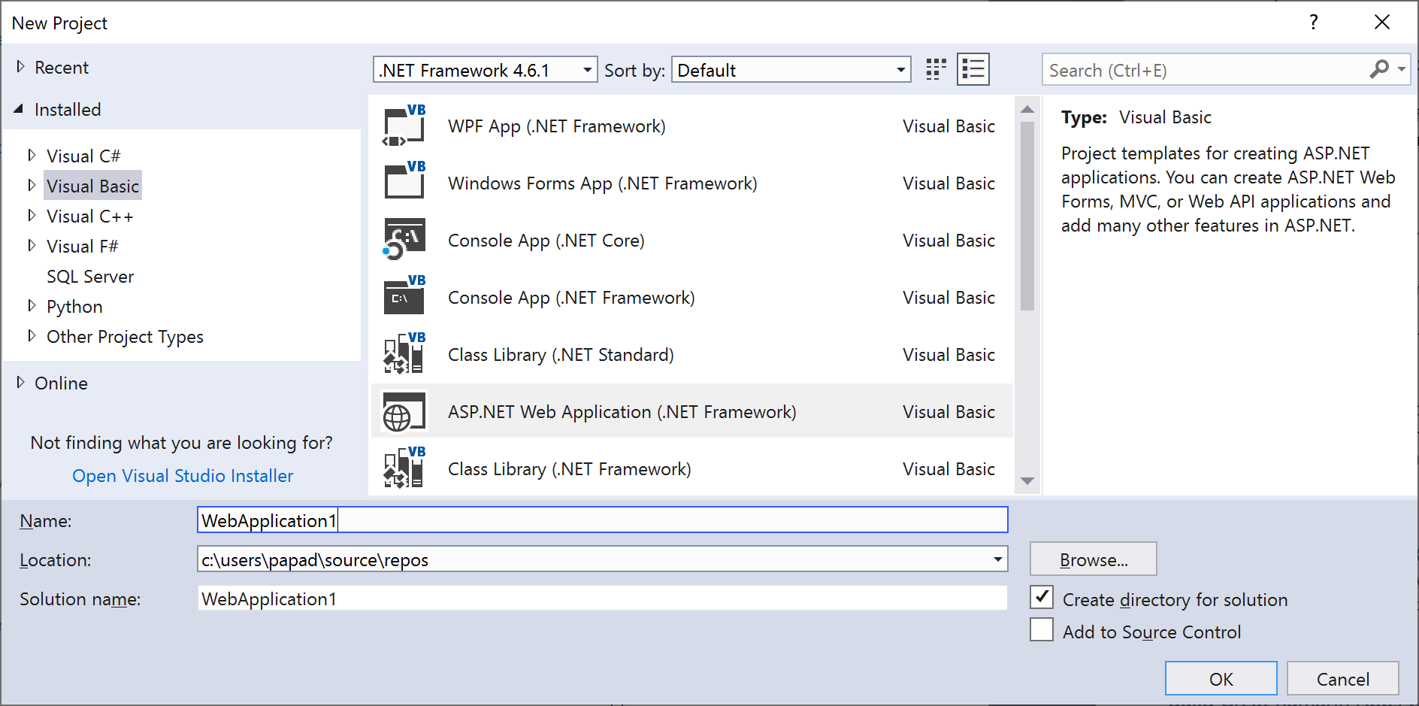

If prompted, select [ Empty ] and close the **New ASP.NET Web Application** dialog box.

**STEP 3 Add a New Web Form**

To add a new Web Form to your project, click [ Project ] and choose   
 [ Add New Item ... ] . Name the Web Form as: **hotel1.aspx**

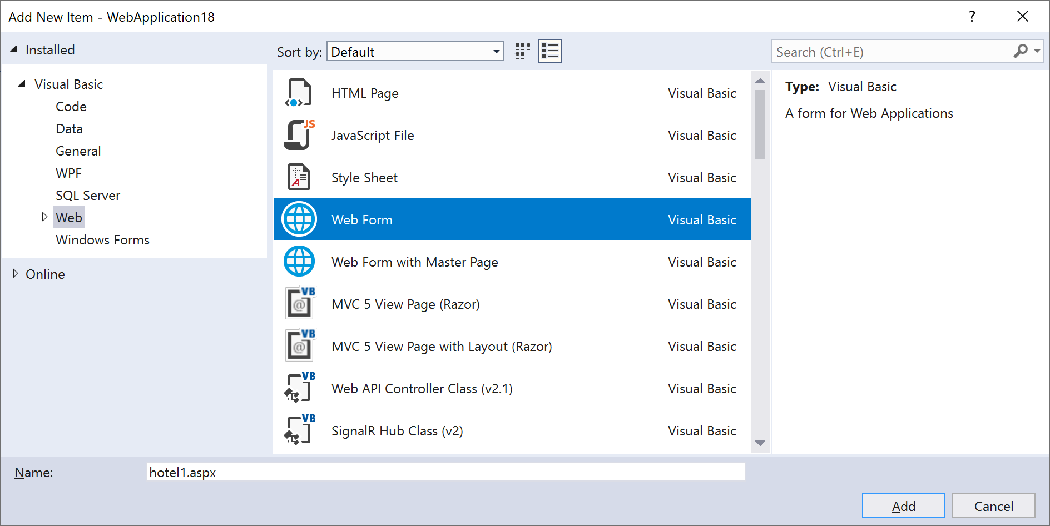

**PROJECT Hotel Reservation System - Retrieve Image File Data with SQL**

**STEP 4**  **Add Code to the Web Form File**

Override any existing code in the new Web Form and use the code in **Figure 2** , which follows, to create the interface shown below.

**Figure 1 Web Form Interface to Create Database Tables**

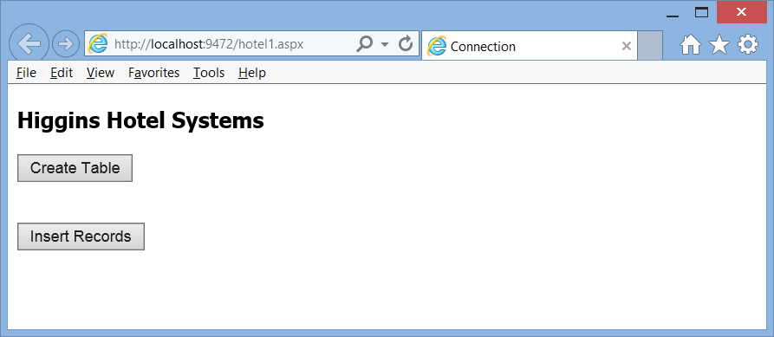

Modify however the following block of code such that the **Guests** table will

include all of the fields in the table grid that follows.

|  |  |  |  |
| --- | --- | --- | --- |
| **Guests** | **Data type** | **Constraint** | **Description / Notes** |
| **GuestID** | **Number** | **PK** |  |
| **LName** | **Text** |  |  |
| **FName** | **Text** |  |  |
| **ZipCode** | **Number** |  |  |
| **StateIDCard** | **Yes/No** |  | **T , F , NULL** |
| **CreditCardNo** | **Number** |  |  |

**Dim sSelectSQL As String = "CREATE TABLE Guests"  
 sSelectSQL &= "([GuestID] Number, [LName] TEXT(20),"  
 sSelectSQL &= "[FName] TEXT(20), [ZipCode] Number,"**

**sSelectSQL &= "[StateID] TEXT(20))"**

Also, modify the path to conform to your own computer system name.

**C:\Users\James\HigginsHotelSystems.accdb**

**PROJECT Hotel Reservation System - Retrieve Image File Data with SQL**

**Figure 2 Web Form Source Code to Create Database Tables ( hotel1.aspx )**

|  |
| --- |
| **<%@ Page Language = "VB" %>**  **<%@ Import Namespace = "System.Data.OleDb" %>**  **<!DOCTYPE html>**  **<html xmlns = "http://www.w3.org/1999/xhtml">**  **<head id = "Head1" runat = "server">**  **<title>Connection</title>**  **<script runat = "server">**  **Sub Create_Click(Src As Object, E As EventArgs)**  **Try**  **'Connect to the Database**  **Dim cnAccess As New OleDbConnection( _**  **"Provider = Microsoft.ACE.OLEDB.12.0;" & _**  **"Data Source = C:\Users\James\HigginsHotelSystems.accdb")**  **Dim sSelectSQL As String = "CREATE TABLE Guests"**  **sSelectSQL &= "([GuestID] Number, [LName] TEXT(20),"**  **sSelectSQL &= "[FName] TEXT(20), [ZipCode] Number,"**  **sSelectSQL &= "[StateID] TEXT(20))"**    **Dim cmdSelect As New OleDbCommand(sSelectSQL, cnAccess)**  **cnAccess.Open()**  **cmdSelect.ExecuteNonQuery()**  **cnAccess.Close()**  **msg.Text = "Table Created!"**    **Catch ex As Exception**  **msg.Text = ex.Message**  **' Response.Write("Table Exists or Connection Failed")**  **End Try**  **End Sub**    **Sub GoTo_Click(Src As Object, E As EventArgs)**  **Response.Redirect("hotel2.aspx")**  **End Sub**  **</script>**  **</head>**  **<body style = "font-family:Tahoma;">**  **<h3>Higgins Hotel Systems</h3>**  **<form runat = "server" id = "form1">**  **<asp:Button Text = "Create Table" OnClick = "Create_Click"**  **runat = "server" ID = "Button1" />**  **<p><asp:Label id = "msg" runat = "server" /></p>**  **<br />**  **<asp:Button Text = "Insert Records" OnClick = "GoTo_Click"**  **runat = "server" ID = "Button2" />**  **</form>**  **</body>**  **</html>** |

**PROJECT Hotel Reservation System - Retrieve Image File Data with SQL**

**STEP 5**  **Test the Server - Side Application**

Use [ Ctrl ] + [ F5 ] to run the Visual Studio Application and to create the **Guests** table.

**Figure 3 Web Form in Run Mode**

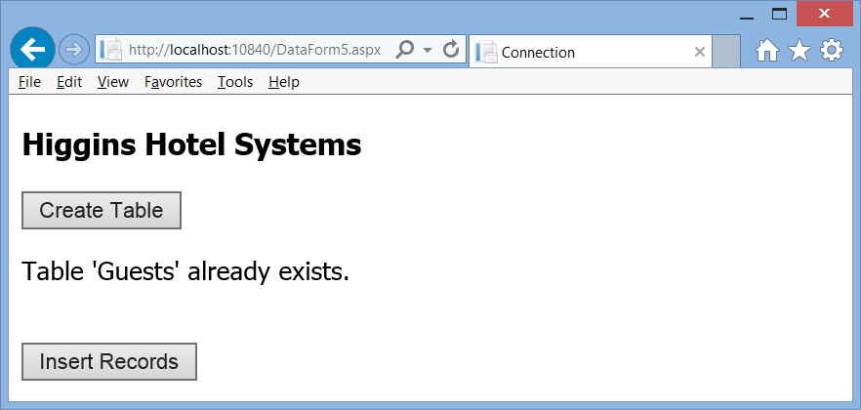

**STEP 6**  **Create a New Web Form**

Add a new Web Form ( **hotel2.aspx** ) to your Visual Studio project to populate the **Guests** table.

The interface for this Web Form follows below. The source code for this Web Form also follows.

Modify the Source Code such that it includes the extra database table field that you added in the **hotel1.aspx** file.

**PROJECT Hotel Reservation System - Retrieve Image File Data with SQL**

**Figure 4 Web Form in Run Mode**

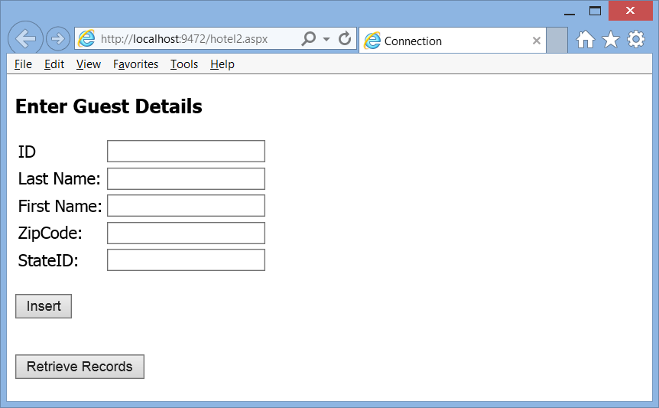

**PROJECT Hotel Reservation System - Retrieve Image File Data with SQL**

**Figure 5 Web Form Source Code to Populate Database Table ( hotel2.aspx )**

|  |
| --- |
| **<%@ Page Language = "VB" %>**  **<%@ Import Namespace = "System.Data.OleDb" %>**  **<!DOCTYPE html>**  **<html xmlns = "http://www.w3.org/1999/xhtml">**  **<head id="Head1" runat = "server">**  **<title>Connection</title>**  **<script runat = "server">**  **Sub Insert_Click(Src As Object, E As EventArgs)**  **Try**  **'Connect to the Database**  **Dim cnAccess As New OleDbConnection( _**  **"Provider = Microsoft.ACE.OLEDB.12.0;" & _**  **"Data Source = C:\Users\James\HigginsHotelSystems.accdb")**    **cnAccess.Open()**  **Dim sID, sFName, sLName, sZip, sState, sInsertSQL As String**  **sID = GuestID.Text**  **sFName = FName.Text**  **sLName = LName.Text**  **sZip = Zip.Text**  **sState = State.Text**  **'Construct the insert statement**  **sInsertSQL = "INSERT INTO Guests(" & _**  **"[GuestID], [LName], [FName], [ZipCode], [StateID]) VALUES" & _**  **"(" & sID & ",'" & sLName & "','" & sFName & "'," & sZip & ",'" & sState & "');"**  **'Construct the OleDbCommand object**  **Dim cmdInsert As New OleDbCommand(sInsertSQL, cnAccess)**  **'since this is not a query, we do not expect to return data**  **cmdInsert.ExecuteNonQuery()**  **Response.Write("Data Recorded!")**  **Catch ex As Exception**  **Response.Write(ex.Message)**  **Response.Write("Connection Failed")**  **End Try**  **End Sub**  **Sub GoTo_Click(Src As Object, E As EventArgs)**  **Response.Redirect("hotel3.aspx")**  **End Sub**  **</script>**  **</head>** |

**PROJECT Hotel Reservation System - Retrieve Image File Data with SQL**

**Figure 5 Web Form Source Code ( hotel2.aspx ) Continued**

|  |
| --- |
| **<body style = "font-family:Tahoma;">**  **<h3>Enter Guest Details</h3>**  **<form runat = "server" id = "form1">**  **<table>**  **<tr>**  **<td>ID</td>**  **<td><asp:Textbox id = "GuestID" runat="server" /></td>**  **</tr>**  **<tr>**  **<td>Last Name: </td>**  **<td><asp:Textbox id = "LName" runat = "server" /></td>**  **</tr>**  **<tr>**  **<td>First Name: </td>**  **<td><asp:Textbox id = "FName" runat = "server" /></td>**  **</tr>**  **<tr>**  **<td>ZipCode: </td>**  **<td><asp:Textbox id = "Zip" runat = "server" /></td>**  **</tr>**  **<tr>**  **<td>StateID: </td>**  **<td><asp:Textbox id = "State" runat = "server" /></td>**  **</tr>**  **</table>**  **<br />**  **<asp:Button Text = "Insert" OnClick = "Insert_Click"**  **runat = "server" ID = "Button1" />**  **<p>**  **<asp:Label id = "msg" runat = "server" />**  **</p>**  **<br />**  **<asp:Button Text = "Retrieve Records" OnClick = "GoTo_Click"**  **runat = "server" ID = "Button2" />**  **</form>**  **<div></div>**  **</body>**  **</html>** |

**PROJECT Hotel Reservation System - Retrieve Image File Data with SQL**

**STEP 7**  **Populate the Guests Table**

Run the **hotels2.aspx** file and populate the Guests table with five sample records.

**STEP 8**  **Create a New Web Form**

Add a new Web Form ( **hotel3.aspx** ) to your Visual Studio project to search the **Guests** table.

The interface for this Web Form follows below. The source code for this Web Form also follows.

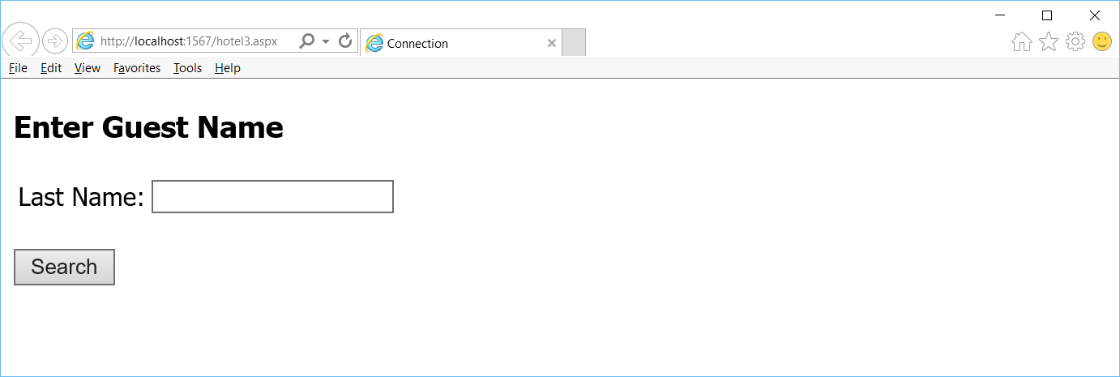

The **hotel3.aspx** file will search for records in the **Guests** table by entering the last name of a guest.

**PROJECT Hotel Reservation System - Retrieve Image File Data with SQL**

**Figure 6 Web Form Source Code ( hotel3.aspx )**

|  |
| --- |
| **<%@ Page Language = "VB" %>**  **<%@ Import Namespace = "System.Data.OleDb" %>**  **<!DOCTYPE html>**  **<html xmlns = "http://www.w3.org/1999/xhtml">**  **<head id="Head1" runat = "server">**  **<title>Connection</title>**  **<script runat = "server">**    **Sub Search_Click(Src As Object, E As EventArgs)**  **Try**  **'Connect to the Database**  **Dim cnAccess As New OleDbConnection( _**  **"Provider = Microsoft.ACE.OLEDB.12.0;" & _**  **"Data Source = C:\Users\James\HigginsHotelSystems.accdb")**    **cnAccess.Open()**    **Dim sLName As String**  **sLName = LName.Text.Trim**    **'Construct the SELECT statement**    **Dim sSelectSQL As String**  **'Create the SQL Select Statement**    **sSelectSQL = "SELECT * FROM Guests WHERE ([LName] LIKE '" & sLName & "')"**    **'Create the OleDbCommand object**  **Dim cmdSelect As New OleDbCommand(sSelectSQL, cnAccess)**  **Dim drEmp As OleDbDataReader, sbResults As New StringBuilder()**  **drEmp = cmdSelect.ExecuteReader()**  **sbResults.Append("<table>")**  **Do While drEmp.Read()**  **sbResults.Append("<tr><td>")**  **sbResults.Append(drEmp.GetInt32(0).ToString)**  **sbResults.Append("</td><td>")**  **sbResults.Append(drEmp.GetString(1))**  **sbResults.Append("</td><td>")**  **sbResults.Append(drEmp.GetString(2))**  **sbResults.Append("</td><td>")**  **sbResults.Append(drEmp.GetInt32(3).ToString)**  **sbResults.Append("</td></tr>")**  **Loop** |

**PROJECT Hotel Reservation System - Retrieve Image File Data with SQL**

**Figure 6 Web Form Source Code ( hotel3.aspx ) Continued**

|  |
| --- |
| **sbResults.Append("</table>")**  **msg.Text = sbResults.ToString()**  **cnAccess.Close()**  **cnAccess = Nothing**    **Response.Write("Data Found!")**  **Catch ex As Exception**  **Response.Write(ex.Message)**  **Response.Write("Connection Failed")**  **End Try**  **End Sub**  **</script>**  **</head>**  **<body style = "font-family:Tahoma;">**  **<h3>Enter Guest Name</h3>**  **<form runat = "server" id = "form1">**  **<table>**  **<tr>**  **<td>Last Name: </td>**  **<td><asp:Textbox id = "LName" runat = "server" /></td>**  **</tr>**  **</table>**  **<br />**  **<asp:Button Text = "Search" OnClick = "Search_Click"**  **runat = "server" ID = "Button1" />**  **<p>**  **<asp:Label id = "msg" runat = "server" />**  **</p>**  **</form>**  **<div></div>**  **</body>**  **</html>** |

Note: when you proceed to the testing step for this Web Form, you may encounter an invalid cast exception. If so, you can modify the **Do While drEmp.Read()** statements to appear as shown below, whereby the **GetValue()** method is used instead of the

**GetInt32()** method.

**Do While drEmp.Read()**

**sbResults.Append("<tr><td>")**

**sbResults.Append(drEmp.GetValue(0).ToString)**

**sbResults.Append("</td><td>")**

**sbResults.Append(drEmp.GetString(1))**

**sbResults.Append("</td><td>")**

**sbResults.Append(drEmp.GetString(2))**

**sbResults.Append("</td><td>")**

**sbResults.Append(drEmp.GetValue(3).ToString)**

**sbResults.Append("</td></tr>")**

**Loop**

**PROJECT Hotel Reservation System - Retrieve Image File Data with SQL**

**STEP 9**  **Test the Search Web Form**

Use [ Ctrl ] + [ F5 ] to run and test **hotels3.aspx** by searching for a Guest name.

**STEP 10 Add a New Web Form to Your Hotel Application**

Create the **hotels4.aspx** file that will use code similar to the **hotels1.aspx** file

to create the following **Staff** table to be added to the **HigginsHotelSystems**

databasefile.

|  |  |  |  |
| --- | --- | --- | --- |
| **Staff** | **Data type** | **Constraint** | **Description / Notes** |
| **StaffID** | **Number** | **PK** |  |
| **FName** | **ShortText** |  |  |
| **LName** | **ShortText** |  |  |
| **Location** | **Number** |  |  |
| **HireDate** | **Date** |  |  |
| **StaffPic** | **LongText** |  |  |

**STEP 11 Open MS Access and Populate the Staff Table**

Open MS Access and populate the Staff table with five fictitious records. If you set the StaffPic field to an OleObject, then you can create a form in Access to paste the gif or png images of the fake staff members into the table.

If the StaffPic field is set to LongText then you can place the file name of the pictures, e.g. **mypic1.jpg** , into the table and load the images into your Visual S tudio project.

**STEP 12 Add a New Web Form to Your Hotel Application**

Create the **hotels5.aspx** file that will use code similar to the **hotels3.aspx** file

to display a **Staff** member into an ASP file.

Some code suggestions for this file are shown in **Figure 7** .

**STEP 12 Add a New Web Form to Your Hotel Application**

Create the **menu.aspx** file that will allow the Web application user, of the Hotel Reservation system, to navigate to any of the Web Forms that comprise the application.

**STEP 13 Test Your Hotel Application**

Test your entire application and take screen snapshots of the operation of your program and paste them into an MS Word document along with your program file source codes.

Review the project summary sheet, which follows on the next page.

Submit the MS Word document for credit.

**PROJECT Hotel Reservation System - Retrieve Image File Data with SQL**

**Figure 7 Web Form Source Code ( hotel5.aspx )**

|  |
| --- |
| **<%@ Page Language = "VB" %>**  **<%@ Import Namespace = "System.Data.OleDb" %>**  **<%@ Import Namespace = "System.IO" %>**  **<%@ Import Namespace = "System.Drawing" %>**  **<!DOCTYPE html>**  **<html xmlns = "http://www.w3.org/1999/xhtml">**  **<head id = "Head1" runat = "server">**  **<title>Connection</title>**  **<script runat = "server">**  **Public Class PictureBox**  **Property Image As Drawing.Bitmap**  **End Class**  **Sub Search_Click(Src As Object, E As EventArgs)**  **Try**  **'Connect to the Database**  **Dim cnAccess As New OleDbConnection(**  **"Provider = Microsoft.ACE.OLEDB.12.0;" &**  **"Data Source = C:\Users\James\HigginsHotelSystems.accdb")**    **cnAccess.Open()**  **Dim sLName As String**  **sLName = LName.Text.Trim**  **'Construct the SELECT statement**  **Dim sSelectSQL As String**  **'Create the SQL Select Statement**  **sSelectSQL = "SELECT * FROM Staff WHERE ([LName] Like '" & sLName & "')"**  **'Create the OleDbCommand object**  **Dim cmdSelect As New OleDbCommand(sSelectSQL, cnAccess)**  **Dim drEmp As OleDbDataReader, sbResults As New StringBuilder()**  **drEmp = cmdSelect.ExecuteReader()** |

**PROJECT Hotel Reservation System - Retrieve Image File Data with SQL**

**Figure 7 Web Form Source Code ( hotel5.aspx ) Continued**

|  |
| --- |
| **sbResults.Append("<table>")**  **Do While drEmp.Read()**  **sbResults.Append("<table>")**  **sbResults.Append("<tr><td><b>Staff ID: </b>")**  **sbResults.Append(drEmp.GetValue(0).ToString)**  **sbResults.Append("</td></tr><tr><td><b> Name: </b>")**  **sbResults.Append(drEmp.GetString(1))**  **sbResults.Append("</td></tr><tr><td><b> Last Name: </b>")**  **sbResults.Append(drEmp.GetString(2))**  **sbResults.Append("</td></tr><tr><td><b> Hire Date: </b>")**  **sbResults.Append(drEmp.GetValue(3).ToString)**  **sbResults.Append("</td></tr><img id='image' width='100' height='100' src=' ")**  **sbResults.Append(drEmp.GetString(4))**  **sbResults.Append("' />")**  **sbResults.Append("</table>")**  **sbResults.Append("<br></br>")**  **Loop**  **sbResults.Append("</table>")**    **msg.Text = sbResults.ToString()**  **cnAccess.Close()**  **cnAccess = Nothing**  **Response.Write("Data Found!")**  **Catch ex As Exception**  **Response.Write(ex.Message)**  **Response.Write("Connection Failed")**  **End Try**  **End Sub** |

**PROJECT Hotel Reservation System - Retrieve Image File Data with SQL**

**Figure 7 Web Form Source Code ( hotel5.aspx ) Continued**

|  |
| --- |
| **</script>**  **</head>**    **<body style = "font-family:Tahoma;">**  **<h3>Enter Staff Name</h3>**  **<form runat = "server" id = "form1">**  **<table>**  **<tr>**  **<td>Last Name: </td>**  **<td><asp:Textbox id = "LName" runat = "server" /></td>**  **</tr>**  **</table>**  **<br />**  **<asp:Button Text = "Search" OnClick = "Search_Click"**  **runat = "server" ID = "Button1" />**  **<p>**  **<asp:Label id = "msg" runat = "server" />**  **</p>**    **</form>**  **<div></div>**  **</body>**  **</html>** |

Remember to adjust your HTML / ASP source code to include the Location database table field for the Staff table.

**PROJECT Hotel Reservation System - Retrieve Image File Data with SQL**

**[ Project Map and Summary Sheet ]**

**Project One *Purpose* Web Form to a Create Database Table and**

**to allow redirect to a record input screen**

***Database File* HigginsHotelSystems.accdb**

***Web Form* hotel1.aspx**

**Project Two *Purpose* Insert Records into a Database Table and**

**to allow redirect to a record search screen**

***Database Table* Guests**

***Web Form* hotel2.aspx**

**Project Three *Purpose* Retrieve Records from a Database Table**

***Database Table* Guests**

***Web Form* hotel3.aspx**

**Project Four *Purpose* Web Form to a Create Database Table**

***Database File*  HigginsHotelSystems.accdb**

***Database Table* Staff**

***Web Form* hotel4.aspx**

**Project Five *Purpose* Web Form to a Display a Staff Member**

***Database File*  HigginsHotelSystems.accdb**

***Database Table* Staff**

***Web Form* hotel5.aspx**

**Project Six *Purpose* Web Form for Menu**

***Database File*  HigginsHotelSystems.accdb**

***Database Table* Guest / Staff**

***Web Form* menu.aspx**

**PROJECT Hotel Reservation System - Retrieve Image File Data with SQL**

**STEP 14 Questions and Reflections Concerning this Database Project**

Now that you have completed this lab project, review the questions below to reflect on the procedures and settings that you utilized as you followed the steps to complete the project. Place your responses in your lab submittal document.

**(1)** Hotel Reservations, as with other business applications, may be accessed through the cloud. Web services such as AWS and Microsoft Azure may be / are used by companies having reservation systems. Contrast AWS and Microsoft Azure as to the web service architecture they offer their clients.

**(2)** Data management with reservation systems must be able to accommodate the customer’s requests and requirements. How would you adopt / modify the code for this lab to include a cancellation of a reservation?   
 Place your answer / modified code below this question.

**(3)** Visit the Web site:[**https://www.choicehotels.com/reservations**](https://www.choicehotels.com/reservations). Navigate through the Web site and list the various required input to make a reservation at a hotel in a particular location. Take a snapshot of the reservation input text boxes and place it here below your list.

**(4)** Reservation systems may also apply to an educational institute’s registration procedures. Similarities exist between both hotel reservation and educational registration systems. List the similar input items, appropriate files to be created and monitored, hardware to store the data, and network architecture. Place your answer below this question number.

**(5)** Would you recommend that data for the reservation system be structured or unstructured? Support your answer.