|  |  |  |  |
| --- | --- | --- | --- |
| Instructor |  | Due Date |  |

**PROJECT ONE Report Writing**

**Objective** To create a report in MS Access.

***PROJECT DESCRIPTION***

For this project, you will design a report from the given datasheet. The report is to include a header and will display the particular records in the table displayed in a certain order.

# Information about this Project

This project requires you to create a report, which will display the records of a datasheet in a particular format.

# Steps to Complete this Project

Here are some useful steps to help you complete this project.

**STEP 1** **Creating the Required Database Table**

• Open MS Access on your computer, create a new database file and save it as

( using your own initials ) :

**my_collection_your_initials.accdb**

• Within this new database file, create a new database table and name it **Books**.

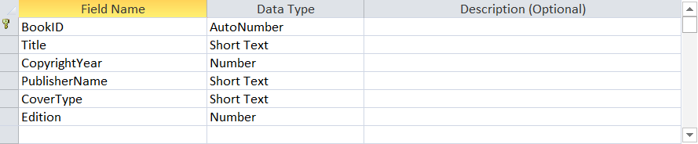

• Import the MS Excel datasheet **Books.xlsx** shown within **Figure 1** below.

To import the data, click the [ External Data ] Ribbon tab and, within the

[ Import & Link ] group, select the [ Excel ] button.

Append the Excel datasheet to your empty **Books** table in Access.

**PROJECT ONE Report Writing**

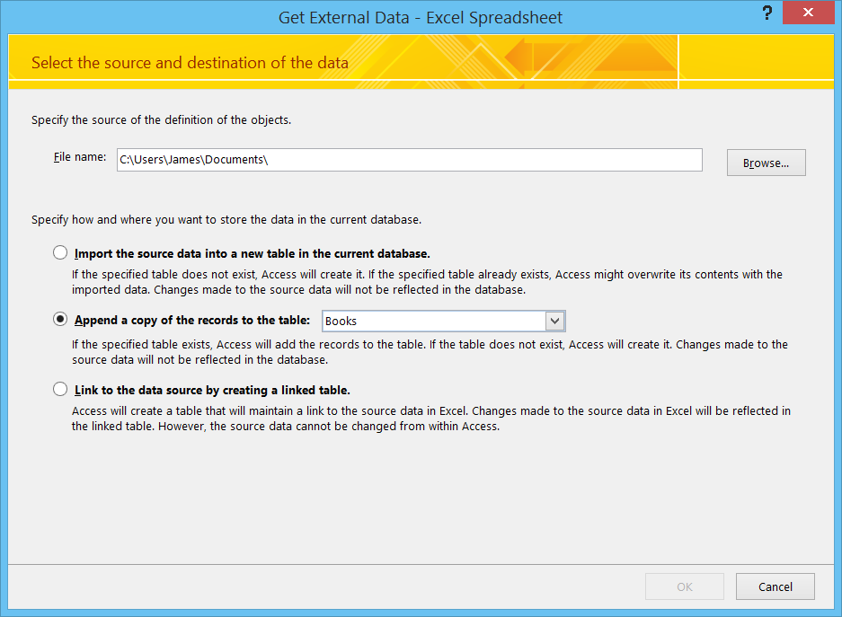

**PROJECT ONE Report Writing**

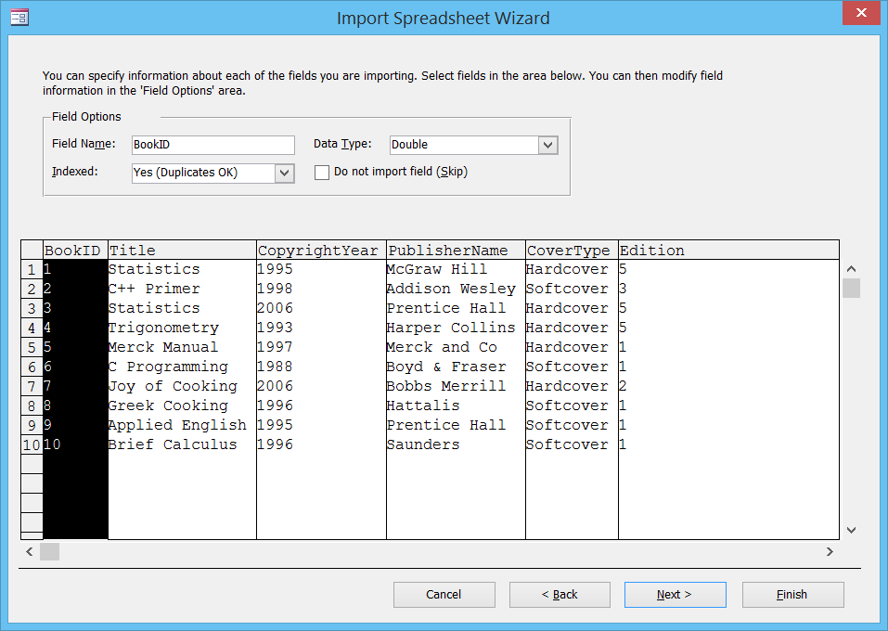

**PROJECT ONE Report Writing**

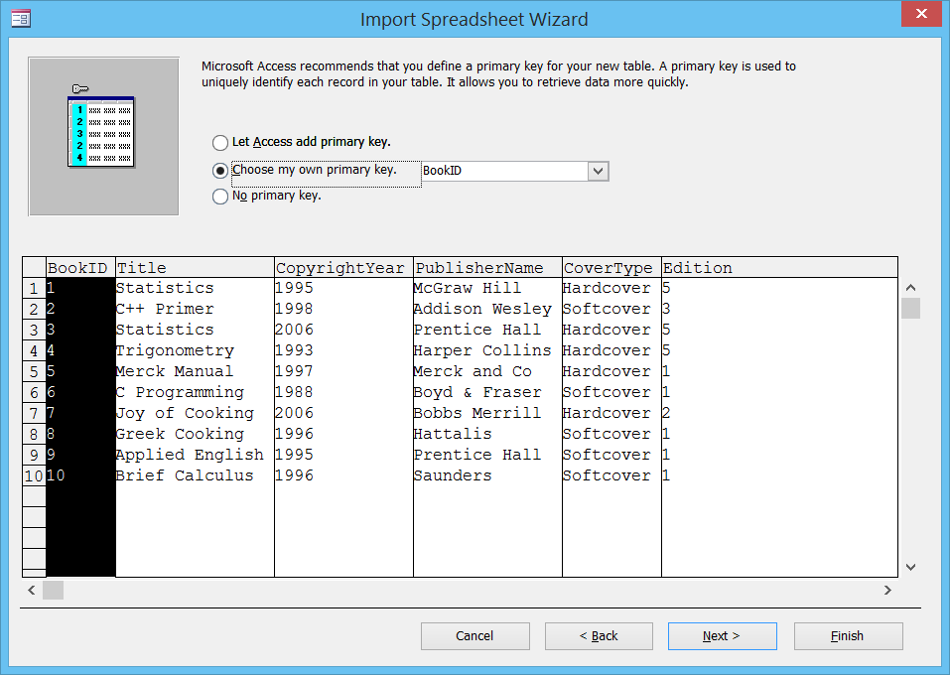

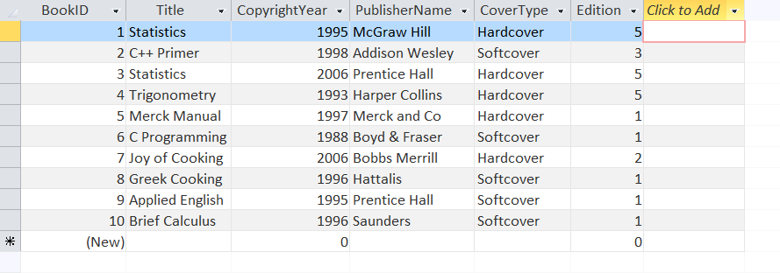

**PROJECT ONE Report Writing**

## Figure 1 Books.xlsx datasheet

|  |  |  |  |  |  |
| --- | --- | --- | --- | --- | --- |
| **BookID** | **Title** | **CopyrightYear** | **PublisherName** | **CoverType** | **Edition** |
| 1 | Statistics | 1995 | McGraw Hill | Hardcover | 5 |
| 2 | C++ Primer | 1998 | Addison Wesley | Softcover | 3 |
| 3 | Statistics | 2006 | Prentice Hall | Hardcover | 5 |
| 4 | Trigonometry | 1993 | Harper Collins | Hardcover | 5 |
| 5 | Merck Manual | 1997 | Merck and Co | Hardcover | 1 |
| 6 | C Programming | 1988 | Boyd & Fraser | Softcover | 1 |
| 7 | Joy of Cooking | 2006 | Bobbs Merrill | Hardcover | 2 |
| 8 | Greek Cooking | 1996 | Hattalis | Softcover | 1 |
| 9 | Applied English | 1995 | Prentice Hall | Softcover | 1 |
| 10 | Brief Calculus | 1996 | Saunders | Softcover | 1 |

• After you import the above datasheet into your **BOOKS** table, design two reports as follows:

**STEP 2** **Designing the First Report**

• The first report for this project is to be designed according to the following specifications:

First, create your report using the Access Report Wizard. The report is to display the records grouped according to cover type. Include the current date in the report header section. If the current date appears in the footer section, delete it.

Once you are finished designing your report, include your name in the footer section of the report. Then, submit a copy of the report and attach to your lab submittal packet.

**STEP 3** **Designing the Second Report**

• The second report for this project is to be designed according to the following specifications:

First, create your report using the Access Report Wizard. The report is to display the records grouped according to copyright. Add an appropriate Clip Art image to your report and include the following label into the footer section:

This booklist is current through December 31 .

Once you are finished designing your report, include your name in the footer section of the report. Then, submit a copy of the report and attach to your lab submittal packet.

**PROJECT TWO Two - Table Relationship**

**Objective** To create a two - table relationship as well as to create and edit a report in MS Access.

***PROJECT DESCRIPTION***

For this project, you will create two tables that show various tax revenues for 10 U.S. states, one for TY2017 and TY2018 . You will also create a Report, which combines both tables to show the differences in tax revenues for the two years.

# Information about This Project

→ This project requires you to create a relationship between two tables.

# Steps to Complete This Project

Here are some useful steps to help you complete this project.

**STEP 1 Creating the Required Database Tables**

• Open a new MS Access database and save it as: **taxDifference.accdb**

• Create both your tables in the Design View as follows:

• First design a table having the field names and data types shown below. Save your table as TY2017 .

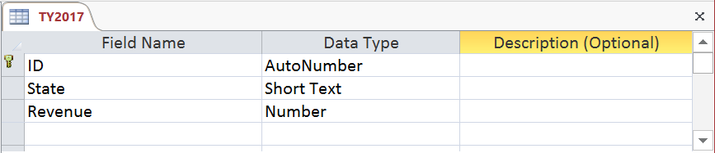

When you are prompted with the following, click Yes .

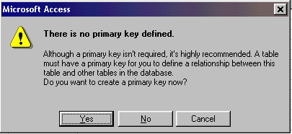

• Create another table by clicking the  button and go into Design View again.

**PROJECT TWO Two - Table Relationship**

Your new table will have the field names and theirs corresponding data types, as shown below.

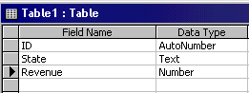

• Save your table this time as TY2018 . Click Yes to create a primary key when prompted.

In your Tables window click on your TY2017 table then click the Open button to go into Datasheet View and key in the following records shown below:

The table shown below lists the records for the TY2017 table.

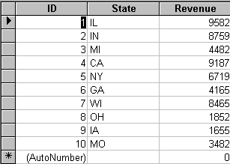

• Next double click on your TY2018 table to enter into the Datasheet View and key the following records:

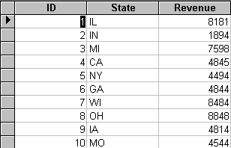

Now that you have completed with the first step of this project, you will now define the relationship between the tables.

**PROJECT TWO Two - Table Relationship**

**STEP 2 Creating the Table Relationship**

• To create a table relationship, go to the Ribbon and choose [ Database Tools ] and then select the option [ Relationships ... ] . A blank screen then appears. Go to the toolbar again and select [ Relationships ... ] and then [ Show Table ] .

The following **Show Table** should then appear with the Tables tab selected, refer to the figure shown below. Here you can select the tables you want to build a relationship with.

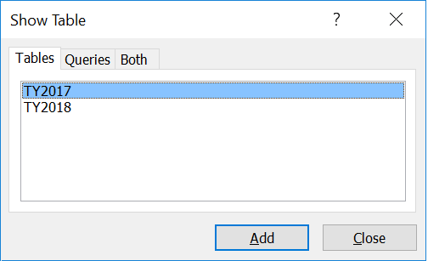

• The TY2017 table should be highlighted so just click the [ Add ] button. Next, click on your table named TY2018 and click [ Add ] again, then click - on   
 [ Close ] . You should now see the following screen tables appear.

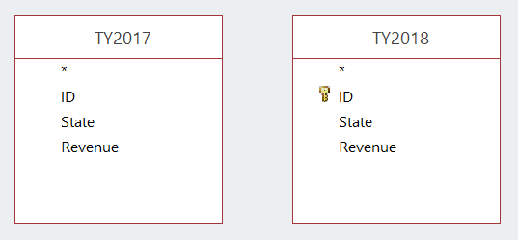

• Click on the ID field in your TY2017 table and drag it directly over the ID field in your TY2018 table and then release.

• You will now be prompted with the following box ( shown on the next page ) to create a One - to - One relationship with your tables. Click on the [ Create ]

button to create your table relationship.

**PROJECT TWO Two - Table Relationship**

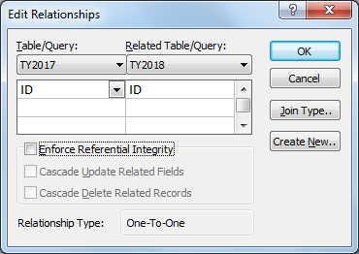

Click to create a One - to - One relationship

Make sure

both columns

match with

the same field

name (i.e., ID)

• When you have finished creating your relationship, click [ File ] and then  
 [ Close ] to return to the database window. Click [ Yes ] to save your relationship layout.

**STEP 3 Report Generation**

• Click on your Reports tab and click your [ New ] button. Click - on Report Wizard for your new report and, in the pull - down box, choose your table named TY2017 as your table choice then click - on the [ OK ] button.

• You can now choose what selected fields you want from your TY2017 table. From the **Available fields** window click - on State then click the [ > ] button. Then click on the Revenue field and finally the [ > ] button.

**PROJECT TWO Two - Table Relationship**

Then go to the pull down box labeled Tables / Queries and click on Table: TY2018 .

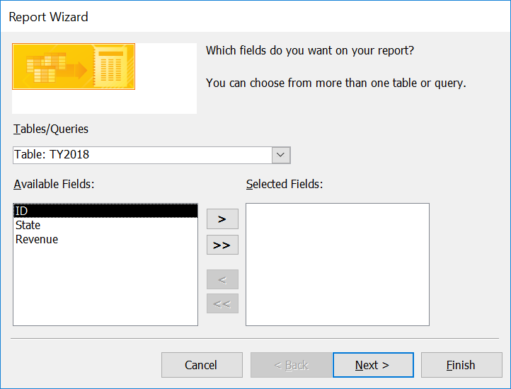

• Next click **Revenue** in the Available Fields section window (as shown below) then click the next button [ > ] .

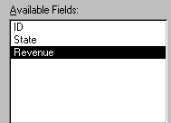

Note: Your Selected fields window should look like the example below with the Revenue field name showing up twice, once from the TY2017 table ( TY2017.Revenue ) and once from the TY2018 table ( TY2018.Revenue ) .

**PROJECT TWO Two - Table Relationship**

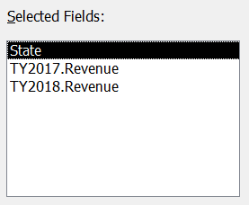

• Click the [ Next> ] button 5 times. Where you are asked, "What title do you want for your report?" type in — 'Revenue Difference Report.' Also click the option to 'Modify the report's design'. By choosing this option you will be able to modify your report such as making changes of the names of the two Revenue fields. Click the [ Finish ] button to modify your report settings.

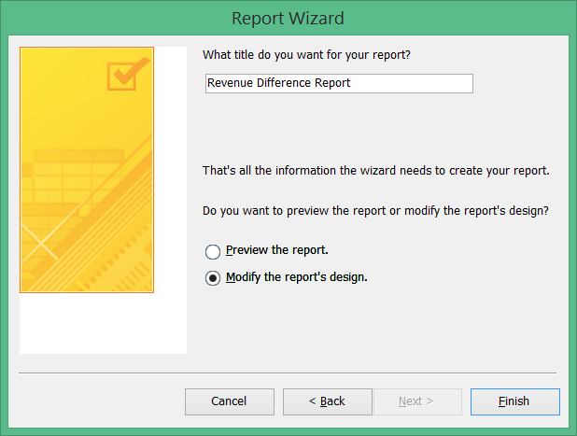

Click here to modify report design

Add a title for your report

here

**PROJECT TWO Two - Table Relationship**

Next adjust the TY2018.Revenue and TY2017.Revenue field names located in the page header area (see snapshot below) to read as TY2018/Revenue and TY2017/Revenue. To accomplish this left click once inside the field TY2018.Revenue then press the [ F2 ] key then your Home key on your keyboard to edit the field name. Press your Shift key and your down arrow key together on your keyboard and type TY2018/Revenue. Next press your Tab key to go the field named TY2017.Revenue. Press your [ F2 ] key then your Home key to edit the field description. Next press your Shift key and your down arrow key together and type TY2017/Revenue.

• To save your changes click on the save  icon then go to File | Close. Click on your  button to review your report then if all looks well click your printer  icon to print out your report, if you choose.

Edit these fields by left clicking once into each field and typing in new field names

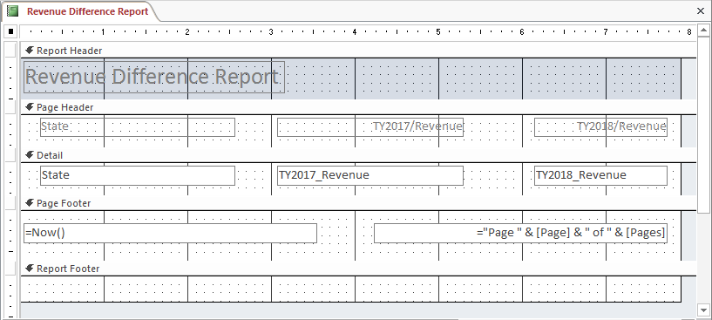

**STEP 4 Submit Your Report**

Prior to submitting your report, supplement the Design View of the report by adding a Date / Time stamp to your report header or footer but modify the date stamp to show tomorrow’s date instead of the current date.

Also, place your full name in the header or footer portion of your report.

Then, submit a copy of the report and attach to your lab submittal packet for credit.

**PROJECT THREE Using SQL**

**Objective** To introduce you to SQL, Structured Query Language.

***PROJECT DESCRIPTION***

This particular project introduces you to SQL through the use of an Access Query.

***Information about This Project***

Designing queries is often accomplished by using SQL, Structured Query Language.

***Steps To Complete This Project***

**STEP 1 Create an Access Database Table**

To start this project, first open MS Access on your computer. Create a new database file and name it as **Database2.accdb**. Within your **Database2** database, design a new table and name it **Clients**. The field names, data types and field descriptions are listed in **Figure 1**.

**Figure 1** **Clients** Table Design

|  |  |  |
| --- | --- | --- |
| Field Name | Data Type | Description |
| ClientID | Text | Primary key |
| ClientName | Text | Enter the client's name |
| ZipCode | Text | Enter the client's zip code |
| ClientCode | Text | Enter client's code |
| Contact | Text | Enter our salesperson's name |
| OrderDate | Date / Time | Enter the date of client's last order |

Once you have finished designing your table, enter, into your **Clients** table, the information from the datasheet shown in **Figure 2** .

**Figure 2** **Clients** Datasheet

|  |  |  |  |  |  |  |  |
| --- | --- | --- | --- | --- | --- | --- | --- |
|  | **ClientID** | **ClientName** | **ZipCode** | **ClientCode** | **Contact** | **OrderDate** |  |
|  | B5182 | Basic Broadcasting | 60631 | A | Sammy | 08 / 03 / 2019 |  |
|  | C1825 | Computer Capers | 60656 | A | Sammy | 01 / 18 / 2020 |  |
|  | D8125 | David D. Davies | 60625 | B | George | 02 / 02 / 2020 |  |
|  | E5051 | Edward's Enterprise | 60604 | A | Paula | 02 / 28 / 2020 |  |
|  | F5150 | Frank's Fixtures | 60629 | C | Paula | 01 / 07 / 2019 |  |
|  | J4712 | Jerry's Journals | 60634 | F | Pete | 01 / 22 / 2020 |  |
|  | M1758 | Montrose Muffler | 60630 | A | Sammy | 12 / 13 / 2019 |  |
|  | M4158 | Music for the Many | 60656 | C | Paula | 12 / 02 / 2019 |  |
|  | S8158 | Styles on State | 60608 | A | Steve | 02 / 12 / 2020 |  |
|  | T0818 | Taxes and More | 60618 | B | Janet | 12 / 20 / 2021 |  |
|  |  |  |  |  |  |  |  |

**PROJECT THREE Using SQL**

Analyze the Performance of the Table to examine if there are any issues with the it.

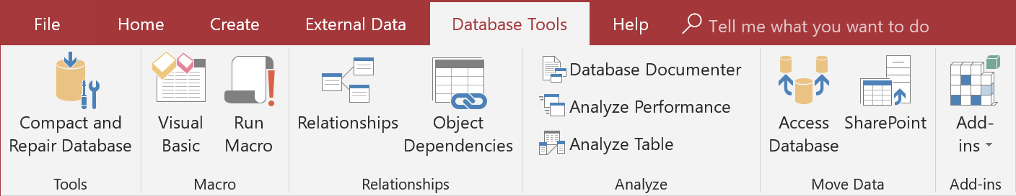

**STEP 2** **Query the Database Table**

• Once you have designed and built your table, you will then run a query that will display all records of clients who have an " B " type client code and whose last order date was prior to February 15 , 2020 .

The design grid for this query is shown below.

|  |  |  |  |  |
| --- | --- | --- | --- | --- |
|  |  |  |  |  |
| Field: | ClientID | ClientName | ClientCode | OrderDate |
| Table: | Clients | Clients | Clients | Clients |
| Sort: | Ascending | Ascending | Ascending | Ascending |
| Show: | .  **🗸** . | .  **🗸** . | .  **🗸** . | .  **🗸** . |
| Criteria: |  |  | = " B" | < # 2 / 15 / 2020 # |
| Or: |  |  |  |  |

Once you have designed your query, save your query as **Clients Query**, run it, print the resulting query datasheet and attach it to this lab packet for credit.

Now change the view of your query to the Design view by clicking the drop down button next to the  View icon and changing the view to the  SQL view.

Your query should now be displayed in the SQL view showing the program code that is displayed in **Figure 3**.

**Figure 3**

|  |
| --- |
| **SELECT Clients.ClientID, Clients.ClientName, Clients.ClientCode, Clients.OrderDate**  **FROM Clients**  **WHERE (((Clients.ClientCode) = "B") AND ((Clients.OrderDate) < #2/15/2020#));** |

**PROJECT THREE Using SQL**

**STEP 3** **Take a Screen Snapshot of your SQL Query**

Once your query screen looks similar to **Figure 3** above, you will take a screen snapshot of your SQL query and paste it into an MS Word document by following the instructions given below.

With your query named **Clients Query** open in the SQL View, press and hold your keyboard [ Alt ] key and then depress your [ Print Screen ] key. Then, leaving MS Access open, paste the screen snapshot into MS Word by opening Word and, in a new document, pressing and holding your [ Ctrl ] key and then tapping your [ V ] key. This maneuver pastes your screen snapshot onto your Word document.

**STEP 4** **Create Another Robust Query**

Finally, design an advanced query that will display the following dynaset.

**Figure 4** **Clients** Datasheet ( Query Dynaset )

|  |  |  |  |  |  |  |  |
| --- | --- | --- | --- | --- | --- | --- | --- |
|  | **ClientID** | **ClientName** | **ZipCode** | **ClientCode** | **Contact** | **OrderDate** |  |
|  | F5150 | Frank's Fixtures | 60629 | C | Paula | 01 / 07 / 2019 |  |
|  | M1758 | Montrose Muffler | 60630 | A | Sammy | 12 / 13 / 2019 |  |
|  | M4158 | Music for the Many | 60656 | C | Paula | 12 / 02 / 2019 |  |
|  |  |  |  |  |  |  |  |

Take a screen snapshot of your query results in Access and place the image into your lab submittal document, labeling the image accordingly.

Also, take a screen snapshot of your query as it appears in the [ SQL View ] .

Place the image into your lab submittal document, labeling the image accordingly.

**STEP 5** **Create Yet Another Robust Query**

Finally, design an advanced query that will display the following dynaset.

**Figure 5** **Clients** Datasheet ( Query Dynaset )

|  |  |  |  |  |  |  |  |
| --- | --- | --- | --- | --- | --- | --- | --- |
|  | **ClientID** | **ClientName** | **ZipCode** | **ClientCode** | **Contact** | **OrderDate** |  |
|  | B5182 | Basic Broadcasting | 60631 | A | Sammy | 08 / 03 / 2019 |  |
|  | D8125 | David D. Davies | 60625 | B | George | 02 / 02 / 2020 |  |
|  | E5051 | Edward's Enterprise | 60604 | A | Paula | 02 / 28 / 2020 |  |
|  | F5150 | Frank's Fixtures | 60629 | C | Paula | 01 / 07 / 2019 |  |
|  | M1758 | Montrose Muffler | 60630 | A | Sammy | 12 / 13 / 2019 |  |
|  | M4158 | Music for the Many | 60656 | C | Paula | 12 / 02 / 2019 |  |
|  | T0818 | Taxes and More | 60618 | B | Janet | 12 / 20 / 2021 |  |
|  |  |  |  |  |  |  |  |

**PROJECT THREE Using SQL**

Take a screen snapshot of your query results in Access and place the image into your lab submittal document, labeling the image accordingly.

Also, take a screen snapshot of your query as it appears in the [ SQL View ] .

Place the image into your lab submittal document, labeling the image accordingly.

**STEP 6** **Submit Your Lab Document**

Submit a copy of your lab submittal document for credit as well as your MS Access database file(s) for credit.

**PROJECT FOUR Questions Concerning this Lab Project**

**STEP 1** **Questions and Reflections Concerning this Database Project**

Now that you have completed this lab project, review the questions below to reflect on the procedures and settings that you utilized as you followed the steps to complete the project. Place your responses in your lab submittal document.

**(1)** Report generation is important for decision - making. What levels of management are apt to request summary reports on the data?

**(2)** How long should summary reports be kept in a business organization?

**(3)** Visit the website [**http://www.bn.com**](http://www.bn.com) and find at least two textbooks on database management. Place the pertinent information from the books that you have located.

**(4)** Name at least two new fields that may be added to the Books database table.

**(5)** What are the relative operators and the logical operators that may be used to construct specific queries?