Glossary
- PV : Photovoltaic
- GHI : Global Horizontal Irradiation
- GTI : Global Tilted Irradiation (in-plane irradiation for a fixed PV panel with a given tilt and azimuth)
- DNI : Direct Normal Irradiation (direct irradiation in a plane tracking the sun position)
- TMY : Typical Meteorological Year
- P50 : 50% percentile of a distribution (median)
- P75 : 75% percentile of a distribution (75% of the values will be above this threshold)
- P90 : 90% percentile of a distribution (90% of the values will be above this threshold)
- P99 : 99% percentile of a distribution (99% of the values will be above this threshold)

Introduction and Methodology
We generated a Typical Meteorological Year (TMY) P50 (median scenario) and P75, P90 (pessimistic scenario) for the site of interest. This report synthesizes the TMY results for both the GHI and the Direct Normal Irradiation (DNI) components.
The method for the TMY (P50) generation exploits the CAMS radiation data, and the ERA5 reanalysis from Copernicus for the other meteorological parameters.
We use the method proposed by NREL, which was built upon the Sandia method, creates TMY P50 data by selecting individual months from different years in a long-term dataset (typically 10-30 years) that best represents median conditions.For each month, the method evaluates four key meteorological parameters:
- Solar radiations.
- Temperature.
- Dew point temperature.
- Wind speed.
Each parameter is weighted differently based on its importance, as the method takes into account multiple factors beyond a simple median value calculation. The approach ensures a more accurate representation of long-term meteorological conditions. For further details, refer to the documentation here https://www.nrel.gov/docs/fy08osti/43156.pdf.
The P90 and P75 TMY calculations follow a statistical approach based on annual values. First, we calculate the standard deviation of the long-term annual driver irradiation values. For P90, we multiply this standard deviation by 1.28155, while for P75 we multiply it by 0.6745. These calculations give us our P90 and P75 estimates respectively. We then select the representative year by identifying which historical year has a total annual driver irradiation closest to these calculated P90 or P75 values.

Data and Description
Name of the site | Constantina-Spain
Longitude | -5.583515
Latitude | 37.872164
Begin date | 2005-01-01
End Date | 2024-12-31
Nb Years | 20
Sampling of data | 60 min
Unit of the data | Wh/m²
Radiations Database | Cams solar Radiations
Meteorological Database | ERA5 (ECMWF)
Output formats:
- CSV compatible with the PVsyst software
- CSV compatible with the System Advisor Model (SAM, NREL)
- CSV compatible with PVGIS Format.

Selected months for the P50, P75 and P90 TMY
Month | P50 | P75 | P90 | P99
Jan. | 2023 | 2024 | 2008 | 2006
Feb. | 2009 | 2024 | 2008 | 2006
Mar. | 2017 | 2024 | 2008 | 2006
Apr. | 2008 | 2024 | 2008 | 2006
May | 2017 | 2024 | 2008 | 2006
Jun. | 2022 | 2024 | 2008 | 2006
Jul. | 2021 | 2024 | 2008 | 2006
Aug. | 2016 | 2024 | 2008 | 2006
Sept. | 2010 | 2024 | 2008 | 2006
Oct. | 2016 | 2024 | 2008 | 2006
Nov. | 2016 | 2024 | 2008 | 2006
Dec. | 2016 | 2024 | 2008 | 2006

Results and Illustrations for the GHI Component, P50 to P99
The long-term variability of the GHI component is represented as a "boxplot" graph for each month.
To understand the monthly boxplot illustration:
- The bottom horizontal line is the minimum monthly value
- The top horizontal line shows the maximum monthly value
- The lightblue box shows the extent from the 25 to 75 percentile values
- The horizontal line in the orange box shows the median value
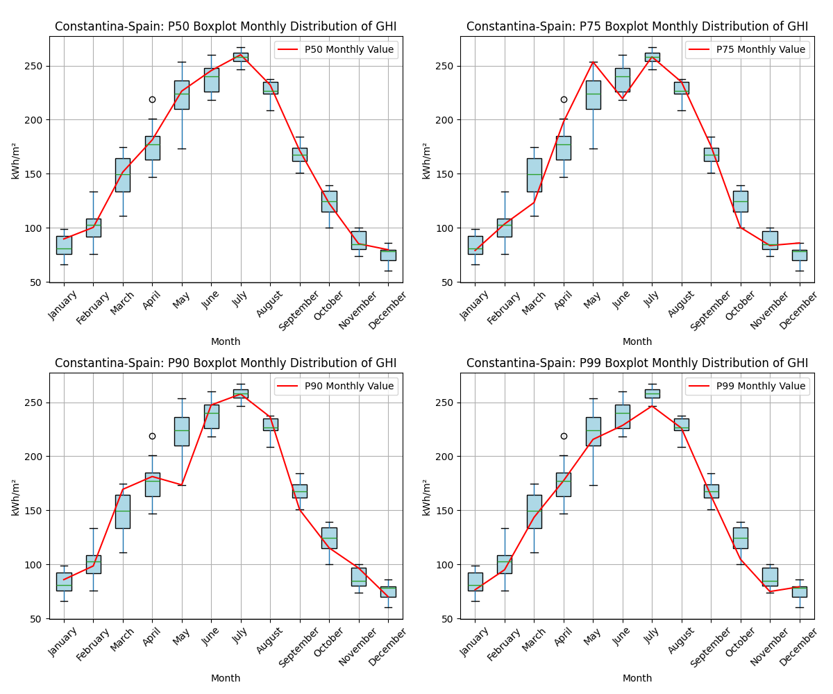
Figure 1: Monthly boxplot for the GHI component with TMY (P50, P75, P90, P99).
The monthly GHI values of the TMYs are:
Month | P50 | P75 | P90 | P99
January | 90 | 79 | 86 | 77
February | 100 | 104 | 99 | 95
March | 152 | 123 | 169 | 144
April | 181 | 198 | 181 | 177
May | 226 | 253 | 174 | 216
June | 245 | 220 | 247 | 228
July | 260 | 258 | 258 | 246
August | 232 | 235 | 236 | 226
September | 172 | 176 | 151 | 164
October | 123 | 100 | 115 | 105
November | 85 | 84 | 97 | 75
December | 80 | 86 | 70 | 79
Yearly | 1946 | 1916 | 1883 | 1832
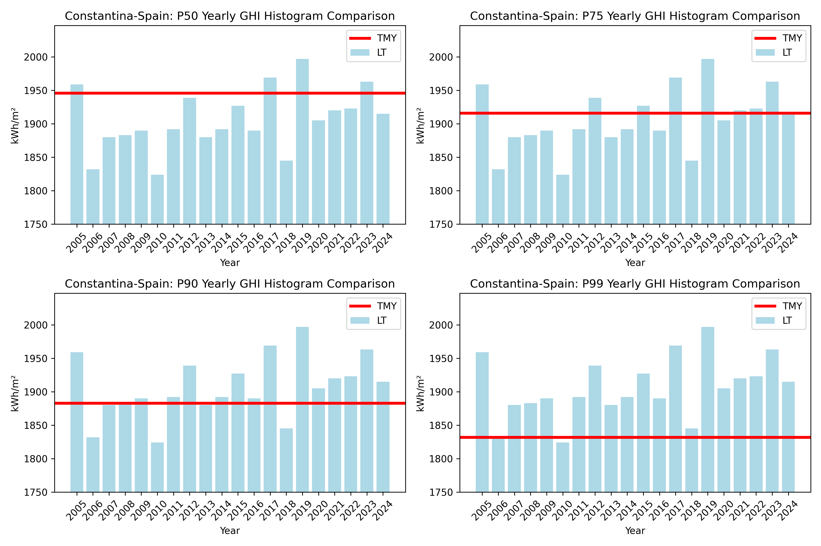
Figure 2: Yearly GHI Histogram comparison with TMY (P50,P75,P90,P99).

Results and Illustrations for the DNI Component, P50 to P99
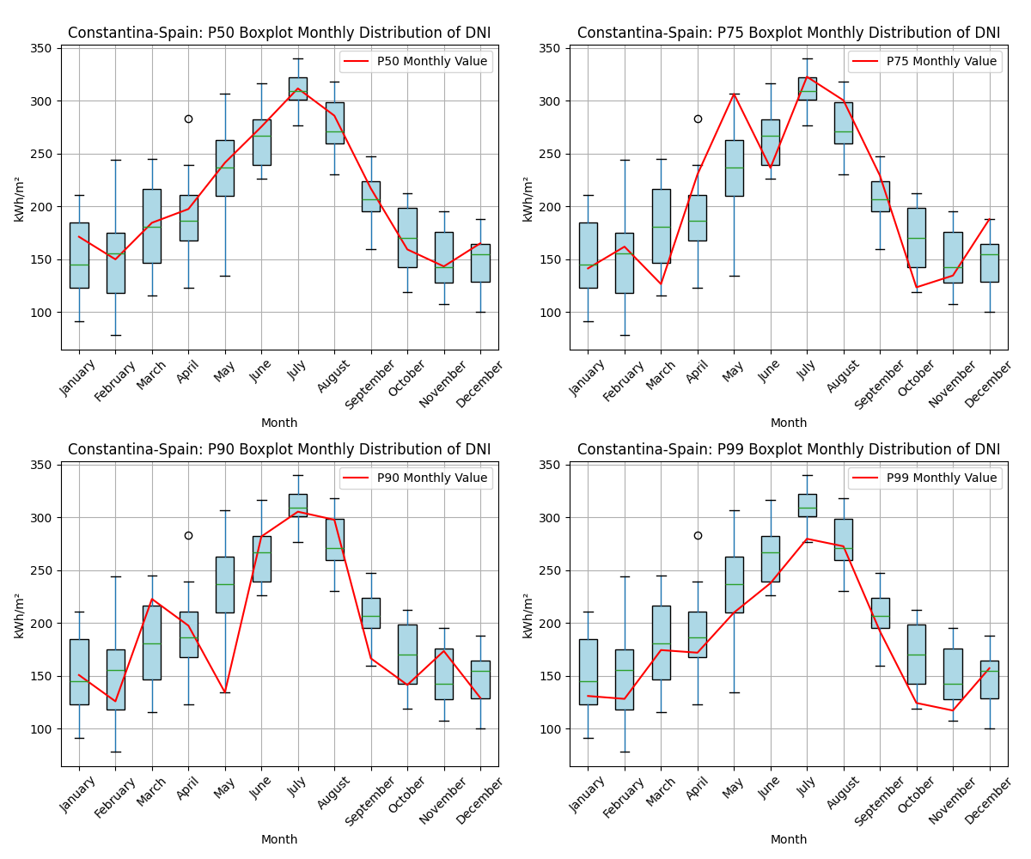
Figure 3: Monthly boxplot for the DNI component with TMY (P50, P75, P90, P99).
The monthly DNI values of the TMYs are:
Month | P50 | P75 | P90 | P99
January | 171 | 141 | 151 | 131
February | 150 | 162 | 126 | 128
March | 185 | 127 | 223 | 174
April | 198 | 230 | 198 | 172
May | 241 | 306 | 134 | 210
June | 275 | 236 | 282 | 238
July | 312 | 323 | 305 | 280
August | 286 | 300 | 298 | 273
September | 217 | 229 | 167 | 192
October | 159 | 124 | 142 | 124
November | 143 | 135 | 174 | 117
December | 165 | 188 | 129 | 157
Yearly | 2502 | 2501 | 2329 | 2196
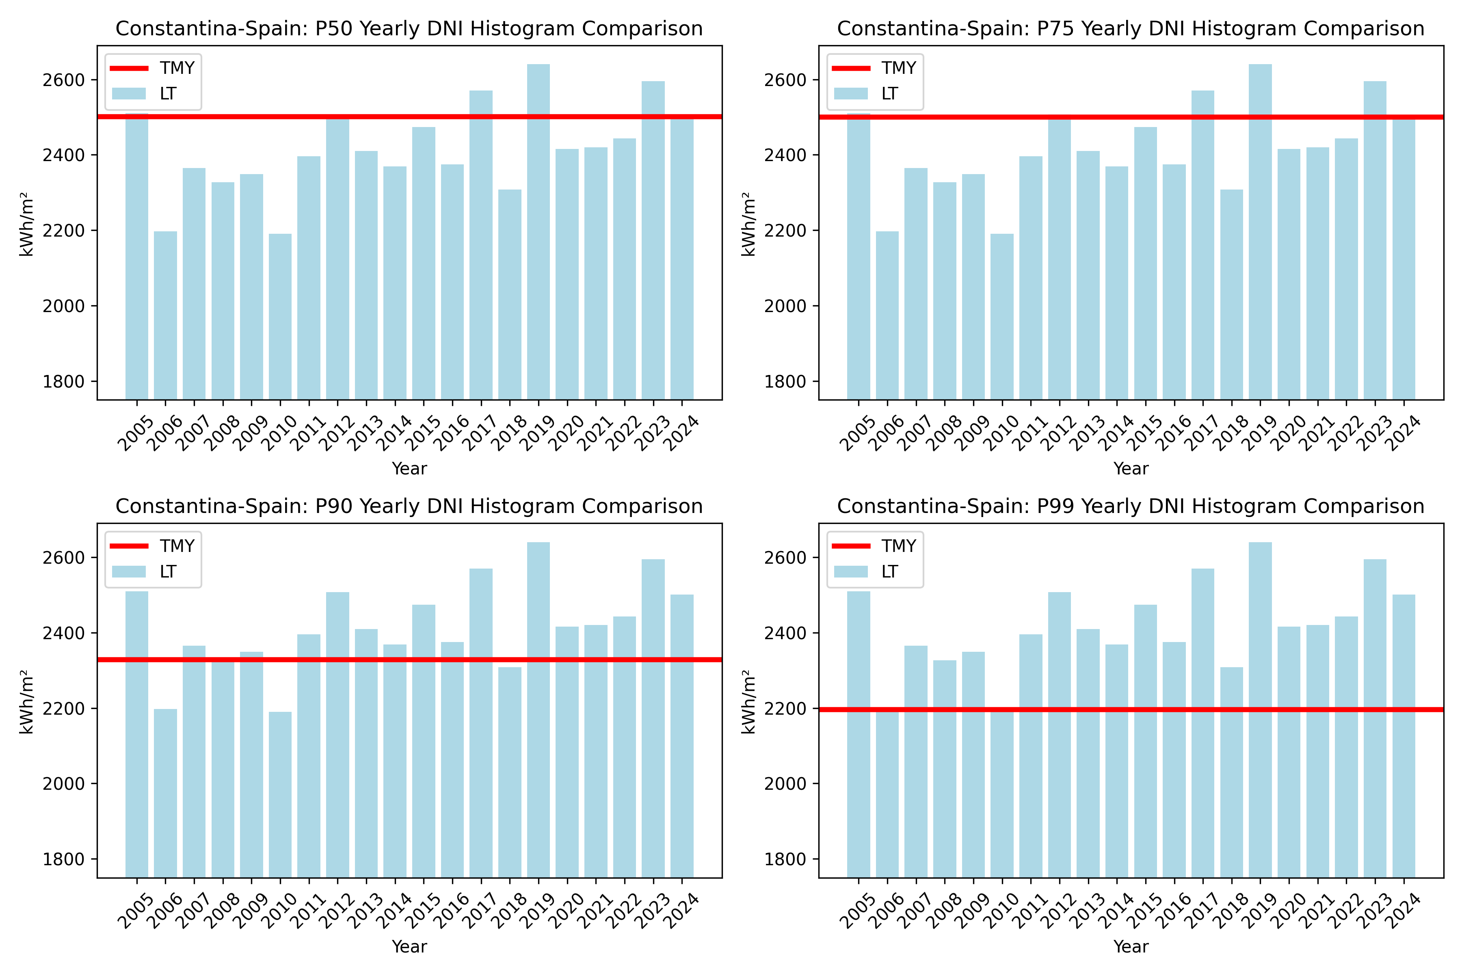
Figure 2: Yearly DNI Histogram comparison with TMY (P50,P75,P90,P99).

Conclusion – Interpretation of the Results
The major results of this TMY analysis are, in kWh/m²:
- GHI P50 yearly average irradiation value: 1946
- GHI P75 yearly average irradiation value: 1916
- GHI P90 yearly average irradiation value: 1883
- GHI P99 yearly average irradiation value: 1832
- DNI P50 yearly average irradiation value: 2502
- DNI P75 yearly average irradiation value: 2501
- DNI P90 yearly average irradiation value: 2329
- DNI P99 yearly average irradiation value: 2196

ANNEX 1: results for the effective part (GTI) of the radiation P50 to P90
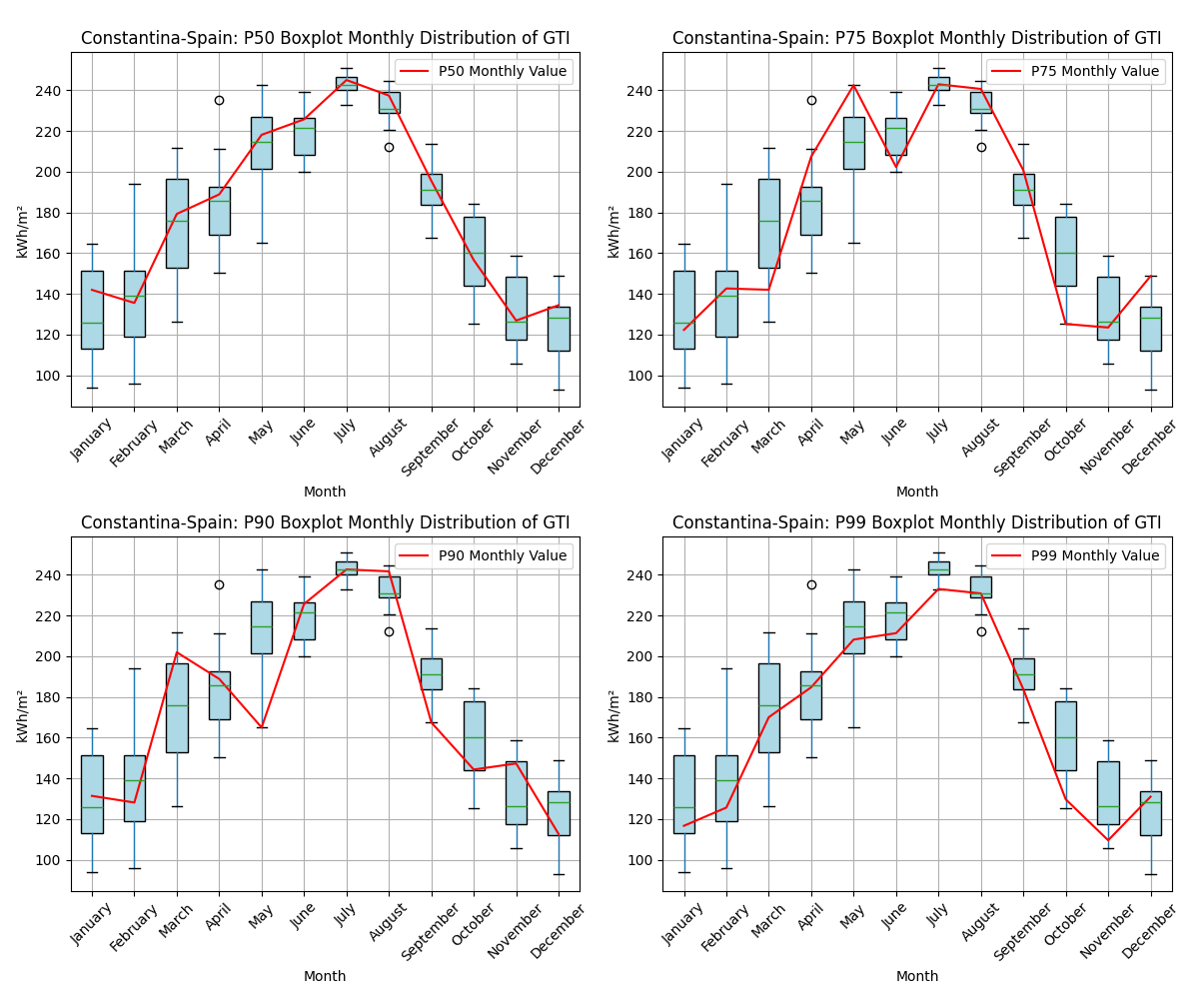
Figure 3: Monthly boxplot for the GTI component with TMY (P50, P75, P90, P99).
The monthly GTI values of the TMYs are:
Month | P50 | P75 | P90 | P99
January | 142 | 122 | 131 | 117
February | 136 | 143 | 128 | 126
March | 179 | 142 | 202 | 170
April | 189 | 207 | 189 | 185
May | 218 | 242 | 165 | 208
June | 226 | 202 | 226 | 211
July | 245 | 243 | 243 | 233
August | 237 | 241 | 242 | 231
September | 196 | 201 | 167 | 184
October | 157 | 125 | 144 | 130
November | 127 | 124 | 147 | 110
December | 134 | 149 | 113 | 131
Yearly | 2186 | 2141 | 2097 | 2036
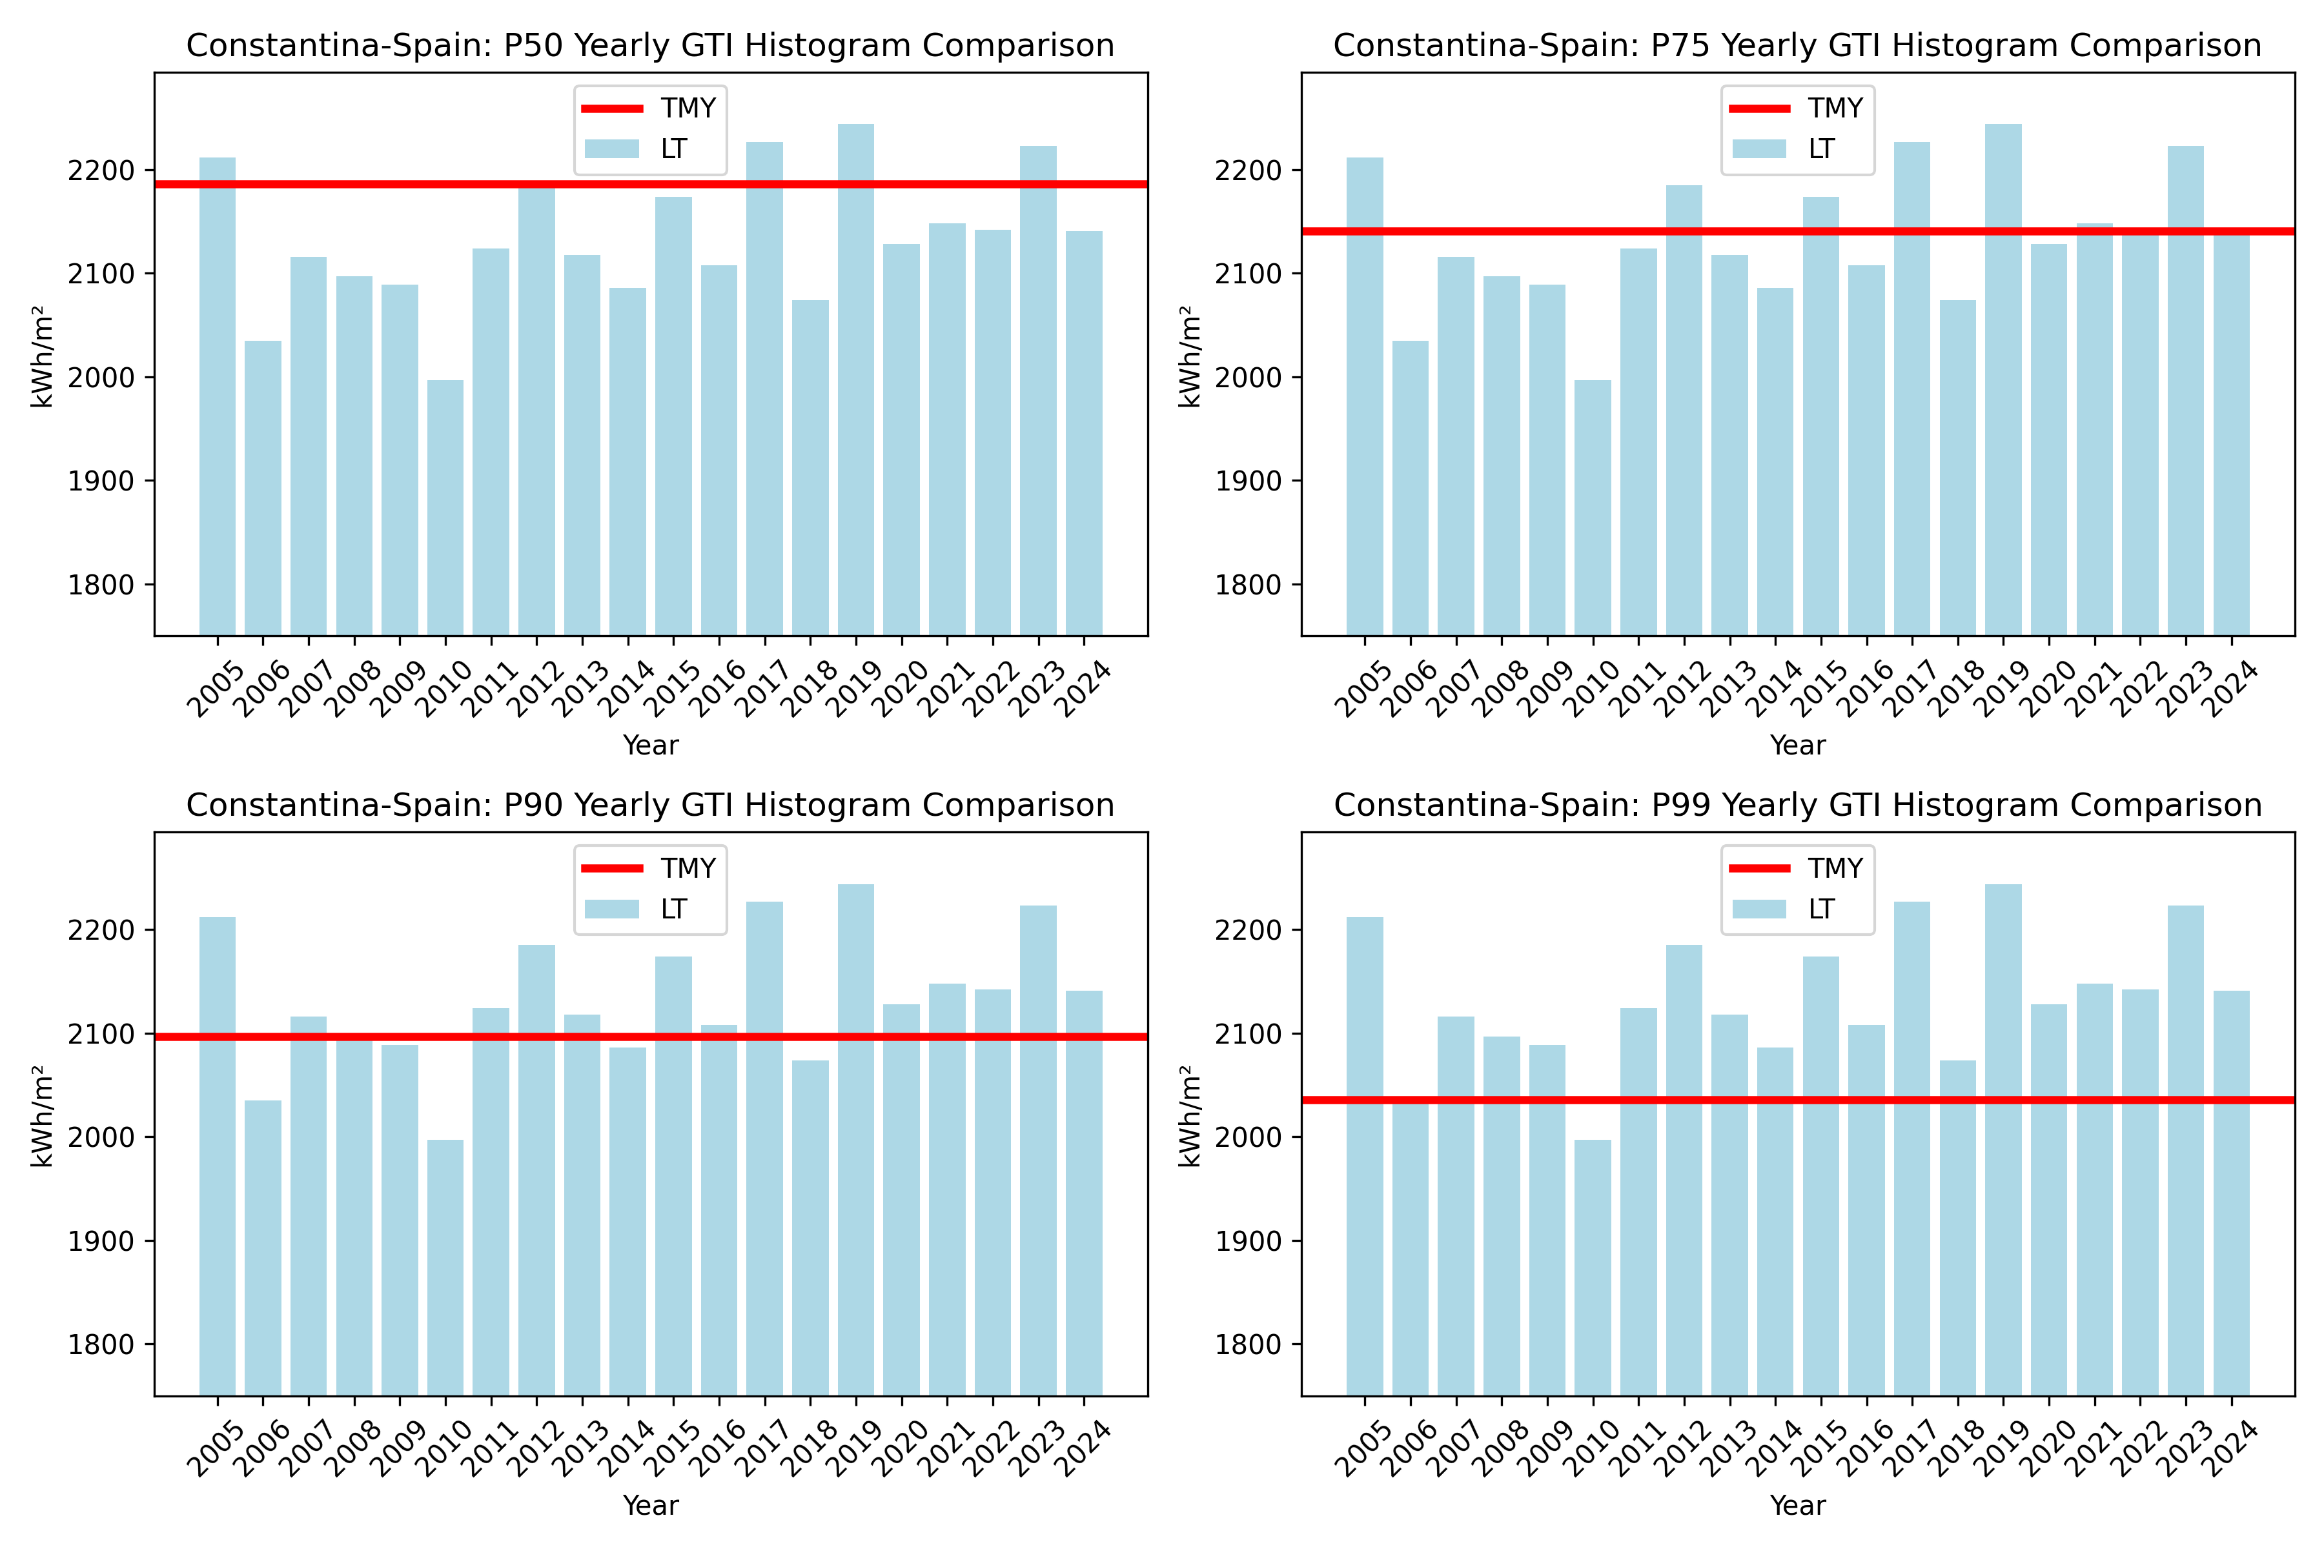
Figure 2: Yearly GTI Histogram comparison with TMY (P50,P75,P90,P99).

ANNEX 2: Summary about CAMS solar adiation

Summary
The CAMS Radiation Service is designed to meet the requirements that have been specified for the Copernicus Atmosphere Monitoring Service (CAMS). The precursor projects MACC and MACC-II/-III prepared the CAMS Radiation Service in terms of implementation, sustained operation and availability.

Solar radiation service
The CAMS solar radiation services (CRS) provide historical values (2004 to present) of solar irradiation. The aim is to fulfil the needs of European and national policy development and the requirements of both commercial and public downstream services, e.g. for planning, monitoring, efficiency improvements and the integration of solar energy systems into energy supply grids.

Methodlogy
The Heliosat-4 method estimates the down-welling shortwave irradiance received at ground level in all sky conditions. It provides global irradiance and its direct and diffuse components on a horizontal plane and direct irradiance for a plane normal to sun rays. It is a fully physical model using a fast, but still accurate approximation of radiative transfer modelling and is therefore well suited for geostationary satellite retrievals. It is composed of two models based on abaci, also called look-up tables: the McClear model calculating the irradiance under cloud-free conditions and the McCloud model calculating the extinction of irradiance due to clouds. Both have been realized by using the libRadtran radiative transfer model.
The main inputs to Heliosat-4 are aerosol properties, total column water vapour and ozone content as provided by the CAMS global services every 3 h. Cloud properties are derived from images of the Meteosat Second Generation (MSG) satellites in their 15 min temporal resolution using the APOLLO_NG (Klüser et al., 2015) scheme. From CAMS v4.0 onwards the use of cloud properties is extended by a circumsolar radiation parametrisation.

About Green Energy Park
The Green Energy Park is a platform for experimentation, research, and training in renewable energies, based in the Green City of Benguerir and built in collaboration between the Institute for Research in Solar Energy and New Energies (IRESEN) and Mohammed VI Polytechnic University (UM6P).
This unique platform, the first in Africa, allows, on the one hand, the creation of synergies and coalitions between several Moroccan research institutions in order to achieve excellence, and on the other hand, the acquisition of knowledge and expertise through partnerships with other universities and Moroccan industries.

References
- [1] S. Wilcox and W. Marion, Users Manual for TMY3 Data Sets 2008
- [2] CAMS solar radiation time-series. Copernicus Atmosphere Monitoring Service (CAMS) Atmosphere Data Store (ADS), https://ads.atmosphere.copernicus.eu/datasets/cams-solar-radiation-timeseries?tab=overview.
- [3] Lefèvre, M. et al, 2013. McClear: a new model estimating downwelling solar radiation at ground level in clear-sky conditions. AMT, 6, 2403-2418, doi: 10.5194/amt-6-2403-2013.
- [4] User Guide to the CAMS Radiation Service 2021.

