Line Follower Robot

Components:

* STM32f103c8 – bluepill
* USB to TTL
* TCRT5000 sensor
* L298 module
* Motors-12v DC (2)
* LCD 16x2
* Ultra sonic-HC-SR04
* HC-05

Softwares:

* Keil
* cube MX
* Flash Loader
* Poroteus
* Tera Term

Peripherals:

* ADC --> Analog to Digital Converter
* DMA --> Direct Memory Access
* UART --> Universal Asynchronous Receiver/Transmitter
* Timer

1. STM32f103c8 – bluepill:

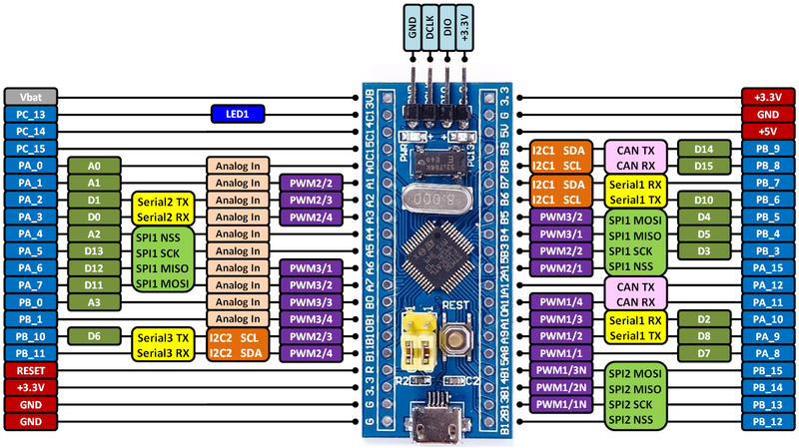

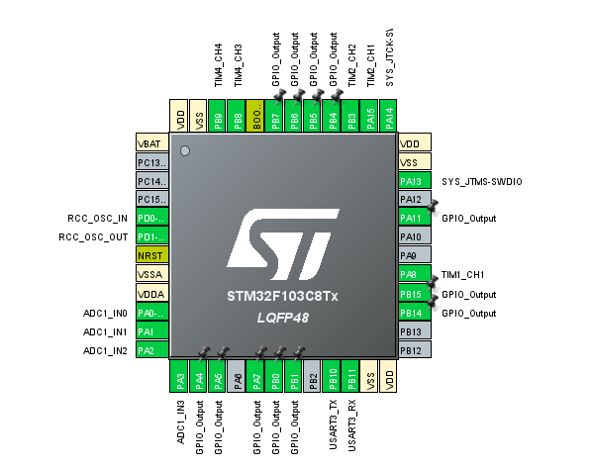

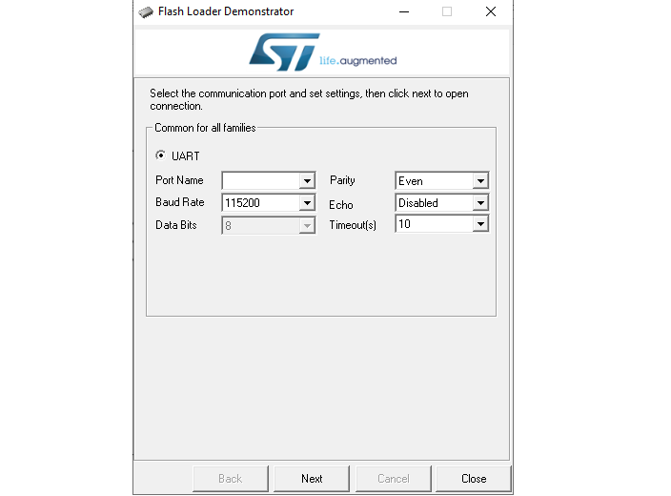



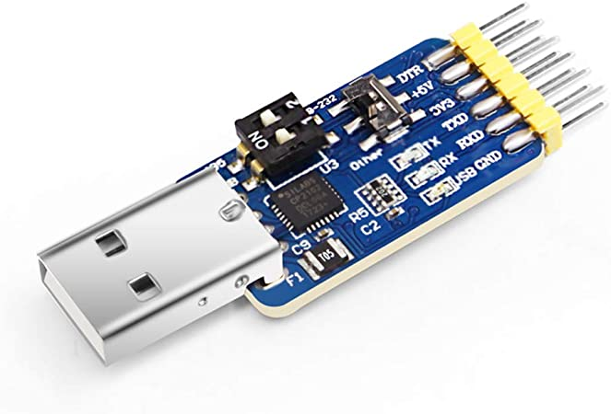

2. TCRT5000 sensor:

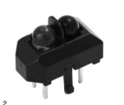

The TCRT5000 and TCRT5000L are reflective sensors which include an infrared emitter and phototransistor in a leaded package which blocks visible light.

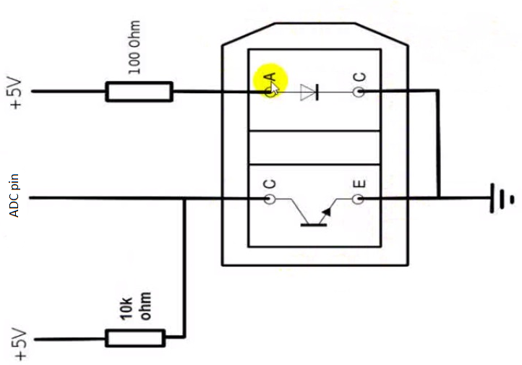

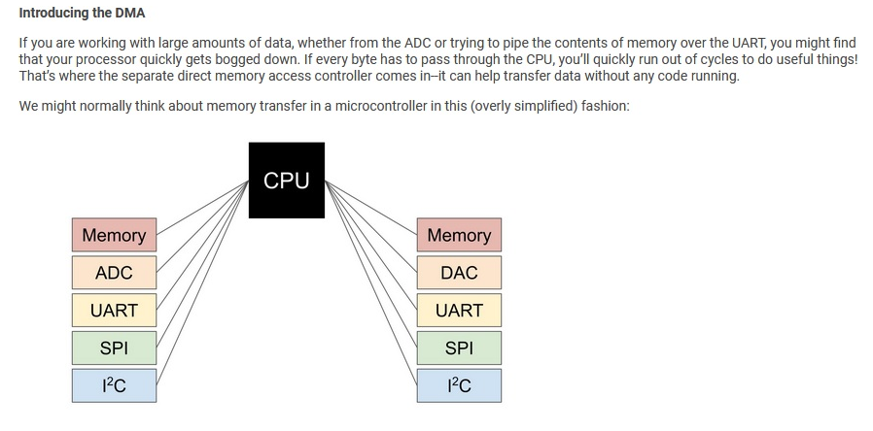

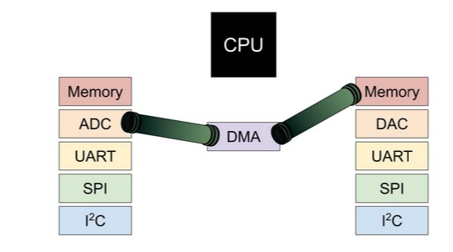

3. Ultra sonic-HC-SR04 :

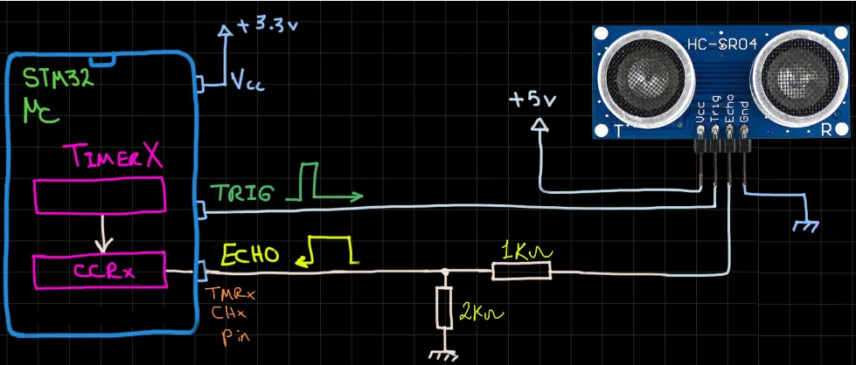

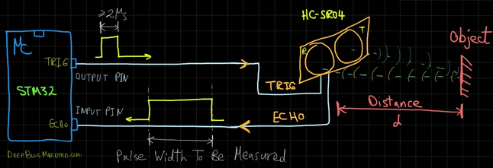

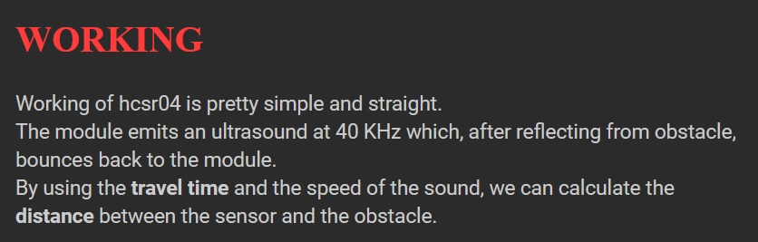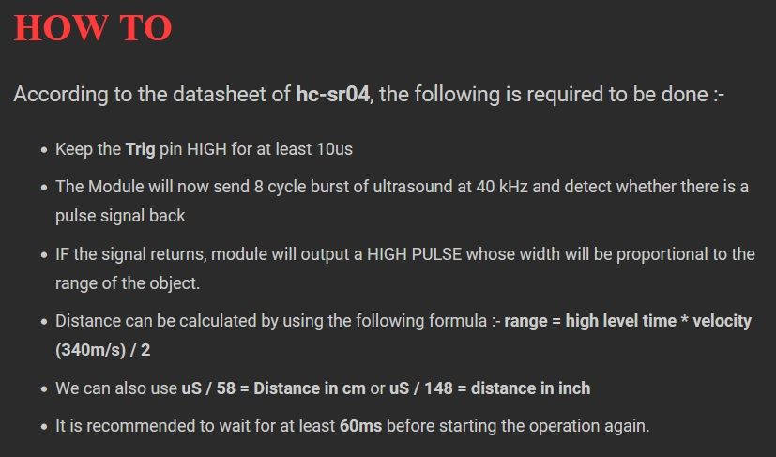

4. HC-05:

HC-05 module is an easy to use Bluetooth SPP (Serial Port Protocol) module, designed for transparent wireless serial connection setup.

* Operating Voltage: 3.3V to 6V ( Typically +5V )
* Operating Current: 30mA
* Range: ~ 9m ( 30ft )
* Works with Serial communication (USART) and TTL compatible
* Can operate in Master, Slave, or Master/Slave mode
* Can be easily interfaced with PCs or Smartphones with a Bluetooth capability

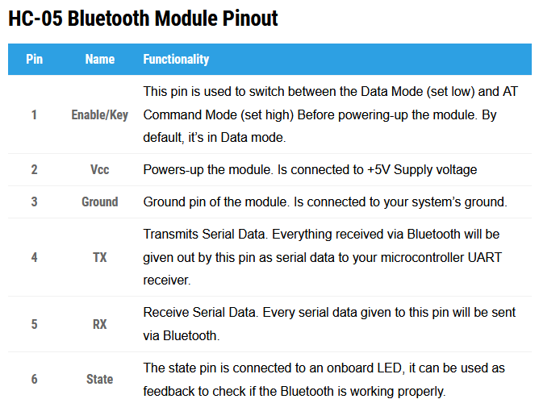

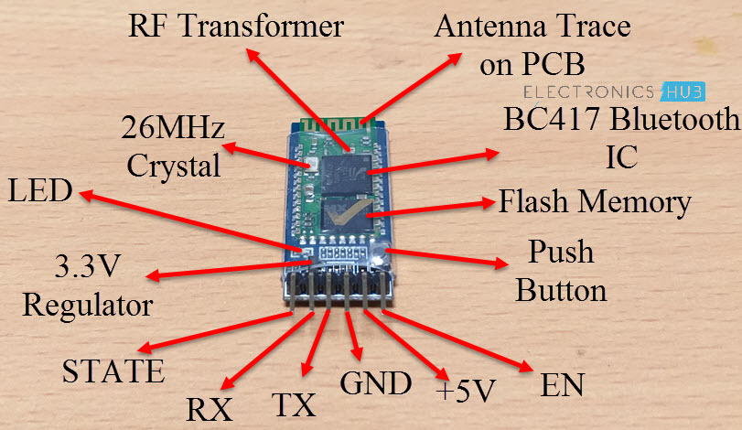

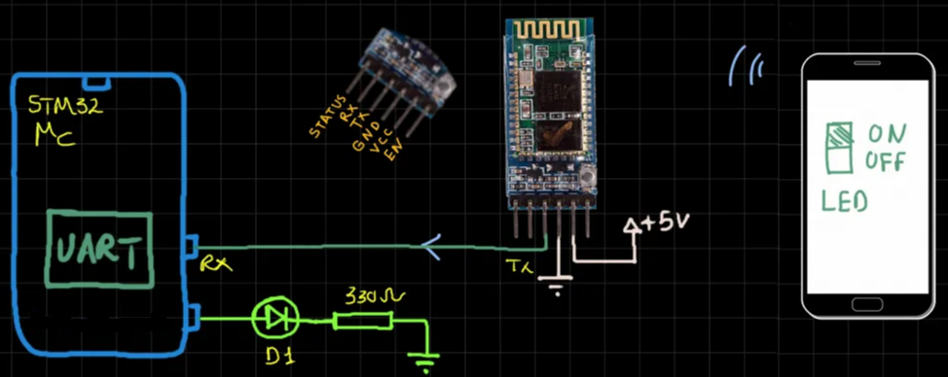

5. L298 **Motor Driver**:

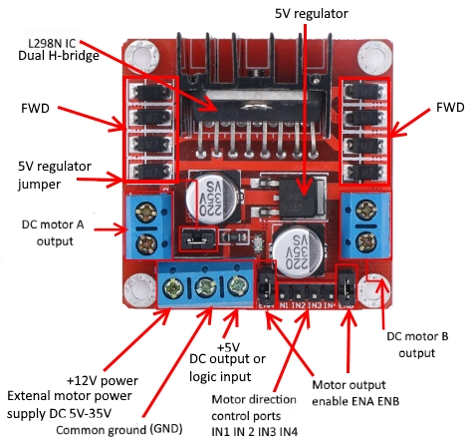

The L298N motor driver IC actually has two input power pins viz. ‘Vss’ and ‘Vs’.

From Vs pin the H-Bridge gets its power for driving the motors which can be 5 to 35V. Vss is used for driving the logic circuitry which can be 5 to 7V. And they both sink to a common ground named ‘GND’.

