Sara White
CSD-310
Assignment 2.3

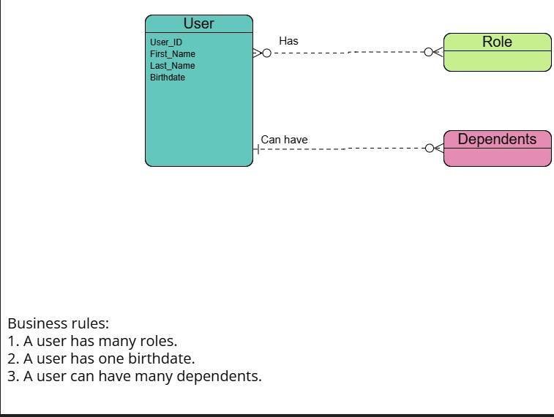

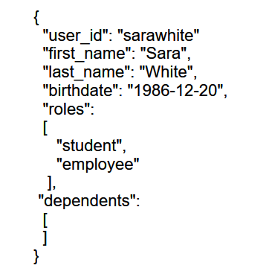
References

Albayrak, M. E. (2020, May 5). JSON Structure and Schema. Medium
https://medium.com/swlh/json-structure-and-schema-986f6ff64b94

